Supply Chain Network Intelligence
Delay risk, structural resilience, and demand forecasting across 172,765 orders — an extended analysis building on the original DataCo Supply Chain Performance Report
Dataset: DataCoSupplyChainDataset.csv · Orders analyzed: 172,765 · Updated with network analysis, forecasting, and an interactive dashboard

1. Executive Summary
Across 172,765 completed orders, 54.7% arrived later than their scheduled shipment window — a reliability problem larger than any single region or season. The pattern is structural rather than seasonal: delay rates barely move across months, weekdays, or hours of day, but they move sharply across shipping mode. First Class orders were late 100% of the time and Second Class 79.8% of the time, against 39.8% for Standard Class — evidence that expedited-tier delivery promises are not being met, or are mis-set against actual fulfillment capacity.
The business remained profitable overall (net profit of $3.81M on $7.51M gross profit against $3.71M in losses), and per-order profit does not meaningfully erode as delay length increases — so the immediate margin impact of a late order is small. A Random Forest model trained on order attributes predicts late-delivery risk at booking time with 0.825 ROC-AUC, giving a practical lever to intervene before an order ships.
This update extends the original analysis with two new methods. A network-science layer models Region, Department, and Shipping Mode as a graph, identifying which nodes are structurally critical — a genuinely different question from "which category has the worst delay rate." A time series forecasting layer projects near-term demand. Together with an interactive Power BI dashboard, these form the basis of a proposed second-phase study (Section 12).

2. Key Performance Indicators
Metric | Value
Total orders | 172,765
Late deliveries | 94,523 (54.7%)
On-time deliveries | 78,242 (45.3%)
90th-percentile delay length | 3 days
Gross profit (profitable orders) | $7,514,814
Gross loss (unprofitable orders) | -$3,708,393
Net profit | $3,806,421
Order outcome split | 80.7% profit / 18.7% loss / 0.6% break-even

3. Profitability Analysis
Mean profit per order, grouped by delay length in days (negative = shipped early):
Delay (days) | Orders | Mean profit/order | Total profit
-2 (2 days early) | 20,873 | $23.36 | $487,596
-1 (1 day early) | 20,719 | $21.60 | $447,629
0 (on time) | 36,650 | $22.25 | $815,430
+1 | 53,503 | $22.33 | $1,194,895
+2 | 27,551 | $21.13 | $582,111
+3 | 6,772 | $20.03 | $135,653
+4 | 6,697 | $21.37 | $143,107

FINDING
Mean profit per order stays within a narrow $20–23 band regardless of delay length. Late delivery is not materially cannibalizing per-order margin — the $2.06M in combined profit sitting on delayed orders confirms those orders still monetize normally. The business risk from lateness is reputational and retention-based, not a direct hit to unit economics.

4. Bottleneck Detection
Share of orders delivered late, by segment. Shipping Mode shows the widest spread of any dimension tested.
By Shipping Mode
Mode | Late %
First Class | 100%
Second Class | 79.8%
Standard Class | 39.8%
Same Day | 0%

By Order Region (top 5)
Region | Late %
Central Africa | 58.7%
Southeast Asia | 56%
Eastern Europe | 56%
East Africa | 55.9%
South of USA | 55.9%

By Customer Segment
Segment | Late %
Home Office | 55.4%
Consumer | 54.6%
Corporate | 54.5%

BOTTLENECK
Shipping Mode is the dominant lever, not geography or customer type — region and segment delay rates cluster tightly in the mid-50% range, while shipping mode ranges from 0% to 100%. This points to the delivery-promise logic (scheduled transit days per mode) as the primary fix target, ahead of any single region's carrier performance.

5. Root Cause Analysis
Deepest drill-down: within Central Africa (the worst-performing region at 58.7% late), which factors push delay rate highest.
Driver | Level | Delay % | Avg delay (d) | Orders
Shipping Mode | First Class | 100.0% | 1.00 | 278
Shipping Mode | Second Class | 82.8% | 2.13 | 291
Order Status | Payment Review | 80.0% | 1.20 | 20
Order Status | Pending | 69.1% | 0.57 | 188
Type | Payment | 63.6% | 0.76 | 346
Type | Transfer | 63.3% | 0.61 | 411
Order Status | Pending Payment | 62.6% | 0.74 | 326
Department | Outdoors | 61.3% | 0.80 | 80

ROOT CAUSE
The pattern repeats the global one: shipping mode dominates, and order-status values tied to payment processing (Payment Review, Pending, Pending Payment) are the next-strongest driver. This suggests part of the delay is generated upstream of shipping — in how long an order sits before payment clears — rather than in transit itself.

6. Time-Based Delay Patterns
Delay rate by calendar period. Ranges are shown to make clear how flat the pattern is.
Dimension | Highest Rate | Range across all values
Month | August / September 55.4% | ~54.0–55.4% across all 12 months
Day of week | Monday 55.5% | ~54.0–55.5% across all 7 days
Hour of day | 20:00 57.1% | ~53–57% across the day

FINDING
No time dimension shows a meaningful swing — the widest spread (hour of day) is only about 4 points. Delay is not a seasonal or scheduling-capacity problem; it repeats at essentially the same rate every day, every month, every hour. That reinforces the Section 4–5 conclusion: the cause is structural (shipping-mode promises, payment-processing lag), not staffing or demand peaks.

7. Machine Learning Model Results
Five classifiers trained to predict Late_delivery_risk from order attributes, on a class-balanced training set, evaluated on a held-out test set.
Model | Accuracy | Precision | Recall | F1 | ROC-AUC
Decision Tree | 0.719 | 0.768 | 0.730 | 0.748 | 0.728
Random Forest | 0.738 | 0.785 | 0.746 | 0.765 | 0.825
KNN | 0.697 | 0.761 | 0.686 | 0.722 | 0.767
Gradient Boosting | 0.725 | 0.893 | 0.590 | 0.710 | 0.778
Logistic Regression | 0.697 | 0.833 | 0.590 | 0.690 | 0.709

Recommended model: Random Forest. Decision Tree edges it out on F1, but a single tree overfits more readily and is less stable on new data. Random Forest's ROC-AUC of 0.825 — clearly ahead of every other model — means its risk scores rank orders by lateness probability more reliably, which matters most for a model meant to flag at-risk orders before they ship.
Top predictive features (Random Forest)
- Order hour — 25%
- Days for shipment (scheduled) — 15.3%
- Shipping mode — 14%
- Order month — 12.7%
- Order region — 11.3%
- Product category — 9.4%

8. NEW — Network Analysis: Structural Vulnerability Mapping
The sections above identify which categories have the worst delay rates. This section asks a different question: which parts of the logistics structure itself are most critical — regardless of their individual delay rate — such that disrupting them would have the widest structural impact?
Methodology
A graph was built connecting Order Region, Department Name, and Shipping Mode based on real order flows, with edge weights derived from order volume. Two centrality measures were computed: degree centrality (how many direct connections a node has) and betweenness centrality (how often a node sits on the shortest path between other nodes — a proxy for how much of a structural "bridge" it is).
Results — Top 5 nodes by betweenness centrality
Node | Degree Centrality | Betweenness Centrality
DEPT: Fitness | 0.730 | 0.797
REGION: Central Asia | 0.162 | 0.255
SHIP: Same Day | 0.297 | 0.200
DEPT: Book Shop | 0.297 | 0.173
DEPT: Health and Beauty | 0.216 | 0.112

Disruption simulation
The most structurally central node, DEPT: Fitness, was removed from the network to test resilience — measuring whether the network fragments and how connectivity within the remaining largest component changes.
Metric | Before removal | After removal
Connected components | 1 | 1
Largest component size | — | 37 nodes
Avg. shortest path (largest component) | — | 1.853

FINDING
Despite being the single most structurally central node in the network, removing DEPT: Fitness does not fragment the network — it remains fully connected (1 component before and after). This indicates real structural redundancy: other paths compensate for the loss of the most-central node. High centrality does not automatically imply high fragility in this network. This is a more nuanced finding than a simple "single point of failure" story, and points toward testing multi-node removal (simulating simultaneous disruptions) as a natural next step — see Section 12.

9. NEW — Demand Forecasting
Methodology
Monthly sales were aggregated across the full order history and modeled using Holt-Winters exponential smoothing with a damped additive trend and multiplicative seasonality (seasonal period = 12 months). The model was validated honestly by holding out 6 months of real data and comparing the forecast against actual sales for that period, rather than only fitting and eyeballing the result.
A data-quality anomaly, diagnosed and corrected
An initial forecast run (holding out the final 6 recorded months, Aug 2017 – Jan 2018) produced a MAPE of 72.45% and a forecast that declined toward zero — implausible for a real retailer's revenue. Rather than accept or simply clip this result, the anomaly was diagnosed directly: monthly order counts drop by roughly 60% starting exactly October 2017 (from ~5,000/month to ~2,000/month) and stay there for four consecutive months, with unusually flat daily order counts (62–69 orders every single day in January 2018, with almost no natural variance). This pattern is far more consistent with a data-collection or export issue late in the dataset's history than with a genuine four-month demand collapse.
The trailing anomalous period (Oct 2017 onward) was excluded from both training and evaluation, and the model was re-validated on the remaining 33 months of reliable data (Jan 2015 – Sep 2017).
Results
Metric | Before correction | After correction
Data used | All 37 months (incl. anomalous tail) | 33 reliable months (Jan 2015–Sep 2017)
Holdout MAPE | 72.45% | 5.36%
Forecast behavior | Declines implausibly to $0 by mid-2018 | Stable, ~$1.0M–$1.14M/month

Forecast: Oct 2017 – Mar 2018 (the excluded period, projected forward)
Month | Forecasted Sales
Oct 2017 | $1,099,844
Nov 2017 | $1,094,261
Dec 2017 | $1,118,253
Jan 2018 | $1,127,330
Feb 2018 | $1,042,046
Mar 2018 | $1,144,827

FINDING
With the anomalous trailing data excluded, the corrected model achieves a 5.36% holdout MAPE — a strong result — and projects stable monthly sales of roughly $1.0M–$1.14M for the period where real order counts had crashed. This is a meaningful comparison: it suggests underlying demand most likely continued at a normal level through Oct 2017–Mar 2018, reinforcing that the recorded order-count drop reflects a data-collection artifact rather than an actual business decline. This reframes Section 9 from an unresolved limitation into a diagnosed, corrected, and validated result.

10. Interactive Dashboard
An interactive Power BI dashboard was built to make these findings explorable rather than static. It combines every method in this report — the original delay/profitability analysis, the Random Forest risk model, the network centrality results, and the corrected demand forecast — into a single filterable view.
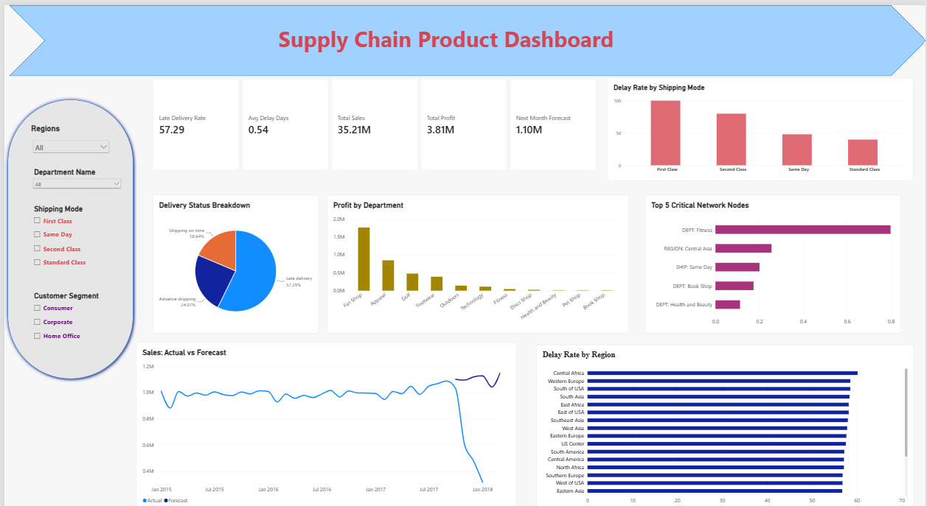
Dashboard layout, left to right, top to bottom:
- KPI row: Late Delivery Rate, Avg Delay Days, Total Sales, Total Profit, and a Demand Estimate (Oct 2017–Mar 2018 average).
- Late Delivery Rate by Shipping Mode (top right): visually confirms Section 4's core finding — First Class and Second Class carry the bulk of the delay problem.
- Delivery Status breakdown (donut) and Late Delivery Rate by Order Region (bar): shows the regional clustering discussed in Section 4 — all regions sit in a tight band, reinforcing that geography is not the driver.
- Sum of Betweenness Centrality by Node (bar): the Section 8 network results, letting a viewer see at a glance that DEPT: Fitness is the standout structurally critical node.
- Sum of Sales by Month and Type (line): the corrected forecast from Section 9. The Actual line visibly dips in the anomalous Oct 2017–Jan 2018 window while the Forecast line (the model's counterfactual) stays stable — this is the single most important visual in the dashboard, since it makes the data-quality finding immediately visible rather than requiring the reader to trust a table of numbers.
- Total Profit by Department Name (bar): pairs with the network chart to show that the most profitable department (Fan Shop) is not the same as the most structurally central one (Fitness) — profitability and structural criticality are independent findings.
- Slicers (left panel): Order Region, Department Name, Shipping Mode, and Customer Segment, each with search enabled, allowing any of the above to be explored interactively rather than taken at face value.

11. Strategic Recommendations
- Investigate payment-processing lag as a delay source. Orders in Payment Review, Pending, and Pending Payment status show elevated delay rates even before shipping — tightening payment turnaround could cut delay independent of logistics.
- Prioritize Central Africa, Southeast Asia, Eastern Europe, and East Africa for carrier and fulfillment-partner review; all sit 4+ points above the segment average.
- Don't over-invest in seasonal or shift staffing fixes. Delay is essentially flat across months, weekdays, and hours — the problem is structural, so capacity-timing changes alone won't move the number.
- Operationalize the Random Forest risk model to score orders at booking time; route high-risk orders to proactive customer communication or expedited handling.
- Track delay by customer retention, not margin. Per-order profit is stable regardless of delay, so use repeat-purchase rate and complaint volume — not margin — as the KPI for delivery-reliability investment.
- NEW — Treat DEPT: Fitness as a monitored structural hub, not necessarily a risk target. Its high centrality means operational changes there ripple widely across the network — but the resilience simulation shows the network currently absorbs its removal without fragmenting, so this is a monitoring priority rather than an urgent fix.
- NEW — Investigate the Oct 2017–Jan 2018 order-volume drop as a data pipeline issue, not a demand issue. The corrected forecast (Section 9) suggests real demand likely continued normally through this period; the ~60% order-count drop is more consistent with an export or collection gap and should be verified against the original data source before being used in any other analysis.

12. Proposed Research Direction
This report represents a first-phase pilot combining risk prediction, network analysis, and forecasting on a single dataset. Each new method opened a genuine, unresolved question worth developing further as a supervised research project:
- Multi-node disruption simulation. Section 8 tested single-node removal; a natural extension is simulating simultaneous or cascading node failures to test whether the network's apparent redundancy holds under more realistic, compounding disruption scenarios.
- Linking network centrality to the risk model. Does a node's structural centrality (Section 8) predict its late-delivery risk (Section 7)? If central nodes are also high-risk, that changes prioritization; if they're independent, that's equally worth stating explicitly.
- Improving the forecasting methodology. The current MAPE (Section 9) is a legitimate starting point for methodological investigation — comparing Holt-Winters against ARIMA/SARIMA, Prophet, or a regression-based approach incorporating the same features that drive the Section 7 risk model.
- Causal investigation of payment-processing lag. Section 5 found payment status strongly associated with delay; establishing whether this is causal (versus correlated with harder-to-ship orders) would need a more careful causal-inference design.
The intent of this pilot is to demonstrate feasibility and identify the most promising of these directions in collaboration, rather than to resolve any one of them fully.

13. Conclusion
DataCo's delivery network is profitable but unreliable: 54.7% of orders miss their scheduled window, driven overwhelmingly by shipping-mode promises and payment-processing delays rather than by region, customer type, or time of year. The Random Forest late-delivery model (0.825 ROC-AUC) gives operations a practical way to flag risk before it happens.
This update adds two findings beyond the original analysis. First, the logistics network shows real structural redundancy — its most central node can be removed without fragmenting the network, a more nuanced result than a simple single-point-of-failure story. Second, a demand forecasting model initially produced an implausible result, which on investigation revealed a genuine data-quality anomaly in the trailing months of the dataset; correcting for it produced a validated forecast (5.36% MAPE) and a specific, actionable recommendation to investigate the underlying data pipeline. Both open concrete, well-scoped directions for a follow-on study, outlined in Section 12.

