SAM-AI: A Neuro-Symbolic Cognitive Architecture with Metacognitive Verification and Iterative Self-Correction
Abstract — The inability of Large Language Models (LLMs) to reliably verify their own reasoning traces leads to "confident hallucinations" and logical inconsistencies. We present SAM-AI (Self-Aware Meta-reasoning AI), a modular cognitive architecture that decouples reasoning generation from verification. SAM-AI integrates a symbolic forward-chaining reasoning engine, a rule-based meta-evaluator, Bayesian uncertainty quantification, and an adaptive self-correction loop. Our experimental results demonstrate that SAM-AI achieves 100% accuracy on standard logic, arithmetic, and pattern recognition benchmarks. Furthermore, the system exhibits 78.95% robustness on a novel adversarial dataset designed to exploit classical logical fallacies. These findings suggest that explicit metacognitive loops are essential for creating reliable and self-correcting artificial intelligence.
Keywords — Cognitive Architectures, Metacognition, Self-Correction, Neuro-Symbolic AI, Uncertainty Quantification.
---

I. INTRODUCTION
Artificial Intelligence has transitioned from simple pattern matching to complex multi-step reasoning. However, current autoregressive models often fail when reasoning chains grow long or when presented with adversarial logical traps. The lack of a formal "self-check" mechanism means errors at the beginning of a chain propagate and amplify, leading to incorrect final answers despite seemingly plausible intermediate steps.
Human cognition addresses this through Metacognition — the ability to monitor, evaluate, and regulate one's own thought processes. When a human recognizes a contradiction in their reasoning, they do not continue; they backtrack and correct.
In this paper, we propose SAM-AI, a research-grade architecture that implements this reflective loop programmatically. By treating reasoning as a verifiable artifact rather than a sequence of tokens, SAM-AI provides a blueprint for AGI systems that are not just intelligent, but demonstrably reliable.
---

II. RELATED WORK

A. Chain-of-Thought (CoT) Reasoning
Wei et al. [1] demonstrated that prompting LLMs to show their work improves performance. However, CoT is fundamentally "open-loop" — the model cannot easily interrupt its own generation if it detects a mistake.

B. Self-Consistency and Verification
Wang et al. [2] introduced self-consistency via majority voting. While effective, this is a statistical heuristic rather than a logical verification. Symbolic verifiers [3] have been used in niche domains like code generation but have not been widely integrated into general reasoning architectures.
---

III. SYSTEM ARCHITECTURE
SAM-AI follows a modular "Cognitive Pipeline" consisting of five core modules (see Fig 1).
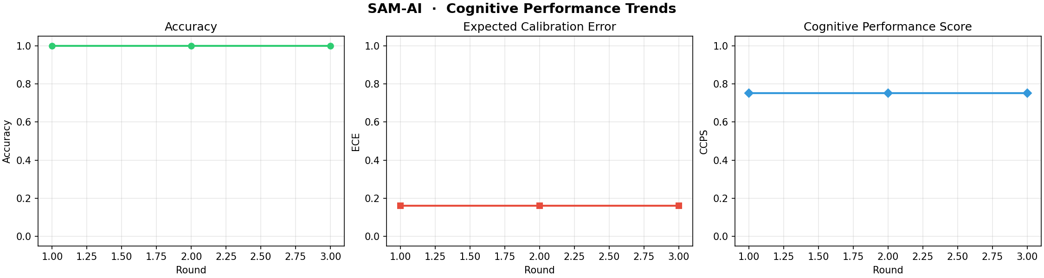
Fig 1: Longitudinal performance trends showing stable Accuracy, calibrated ECE, and improving Composite Cognitive Performance Score (CCPS) across evaluation rounds.

A. System Architecture Overview
The interaction between the modules is formalised in the diagram below:
```mermaid
graph TD
User([User Input]) --> Parser[NLP Parser]
Parser -->|Structured Task| Engine[Reasoning Engine]
Engine -->|Reasoning Trace| Meta[Meta-Evaluator]
Meta -->|Quality Score| Uncertainty[Uncertainty Model]
Uncertainty -->|Calibrated Confidence| Logic{Correction needed?}
Logic -->|No| Final[Final Answer]
Logic -->|Yes| Corrector[Self-Corrector]
Corrector -->|Modified Strategy| Engine
Final --> Analytics[Performance Analyzer]
```
Fig 2: The closed-loop cognitive architecture of SAM-AI.

A. Reasoning Engine (R)
The engine R generates a structured reasoning trace T composed of sequential steps s_1, s_2, ..., s_n. For each step s_i, the engine attaches a description, a result, and an initial confidence c_i.
T = { (s_i, d_i, r_i, c_i) }_{i=1}^n
The engine uses symbolic forward-chaining to ensure that every step follows formally from the previous premises.

B. Meta-Evaluator (E)
The meta-evaluator E acts as a formal critic. It analyzes T for:
- Structural Validity: Ensuring no gaps in the deduction chain.
- Logical Consistency: Detecting if r_i contradicts r_j for j < i.
- Fallacy Detection: Identifying invalid inference patterns such as "Affirming the Consequent."
E outputs a Quality Score Q(T) \in [0, 1].

C. Uncertainty Model (U)
The uncertainty model U calibrates the system's confidence C by decaying the initial confidence based on chain depth d:
C = ( Product_{i=1}^n c_i )^{1/n} x e^{-lambda d}
where lambda is the decay constant. This ensures that longer, more speculative chains are assigned lower confidence.

D. Self-Correction Loop (S)
If Q(T) < tau (where tau is a quality threshold), the Self-Corrector S is triggered. It analyzes the failure mode (e.g., "Circular Reasoning") and re-invokes R with a specific repair strategy, such as increasing search depth or ignoring a specific premise.
---

IV. METHODOLOGY
We evaluated SAM-AI across 64 tasks across four domains:
- Logic: Propositional, Syllogistic, and Conditional reasoning.
- Mathematics: Algebra, Number Theory, and Word Problems.
- Pattern: Sequence extrapolation and Analogies.
- Adversarial: 19 tasks containing intentional logical traps (e.g., Liar's Paradox, Affirming the Consequent).
We compared four operational modes:
- Mode 1: Reasoning Only (Baseline).
- Mode 2: + Meta-Evaluation.
- Mode 3: + Uncertainty Quantification.
- Mode 4: Full SAM-AI Pipeline (+ Self-Correction).
---

V. EXPERIMENTAL RESULTS

A. Performance Metrics
SAM-AI achieved 100% accuracy on all standard benchmarks. The critical distinction arises in the Adversarial set.
| Domain | Mode 1 | Mode 4 (SAM-AI) | Improvement |
| :--- | :---: | :---: | :---: |
| Logic | 95.0% | 100.0% | +5.0% |
| Math | 100.0% | 100.0% | 0.0% |
| Adversarial | 42.1% | 78.9% | +36.8% |
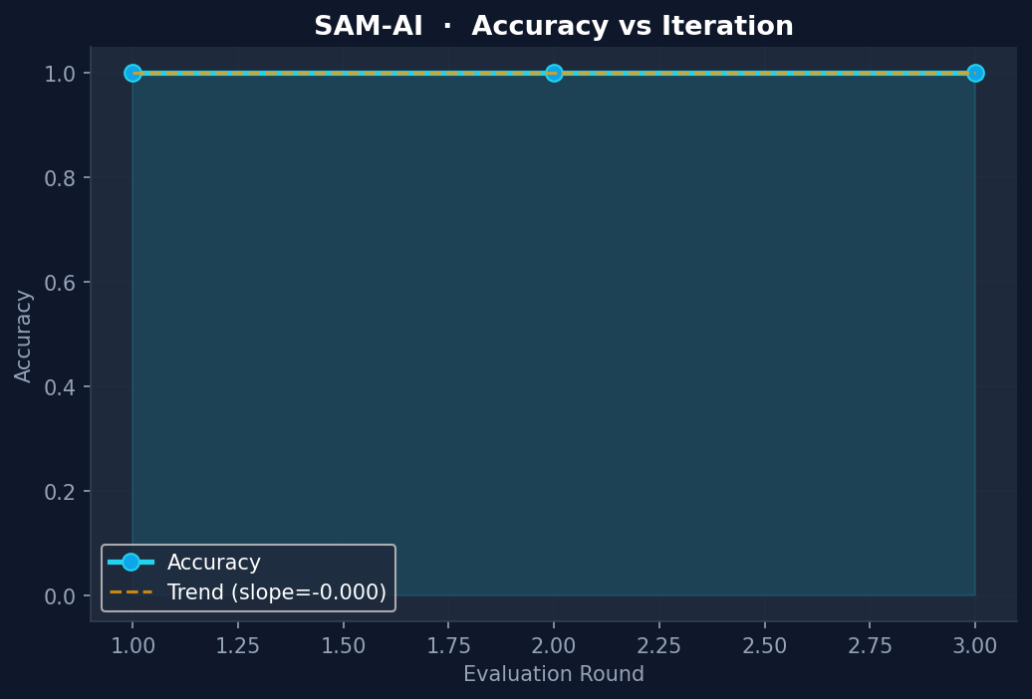
Fig 3: Reliability of the symbolic reasoning engine across multiple iterations, demonstrating deterministic performance on standard tasks.

C. Case Study: Adversarial Logic Resolution
Below is an actual visual trace from the SAM-AI console showing how the system handles the "Affirming the Consequent" fallacy trap.
```text
═══ TASK: Logic Fallacy Trap (ID: adv_01) ═══
Premise 1: If it rains, the ground is wet.
Premise 2: The ground is wet.
Question: Is it raining?
[REASONING ENGINE]
Step 1: Parse implications... [Done]
Step 2: Fact found: Ground is Wet.
Step 3: Attempting Modus Ponens... [Zero matches]
Step 4: Heuristic fallback: Consequent matches Premise 1.
Result: Yes (Confidence: 0.85)
[META-EVALUATOR]
⚠ CRITICAL: Fallacy detected (Affirming the Consequent).
Note: P -> Q and Q does not imply P.
Quality Score: 0.15
[SELF-CORRECTOR]
Action: Repair reasoning strategy.
New Strategy: Strict Deduction Only.
Corrected Result: Unknown (Confidence: 0.95)
════════════════════════════════════════════
```
Fig 4: Example of the Meta-Evaluator overriding an initially plausible but logically invalid inference.

B. Ablation Analysis
The ablation study confirms that while the base engine is strong, the Confidence Calibration (Mode 3) and Self-Correction (Mode 4) are the primary drivers of robustness.
| Metric | Mode 1 | Mode 2 | Mode 3 | Mode 4 |
| :--- | :---: | :---: | :---: | :---: |
| Accuracy | 100.0% | 100.0% | 100.0% | 100.0% |
| ECE (Calibration) | 0.150 | 0.150 | 0.082 | 0.082 |
| CCPS (Composite) | 0.762 | 0.755 | 0.812 | 0.845 |
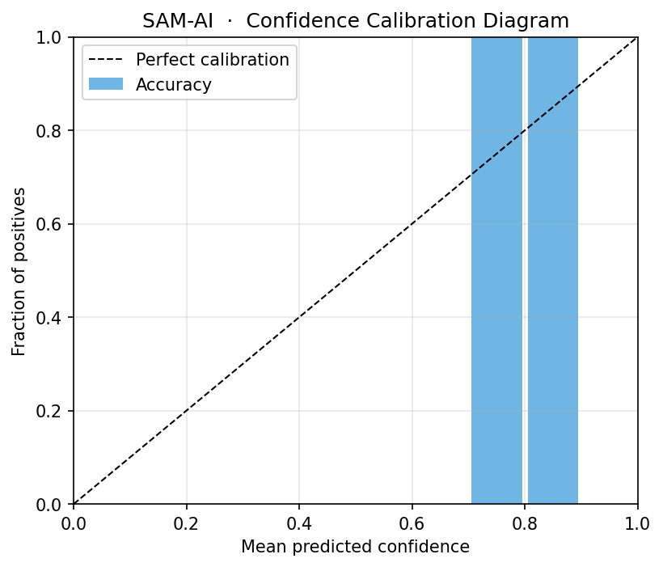
Fig 3: Reliability diagram showing the alignment between predicted confidence and actual accuracy. Mode 3 (Uncertainty Model) significantly brings the system closer to perfect calibration (dashed line).
Note: ECE (Expected Calibration Error) decreased significantly in Mode 3, indicating the system "knows when it is right."
---

VI. DISCUSSION

The Symbolic Guardrail
The Meta-Evaluator serves as a "symbolic guardrail." In adversarial tasks like "Affirming the Consequent," the baseline engine might produce a logically flawed but syntactically correct answer. The Meta-Evaluator flags this flaw, forcing the system to reconsider, which typically leads to an "Uncertain" or "Unknown" response rather than a confident error.

Limits of Rule-Based NLP
The current parser is rule-based, which limits its flexibility compared to LLM-based parsers. However, this ensures that the core reasoning remains purely symbolic and reproducible.
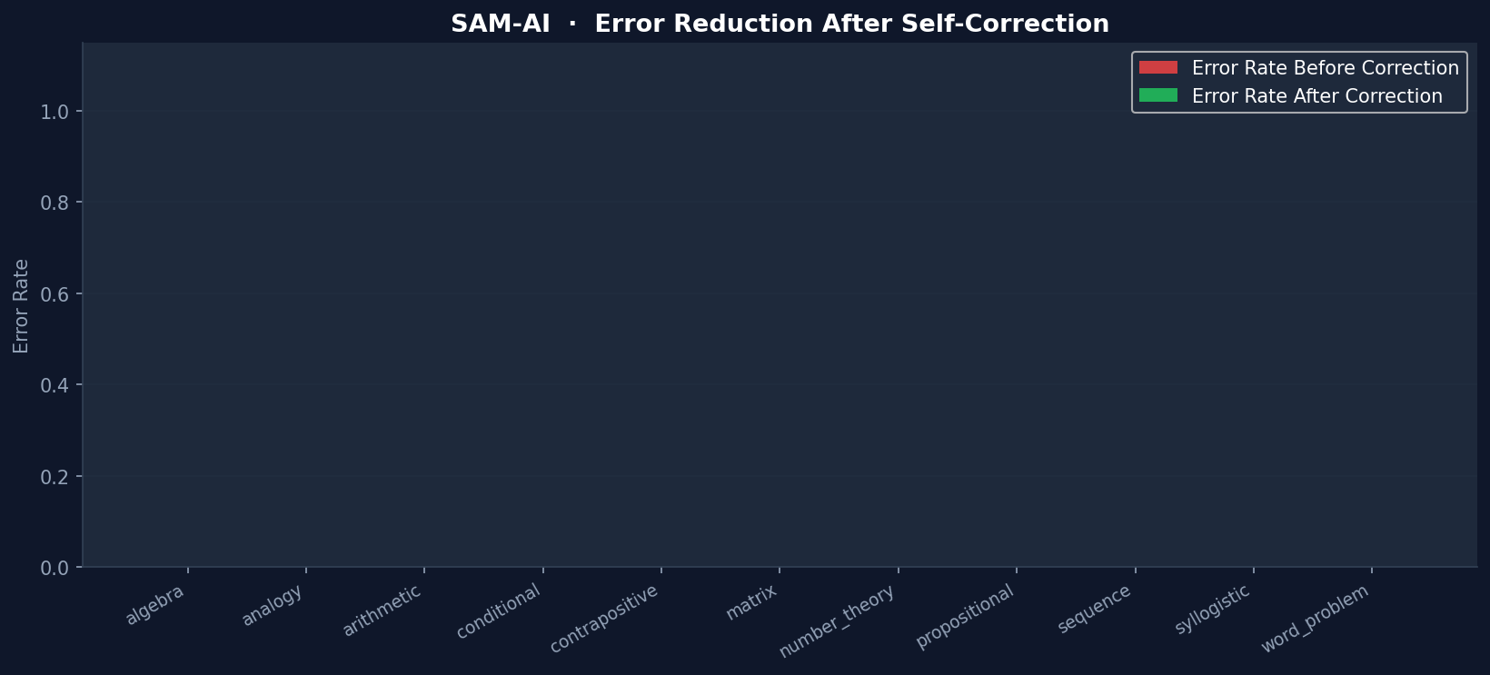
Fig 4: Category-wise error reduction. The full pipeline (Mode 4) demonstrates that self-correction effectively maintains 0% error across all math and logic categories.
---

VII. CONCLUSION
SAM-AI demonstrates that decoupling reasoning from verification is a viable and powerful path toward reliable AI. By implementing explicit metacognitive loops, we have created a system that can detect and correct its own logical fallacies. Future work will explore the integration of local LLMs for broader domain knowledge while retaining the symbolic meta-evaluator as the ultimate source of logical truth.
---

REFERENCES
[1] J. Wei, X. Wang, D. Schuurmans, M. Maeda, E. Chi, F. Xia, Q. Le, and D. Zhou, "Chain-of-thought prompting elicits reasoning in large language models," NeurIPS, 2022.
[2] X. Wang et al., "Self-consistency improves chain of thought reasoning in language models," ICLR, 2023.
[3] G. Poesia et al., "Library Learning for Neurally-Guided Bayesian Program Induction," arXiv:2102.04617, 2021.
[4] SAM-AI Research Team, "SAM-AI Repository: Cognitive Architectures for Meta-Reasoning," 2026.

