Scientific Calculator v1.3.4
Documentation
By Sam Gleske

Table of Contents
Table of Contents 2
1. Introduction 3
1.1. Welcome 3
1.2. Calculator Info 3
1.3. Compatible Browsers 4
1.4. Keyboard Shortcuts 5
2. Menu Help 6
2.1. Overview 6
2.2. File Menu 6
2.3. Edit Menu 7
2.4. Conv Menu 7
2.5. Help Menu 8
3. Button Help 9
3.1. Overview 9
3.2. Deletion Buttons 10
3.3. Basic Equations 11
3.4. Memory Buttons 11
3.5. Power Functions 14
3.6. Trigonometric Functions 15
3.7. Miscellaneous 16
4. License Information 17
4.1. Disclaimer 17
4.2. License 17
5. The Author 19
5.1. Contributors 19
5.2. About the Author 19
5.4. Technologies Used 19
5.5. Contact the Author 20
5.6. Resume Request 20

1. Introduction

1.1. Welcome
Welcome to the Scientific Calculator v1.3.4 Help Documentation. Here you will find extensive knowledge and expertise with the function of this calculator, what different buttons do, examples in computing equations, as well as descriptions of menus and their functions.
I hope this will be of great help to you and that you find many uses for my calculator.

1.2. Calculator Info
What is the Scientific Calculator v1.3.4?
It is an advanced calculator that uses JavaScript (not Java) to compute advanced math functions. Type in almost any equation and my calculator can handle it!
Why is the version 1.x.x?
That is the number of times the calculator has bad major revisions since its original release November, 2005. 2.x.x will be the version when the calculator has had 100 revisions. Each revision usually contains 3 or more changes to the programming, UI, or documentation.
Other Fun Facts:
- It took me 10 hours to make the initial design of the calculator. So when I mean it was created on November 28th, 2005.I literally mean it was created that day!
- The original calculator had the following menus:
  - File > Exit
  - Edit > Copy
  - Edit > Paste
  - Conv > Bin > Dec
  - Conv > Bin > Hex
  - Conv > Dec > Bin
  - Conv > Dec > Hex
  - Conv > Hex > Bin
  - Conv > Hex > Dec
  - View > Standard
  - View > Scientific (disabled)
  - Help > Help (disabled)
  - Help > About Calculator
- The original calculator had most of the current buttons as well.
- The original calculator only supported Internet Explorer.
What changes have there been?
All code has been entirely rewritten over versions 1.0.x and 1.1.x. It was rewritten to be better optimized, more efficient, and it was even reformatted to a common human readable tabular format across all documents. Even the file structure of the calculator has been changed. More menus have been added such as an Octal conversion and Temperature conversion in the Conv menu. In version 1.3.3 Scientific Calculator saw another complete rewrite. The method for grabbing and interpreting keystrokes was rewritten to be more compatible with IE8+. The math interpreter, error checking, base converter, float rounding, and all math functions were taken out of the calculator and placed within a single JavaScript object. This way any web application can benefit from the advanced interpreting, error checking, and calculating just like the Scientific Calculator. This object is now a download option on my sourceforge project labeled JavaScript Human Readable Math Library/Compute Object.
Future Plans?
Eventually I want the calculator to be able to calculate in hexadecimal, octal, and binary modes. And give the user the option to possibly automatically clean up equation errors. Possibly saving settings within cookies?

1.3. Compatible Browsers
Scientific Calculator v1.3.x fully supports the following web browsers on all platforms:
- Firefox
- Internet Explorer 6.0+
- Konqueror 3.4.2
- Mozilla 1.7
- Netscape
- Opera 9+
- Safari 3+
All other browsers work but may not be fully supported with detecting the keystrokes and having shortcut keys.

Compatibility Tests
Successfully tested browsers
- Windows 7
- Firefox 3.6.x
- Internet Explorer 8/9
- Opera 10.x
- Windows 2000/XP/Vista
  - Firefox 1.0.x/1.5.x/2.0.x
  - Internet Explorer 6.x/7.x
  - Mozilla 1.7
  - Netscape 9.x
  - Opera 9.x
  - Safari 3.0
- Linux/UNIX
  - Firefox 1.0.x/1.5.x/2.0.x
  - KDE Konqueror 3.4.2
  - Mozilla web browser
  - Netscape 7.x
  - Opera 9.x
- MAC OSX
  - Firefox 1.5.x
  - Safari 3.0
Untested browsers (planned for testing)
- MAC OSX
  - Internet Explorer 5
Test results
Scientific Calculator v1.3.3 is compatible with the following web browsers on all platforms:
- Firefox 1.0+
- Internet Explorer 6.0+
- KDE Konqueror 3.4.2+
- Mozilla
- Netscape 7+
- Opera 9+
- Safari 3+
Note: Older versions of those browsers may still work with Scientific Calculator. Though I have not tested older versions so there's no guarantee that it will work.
Compatibility Alert!
Recently I have discovered that the following Firefox extension(s) do not allow the calculator to be sized correctly:
- 1-ClickWeather 1.1.4
I highly recommend you uninstall these extension(s) because they seem to mess with the CSS engine of Firefox which affects all web pages, not just this calculator.

1.4. Keyboard Shortcuts
- All the Basic Equation Keys work (0-9+-*/^%<>.)
- MC press C key
- MR press R key
- MS press S key
- M+ press M key
- pi press P key
- () press () keys
- Backspace press BACKSPACE key
- CE press DELETE key
- = press Enter (Return) key
- EE press E key

1.4.1 Two Modes of Input
When the Calculator Display is focused, the keyboard shortcuts are disabled and it acts like a normal text field. This is to maximize the compatibility and give the user more control over editing their equations.

2. Menu Help

2.1. Overview
What is the menu?

What is a submenu?
A submenu is a branch within the main headers of the menu. Click on the main header File. You will notice other menus extend from it (Reload and Close); these are called submenus.
What are submenu notations?
A submenu notation is similar to a webpage breadcrumb menu.
For example if you were specified to click File and then click Reload, then the menu notation would be "select Reload under File > Reload".

2.2. File Menu
What is the File Menu?
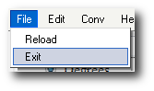
Functions of the File Menu:
- Under File > Reload: This submenu resets all settings of the calculator
- Under File > Exit: This submenu closes the calculator

2.3. Edit Menu
What is the Edit Menu?
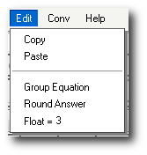
Functions of the Edit Menu:
- Edit > Copy Copies the diplayed equation.
- Edit > Paste Pastes contents of clipboard into the current equation.
- Edit > Group Equation Takes the current equation and wraps it in parenthesis. This way all further operations are applied to the entire equation. If the equation is already grouped then it toggles the grouping off.
- Edit > Round Answer Rounds the current answer/equation to the decimal places specified.
- Edit > Float Specifies the number of decimal places to be rounded.
Note: Copy and Paste menus only show up in Internet Explorer where clipboard access by JavaScript is allowed. It won't work in any other browser so therefore it only shows up in IE.

2.4. Conv Menu
What is the Conv Menu?
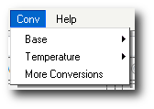
What does Conv mean?
Conv is abbreviated for Convert. It's purpose is to convert between number types
Functions of the Conv Menu:
- Conv > Base Converts the equation between Binary, Decimal, Hexadecimal, and Octal bases.
- Conv > Temperature Converts the equation between Celsius, Fahrenheit, Rankine, and Reaumur temperatures.
- Conv > Other Conversions is a link to onlineconversion.com where there is an extensive list of units to convert from.

2.5. Help Menu
What is the Help Menu?
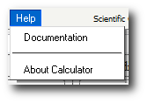
Functions of the Help Menu:
- Help > Documentation Displays the Calculator Help (this entire help guide).
- Help > About Displays a quick information dialog about this calculator.

3. Button Help

3.1. Overview
This section is to teach you how to use the different buttons of the Scientific Calculator. You will learn the names of the function of each button as well as how to use them. The buttons are split into sections:
- Deletion Buttons (Backspace, CE, AC)
- Basic Equation Buttons (0-9, /, *, +, -, -/+, ., =)
- Memory Buttons (MC, MR, MS, M+)
- Power Functions (%, x^y, >>, <<)
- Trigonometric Functions (exp, ln, log, cos, sin, tan, acos, asin, atan)
- Miscellaneous (remaing buttons not covered in other sections)
Quick note before you proceed:
The display below will be called a few things.
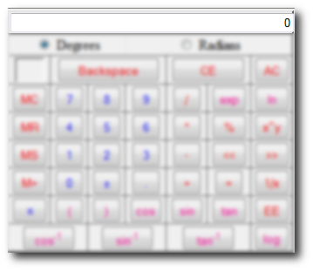
Display, Equation Display, Current Equation, the Equation

3.2. Deletion Buttons
There are several ways to remove variables or entire equations from the display or memory of the Scientific Calculator.
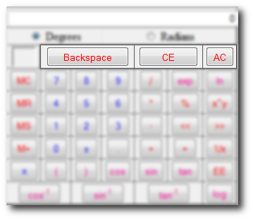
- The next button to the right, "Backspace", deletes a value from the Equation Display from right to left.
- The next button to the right is the CE button or better known as the Clear Equation button.It gets rid of any contents within the Display and sets it back to its default value "0".
- The AC button or All Clear button clears both the memory (by getting rid of the "M" along with the stored data) as well as the Display (sets back to "0")

3.3. Basic Equations
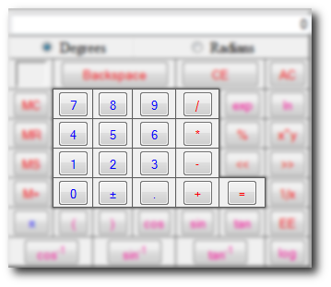
Above are the basic calculator buttons found on every calculator.
Rules: There has to be a symbol in between any two algebraic functions. For example (8)(2)=16 algebraically. But that has to be inputed into the calculator as (8)*(2)=16.

3.4. Memory Buttons
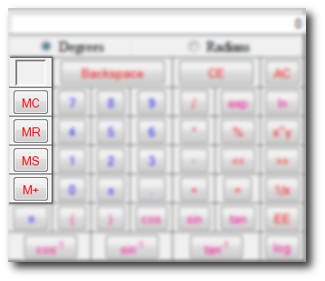
In this help topic you will learn how to use the memory functions of the Scientific Calculator. At the top you should recognize the memory indicator (see Deletion Buttons). Click on the word memory indicator to see its definition.Now before you can use the memory functions you must learn what its buttons mean. Look below for explanations:
- The empty box at the top is known as the memory state. It "indicates" if it has value stored in memory by showing an "M" in its center.
- MC (Memory Clear) Clears the memory and takes the "M" out of the memory indicator
- MR (Memory Recall) Takes the equation out of memory and adds it to the end of the Equation Display **See examples for a better explanation
- MS (Memory Store) Calulates and then stores current Equation into memory to be later recalled. Also a large "M" will appear inside of the memory indicator to show a value has been stored.
- M+ (Memory Plus) Takes the value stored in memory, calculates and takes the currently Displayed equation, and adds them both together while storing the answer once again into memory.
Example 1 (Storing in Memory):
- Type in 45
- Hit MS
- Your memory indicator should have an "M" like the one below
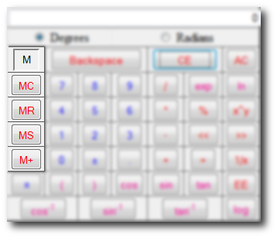
Exampe 2 (Recalling Memory):
- Type in 45
- Hit MS
- Now type in + (your Display should look like "45+")
- Hit MR
- You should get 45+45
- Hit Enter (Return) and your answer should be 90
Note: If you did not type in the + symbol then you would have gotten 4545. So don't for get to put an equation symbol before hitting MR
Example 3 (Adding to Memory and then Clearing it):
- Type in 45
- Hit MS
- This time hit M+
- Now type in + (your Display should look like "45+")
- Hit MR
- You should get 45+90
- Now hit MC to clear the memory and you memory indicator should be empty like the picture below

3.5. Power Functions
Now we discuss power functions. Look at the picture below for a list of the power function buttons:
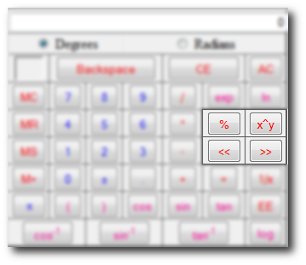
Modulo Operator
The modulo operator (also called the percent operator or %) divides the number on the left of the operator by the number on the right and the result is the remainder.
Take 5/3 for example. Three goes into five one time with a remainder of two. So 5%3 = 2.
Take 12/4 for example. Four goes into twelve three times with a remainder of zero. So 12%4 = 0.
Examples of "x^y" functions:
The power function is the x^y button. Some may get confused as to how this works because when they click it what appears in the Display is "^" without quotes. This is actually just an easy way for you to write an equation and a feature not common to JavaScript based calculators.
x^y is the same thing as XY.
23=8 is the same as 2^3=8
Putting it in a more complex equation is no problem either:
4(23+4)=48 which is like 4*(2^3+4)
To take the root of an equation remember that the exponent must be a fraction. Square root would be x^(1/2), cube root would be x^(1/3), and so on.
Don't forget the a symbol goes between 2 algebraic functions like (8)*(8)
Also all parenthesis have to be closed in order for any function to work
Bitwise Operations
There are two shift operations. Shift left (x<<y) and shift right (x>>y). Essentially this is the same thing as multiplying or dividing the x by 2y
For example 5<<2 is the same as 5*2^2 = 20. In binary it would be 00101<<2 = 10100 which is 20. The same can be said for 20>>2 which is 20/(2^2). In binary it would be 10100>>2 = 00101 which is 5.

3.6. Trigonometric Functions
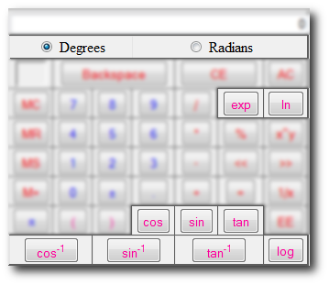
- At the top you can select a mode for the trig functions to be calculated in, Degrees or Radians. Depending on what you need to calculate is how you decide what mode you need to be in. Most commonly it's Degrees unless you're calculating angular kinematics or simple harmonic motion.
- exp (exponential, ex) inserts 'e^(' into the current equation.
  - Not to be confused with regular e.
  - 2e3 = 2*10^3 = 2000
  - 2*e^(3) = 40.171...
- ln (natural log) inserts 'ln(' into the current equation.
- log (log base 10) inserts 'log(' into the current equation.
- cos inserts 'cos(' into the current equation.
- sin inserts 'sin(' into the current equation.
- tan inserts 'tan(' into the current equation.
- cos-1 inserts 'acos(' into the current equation. Also known as the inverse cos or arc-cos.
- sin-1 inserts 'asin(' into the current equation. Also known as the inverse sin or arc-sin.
- tan-1 inserts 'atan(' into the current equation. Also known as the inverse tan or arc-tan.

Common Math rules
ex and ln(x) are inverse of each other meaning eln(x)=x and ln(ex)=x
ln(x) (natural log) is the integral of 1/x which was proven by Euler.
log(x) is the ratio of ln(x)/ln(10). The inverse of log(x) is 10x so log(10x)=x and 10log(x)=x. By default log(x) is log10(x)
To calculate a different base of log, for example log3(3x)=x, you would have to calculate ln(3x)/ln(3)=x

3.7. Miscellaneous
The rest of the button functions of the Scientific Calculator fall into this category. After you read this you will be scott free and on your way to being a calculator expert!!!
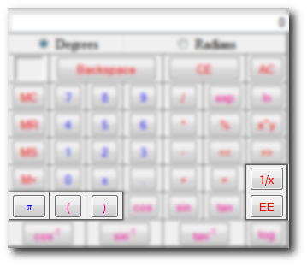
π which is known as pi in the equation Display is = 3.141592653589793...
It is a greek constant for finding properties of circles such as the area and circumference.
The ( and ) buttons insert left and right parenthensis into the equation.
1/x flips the equation by dividing it into 1.
EE is the same thing as x10x for example 1x103=1e3=1000. It is NOT an exponential (exp,ex).

4. License Information

4.1. Disclaimer
Warning!
I do my best to make sure all the calculations and conversions are accurate and correct. But there is always the possibility that they are still inaccurate or incorrect. Here are some points I would like to bring to your attention.
- Do not assume any calculation/conversion this calculator makes is accurate and correct.
- Do not use the Scientific Calculator where loss of life, money, or property could result from inaccurate or incorrect conversions and/or calculations.
- Rounding Errors: Often times, converting/calculating between large and small units causes rounding errors.
  - Rounding errors are cause by different: browser types (even separate versions of the same type), operating systems, versions of JavaScript, and other factors. For example, you will sometimes see 999.9999999 or 1000.0000001 instead of 1000.
Example Equation:
1.001*(10^3)=1000.9999999999999 instead of 1001
Please keep these key points in mind when using this Scientific Calculator.
A quick tip would be, in the edit menu, to set float=10 and round your answers. This will help reduce the rounding error effect.
The above warnings were modified from the onlineconversion.com license.

4.2. License
Copyright © 2005 Sam Gleske
Permission is hereby granted, free of charge, to any person obtaining a copy of this software and associated documentation files (the "Software"), to deal in the Software without restriction, including without limitation the rights to use, copy, modify, merge, publish, distribute, sublicense, and/or sell copies of the Software, and to permit persons to whom the Software is furnished to do so, subject to the following conditions:
The above copyright notice and this permission notice shall be included in all copies or substantial portions of the Software. Copyright notices within the source code must remain as well.
THE SOFTWARE IS PROVIDED "AS IS", WITHOUT WARRANTY OF ANY KIND, EXPRESS OR IMPLIED, INCLUDING BUT NOT LIMITED TO THE WARRANTIES OF MERCHANTABILITY, FITNESS FOR A PARTICULAR PURPOSE AND NONINFRINGEMENT. IN NO EVENT SHALL THE AUTHORS OR COPYRIGHT HOLDERS BE LIABLE FOR ANY CLAIM, DAMAGES OR OTHER LIABILITY, WHETHER IN AN ACTION OF CONTRACT, TORT OR OTHERWISE, ARISING FROM, OUT OF OR IN CONNECTION WITH THE SOFTWARE OR THE USE OR OTHER DEALINGS IN THE SOFTWARE.

The above license is a lightly modified version of the MIT License.

5. The Author

5.1. Contributors
The following are contributors who helped this calculator along the way:
- name - year contributed
- Kyle Winters - 2005
- Chad Carreras - 2005,2007
- Shriram Raghu - 2008
- George Purkins - 2010

5.2. About the Author
Currently there are many of the open source projects I participate and develop listed on my website.
On my sourceforge user page is more projects I develop for or assist in some way listed under "My Projects" at sourceforge.
Currently Scientific Calculator is used by other open projects such as Amahi (Read about Amahi) which is currently based on Fedora.
Since becoming a GNU/Linux user in 2004 I have contributed tens of thousands of lines of code across many FOSS projects including patches, bug submissions, and creating my own software.
Other major projects I love and have contributed code and docs to include: Openfire, Aptana, MEPIS Linux, LinuxQuestions.org, NSIS, PortableApps.com and many others.
My user is sag47 across many projects (not all).

5.4. Technologies Used
This section discusses the technologies that were used to create the calculator and this help system.
First of all, the web languages CSS 2.0, HTML 4.01 Transitional, and JavaScript were programmed according to W3C standards and were validated successfully at validator.w3.org and jigsaw.w3.org/css-validator
Programs used during development:
- Aptana Replaced Notepad++ as my JavaScript IDE because of autocompletion.
- GIMP: Used for advanced graphic editing using layers. Better than Adobe Photoshop in my opinion because it's free. This is how I blurred portions of my sample images and gave them background shadows.
- Notepad++: Used for syntax highlighting in HTML, CSS, and JavaScript documents. It also provided a useful function list for navigating JavaScript files.
- OpenOffice.org: Used to draft PDF format of documentation using OO Writer.
- Quanta: An advanced HTML/JavaScript/CSS IDE used on Linux.
- Zoom Search Engine: This is a nice little piece of software that gave my help documentation search functionality. It is free for small websites (or documentation) and is a handy and useful tool for my end users.

5.5. Contact the Author
Sam Gleske
sag47@drexel.edu
http://www.pages.drexel.edu/~sag47/

5.6. Resume Request
If you would like to see my resume then you must request it because I don't post it on-line. You can simply email me (my email is in the contacts section). Enter "Resume Request" as the subject header.

