Lab 4
By Sindy Kola and Siamion Rondzel

State Transition Diagram:
S0
S1
S2
S3
0
0
1
1
0
1
1
0

S0 = 00; S1 = 01; S2 = 10; S3 = 11
State Transition Table:

State |  | Input | Next State |  | Flip-Flops
Q1 | Q0 | x | Q1 | Q0 | J1 | K1 | J0 | K0
0 | 0 | 0 | 0 | 1 | 0 | X | 1 | X
0 | 0 | 1 | 1 | 1 | 1 | X | 1 | X
0 | 1 | 0 | 1 | 0 | 1 | X | X | 1
0 | 1 | 1 | 0 | 0 | 0 | X | X | 1
1 | 0 | 0 | 1 | 1 | X | 0 | 1 | X
1 | 0 | 1 | 0 | 1 | X | 1 | 1 | X
1 | 1 | 0 | 0 | 0 | X | 1 | X | 1
1 | 1 | 1 | 1 | 0 | X | 0 | X | 1

Karnaugh Maps:

1) For J1:

x
q1/q0 | 0 | 1
00 | 0 | 1
01 | 1 | 0
11 | X | X
10 | X | X

J1 = x*q0 + x*q0

2)For K1:
x
q1/q0 | 0 | 1
00 | X | X
01 | X | X
11 | 1 | 0
10 | 0 | 1

K1 = x*q0 + x*q0

3)For J0:
x
q1/q0 | 0 | 1
00 | 1 | 1
01 | X | X
11 | X | X
10 | 1 | 1

J0 = 1

4)For K0:
x
q1/q0 | 0 | 1
00 | X | X
01 | 1 | 1
11 | 1 | 1
10 | X | X

K0 = 1
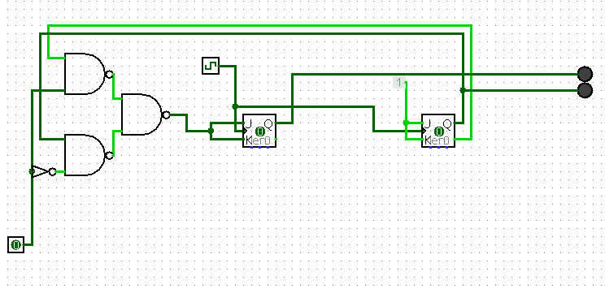

Design of the circuit using logic gates
NAND, NOT, and JK flip-flops

