Lab 5
By Sindy Kola and Siamion Rondzel
State Transition Diagram:
S0/0
S1/0
S2/0
S3/1
1
0
1
0
0

1

0
1

S0 = 00; S1 = 01; S2 = 10; S3 = 11

State Transition Table:

State |  | Input | Output | Next State |  | Flip-Flops
Q1 | Q0 | x | y | Q1 | Q0 | J1 | K1 | D0
0 | 0 | 0 | 0 | 0 | 0 | 0 | X | 0
0 | 0 | 1 | 0 | 0 | 1 | 0 | X | 1
0 | 1 | 0 | 0 | 1 | 0 | 1 | X | 0
0 | 1 | 1 | 0 | 0 | 1 | 0 | X | 1
1 | 1 | 0 | 1 | 1 | 0 | X | 0 | 0
1 | 1 | 1 | 1 | 0 | 1 | X | 1 | 1
1 | 0 | 0 | 0 | 0 | 0 | X | 1 | 0
1 | 0 | 1 | 0 | 1 | 1 | X | 0 | 1

Karnaugh Maps:

1) For J1:

x
q1/q0 | 0 | 1
00 | 0 | 0
01 | 1 | 0
11 | X | X
10 | X | X

J1 = x*q0

2)For K1:
x
q1/q0 | 0 | 1
00 | X | X
01 | X | X
11 | 0 | 1
10 | 1 | 0

J1 = x*q0 + x*q0

3)For D0:
x
q1/q0 | 0 | 1
00 | 0 | 1
01 | 0 | 1
11 | 0 | 1
10 | 0 | 1

D0 = x

4)For y: → function for output
x
q1/q0 | 0 | 1
00 | 0 | 1
01 | 0 | 1
11 | 0 | 1
10 | 0 | 1

D0 = x
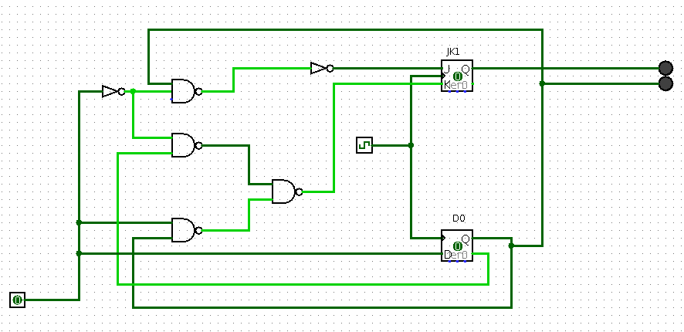

Design of the circuit using logic gates
NAND, NOT, JK flip-flop, and D flip-flop

