My Portfolio Website

Student ID: 16431878

Name: Sam Rowe

Github URL:

Assignment 1: Web Development

Submission Date: 04/01/2017

**Website Design**

For the design of my website I first drew rough sketches of the layout. I then created a photoshop document to bring my sketches to life. I’m not the most artistic person so I went with a simple design and colour scheme that I thought would be readable, professional and presentable. The image below is the photoshop document that I created. I only created a design for the home page in photoshop as the other pages would follow the same design, only the main content, i.e. bio instead of cv, would change.

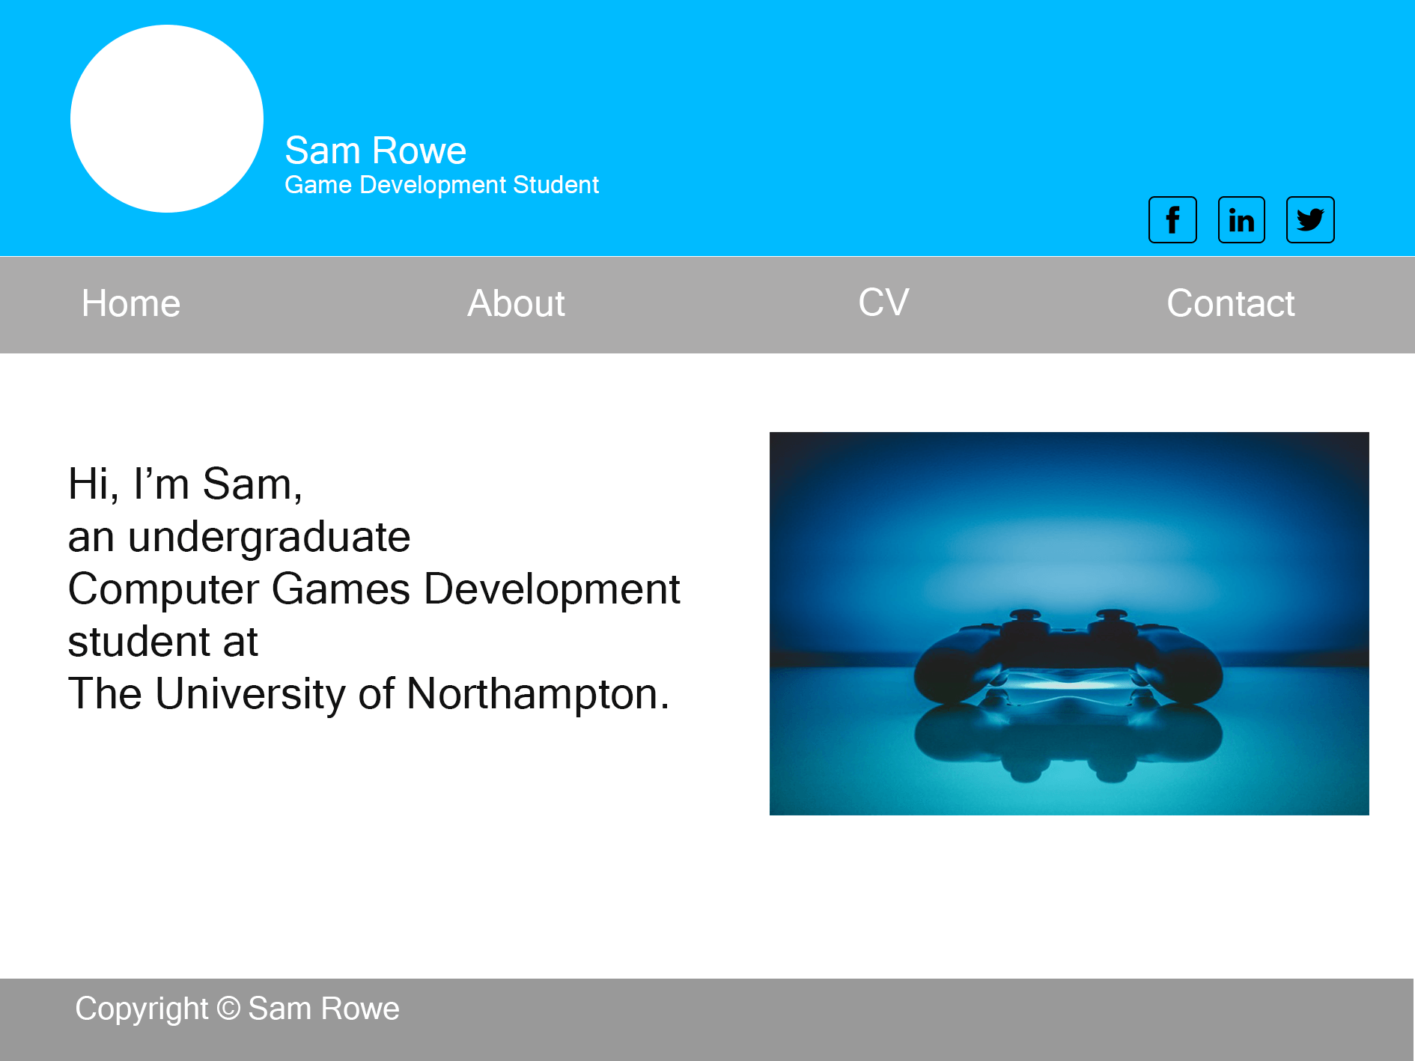

Social media icons that link to their respective sites.

Navigation bar menu

Self-portrait image

This is a placeholder image. I would likely showcase my best work here. I believe I would need to use JavaScript for this.

**Changes to Design**

1. Changes made to container

I changed the layout of the website so that there was a border around the container. I did this because my original design looked stretched when at full screen. I got this idea after viewing multiple portfolio websites with this layout, e.g. <http://www.mollyjameson.com/>, <http://www.davidshaver.net/>.

1. Changes made to navigation bar

I also redesigned the navigation menu bar so that the page links were centred. I did this partly because I was having trouble with getting the previous version to change from horizontal to vertical when the window size was changed, and because I preferred the design when the links were centred and though it looked more professional.

1. Removed social media icons from header

I decided to remove the social media icons inside the header, as I was having a difficult time making the website responsive when they were in the header. They are located in the contact page now only.

1. Centred the content on the home page

I centred the content on the home page instead of having the text and image either side.

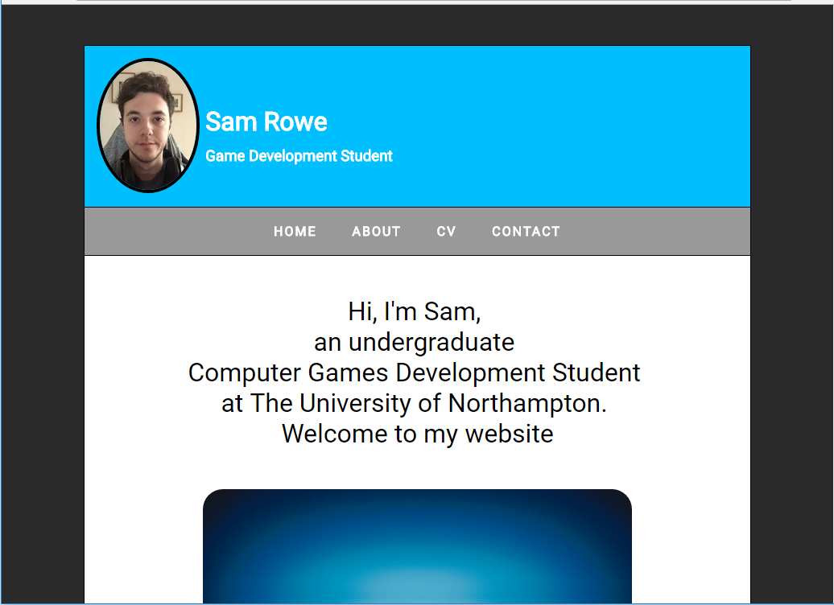

New navigation menu that is responsive

**Code**

To learn HTML and CSS I used online resources such as [Codecademy](https://www.codecademy.com/learn/learn-html-css) and [W3schools](http://www.w3schools.com/). All code that I came up with, except for one or two sections of code, was thought of after viewing these online tutorial websites and from what was taught in the Web Development lectures.

**Code References**

I modified code from [W3schools](http://www.w3schools.com/css/tryit.asp?filename=trycss_forms) to create a form that matched the layout and colour scheme of my website.

Line 33-47 in contact.html

Line 141-175 in contact.css

*Tryit Editor v3.3.* 2017. Tryit Editor v3.3. [ONLINE] Available at: <http://www.w3schools.com/css/tryit.asp?filename=trycss_forms>. [Accessed 04 January 2017].

**Image References**

The images that I used were free to download and use for personal and commercial use. Below is attribution for both the images that were used.

Reference for gamepad image: *Paweł Kadysz*, (2015), Playing more Fallout [ONLINE]. Available at: <https://stock.tookapic.com/photos/36313> [Accessed 1 January 2017].

Reference for social media icons: Alfredo Hernandez, (2016), Social Media FREE [ONLINE]. Available at: <https://www.iconfinder.com/iconsets/social-media-outline-1> [Accessed 1 January 2017].

**Website Responsiveness**

I included two media queries in my design to change the layout of each page when the window size changed. The fist query changed the layout of elements, to fit the page, when the page width was 700px and below and the second query changed the layout of elements when the page width was 400px and below.

**Website Validation**

I validated all HTML and CSS files that make up my website. There were no errors and only one warning that was resolved by including a HTML language attribute in the HTML tag.

**index.html**

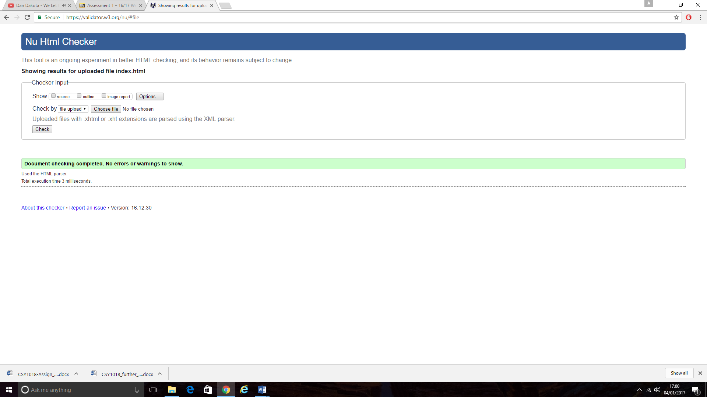

**bio.html**

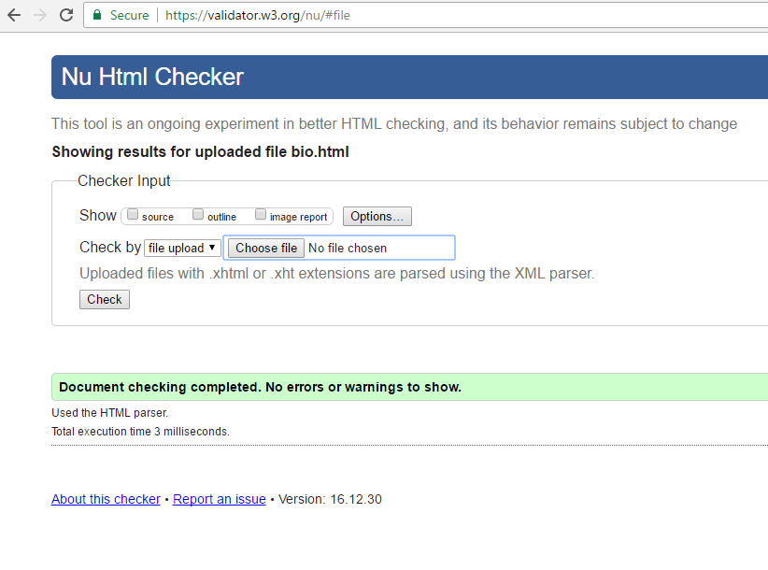

**cv.html**

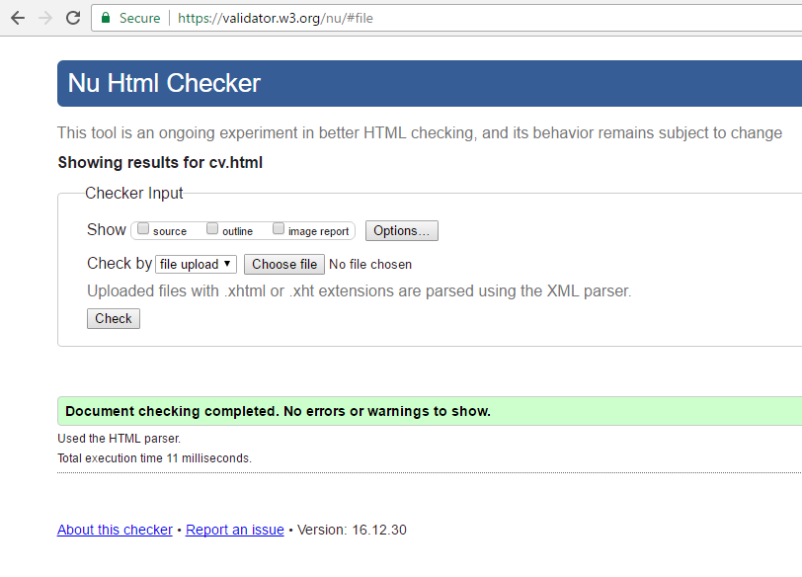

**contact.html**

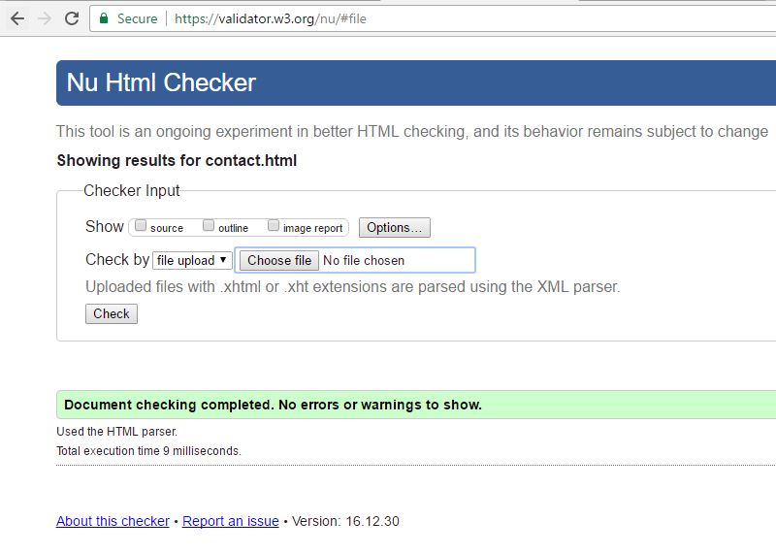

**index.css**

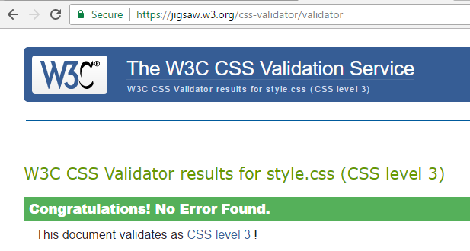

**bio.css**

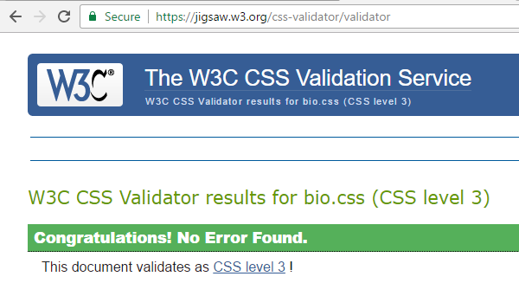

**cv.css**

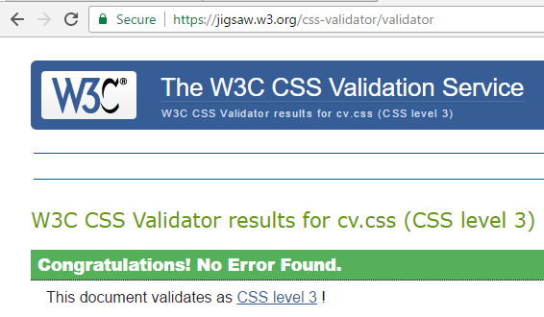

**contact.css**

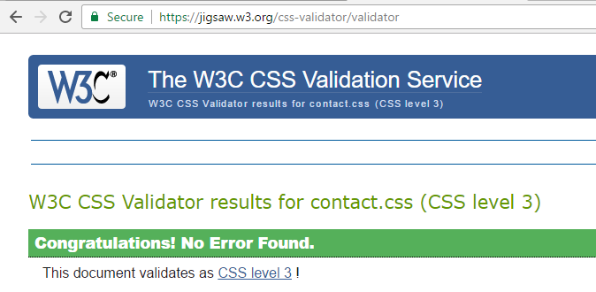

**Conclusion**

I spent approximately 28 hours researching, designing and creating my portfolio website. It is made up of 4 HTML files, 4 CSS files and is responsive in design. My website contains transitions, transformations, a form field and an image in the top left hand corner that links back to the homepage. The text is clear and readable and the design and layout is presentable.

What I found difficult:

* I found making the website responsive difficult. Changing the layout of the website so that all elements fit relative to the window size was a challenge.

What I like:

* Simple layout
* Colour scheme
* Text is clear and readable

What I would/could change/add:

* I would change the image of a gamepad on the homepage to showcase my best work.
* I would add media queries for multiple devices such as iPads, iPhones, Samsung phones, etc.
* I would add compatibility with different and older versions of browsers.
* A menu button for when the window size changes that reveals the menu options. I think this could be achieved with JavaScript.
* I could add animations to the navigation menu or social media icons to add more interactivity to the website.

What I would/could do differently:

* I would use rough sketches, wireframes and photoshop to design all web pages.
* I would create designs for every device starting with mobile devices to optimise responsiveness.

What I could improve:

* I could improve the design and interactivity of the website e.g. through animations.
* I could add more content to the site as the pages look bare when at a large window size.

I will continue to improve my HTML, CSS and design skills so that when I next create a website it will be engaging, interactive and have advanced features.