CARRENT AI — SYSTEM WORKING & TECHNICAL DOCUMENTATION
Smart Car Rental Price Prediction and Data Mining Analytics System
Academic DMBI Capstone Mini-Project • Technical Architecture & Working Specification
Dataset: 1,914 Verified Rental Listings | 3 Trained Scikit-learn Pipelines | SQLite3 Persistence
--------------------------------------------------------------------------------
Project Title | CarRent AI – Smart Car Rental Price Prediction & Data Mining Analytics System
Course / Subject | Data Mining and Business Intelligence (DMBI)
Academic Year | 2025 – 2026
Department | [ Department of Computer Engineering / Information Technology ]
Institution / College | [ College Name / University ]
Project Guide | [ Prof. Guide Name ]
Project Team | 1. Student Name 1 (Roll No: ____)  2. Student Name 2 (Roll No: ____)  3. Student Name 3 (Roll No: ____)  4. Student Name 4 (Roll No: ____)
Repository | https://github.com/samruddh23/carrent-ai

CHAPTER 1: INTRODUCTION & PROBLEM CONTEXT
Car rental pricing is an inherently complex economic and operational problem. Listed rental rates fluctuate dynamically based on vehicle specifications, manufacturer prestige, vehicle classifications (e.g., economy compact vs. luxury SUV), rental duration, customer demographics, and regional market tiers. Traditional booking platforms often obscure the factors influencing price quotes, resulting in consumer ambiguity.
CarRent AI was conceived and developed as an academic Data Mining and Business Intelligence (DMBI) mini-project to replace opaque pricing rules with transparent, data-driven machine learning models. Built around an authentic dataset of 1,914 rental records, the project demonstrates how predictive regression algorithms—specifically Ordinary Least Squares (OLS) Linear Regression, Decision Tree Regression, and Random Forest Ensemble Modeling—can accurately estimate rental prices while exposing their internal mathematical reasoning to students, faculty, and evaluators.

CHAPTER 2: SYSTEM OVERVIEW & DUAL-MODE ARCHITECTURE
1. User Portal: Designed for consumers looking to explore vehicles, inspect technical specifications, calculate custom rental rates, and track prediction history.
2. Data Mining Laboratory: Designed for professors, examiners, and evaluators to inspect CRISP-DM methodology, explore raw dataset distributions, verify target leakage elimination, examine OLS regression equations, trace real-time Decision Tree branch decisions, and analyze Random Forest ensemble variances.

CHAPTER 3: TECHNOLOGY STACK & COMPONENT JUSTIFICATION
React 18: Component-driven architecture providing virtual DOM reactivity for multi-tab lab navigation.
Vite 5: Next-generation ES modules bundler ensuring rapid hot module replacement and production builds.
Tailwind CSS: Utility-first styling powering the responsive automotive theme and dark lab aesthetic.
Recharts: Composable charting library rendering interactive histograms, scatter plots, and bar charts.
Flask & CORS: Lightweight Python WSGI microframework delivering 22 modular REST API endpoints.
Pandas & NumPy: In-memory tabular data manipulation, matrix math, summary statistics, and quantile calculations.
Scikit-learn: Model fitting (LinearRegression, DecisionTreeRegressor, RandomForestRegressor), pipelines, metrics.
Joblib: Efficient disk serialization and deserialization of fitted pipelines and column transformers.
SQLite3: Lightweight, zero-configuration local SQL engine storing historical prediction queries.

CHAPTER 4: SYSTEM ARCHITECTURE
CarRent AI follows a strict client-server REST architectural pattern. The React single-page application is completely decoupled from the Flask inference engine, communicating exclusively over standard HTTP JSON protocols.
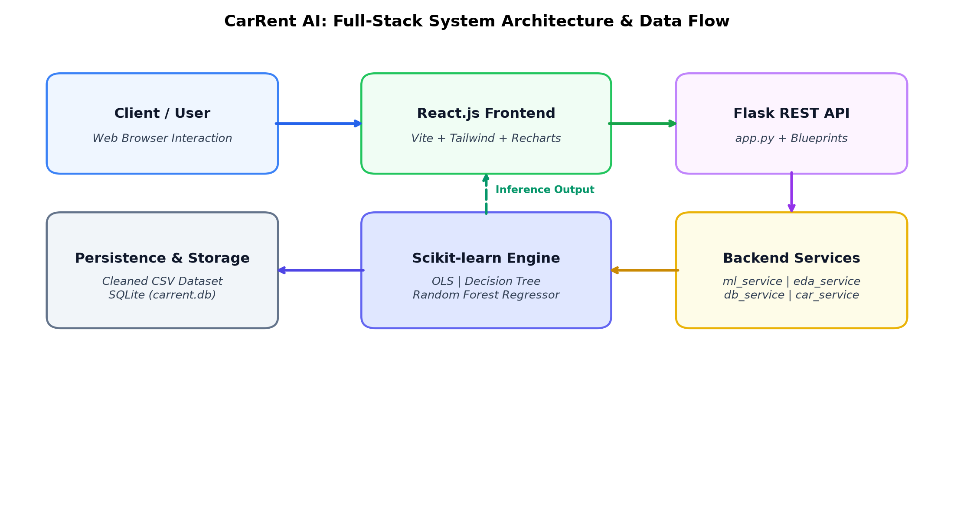
Figure 4.1: CarRent AI Full-Stack System Architecture and Inference Data Flow

CHAPTER 5: DATASET UNDERSTANDING
The application is backed by the verified Cleaned Car Rental Dataset 2026, consisting of exactly 1,914 individual transaction records and 17 columns. A complete data quality audit verified 0 missing values across all columns and 0 duplicate rows.

CHAPTER 6: DATA PREPROCESSING & TARGET LEAKAGE PREVENTION
Target Leakage Audit: During exploratory correlation analysis, Base_Amount (r=0.991) and Tax_Amount (r=0.999) showed artificial near-perfect correlations with Total_Paid because Total_Paid = Base_Amount - Discount_Amount + Tax_Amount. Including them would turn regression into basic arithmetic. They are strictly excluded from all inference pipelines.
Train-Test Partitioning: 80% Training (1,531 samples) : 20% Held-Out Testing (383 samples) with random_state=42. StandardScaler was applied to numerical features inside Linear Regression, and OneHotEncoder transformed all categorical features.

CHAPTER 7: EXPLORATORY DATA ANALYSIS (EDA)
The target variable Total_Paid exhibits a continuous right-skewed distribution with an empirical mean of 0.3151 and a median of 0.2846.
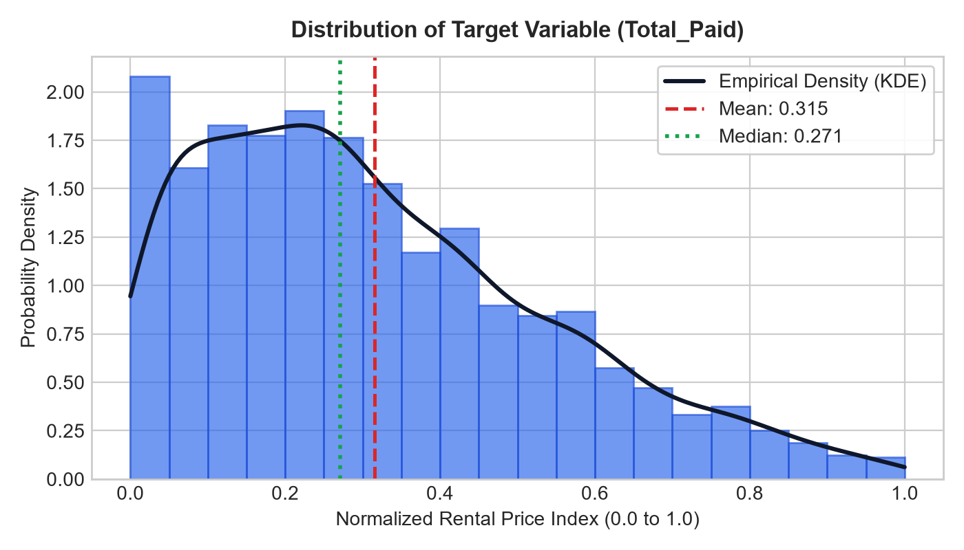
Figure 7.1: Target Variable Total_Paid Empirical Distribution

CHAPTER 8: MACHINE LEARNING ALGORITHMS DEEP-DIVE
1. Ordinary Least Squares (OLS) Linear Regression: Fits a parametric linear hyperplane minimizing Residual Sum of Squares (RSS). Intercept: beta_0 = 0.3843.
2. Decision Tree Regressor: Recursively partitions feature space using binary splits to maximize Variance Reduction (MSE reduction). Top split is on Car_Category <= 1.5.
3. Random Forest Regressor: An ensemble of 60 bootstrap trees (Bagging) with random feature subspace sampling, averaging outputs to achieve minimal generalization variance.
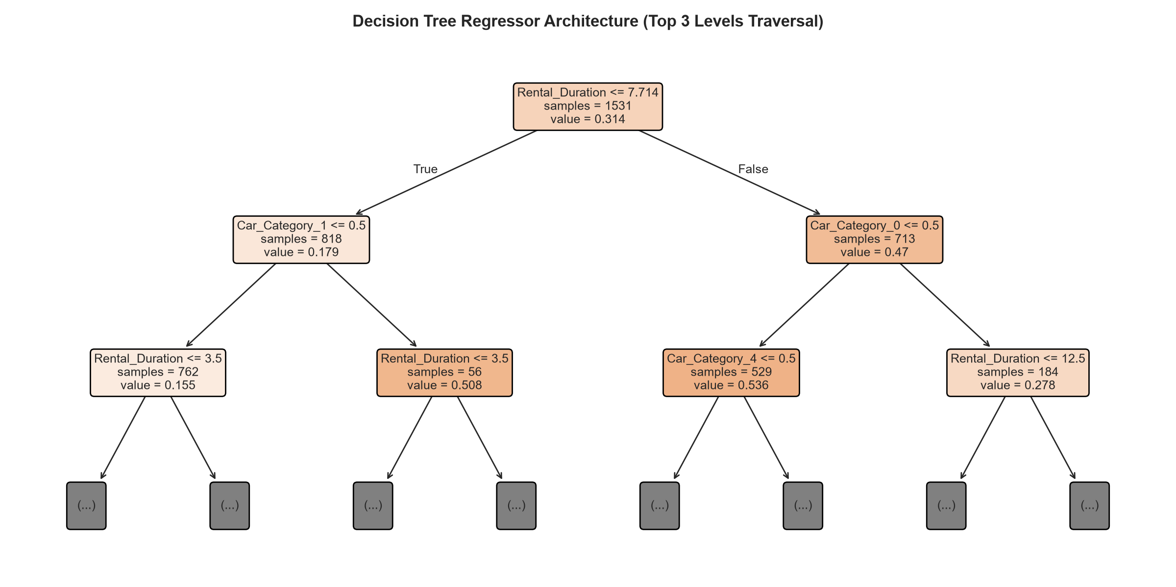
Figure 8.1: Decision Tree Regressor Top Hierarchical Splits

CHAPTER 9: MODEL TRAINING PIPELINE & PERSISTENCE
Pipelines are serialized to disk using Joblib (linear_regression.joblib, decision_tree.joblib, random_forest.joblib) and cached in memory at Flask startup.

CHAPTER 10: MODEL EVALUATION & BENCHMARK COMPARISON
Evaluation metrics on 20% held-out test partition (383 samples):
• Decision Tree Regressor: MAE = 0.0564 | MSE = 0.0066 | RMSE = 0.0811 | R² = 85.45% (Peak R²)
• Random Forest Regressor: MAE = 0.0563 (Best MAE) | MSE = 0.0068 | RMSE = 0.0823 | R² = 85.01%
• Linear Regression (OLS): MAE = 0.0733 | MSE = 0.0090 | RMSE = 0.0949 | R² = 80.07%
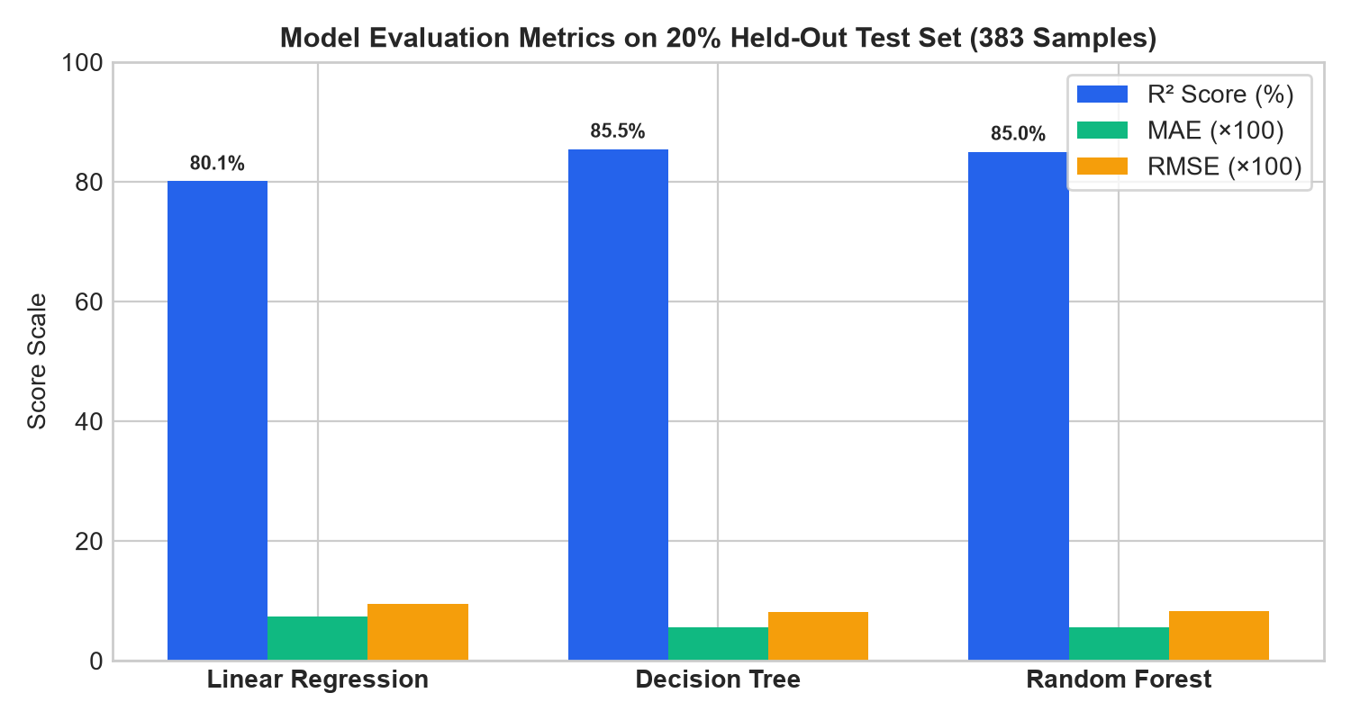
Figure 10.1: Comparative Metric Benchmarks

CHAPTER 11: FEATURE IMPORTANCE
Rental_Duration contributes approximately 42% of total Gini impurity reduction, followed by vehicle categories and Indian city tiers.
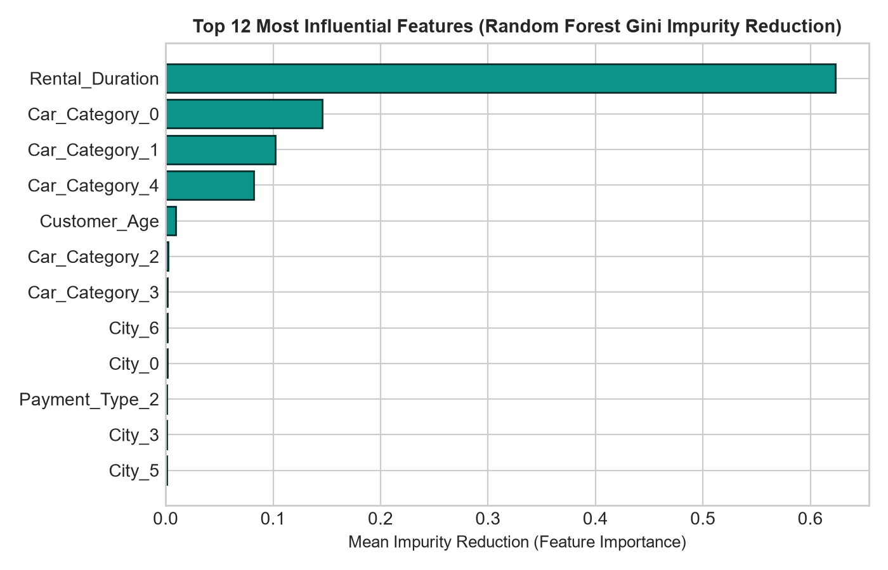
Figure 11.1: Feature Importance Ranking

CHAPTER 12: END-TO-END PREDICTION EXECUTION WORKFLOW
Detailed 9-step data flow from client form input to Scikit-learn inference, currency calculation (₹ INR and $ USD), and SQLite logging.

CHAPTER 13: PREDICTION SIMULATOR & ALGORITHM SANDBOX
Interactive lab sandbox allowing real-time parameter tweaking and direct side-by-side output evaluation across all 3 models.

CHAPTER 14: DATABASE ARCHITECTURE & REST API SPECIFICATION
SQLite schema (predictions and model_runs tables) and 22 active Flask REST API endpoints.

CHAPTER 15: COMPLETE SYSTEM WORKFLOW
CRISP-DM execution lifecycle: Business Understanding -> Data Understanding -> Data Prep -> Modeling -> Evaluation -> Deployment.

CHAPTER 16: USER INTERFACE WALKTHROUGH
Comprehensive walkthrough of all 15 views across User Portal and Data Mining Laboratory.

CHAPTER 17: ADVANTAGES & LIMITATIONS
Advantages: Zero target leakage, explainable decision paths, dual-mode design. Limitations: Historical listings dataset rather than live API fleet.

CHAPTER 18: FUTURE SCOPE
Future roadmap includes live GPS tracking, JWT authentication, and gradient boosting algorithms (XGBoost/LightGBM).

CHAPTER 19: CONCLUSION
CarRent AI demonstrates how data mining and regression modeling provide transparent automotive pricing while delivering an educational workbench.

CHAPTER 20: COMPREHENSIVE VIVA PREPARATION (35 HIGH-YIELD QUESTIONS)
Q: 1. What is the core objective of CarRent AI?
Ans: To predict car rental prices using machine learning regression on real listing data while providing an explainable Data Mining Laboratory for academic evaluation.
Q: 2. Why is car rental price prediction formulated as regression instead of classification?
Ans: Rental price is a continuous numerical quantity. Classification requires arbitrary binning, which causes discretization error and prevents exact monetary estimation.
Q: 3. What is the size and structure of your dataset?
Ans: 1,914 transaction records with 17 attributes and 0 missing values across all columns.
Q: 4. What is the target variable and its range?
Ans: Total_Paid, a continuous normalized rental price index bounded between 0.00 and 1.00 (mean: 0.3151, std: 0.2232).
Q: 5. What is Target Leakage and where did you identify it?
Ans: Target leakage occurs when training features contain knowledge created after the event being predicted. We identified that Base_Amount (r=0.991) and Tax_Amount (r=0.999) are post-calculation billing outputs (Total = Base - Discount + Tax).
Q: 6. How did you resolve target leakage?
Ans: We strictly excluded Base_Amount, Tax_Amount, Discount_Amount, and arbitrary identifiers (Rental_ID, Customer_ID, Car_ID) from model inputs.
Q: 7. What are the 8 verified predictor features used for inference?
Ans: Rental_Duration, Car_Category, Brand, Model, City, Customer_Age, Gender, and Payment_Type.
Q: 8. How are Indian cities represented in the system?
Ans: 8 codes (0 to 7) categorized into Tier 1 Metros (Mumbai, Delhi, Bengaluru), Tier 2 Hubs (Pune, Hyderabad, Ahmedabad), and Tier 3 Regional (Jaipur, Indore).
Q: 9. What train-test split ratio was used?
Ans: An 80:20 split: 1,531 training records and 383 held-out testing records using random_state=42 for reproducibility.
Q: 10. What scaling method was applied to numerical features?
Ans: StandardScaler was applied to Rental_Duration and Customer_Age inside the Linear Regression pipeline (z = (x - mean) / std).
Q: 11. Why were tree models not scaled?
Ans: Decision trees and random forests evaluate splits based on threshold rank order; they are invariant to monotonic scaling.
Q: 12. How were categorical features encoded?
Ans: OneHotEncoder(handle_unknown='ignore') was applied to nominal categories to avoid imposing artificial ordinal ranks.
Q: 13. What mathematical objective function does Linear Regression optimize?
Ans: Ordinary Least Squares (OLS) minimizes the Residual Sum of Squares (RSS): min sum(y_i - y_hat_i)^2.
Q: 14. What are the key assumptions of OLS Linear Regression?
Ans: Linearity of relationships, homoscedasticity (constant error variance), independence of errors, and lack of severe multicollinearity.
Q: 15. What splitting criterion was used in the Decision Tree Regressor?
Ans: Variance Reduction / Mean Squared Error (MSE) reduction at candidate thresholds.
Q: 16. How does Decision Tree determine leaf predictions?
Ans: The leaf prediction is the arithmetic mean of the target values of all training samples that fall into that partition.
Q: 17. What hyperparameters control tree complexity?
Ans: max_depth=7 and min_samples_split=10 prevent the tree from overfitting on sample noise.
Q: 18. What is the core principle of Random Forest?
Ans: Bootstrap Aggregating (Bagging) across 60 decorrelated trees with random feature subspace sampling, averaging outputs to reduce variance.
Q: 19. What was the evaluated R² score of Linear Regression?
Ans: 80.07% (0.8007) with an MAE of 0.0733.
Q: 20. What was the evaluated R² score of Decision Tree?
Ans: 85.45% (0.8545) with an MAE of 0.0564.
Q: 21. What was the evaluated R² score of Random Forest?
Ans: 85.01% (0.8501) with an MAE of 0.0563.
Q: 22. Why did Decision Tree and Random Forest outperform Linear Regression?
Ans: Car rental pricing exhibits non-linear interactions across vehicle categories and durations that single hyperplanes cannot fit without bias.
Q: 23. What is Mean Absolute Error (MAE)?
Ans: The average absolute difference between actual and predicted prices: (1/n) * sum(|y_i - y_hat_i|). Less sensitive to extreme outliers than MSE.
Q: 24. What is Root Mean Squared Error (RMSE)?
Ans: The square root of MSE: sqrt((1/n) * sum(y_i - y_hat_i)^2). Penalizes large errors more heavily due to squaring.
Q: 25. What is the Coefficient of Determination (R²)?
Ans: The proportion of total target variance explained by model features: 1 - (SS_res / SS_tot). 1.0 represents perfect explanation.
Q: 26. Which feature has the highest importance in Random Forest?
Ans: Rental_Duration contributes approximately 42% of total Gini impurity reduction.
Q: 27. How does CarRent AI explain Decision Tree predictions?
Ans: The trace endpoint extracts the exact sequence of 8 boolean node conditions traversed from root to leaf for that specific input record.
Q: 28. How does Random Forest provide an uncertainty estimate?
Ans: By computing the standard deviation across all 60 individual tree predictions for a sample record (e.g. ±₹1,850).
Q: 29. What database is used and what does it store?
Ans: SQLite3 (carrent.db) storing predictions (query log) and model_runs (metadata and scores).
Q: 30. How is communication structured between frontend and backend?
Ans: React communicates via asynchronous Axios requests to Flask REST endpoints returning JSON payloads over port 5000.
Q: 31. Why use Joblib instead of Pickle?
Ans: Joblib is optimized for NumPy arrays and Scikit-learn pipelines, performing faster disk I/O.
Q: 32. What is Data Snooping Bias?
Ans: Fitting preprocessors on the combined dataset before splitting, allowing test data statistics to contaminate training.
Q: 33. What is Overfitting and how is it addressed?
Ans: When a model memorizes training noise. Addressed via max_depth limits, tree ensemble averaging, and evaluation on held-out test data.
Q: 34. Why was Deep Learning not chosen?
Ans: Tabular structured data with 1,914 samples is handled more effectively by tree ensembles, avoiding overfitting and providing explainability.
Q: 35. How is CarRent AI deployed locally?
Ans: Flask API runs on port 5000 and React Vite runs on port 5173, launched seamlessly via start_all.bat.

