1. Find profession wise count of users

[SELECT](http://localhost/phpmyadmin/url.php?url=https://dev.mysql.com/doc/refman/8.0/en/select.html) profession, [count](http://localhost/phpmyadmin/url.php?url=https://dev.mysql.com/doc/refman/8.0/en/aggregate-functions.html%23function_count)(*) AS customercount FROM users

GROUP BY profession ORDER BY customercount DESC;

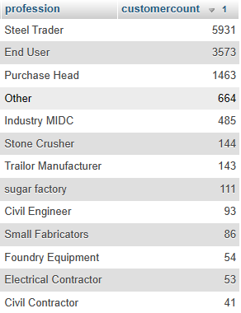

1. Find brand wise count of products

[SELECT](http://localhost/phpmyadmin/url.php?url=https://dev.mysql.com/doc/refman/8.0/en/select.html) B.name, [COUNT](http://localhost/phpmyadmin/url.php?url=https://dev.mysql.com/doc/refman/8.0/en/aggregate-functions.html%23function_count)(*)AS productcounts FROM brands AS B INNER JOIN brandproducts AS BP on B.id = BP.bid INNER JOIN productweights AS PW on BP.pwid = PW.id INNER JOIN products AS P ON P.id = PW.pid group by B.name;

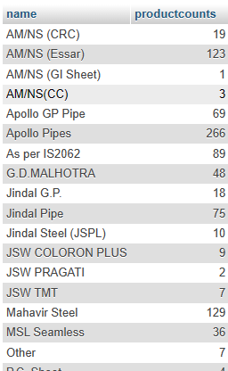

1. Find Brand and Product wise count of Product count

[SELECT](http://localhost/phpmyadmin/url.php?url=https://dev.mysql.com/doc/refman/8.0/en/select.html) B.name, P.product, [COUNT](http://localhost/phpmyadmin/url.php?url=https://dev.mysql.com/doc/refman/8.0/en/aggregate-functions.html%23function_count)(*)AS productcounts FROM brands AS B INNER JOIN brandproducts AS BP on B.id = BP.bid INNER JOIN productweights AS PW on BP.pwid = PW.id INNER JOIN products AS P ON P.id = PW.pid GROUP BY B.name, P.product;

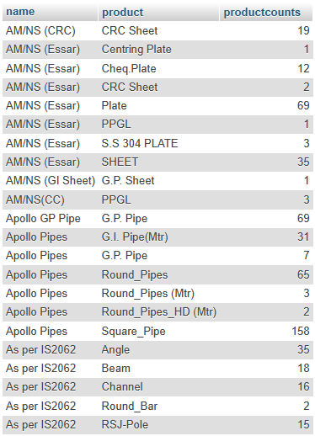

1. Find categories wise count of brands and products

[SELECT](http://localhost/phpmyadmin/url.php?url=https://dev.mysql.com/doc/refman/8.0/en/select.html) C.name,[COUNT](http://localhost/phpmyadmin/url.php?url=https://dev.mysql.com/doc/refman/8.0/en/aggregate-functions.html%23function_count)(DISTINCT(B.id)) as brandcounts, [COUNT](http://localhost/phpmyadmin/url.php?url=https://dev.mysql.com/doc/refman/8.0/en/aggregate-functions.html%23function_count)(PW.id) AS productcount FROM brands AS B INNER JOIN brandproducts AS BP on B.id = BP.bid INNER JOIN productweights AS PW on BP.pwid = PW.id INNER JOIN products AS P ON P.id = PW.pid INNER JOIN categories AS C on C.id =P.categoryid GROUP BY C.name;

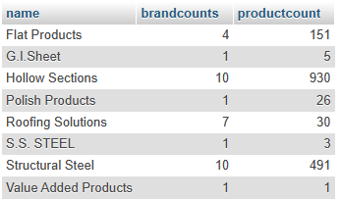

1. Find user wise count of Leads

[SELECT](http://localhost/phpmyadmin/url.php?url=https://dev.mysql.com/doc/refman/8.0/en/select.html) U.name, [COUNT](http://localhost/phpmyadmin/url.php?url=https://dev.mysql.com/doc/refman/8.0/en/aggregate-functions.html%23function_count)(Q.id) AS counts FROM users AS U INNER JOIN quotations AS Q on U.id= Q.userid GROUP BY U.name ORDER BY counts DESC;

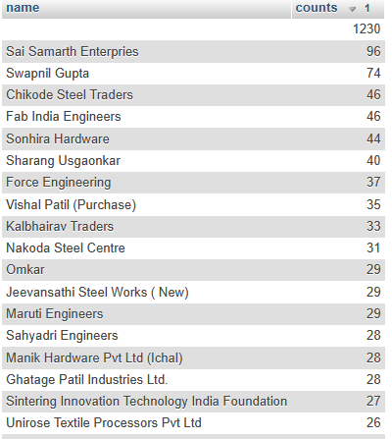

1. List year and month wise count of Leads

[SELECT](http://localhost/phpmyadmin/url.php?url=https://dev.mysql.com/doc/refman/8.0/en/select.html) [COUNT](http://localhost/phpmyadmin/url.php?url=https://dev.mysql.com/doc/refman/8.0/en/aggregate-functions.html%23function_count)(id), YEAR(createdon), month(createdon) FROM quotations GROUP BY YEAR(createdon), month(createdon);

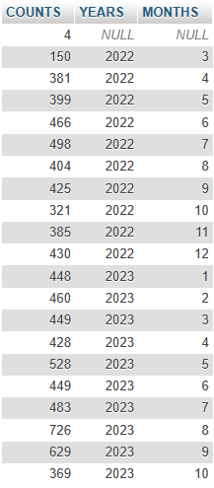

1. Find year and month wise count of Leads

[SELECT](http://localhost/phpmyadmin/url.php?url=https://dev.mysql.com/doc/refman/8.0/en/select.html) YEAR(createdon), month(createdon),[COUNT](http://localhost/phpmyadmin/url.php?url=https://dev.mysql.com/doc/refman/8.0/en/aggregate-functions.html%23function_count)(*) AS leadcount FROM quotations GROUP BY YEAR(createdon), month(createdon);

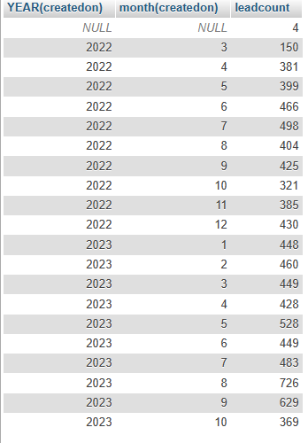

1. Find year and month wise count of Leads of single and multiple brand quotation

[SELECT](http://localhost/phpmyadmin/url.php?url=https://dev.mysql.com/doc/refman/8.0/en/select.html) YEAR(createdon), month(createdon),[COUNT](http://localhost/phpmyadmin/url.php?url=https://dev.mysql.com/doc/refman/8.0/en/aggregate-functions.html%23function_count)(*) AS leadcount, status FROM quotations GROUP BY YEAR(createdon), month(createdon), status;

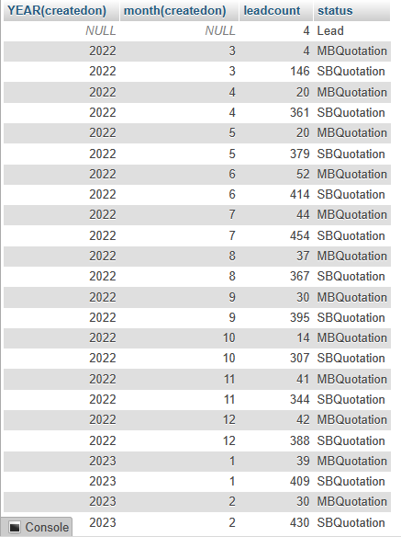

1. List date wise count of Leads for selected month and year

[SELECT](http://localhost/phpmyadmin/url.php?url=https://dev.mysql.com/doc/refman/8.0/en/select.html) month(createdon),[COUNT](http://localhost/phpmyadmin/url.php?url=https://dev.mysql.com/doc/refman/8.0/en/aggregate-functions.html%23function_count)(*) FROM quotations WHERE createdon >= STR_TO_DATE ('01/04/2022','%d/%m/%Y') [AND](http://localhost/phpmyadmin/url.php?url=https://dev.mysql.com/doc/refman/8.0/en/logical-operators.html%23operator_and) createdon <= STR_TO_DATE('31/03/2023', '%d/%m/%Y') GROUP BY month(createdon);

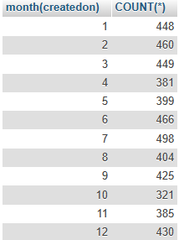

10.List Day wise leads count

[SELECT](http://localhost/phpmyadmin/url.php?url=https://dev.mysql.com/doc/refman/8.0/en/select.html) DAY(createdon) AS day, [COUNT](http://localhost/phpmyadmin/url.php?url=https://dev.mysql.com/doc/refman/8.0/en/aggregate-functions.html%23function_count)(*) AS leadcount FROM quotations AS Q WHERE createdon BETWEEN STR_TO_DATE ('01/09/2023', '%d/%m/%Y') [AND](http://localhost/phpmyadmin/url.php?url=https://dev.mysql.com/doc/refman/8.0/en/logical-operators.html%23operator_and) STR_TO_DATE ('30/09/2023', '%d/%m/%Y')GROUP BY DAY(createdon);

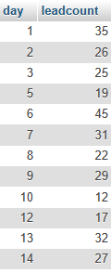

12.List date wise order count and order amount

S[ELECT](http://localhost/phpmyadmin/url.php?url=https://dev.mysql.com/doc/refman/8.0/en/select.html) createdon, [COUNT](http://localhost/phpmyadmin/url.php?url=https://dev.mysql.com/doc/refman/8.0/en/aggregate-functions.html%23function_count)(*) as ordercount, [sum](http://localhost/phpmyadmin/url.php?url=https://dev.mysql.com/doc/refman/8.0/en/aggregate-functions.html%23function_sum)(total) as totalamount FROM orders GROUP BY createdon;

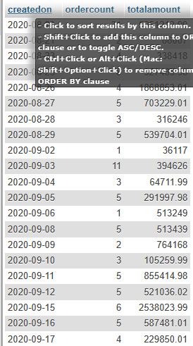

1. List customer wise order count and order amount

[SELECT](http://localhost/phpmyadmin/url.php?url=https://dev.mysql.com/doc/refman/8.0/en/select.html) firmname, [COUNT](http://localhost/phpmyadmin/url.php?url=https://dev.mysql.com/doc/refman/8.0/en/aggregate-functions.html%23function_count)(*) as ordercount, [sum](http://localhost/phpmyadmin/url.php?url=https://dev.mysql.com/doc/refman/8.0/en/aggregate-functions.html%23function_sum)(total) as totalamount FROM orders GROUP BY firmname ORDER BY [COUNT](http://localhost/phpmyadmin/url.php?url=https://dev.mysql.com/doc/refman/8.0/en/aggregate-functions.html%23function_count)(firmname) DESC;

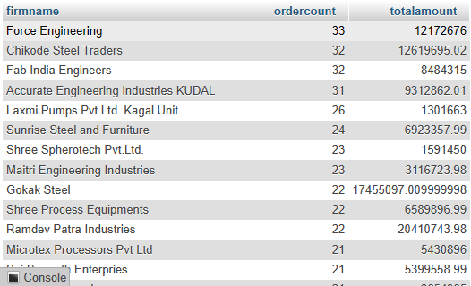

1. List month wise order count, order amount for specific firm

[SELECT](http://localhost/phpmyadmin/url.php?url=https://dev.mysql.com/doc/refman/8.0/en/select.html) firmname, month(createdon) as monthname, [COUNT](http://localhost/phpmyadmin/url.php?url=https://dev.mysql.com/doc/refman/8.0/en/aggregate-functions.html%23function_count)(*) as ordercount, [sum](http://localhost/phpmyadmin/url.php?url=https://dev.mysql.com/doc/refman/8.0/en/aggregate-functions.html%23function_sum)(total) as totalamount FROM orders WHERE firmname =**'Sawantwadi'** GROUP BY month(createdon



1. List state wise, district wise count of leads.

[SELECT](http://localhost/phpmyadmin/url.php?url=https://dev.mysql.com/doc/refman/8.0/en/select.html) U.state AS statesname, U.city, [COUNT](http://localhost/phpmyadmin/url.php?url=https://dev.mysql.com/doc/refman/8.0/en/aggregate-functions.html%23function_count)(*) as leadcount FROM users AS U INNER JOIN quotations AS Q on U.id = Q.userid GROUP BY U.state, U.city;

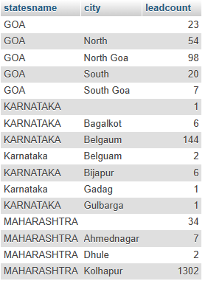

1. List product with count of varieties

[SELECT](http://localhost/phpmyadmin/url.php?url=https://dev.mysql.com/doc/refman/8.0/en/select.html) P.product AS productname, [COUNT](http://localhost/phpmyadmin/url.php?url=https://dev.mysql.com/doc/refman/8.0/en/aggregate-functions.html%23function_count)(*) AS varietycount FROM products as P INNER JOIN productweights AS PW ON P.id= PW.pid GROUP BY productname;

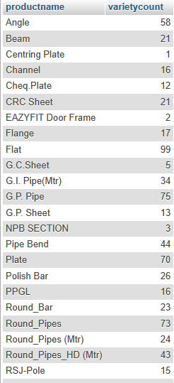

1. List categories wise product variety count

[SELECT](http://localhost/phpmyadmin/url.php?url=https://dev.mysql.com/doc/refman/8.0/en/select.html) C.name as categoryname, [COUNT](http://localhost/phpmyadmin/url.php?url=https://dev.mysql.com/doc/refman/8.0/en/aggregate-functions.html%23function_count)(*) AS varietycount from categories AS C INNER JOIN products as P on P.categoryid= C.id INNER JOIN productweights AS PW ON P.id= PW.pid GROUP BY categoryname;

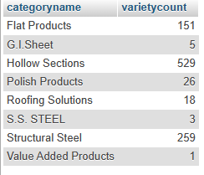

1. Find profession wise order amount

[SELECT](http://localhost/phpmyadmin/url.php?url=https://dev.mysql.com/doc/refman/8.0/en/select.html) profession, [SUM](http://localhost/phpmyadmin/url.php?url=https://dev.mysql.com/doc/refman/8.0/en/aggregate-functions.html%23function_sum)(total) FROM orders GROUP BY profession;

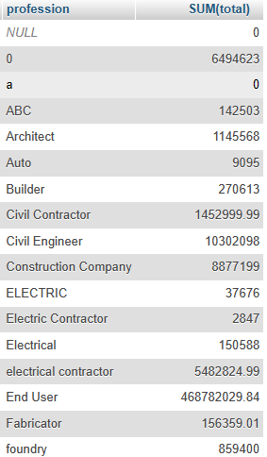

1. Find Year and Month wise total GST

[SELECT](http://localhost/phpmyadmin/url.php?url=https://dev.mysql.com/doc/refman/8.0/en/select.html) YEAR(createdon) AS years , month(createdon) AS months,[SUM](http://localhost/phpmyadmin/url.php?url=https://dev.mysql.com/doc/refman/8.0/en/aggregate-functions.html%23function_sum)(gst)AS totalgst  FROM quotations GROUP BY YEAR(createdon), month(createdon);

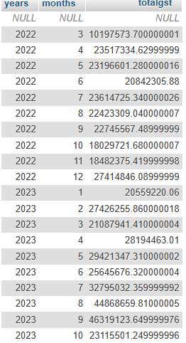

1. Find top 10 orders based on bill amount

[SELECT](http://localhost/phpmyadmin/url.php?url=https://dev.mysql.com/doc/refman/8.0/en/select.html) * FROM quotationdetails ORDER BY amount DESC LIMIT 10;

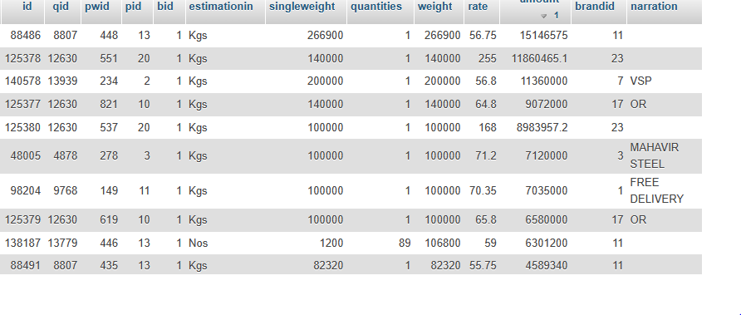

1. Find 2nd largest order details

[SELECT](http://localhost/phpmyadmin/url.php?url=https://dev.mysql.com/doc/refman/8.0/en/select.html) * FROM quotationdetails ORDER BY amount DESC LIMIT 1 OFFSET 1;



1. Find top 10 selling product

[SELECT](http://localhost/phpmyadmin/url.php?url=https://dev.mysql.com/doc/refman/8.0/en/select.html) P.product, [COUNT](http://localhost/phpmyadmin/url.php?url=https://dev.mysql.com/doc/refman/8.0/en/aggregate-functions.html%23function_count)(*) AS ordercount FROM quotationdetails AS Q INNER JOIN products AS P ON P.id = Q.pid group by P.product order by ordercount DESC LIMIT 10;

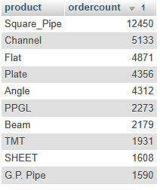

1. Find top selling brands

[SELECT](http://localhost/phpmyadmin/url.php?url=https://dev.mysql.com/doc/refman/8.0/en/select.html) B.name, [COUNT](http://localhost/phpmyadmin/url.php?url=https://dev.mysql.com/doc/refman/8.0/en/aggregate-functions.html%23function_count)(*) AS totalcount FROM brands AS B INNER JOIN quotationbrandprices AS Q ON B.id= Q.bid GROUP BY B.name ORDER BY totalcount DESC;

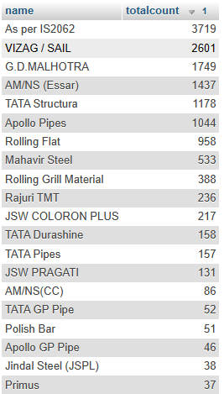

1. Top 5 product of specific brand

[SELECT](http://localhost/phpmyadmin/url.php?url=https://dev.mysql.com/doc/refman/8.0/en/select.html) P.product, PW.sizeinmm, [sum](http://localhost/phpmyadmin/url.php?url=https://dev.mysql.com/doc/refman/8.0/en/aggregate-functions.html%23function_sum)(amount) as total FROM brands as B INNER JOIN orderdetails AS OD on B.id =OD.brandid INNER JOIN productweights as PW on PW.id= OD.pwid INNER JOIN products AS P on P.id = PW.pid WHERE B.id = 1 GROUP BY P.product , PW.sizeinmm ORDER BY [SUM](http://localhost/phpmyadmin/url.php?url=https://dev.mysql.com/doc/refman/8.0/en/aggregate-functions.html%23function_sum)(amount) DESC LIMIT 5;

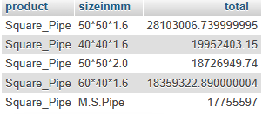

1. List count of leads by enquiry source

[SELECT](http://localhost/phpmyadmin/url.php?url=https://dev.mysql.com/doc/refman/8.0/en/select.html) enquirysource, [COUNT](http://localhost/phpmyadmin/url.php?url=https://dev.mysql.com/doc/refman/8.0/en/aggregate-functions.html%23function_count)(*) as totaleq FROM quotations GROUP BY enquirysource ORDER BY totaleq DESC;

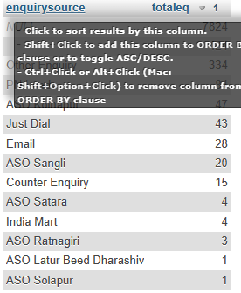

Questions for Practice:

List billing type wise product count

List sales type wise product count

List month wise leads and order count