PRACTICAL-03

Aim: a) Develop an Android app to create two different layouts using LinearLayout:
• One with a vertical orientation (e.g., a form with multiple fields).
• One with a horizontal orientation (e.g., a row of buttons).
b) Create a screen where a button and text are placed at specific (x, y) coordinates using AbsoluteLayout.

- LinearLayout

XML CODE:
<?xml version="1.0" encoding="utf-8"?>
<LinearLayout xmlns:android="http://schemas.android.com/apk/res/android"
xmlns:app="http://schemas.android.com/apk/res-auto"
xmlns:tools="http://schemas.android.com/tools"
android:id="@+id/main"
android:layout_width="match_parent"
android:layout_height="match_parent"
android:background="#F2A7A7"
android:orientation="vertical"
android:padding="16dp"
android:visibility="visible"
tools:context=".MainActivity"
tools:visibility="visible">
<TextView
android:layout_width="match_parent"
android:layout_height="wrap_content"
android:text="Registration Form"
android:textAlignment="center"
android:textSize="20dp"
android:textStyle="bold"
android:visibility="visible"
app:layout_constraintBottom_toBottomOf="parent"
app:layout_constraintEnd_toEndOf="parent"
app:layout_constraintStart_toStartOf="parent"
app:layout_constraintTop_toTopOf="parent"
tools:visibility="visible" />
<EditText
android:id="@+id/editTextText2"
android:layout_width="match_parent"
android:layout_height="wrap_content"
android:ems="10"
android:hint="Enter Name"
android:visibility="visible"
tools:visibility="visible"
android:inputType="text" />
<EditText
android:id="@+id/editTextTextEmailAddress2"
android:layout_width="match_parent"
android:layout_height="wrap_content"
android:ems="10"
android:hint="Enter Email"
android:visibility="visible"
tools:visibility="visible"
android:inputType="textEmailAddress" />
<EditText
android:id="@+id/editTextTextPassword2"
android:hint="Enter Password"
android:visibility="visible"
tools:visibility="visible"
android:layout_width="match_parent"
android:layout_height="wrap_content"
android:ems="10"
android:inputType="textPassword" />
<EditText
android:id="@+id/editTextPhone2"
android:layout_width="match_parent"
android:layout_height="wrap_content"
android:ems="10"
android:hint="Enter Mobile Number"
android:visibility="visible"
tools:visibility="visible"
android:inputType="phone" />
<EditText
android:id="@+id/editTextTextPostalAddress2"
android:layout_width="match_parent"
android:layout_height="wrap_content"
android:hint="Enter Address"
android:visibility="visible"
tools:visibility="visible"
android:ems="10"
android:inputType="textPostalAddress" />
<Button
android:layout_width="match_parent"
android:layout_height="wrap_content"
android:background="#A91B1B"
android:text="Submit"
android:visibility="visible"
tools:visibility="visible" />
</LinearLayout>

OUTPUT:
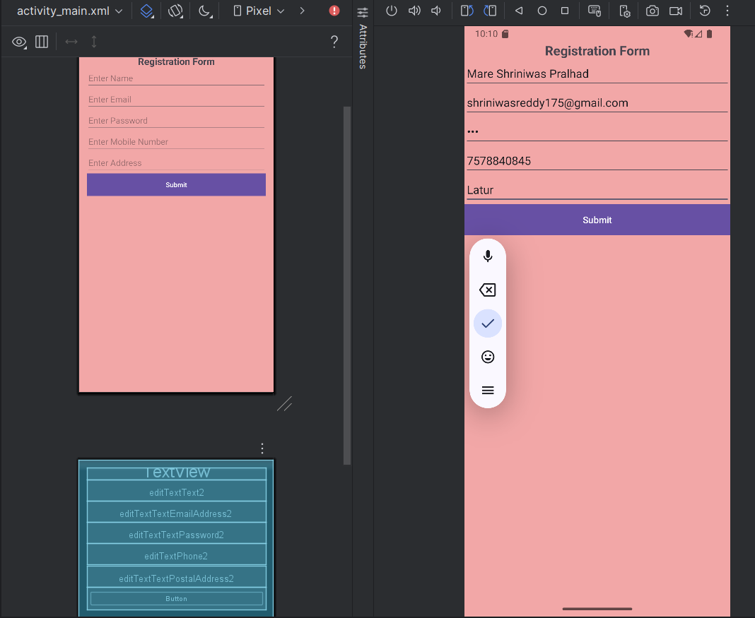

- AbsoluteLayout

XML CODE:
<?xml version="1.0" encoding="utf-8"?>
<AbsoluteLayout xmlns:android="http://schemas.android.com/apk/res/android"
xmlns:app="http://schemas.android.com/apk/res-auto"
xmlns:tools="http://schemas.android.com/tools"
android:id="@+id/main"
android:layout_width="match_parent"
android:layout_height="match_parent"
android:background="#7A2B8C97"
tools:context=".MainActivity">
<TextView
android:id="@+id/textView1"
android:layout_width="match_parent"
android:layout_height="wrap_content"
android:layout_x="-1dp"
android:layout_y="108dp"
android:text="Smile Please!"
android:textAlignment="center"
android:textSize="18sp"
android:visibility="visible"
app:layout_constraintBottom_toBottomOf="parent"
app:layout_constraintEnd_toEndOf="parent"
app:layout_constraintStart_toStartOf="parent"
app:layout_constraintTop_toTopOf="parent"
tools:visibility="visible" />
<Button
android:id="@+id/button1"
android:layout_width="match_parent"
android:layout_height="wrap_content"
android:layout_x="0dp"
android:layout_y="407dp"
android:text="Click"
android:visibility="visible"
tools:visibility="visible" />
<ImageView
android:id="@+id/imageView1"
android:layout_width="251dp"
android:layout_height="269dp"
android:layout_x="89dp"
android:layout_y="133dp"
android:src="@android:drawable/ic_menu_camera"
android:visibility="visible"
tools:visibility="visible" />
</AbsoluteLayout>

OUTPUT:
