PRACTICAL-04

Aim: a) Create a layout where an ImageView and a TextView are stacked using FrameLayout. The ImageView should be at the background,and the TextView should be centered on top of it.
b) Design and implement user interfaces in an Android application using RelativeLayout and TableLayout to arrange UI components

- FrameLayout

XML CODE:

<?xml version="1.0" encoding="utf-8"?>
<FrameLayout
xmlns:android="http://schemas.android.com/apk/res/android"
xmlns:app="http://schemas.android.com/apk/res-auto"
xmlns:tools="http://schemas.android.com/tools"
android:id="@+id/main"
android:layout_width="match_parent"
android:layout_height="match_parent"
tools:context=".MainActivity">
<ImageView
android:layout_width="match_parent"
android:layout_height="match_parent"
android:scaleType="centerCrop"
android:src="@android:drawable/ic_menu_mapmode"
android:visibility="visible"
tools:visibility="visible" />
<TextView
android:layout_width="wrap_content"
android:layout_height="wrap_content"
android:layout_gravity="center"
android:text="Welcome to World Map"
android:textColor="@android:color/system_error_700"
android:textSize="34sp"
android:visibility="visible"
tools:visibility="visible" />
</FrameLayout>

OUTPUT:

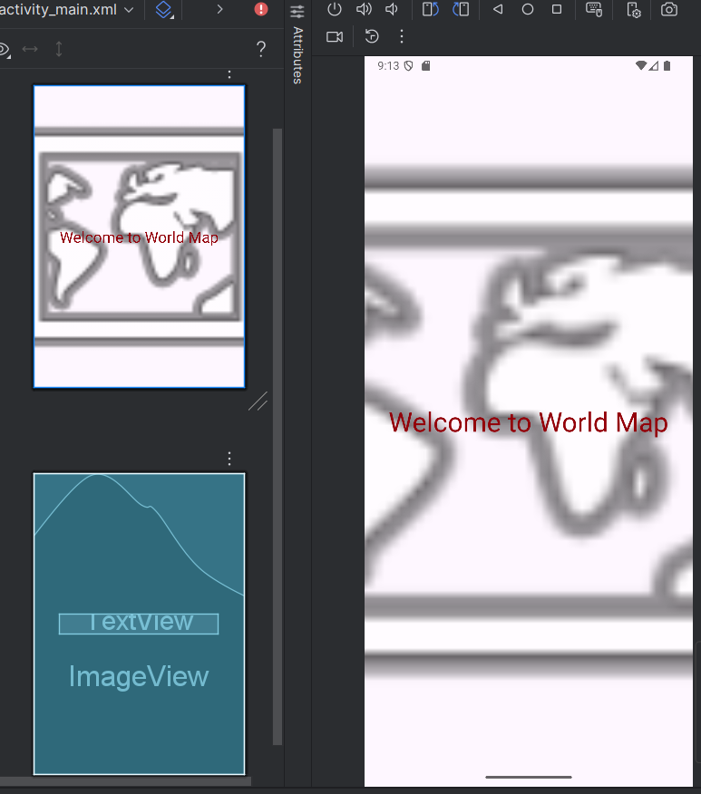

- RelativeLayout

XML CODE:
<?xml version="1.0" encoding="utf-8"?>
<RelativeLayout
xmlns:android="http://schemas.android.com/apk/res/android"
xmlns:app="http://schemas.android.com/apk/res-auto"
xmlns:tools="http://schemas.android.com/tools"
android:id="@+id/main"
android:layout_width="match_parent"
android:layout_height="match_parent"
tools:context=".MainActivity">
<EditText
android:id="@+id/name"
android:hint="Name"
android:inputType="text"
android:layout_width="match_parent"
android:layout_height="wrap_content" />
<EditText
android:id="@+id/username"
android:hint="Username"
android:inputType="textPersonName"
android:layout_below="@id/name"
android:layout_width="match_parent"
android:layout_height="wrap_content" />
<EditText
android:id="@+id/password"
android:hint="Password"
android:inputType="textPassword"
android:layout_below="@id/username"
android:layout_width="match_parent"
android:layout_height="wrap_content" />
<EditText
android:id="@+id/phone"
android:hint="Mobile Number"
android:inputType="phone"
android:layout_below="@id/password"
android:layout_width="match_parent"
android:layout_height="wrap_content" />
<EditText
android:id="@+id/address"
android:hint="Postal address"
android:inputType="textPostalAddress"
android:layout_below="@id/phone"
android:layout_width="match_parent"
android:layout_height="wrap_content" />
<Button
android:text="Login"
android:layout_below="@id/address"
android:layout_centerHorizontal="true"
android:layout_width="wrap_content"
android:layout_height="wrap_content" />
</RelativeLayout>

OUTPUT:
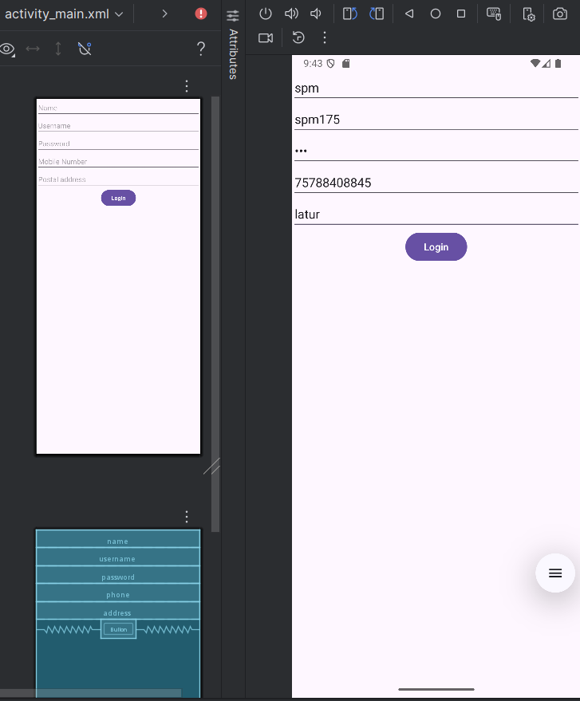

- TableLayout

XMLCODE:

<?xml version="1.0" encoding="utf-8"?>
<TableLayout
xmlns:android="http://schemas.android.com/apk/res/android"
xmlns:app="http://schemas.android.com/apk/res-auto"
xmlns:tools="http://schemas.android.com/tools"
android:id="@+id/main"
tools:context=".MainActivity"
android:layout_width="match_parent"
android:layout_height="wrap_content"
android:stretchColumns="1">
<TableRow>
<TextView
android:text="Name:" />
<EditText
android:hint="Enter Name"
android:inputType="text"/>
</TableRow>
<TableRow>
<TextView
android:text="Email:" />
<EditText
android:hint="Enter Email"
android:inputType="textEmailAddress"/>
</TableRow>
<TableRow>
<TextView
android:text="Mob:" />
<EditText
android:hint="Enter Mobile Number"
android:inputType="phone"/>
</TableRow>
<TableRow>
<TextView
android:text="Add:" />
<EditText
android:hint="Enter Address"
android:inputType="textPostalAddress"/>
</TableRow>
<TableRow>
<Button
android:text="Submit"
android:layout_span="2" />
</TableRow>
</TableLayout>

OUTPUT:

