PRACTICAL: 05
AIM:
a) Develop an Android app that uses TextView and EditText to get and display text from the user.
b) Implement AutoComplete TextView in an Android application to provide user-friendly input suggestions based on partial user input.

XML CODE:
<?xml version="1.0" encoding="utf-8"?>
<androidx.constraintlayout.widget.ConstraintLayout xmlns:android="http://schemas.android.com/apk/res/android"
xmlns:app="http://schemas.android.com/apk/res-auto"
xmlns:tools="http://schemas.android.com/tools"
android:id="@+id/main"
android:layout_width="match_parent"
android:layout_height="match_parent"
android:orientation="vertical"
android:padding="20dp"
tools:context=".MainActivity">
<EditText
android:id="@+id/editTextInput"
android:layout_width="match_parent"
android:layout_height="wrap_content"
android:hint="Enter value in KG"
android:inputType="numberDecimal"
app:layout_constraintBottom_toBottomOf="parent"
app:layout_constraintEnd_toEndOf="parent"
app:layout_constraintHorizontal_bias="1.0"
app:layout_constraintStart_toStartOf="parent"
app:layout_constraintTop_toTopOf="parent"
app:layout_constraintVertical_bias="0.582" />
<Button
android:id="@+id/button0"
android:layout_width="wrap_content"
android:layout_height="wrap_content"
android:layout_marginBottom="112dp"
android:text="Gram"
app:layout_constraintBottom_toTopOf="@+id/textViewOutput"
app:layout_constraintEnd_toEndOf="parent"
app:layout_constraintHorizontal_bias="0.0"
app:layout_constraintStart_toStartOf="parent"
app:layout_constraintTop_toBottomOf="@+id/editTextInput"
app:layout_constraintVertical_bias="0.484" />
<Button
android:id="@+id/button1"
android:layout_width="wrap_content"
android:layout_height="wrap_content"
android:layout_marginBottom="112dp"
android:text="Pound"
app:layout_constraintBottom_toTopOf="@+id/textViewOutput"
app:layout_constraintEnd_toEndOf="parent"
app:layout_constraintStart_toStartOf="parent"
app:layout_constraintTop_toBottomOf="@+id/editTextInput"
app:layout_constraintVertical_bias="0.481" />
<Button
android:id="@+id/button2"
android:layout_width="wrap_content"
android:layout_height="wrap_content"
android:layout_marginBottom="112dp"
android:text="Quintol"
app:layout_constraintBottom_toTopOf="@+id/textViewOutput"
app:layout_constraintEnd_toEndOf="parent"
app:layout_constraintHorizontal_bias="1.0"
app:layout_constraintStart_toStartOf="parent"
app:layout_constraintTop_toBottomOf="@+id/editTextInput"
app:layout_constraintVertical_bias="0.484" />
<TextView
android:id="@+id/textViewOutput"
android:layout_width="wrap_content"
android:layout_height="wrap_content"
android:layout_marginTop="240dp"
android:text="Answer"
android:textSize="18sp"
app:layout_constraintBottom_toBottomOf="parent"
app:layout_constraintEnd_toEndOf="parent"
app:layout_constraintHorizontal_bias="0.498"
app:layout_constraintStart_toStartOf="parent"
app:layout_constraintTop_toBottomOf="@+id/editTextInput"
app:layout_constraintVertical_bias="0.0" />
<ImageView
android:id="@+id/imageView"
android:layout_width="141dp"
android:layout_height="179dp"
android:layout_marginTop="48dp"
app:layout_constraintEnd_toEndOf="parent"
app:layout_constraintStart_toStartOf="parent"
app:layout_constraintTop_toTopOf="parent"
app:srcCompat="@drawable/unit_converter" />
<TextView
android:id="@+id/textView"
android:layout_width="wrap_content"
android:layout_height="wrap_content"
android:background="#6744A9"
android:text="Unit Converter"
android:textAlignment="center"
android:textColor="#FFFFFF"
android:textColorLink="#75254D"
android:textSize="34sp"
app:layout_constraintBottom_toTopOf="@+id/editTextInput"
app:layout_constraintEnd_toEndOf="parent"
app:layout_constraintStart_toStartOf="parent"
app:layout_constraintTop_toBottomOf="@+id/imageView" />
</androidx.constraintlayout.widget.ConstraintLayout>

JAVA CODE:
package com.example.mad_pr_05_getndis;
import android.os.Bundle;
import android.widget.Button;
import android.widget.EditText;
import android.widget.TextView;
import androidx.activity.EdgeToEdge;
import androidx.appcompat.app.AppCompatActivity;
public class MainActivity extends AppCompatActivity {
EditText e;
Button b0, b1, b2;
TextView t;
@Override
protected void onCreate(Bundle savedInstanceState) {
super.onCreate(savedInstanceState);
EdgeToEdge.enable(this);
setContentView(R.layout.activity_main);
e = findViewById(R.id.editTextInput);
b0 = findViewById(R.id.button0);
b1 = findViewById(R.id.button1);
b2 = findViewById(R.id.button2);
t = findViewById(R.id.textViewOutput);
b0.setOnClickListener(v -> {
String input = e.getText().toString().trim();
double temp = Double.parseDouble(input);
double result = temp * 1000;
t.setText(result+" gm");
});
b1.setOnClickListener(v ->{
String input = e.getText().toString().trim();
double temp = Double.parseDouble(input);
double result = temp * 2.20426;
t.setText(result+" lb");
});
b2.setOnClickListener(v ->{
String input = e.getText().toString().trim();
double temp = Double.parseDouble(input);
double result = temp / 100;
t.setText(result+" quintol");
});
}
}

OUTPUT:
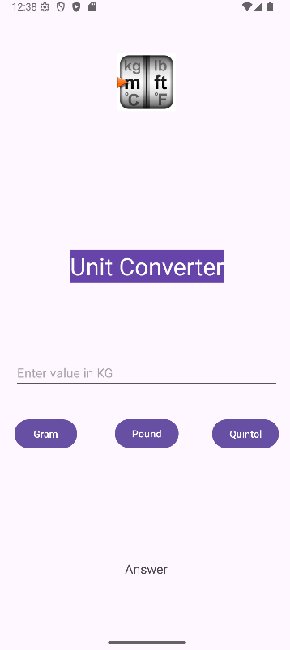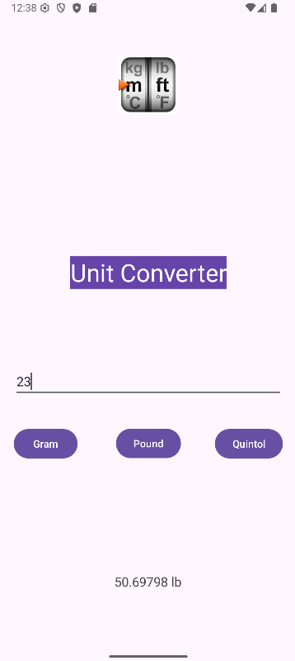
XML CODE:
<?xml version="1.0" encoding="utf-8"?>
<androidx.constraintlayout.widget.ConstraintLayout
xmlns:android="http://schemas.android.com/apk/res/android"
xmlns:app="http://schemas.android.com/apk/res-auto"
xmlns:tools="http://schemas.android.com/tools"
android:id="@+id/main"
android:layout_width="match_parent"
android:layout_height="match_parent"
android:background="#B3E774
"
android:padding="24dp"
tools:context=".MainActivity">
<!-- Profile Image -->
<ImageView
android:id="@+id/imageView"
android:layout_width="120dp"
android:layout_height="120dp"
android:layout_marginTop="16dp"
android:src="@drawable/spm_p"
android:contentDescription="Profile"
app:layout_constraintTop_toTopOf="parent"
app:layout_constraintStart_toStartOf="parent"
app:layout_constraintEnd_toEndOf="parent" />
<!-- Name -->
<AutoCompleteTextView
android:id="@+id/autoCompleteTextView1"
android:layout_width="match_parent"
android:layout_height="wrap_content"
android:layout_marginTop="24dp"
android:hint="Enter your Name"
android:inputType="text"
android:completionThreshold="1"
android:textColor="#000000"
android:textColorHint="#888888"
app:layout_constraintTop_toBottomOf="@id/imageView"
app:layout_constraintStart_toStartOf="parent"
app:layout_constraintEnd_toEndOf="parent" />
<!-- Phone -->
<EditText
android:id="@+id/editTextPhone"
android:layout_width="match_parent"
android:layout_height="wrap_content"
android:hint="Enter your Mobile"
android:inputType="phone"
android:textColor="#000000"
android:textColorHint="#888888"
android:layout_marginTop="16dp"
app:layout_constraintTop_toBottomOf="@id/autoCompleteTextView1"
app:layout_constraintStart_toStartOf="parent"
app:layout_constraintEnd_toEndOf="parent" />
<!-- Email -->
<EditText
android:id="@+id/editTextTextEmailAddress"
android:layout_width="match_parent"
android:layout_height="wrap_content"
android:hint="Enter your Email"
android:inputType="textEmailAddress"
android:textColor="#000000"
android:textColorHint="#888888"
android:layout_marginTop="16dp"
app:layout_constraintTop_toBottomOf="@id/editTextPhone"
app:layout_constraintStart_toStartOf="parent"
app:layout_constraintEnd_toEndOf="parent" />
<!-- DOB -->
<EditText
android:id="@+id/editTextDate"
android:layout_width="match_parent"
android:layout_height="wrap_content"
android:hint="Enter your DOB"
android:inputType="date"
android:textColor="#000000"
android:textColorHint="#888888"
android:layout_marginTop="16dp"
app:layout_constraintTop_toBottomOf="@id/editTextTextEmailAddress"
app:layout_constraintStart_toStartOf="parent"
app:layout_constraintEnd_toEndOf="parent" />
<!-- Country -->
<AutoCompleteTextView
android:id="@+id/autoCompleteTextView2"
android:layout_width="match_parent"
android:layout_height="wrap_content"
android:hint="Enter Country"
android:inputType="text"
android:completionThreshold="1"
android:textColor="#000000"
android:textColorHint="#888888"
android:layout_marginTop="16dp"
app:layout_constraintTop_toBottomOf="@id/editTextDate"
app:layout_constraintStart_toStartOf="parent"
app:layout_constraintEnd_toEndOf="parent" />
<!-- Submit Button -->
<Button
android:id="@+id/button"
android:layout_width="wrap_content"
android:layout_height="wrap_content"
android:text="Submit"
android:layout_marginTop="24dp"
app:layout_constraintTop_toBottomOf="@id/autoCompleteTextView2"
app:layout_constraintStart_toStartOf="parent"
app:layout_constraintEnd_toEndOf="parent" />
<!-- Output -->
<TextView
android:id="@+id/textView"
android:layout_width="match_parent"
android:layout_height="wrap_content"
android:text="Entered data will display here."
android:textColor="#000000"
android:textSize="16sp"
android:layout_marginTop="24dp"
app:layout_constraintTop_toBottomOf="@id/button"
app:layout_constraintStart_toStartOf="parent"
app:layout_constraintEnd_toEndOf="parent" />
</androidx.constraintlayout.widget.ConstraintLayout>

JAVA CODE:
package com.example.mad_pr_05_autosugg;
import android.os.Bundle;
import android.view.View;
import android.widget.Adapter;
import android.widget.ArrayAdapter;
import android.widget.AutoCompleteTextView;
import android.widget.Button;
import android.widget.EditText;
import android.widget.TextView;
import android.widget.Toast;
import androidx.appcompat.app.AppCompatActivity;
public class MainActivity extends AppCompatActivity
{
EditText phone, email, dob;
AutoCompleteTextView country, name;
TextView output;
Button submit;
@Override
protected void onCreate(Bundle savedInstanceState)
{
super.onCreate(savedInstanceState);
setContentView(R.layout.activity_main);
name = findViewById(R.id.autoCompleteTextView1);
phone = findViewById(R.id.editTextPhone);
email = findViewById(R.id.editTextTextEmailAddress);
dob = findViewById(R.id.editTextDate);
country = findViewById(R.id.autoCompleteTextView2);
output = findViewById(R.id.textView);
submit = findViewById(R.id.button);
String[] countries = {"India", "Indonesia", "USA", "UK", "Uganda", "Ukraine", "Canada", "China"};
ArrayAdapter<String> adapter1 = new ArrayAdapter<>(MainActivity.this, android.R.layout.simple_dropdown_item_1line, countries);
country.setAdapter(adapter1);
String[] names = {"Shrinivas", "Shriniwas", "Shree", "Mare", "Pralhad", "SPM", "MSP", "Reddy"};
ArrayAdapter<String> adapter2 = new ArrayAdapter<>(MainActivity.this, android.R.layout.simple_dropdown_item_1line, names);
name.setAdapter(adapter2);
submit.setOnClickListener(new View.OnClickListener()
{
@Override
public void onClick(View view)
{
String name1 = name.getText().toString().trim();
String phone1 = phone.getText().toString().trim();
String email1 = email.getText().toString().trim();
String dob1 = dob.getText().toString().trim();
String country1 = country.getText().toString().trim();
if (name1.isEmpty()||phone1.isEmpty()||email1.isEmpty()||dob1.isEmpty()||country1.isEmpty())
{
Toast.makeText(getApplicationContext(), "Please fill all field", Toast.LENGTH_SHORT).show();
}
else
{
String message = "Name: "+name1+"\nMob: "+phone1+"\nEmail: "+email1+"\nDOB: "+dob1+"\nCountry: "+country1 ;
output.setText(message);
}
}
});
}
}

OUTPUT:
