PRACTICAL: 06
AIM:
- Develop an Android application that uses Button, ImageButton to perform actions based on user interactions.
- Develop an Android application that uses a ToggleButton to switch between two states (on/off) and perform actions based on the user's selection.

PART A:

XML CODE:

<LinearLayout
xmlns:android="http://schemas.android.com/apk/res/android"
android:layout_width="match_parent"
android:layout_height="match_parent"
android:orientation="vertical"
android:gravity="center"
android:padding="16dp">
<Button
android:id="@+id/buttonClick"
android:layout_width="wrap_content"
android:layout_height="wrap_content"
android:text="@string/click_me" />
<ImageButton
android:id="@+id/imageButton"
android:layout_width="100dp"
android:layout_height="100dp"
android:layout_marginTop="20dp"
android:background="@null"
android:contentDescription="@string/image_button"
android:src="@android:drawable/btn_star_big_on" />
<TextView
android:id="@+id/textViewOutput"
android:layout_width="wrap_content"
android:layout_height="wrap_content"
android:text="@string/output_will_appear_here"
android:layout_marginTop="20dp"
android:textSize="16sp"/>
</LinearLayout>

JAVA CODE:

package com.example.m6_button_imagebutton;
import android.os.Bundle;
import android.widget.Button;
import android.widget.ImageButton;
import android.widget.TextView;
import androidx.appcompat.app.AppCompatActivity;
public class MainActivity extends AppCompatActivity {
@Override
protected void onCreate(Bundle savedInstanceState) {
super.onCreate(savedInstanceState);
setContentView(R.layout.activity_main);
Button btn = findViewById(R.id.buttonClick);
ImageButton imgBtn = findViewById(R.id.imageButton);
TextView output = findViewById(R.id.textViewOutput);
btn.setOnClickListener(v -> output.setText("Normal Button Clicked!"));
imgBtn.setOnClickListener(v -> output.setText("ImageButton Clicked!"));
}
}

OUTPUT:
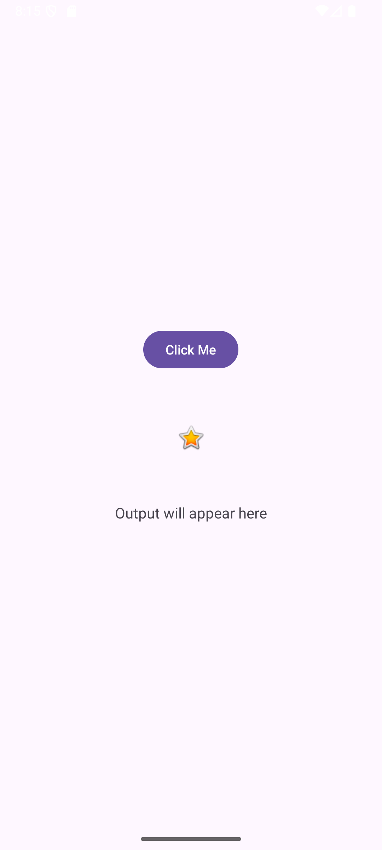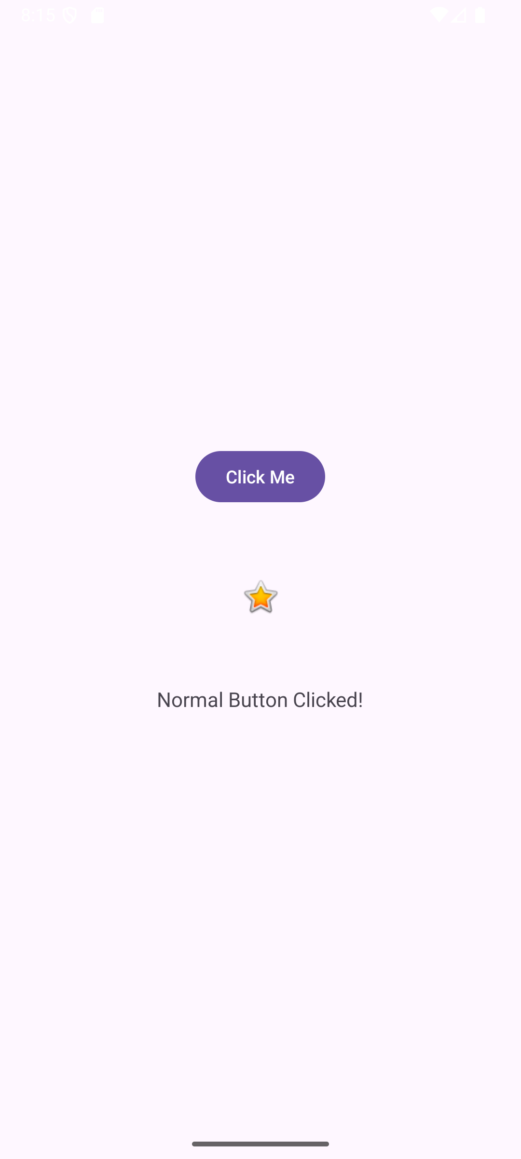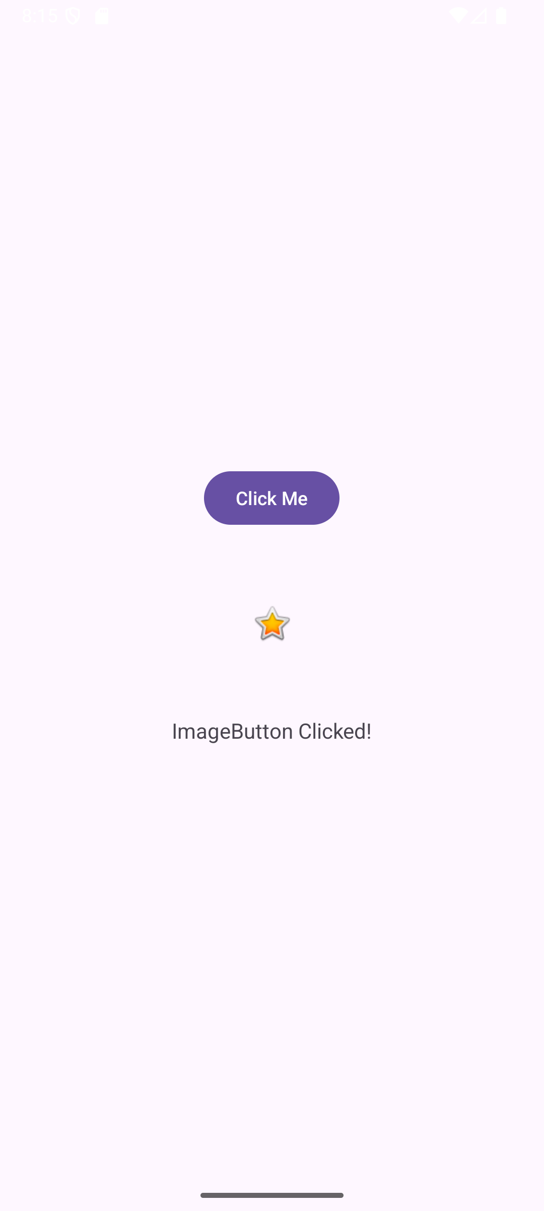
PART B:

XML CODE:
<LinearLayout xmlns:android="http://schemas.android.com/apk/res/android"
android:id="@+id/mainLayout"
android:layout_width="match_parent"
android:layout_height="match_parent"
android:orientation="vertical"
android:gravity="center"
android:padding="20dp"
android:background="#FFFFFF">
<ToggleButton
android:id="@+id/toggleButton"
android:layout_width="200dp"
android:layout_height="wrap_content"
android:textOn="Light ON"
android:textOff="Light OFF"
android:checked="false"
android:textSize="18sp"
android:padding="10dp" />
<TextView
android:id="@+id/toggleOutput"
android:layout_width="wrap_content"
android:layout_height="wrap_content"
android:text="The light is OFF"
android:textSize="20sp"
android:textColor="#333333"
android:layout_marginTop="30dp" />
</LinearLayout>

JAVA CODE:
package com.example.m6_togglebutton;
import android.os.Bundle;
import android.widget.LinearLayout;
import android.widget.TextView;
import android.widget.ToggleButton;
import android.widget.Toast;
import androidx.appcompat.app.AppCompatActivity;
public class MainActivity extends AppCompatActivity {
@Override
protected void onCreate(Bundle savedInstanceState) {
super.onCreate(savedInstanceState);
setContentView(R.layout.activity_main);
ToggleButton toggleButton = findViewById(R.id.toggleButton);
TextView toggleOutput = findViewById(R.id.toggleOutput);
LinearLayout layout = findViewById(R.id.mainLayout);
toggleButton.setOnCheckedChangeListener((buttonView, isChecked) -> {
if (isChecked) {
toggleOutput.setText("The light is ON");
toggleOutput.setTextColor(getResources().getColor(android.R.color.holo_orange_dark));
layout.setBackgroundColor(getResources().getColor(android.R.color.holo_orange_light));
Toast.makeText(this, "Light turned ON!", Toast.LENGTH_SHORT).show();
} else {
// When ToggleButton is OFF
toggleOutput.setText("The light is OFF");
toggleOutput.setTextColor(getResources().getColor(android.R.color.darker_gray));
layout.setBackgroundColor(getResources().getColor(android.R.color.white));
Toast.makeText(this, "Light turned OFF!", Toast.LENGTH_SHORT).show();
}
});
}
}

OUTPUT:
