PRACTICAL:10

AIM: Develop a program to implement List View, Grid View.

A] ListView

XML CODE:
<LinearLayout xmlns:android="http://schemas.android.com/apk/res/android"
android:layout_width="match_parent"
android:layout_height="match_parent"
android:orientation="vertical"
android:padding="16dp">
<ListView
android:id="@+id/listView"
android:layout_width="match_parent"
android:layout_height="wrap_content"
android:divider="@android:color/holo_blue_light"
android:dividerHeight="2dp"/>
</LinearLayout>

JAVA CODE:
package com.example.m10_listview;
import android.os.Bundle;
import android.view.View;
import android.widget.AdapterView;
import android.widget.ArrayAdapter;
import android.widget.ListView;
import android.widget.Toast;
import androidx.activity.EdgeToEdge;
import androidx.appcompat.app.AppCompatActivity;
public class MainActivity extends AppCompatActivity {
String[] items = {"Android", "Java", "Python", "C++", "Kotlin", "Flutter"};
ListView listView;
@Override
protected void onCreate(Bundle savedInstanceState) {
super.onCreate(savedInstanceState);
EdgeToEdge.enable(this);
setContentView(R.layout.activity_main);
listView = findViewById(R.id.listView);
ArrayAdapter<String> adapter = new ArrayAdapter<>(this, android.R.layout.simple_list_item_1, items);
listView.setAdapter(adapter);
listView.setOnItemClickListener(new AdapterView.OnItemClickListener()
{
@Override
public void onItemClick(AdapterView<?> parent, View view, int position, long id)
{
String selectedItem = items[position];
Toast.makeText(getApplicationContext(),
"You selected: " + selectedItem,
Toast.LENGTH_SHORT).show();
}
});
}
}

OUTPUT:
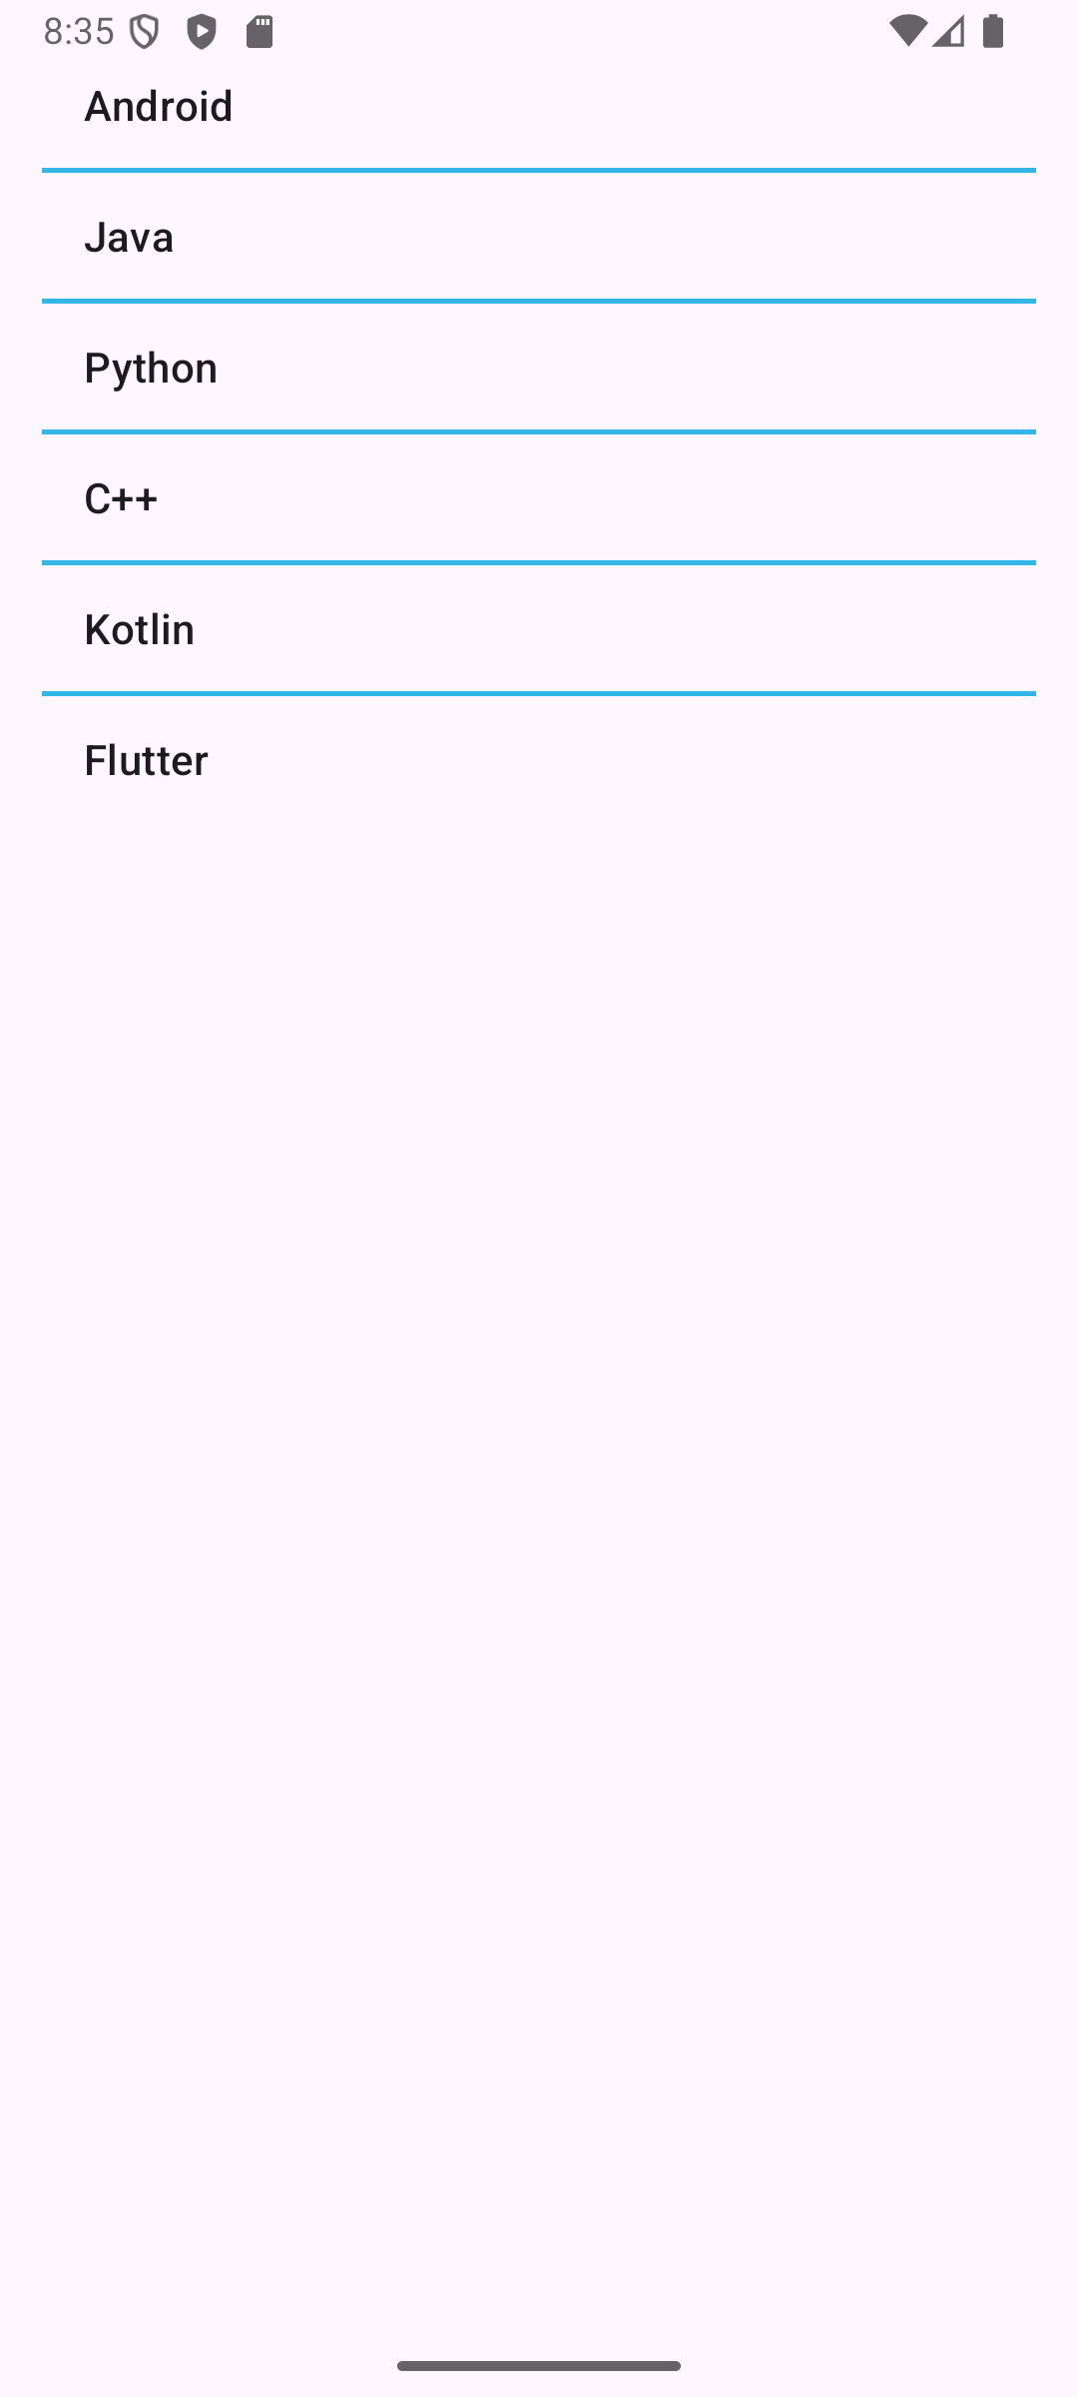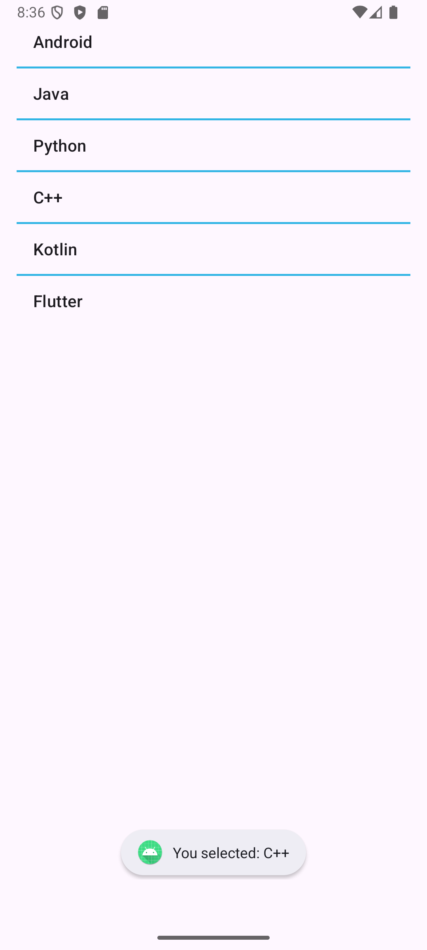

B] GridView

XML CODE:
<LinearLayout xmlns:android="http://schemas.android.com/apk/res/android"
android:layout_width="match_parent"
android:layout_height="match_parent"
android:orientation="vertical"
android:padding="16dp">

<GridView
android:id="@+id/gridView"
android:layout_width="match_parent"
android:layout_height="wrap_content"
android:numColumns="3"
android:verticalSpacing="10dp"
android:horizontalSpacing="10dp"
android:stretchMode="columnWidth"
android:gravity="center"/>
</LinearLayout>

JAVA CODE:
package com.example.m10_gridview;
import android.os.Bundle;
import android.widget.ArrayAdapter;
import android.widget.GridView;
import android.widget.Toast;
import androidx.activity.EdgeToEdge;
import androidx.appcompat.app.AppCompatActivity;
public class MainActivity extends AppCompatActivity
{
@Override
protected void onCreate(Bundle savedInstanceState)
{
super.onCreate(savedInstanceState);
EdgeToEdge.enable(this);
GridView gridView = findViewById(R.id.gridView);
String[] fruits = {"Apple", "Banana", "Mango", "Orange", "Grapes", "Pineapple"};
ArrayAdapter<String> gridAdapter = new ArrayAdapter<>(this, android.R.layout.simple_list_item_1, fruits);
gridView.setAdapter(gridAdapter);
gridView.setOnItemClickListener((parent, view, position, id) ->
{
String selectedItem = fruits[position];
Toast.makeText(getApplicationContext(), "Grid item: " + selectedItem, Toast.LENGTH_SHORT).show();
});
}
}

OUTPUT:
