PRACTICAL: 11

AIM: Develop an Android app that uses explicit intents to switch between activities and interact with external components.

activity_main.xml:
<LinearLayout xmlns:android="http://schemas.android.com/apk/res/android"
android:layout_width="match_parent"
android:layout_height="match_parent"
android:orientation="vertical"
android:padding="20dp">
<EditText
android:id="@+id/Name"
android:layout_width="match_parent"
android:layout_height="wrap_content"
android:hint="Enter your first name" />
<EditText
android:id="@+id/Name1"
android:layout_width="match_parent"
android:layout_height="wrap_content"
android:hint="Enter your mother name" />
<EditText
android:id="@+id/Name2"
android:layout_width="match_parent"
android:layout_height="wrap_content"
android:hint="Enter your father name" />
<EditText
android:id="@+id/Name3"
android:layout_width="match_parent"
android:layout_height="wrap_content"
android:hint="Enter your last name" />
<EditText
android:id="@+id/Name4"
android:layout_width="match_parent"
android:layout_height="wrap_content"
android:hint="Enter your college name" />
<Button
android:id="@+id/btnNext"
android:layout_width="wrap_content"
android:layout_height="wrap_content"
android:text="Go to Next Screen"
android:layout_marginTop="20dp"/>
</LinearLayout>

Activity_main2.xml:
<LinearLayout xmlns:android="http://schemas.android.com/apk/res/android"
android:layout_width="match_parent"
android:layout_height="match_parent"
android:gravity="center"
android:orientation="vertical">
<TextView
android:id="@+id/txtMessage"
android:layout_width="wrap_content"
android:layout_height="wrap_content"
android:text="Welcome!"
android:textSize="20sp"/>
<TextView
android:id="@+id/txtTable"
android:layout_width="wrap_content"
android:layout_height="wrap_content"
android:text="Data:"
android:textSize="20sp"/>
<Button
android:id="@+id/btnPrevious"
android:layout_width="wrap_content"
android:layout_height="wrap_content"
android:text="Go to Previous Screen"
android:layout_marginTop="20dp"/>
</LinearLayout>

MainActivity.java:
package com.example.m14_exp_intent;
import static android.widget.Toast.LENGTH_SHORT;
import android.content.Intent;
import android.os.Bundle;
import android.widget.Button;
import android.widget.EditText;
import android.widget.Toast;
import androidx.activity.EdgeToEdge;
import androidx.appcompat.app.AppCompatActivity;
public class MainActivity extends AppCompatActivity
{
EditText Name, Name1, Name2, Name3, Name4;
Button btnNext;
@Override
protected void onCreate(Bundle savedInstanceState)
{
super.onCreate(savedInstanceState);
EdgeToEdge.enable(this);
setContentView(R.layout.activity_main);
Name = findViewById(R.id.Name);
Name1 = findViewById(R.id.Name1);
Name2 = findViewById(R.id.Name2);
Name3 = findViewById(R.id.Name3);
Name4 = findViewById(R.id.Name4);
btnNext = findViewById(R.id.btnNext);
btnNext.setOnClickListener(v ->
{
String first = Name.getText().toString();
String mother = Name1.getText().toString();
String father = Name2.getText().toString();
String last = Name3.getText().toString();
String college = Name4.getText().toString();
if(first.isEmpty() || mother.isEmpty() || father.isEmpty() || last.isEmpty() || college.isEmpty())
{
Toast.makeText(this, "Enter all fields.", LENGTH_SHORT).show();
}
else
{
Intent intent = new Intent(MainActivity.this, MainActivity2.class);
intent.putExtra("firstName", first);
intent.putExtra("motherName", mother);
intent.putExtra("fatherName", father);
intent.putExtra("lastName", last);
intent.putExtra("collegeName", college);
startActivity(intent);
}
});
}
}

MainActivity2.java:
package com.example.m14_exp_intent;
import android.content.Intent;
import android.os.Bundle;
import android.widget.Button;
import android.widget.TextView;
import androidx.activity.EdgeToEdge;
import androidx.appcompat.app.AppCompatActivity;
public class MainActivity2 extends AppCompatActivity
{
TextView txtMessage;
TextView txtTable;
Button btnPrevious;
@Override
protected void onCreate(Bundle savedInstanceState)
{
super.onCreate(savedInstanceState);
EdgeToEdge.enable(this);
setContentView(R.layout.activity_main2);
txtMessage = findViewById(R.id.txtMessage);
txtTable = findViewById(R.id.txtTable);
btnPrevious = findViewById(R.id.btnPrevious);
txtMessage.setText("Welcome to Second Screen.");
String first = getIntent().getStringExtra("firstName");
String mother = getIntent().getStringExtra("motherName");
String father = getIntent().getStringExtra("fatherName");
String last = getIntent().getStringExtra("lastName");
String college = getIntent().getStringExtra("collegeName");
String table = "First Name: " + first + "\n"
+ "Mother Name: " + mother + "\n"
+ "Father Name: " + father + "\n"
+ "Last Name: " + last + "\n"
+ "College Name: " + college;
txtTable.setText(table);
btnPrevious.setOnClickListener(v -> {
Intent intent = new Intent(MainActivity2.this, MainActivity.class);
startActivity(intent);
});
}
}

AndroidManifest.xml;
<?xml version="1.0" encoding="utf-8"?>
<manifest xmlns:android="http://schemas.android.com/apk/res/android"
xmlns:tools="http://schemas.android.com/tools">
<application
android:allowBackup="true"
android:dataExtractionRules="@xml/data_extraction_rules"
android:fullBackupContent="@xml/backup_rules"
android:icon="@mipmap/ic_launcher"
android:label="@string/app_name"
android:roundIcon="@mipmap/ic_launcher_round"
android:supportsRtl="true"
android:theme="@style/Theme.M14_Exp_Intent">
<activity
android:name=".MainActivity2"
android:exported="false" />
<activity
android:name=".MainActivity"
android:exported="true">
<intent-filter>
<action android:name="android.intent.action.MAIN" />
<category android:name="android.intent.category.LAUNCHER" />
</intent-filter>
</activity>
</application>
</manifest>

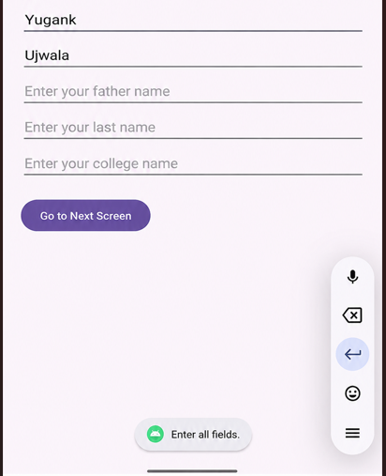
OUTPUT:
