GOVERNMENT POLYTECHNIC PUNE
(An Autonomous Institute of Government of Maharashtra)
University Road, Shivajinagar, Pune-411016

DEPARTMENT OF COMPUTER ENGINEERING
Academic Year 2025-26



A MICRO PROJECT REPORT ON:
“BlueChat - Secure Chat App Over Bluetooth”

SUBMITTED BY:

NAME | ENROLLMENT NUMBER
MANVAL SHRUTI SANDIP | 2306114
MARE SHRINIVAS PRALHAD | 2306115

UNDER THE GUIDANCE OF:
Prof. J. P. Dandale
(Academic Year:2025-26)

GOVERNMENT POLYTECHNIC PUNE
(An Autonomous Institute of Government of Maharashtra)
University Road, Shivajinagar, Pune-411016

DEPARTMENT OF COMPUTER ENGINEERING
Academic Year 2025-26

CERTIFICATE

This is to certify that the micro-project work entitled “BlueChat - Secure Chat App Over Bluetooth” is a bonafide work carried out by Manval Shruti Sandip- 2306114 of class H3 Third Year in partial fulfillment of the requirement for the completion of Course- MOBILE APPLICATION DEVELOPMENT (CM51203) of Diploma in Computer Engineering from Government
Polytechnic Pune. The report has been approved as it satisfies the academic requirements in respect of the micro-project work prescribed for the course.

Prof. J.P.Dandale Prof.J.R.Hange Dr.R.K.Patil

(Microproject Guide) (Head of Department ) (Principal)

INDEX

Sr no | Content | Page
1. | Introduction | 6
2. | Implementation | 7
3. | Code | 8
4. | Output | 23
5. | Advantages | 25
6. | Future Scope | 25
7. | Course Level Outcomes Achieved | 26
8. | Skills Developed | 26
9. | References | 26
10. | Conclusion | 26

ACKNOWLEDEMENT

I would like to express my sincere gratitude to Dr. Rajendra Patil, our Principal, for his constant support, valuable guidance, and continuous encouragement throughout the development of my project “BlueChat - Secure Chat App Over Bluetooth” His inspiring leadership and motivation have been instrumental in the successful completion of this work.
I am deeply thankful to Mrs. J. R. Hange, Head of Department, for her valuable insights, encouragement, and constant motivation, which greatly contributed to enhancing the quality of this project.
My heartfelt thanks to Prof.J.P.Dandale, my project guide, for her continuous guidance, patience, and valuable suggestions at every stage of the project. Her support and constructive feedback have been a constant source of inspiration and learning.
Finally, I would like to express my deep appreciation to my friends and family for their unwavering support, cooperation, and encouragement, which helped me to successfully complete this project

ABSTRACT

BlueChat is a secure mobile application designed to enable instant communication between users using Bluetooth technology, without the need for an internet connection. The app allows users to send and receive text messages, share files, and maintain private conversations within a limited Bluetooth range. By leveraging peer-to-peer Bluetooth connectivity, BlueChat ensures fast, reliable, and offline communication — ideal for environments with limited or no network coverage.

The application prioritizes user privacy and data security through message encryption and secure pairing between devices. Each chat session is established only after mutual authentication, preventing unauthorized access or data interception. With its clean and intuitive interface, BlueChat offers a seamless chatting experience, supporting both individual and group conversations.

Built with scalability and efficiency in mind, the app follows modern software development principles to ensure smooth performance across a wide range of Android devices. BlueChat serves as a practical solution for secure, offline communication, combining convenience, safety, and accessibility — making it particularly useful for personal, academic, and emergency communication scenarios.

1.Introduction
In today’s digitally connected world, instant communication has become an essential part of daily life. However, most messaging platforms rely on internet connectivity, which may not always be available — especially in remote areas, during emergencies, or in environments with restricted network access. To overcome this limitation, BlueChat – Secure Chat App Over Bluetooth is developed as a reliable and secure offline communication solution.
BlueChat enables users to exchange text messages and share files seamlessly using Bluetooth technology, eliminating the need for mobile data or Wi-Fi. It is particularly useful for short-range communication between friends, classmates, or team members in areas without internet access. The application emphasizes security and privacy, ensuring that every message is transmitted safely through encryption and device-level authentication.

The Problem
In modern times, communication heavily depends on internet-based platforms such as WhatsApp, Messenger, or Telegram. However, these applications become useless in situations where internet connectivity is unavailable or unreliable — such as in rural areas, during travel, or in emergencies like natural disasters. This creates a significant gap in short-range, real-time communication.
Existing offline communication methods, like traditional SMS or walkie-talkies, are either costly, limited in functionality, or lack proper security. Moreover, many Bluetooth-based apps available today either have poor connectivity, lack encryption, or provide a complicated user interface, making them inconvenient for everyday users.
Another major issue is data privacy — most popular chat applications rely on centralized servers that store user conversations, increasing the risk of data breaches or misuse. There is a growing need for a secure, private, and easy-to-use chat system that works independently of the internet while ensuring data confidentiality.
The Solution
- Bluetooth-Based Messaging: BlueChat enables users to send and receive text messages instantly using Bluetooth connectivity, completely eliminating the need for internet or mobile data.
- Secure Communication: Every chat session is encrypted to ensure privacy and prevent unauthorized access or data interception during Bluetooth transmission.
- Quick Device Pairing: Users can easily connect and authenticate nearby devices, establishing a safe peer-to-peer connection for seamless communication.

2. Implementation Steps

Phase 1: Project Setup and Foundation
The development of BlueChat began with setting up Android Studio and creating a new project using Java as the main programming language. Initial configurations involved defining the package structure, setting up Gradle dependencies, and updating the AndroidManifest.xml to include permissions for Bluetooth, Bluetooth Admin, and Storage Access.

Phase 2: Bluetooth Connectivity Implementation
Core Bluetooth functionalities were implemented using Android’s BluetoothAdapter and BluetoothSocket classes. The system was designed to discover nearby Bluetooth devices, establish secure connections, and manage paired device communication. Separate threads were created for sending and receiving messages, ensuring smooth data transmission without freezing the UI. The app also handles connection requests, pairing authentication, and error management for disconnected or unavailable devices.

Phase 3: Database Layer Implementation
BlueChat uses SQLite for local data storage, maintaining records of chat history, paired devices, and message logs. Database tables were designed to store sender information, timestamps, and message content. Helper classes were implemented to perform CRUD (Create, Read, Update, Delete) operations efficiently.

Phase 4: User Interface Development
User interface layouts were designed using XML to ensure a clean and modern appearance following Material Design guidelines. Key screens include device discovery, connection list, chat interface, and settings. The chat screen features RecyclerView for dynamic message display, text input fields, and send buttons. Consistent themes, icons, and color palettes were defined in colors.xml and styles.xml to enhance readability and provide a friendly user experience.

Phase 5: Secure Messaging Integration
A lightweight encryption mechanism was added to secure message content during Bluetooth transmission. Before sending a message, it is encrypted on the sender side and decrypted on the receiver side using shared secret keys generated during pairing. This ensures that messages remain private and cannot be intercepted by unauthorized devices.

Phase 6: Testing and Refinement
Comprehensive testing was performed on multiple Android devices with different Bluetooth versions and API levels. Testing included device discovery, pairing, message exchange, disconnection handling, and reconnection stability. Performance testing ensured minimal latency and battery efficiency during continuous chat sessions.

3.Code

activity_main.xml:
<?xml version="1.0" encoding="utf-8"?>
<LinearLayout xmlns:android="http://schemas.android.com/apk/res/android"
xmlns:app="http://schemas.android.com/apk/res-auto"
android:layout_width="match_parent"
android:layout_height="match_parent"
android:orientation="vertical"
android:background="@android:color/white">
<!-- TOOLBAR HOSTING THE ACTION BAR/MENU -->
<androidx.appcompat.widget.Toolbar
android:id="@+id/my_toolbar"
android:layout_width="match_parent"
android:layout_height="?attr/actionBarSize"
android:background="?attr/colorPrimary"
android:theme="@style/ThemeOverlay.AppCompat.Light"
app:popupTheme="@style/ThemeOverlay.AppCompat.DayNight.ActionBar"/>
<!-- Status Bar for Connection State -->
<TextView
android:id="@+id/status"
android:layout_width="match_parent"
android:layout_height="wrap_content"
android:padding="8dp"
android:background="#DDDDDD"
android:text="@string/title_not_connected"
android:textColor="@android:color/black"
android:gravity="center"
android:textStyle="bold" />
<!-- Scrollable Chat History Area (chatScrollView is used for auto-scrolling) -->
<ScrollView
android:id="@+id/chatScrollView"
android:layout_width="match_parent"
android:layout_height="0dp"
android:layout_weight="1"
android:fillViewport="true"
android:padding="8dp">
<TextView
android:id="@+id/chatBox"
android:layout_width="match_parent"
android:layout_height="wrap_content"
android:text=""
android:textColor="@android:color/black"
android:textSize="16sp"
android:gravity="bottom"
android:scrollbars="vertical"/>
</ScrollView>
<!-- Message Input and Send Button Area -->
<LinearLayout
android:layout_width="match_parent"
android:layout_height="wrap_content"
android:orientation="horizontal"
android:background="#EEEEEE"
android:padding="8dp"
android:gravity="bottom">
<EditText
android:id="@+id/writeMsg"
android:layout_width="0dp"
android:layout_height="wrap_content"
android:layout_weight="1"
android:hint="Type a message..."
android:inputType="text"
android:maxLines="4"
android:textColor="@android:color/black"
android:background="@android:color/white"
android:padding="8dp"/>
<Button
android:id="@+id/sendBtn"
android:layout_width="wrap_content"
android:layout_height="wrap_content"
android:layout_marginStart="8dp"
android:text="Send"/>
</LinearLayout>
</LinearLayout>

MainActivity.java:
package com.example.local_chat_app;
import android.Manifest;
import android.bluetooth.BluetoothAdapter;
import android.bluetooth.BluetoothDevice;
import android.content.Context;
import android.content.Intent;
import android.content.SharedPreferences;
import android.content.pm.PackageManager;
import android.database.Cursor;
import android.os.Build;
import android.os.Bundle;
import android.os.Handler;
import android.os.Message;
import android.view.Menu;
import android.view.MenuInflater;
import android.view.MenuItem;
import android.view.View;
import android.widget.Button;
import android.widget.EditText;
import android.widget.ScrollView;
import android.widget.TextView;
import android.widget.Toast;
import androidx.annotation.NonNull;
import androidx.annotation.Nullable;
import androidx.appcompat.app.AppCompatActivity;
import androidx.appcompat.widget.Toolbar;
import java.text.SimpleDateFormat;
import java.util.Date;
public class MainActivity extends AppCompatActivity implements Constants {
private TextView status, chatBox;
private EditText writeMsg;
private Button sendBtn;
private ScrollView chatScrollView;
private BluetoothService bluetoothService;
private BluetoothAdapter bluetoothAdapter;
private DBHelper dbHelper;
private String myUserName = "Me"; // Default name until loaded
// Key used to launch this activity in history mode
public static final String EXTRA_PARTNER_NAME = "extra_partner_name";
private String chatPartnerInView = null; // null for live chat, name for history view
private String connectedChatPartner = null; // Stores the name of the currently connected partner
private final int REQUEST_ENABLE_BT = 1;
private final int DEVICE_LIST_REQUEST = 2;
private static final int REQUEST_PERMISSION = 100;
private String connectedDeviceName = null;
@Override
protected void onCreate(Bundle savedInstanceState) {
super.onCreate(savedInstanceState);
setContentView(R.layout.activity_main);
// --- AUTHENTICATION STEP (NEW) ---
SharedPreferences prefs = getSharedPreferences("ChatPrefs", Context.MODE_PRIVATE);
myUserName = prefs.getString(AuthActivity.KEY_USER_NAME, "Me");
// --- TOOLBAR/ACTION BAR SETUP ---
Toolbar toolbar = findViewById(R.id.my_toolbar);
setSupportActionBar(toolbar);
if (getSupportActionBar() != null) {
getSupportActionBar().setTitle(myUserName);
}
// --- UI Initialization ---
status = findViewById(R.id.status);
chatBox = findViewById(R.id.chatBox);
writeMsg = findViewById(R.id.writeMsg);
sendBtn = findViewById(R.id.sendBtn);
chatScrollView = findViewById(R.id.chatScrollView);
// --- Core Setup ---
bluetoothAdapter = BluetoothAdapter.getDefaultAdapter();
if (bluetoothAdapter == null) {
Toast.makeText(this, "Bluetooth not supported", Toast.LENGTH_SHORT).show();
finish();
return;
}
dbHelper = new DBHelper(this);
Handler handler = new Handler(this::handleMessage);
bluetoothService = new BluetoothService(handler);
checkBluetoothPermissions();
// --- CONDITIONAL APP MODE ---
if (getIntent().hasExtra(EXTRA_PARTNER_NAME)) {
// MODE: HISTORY VIEW (Read-only)
chatPartnerInView = getIntent().getStringExtra(EXTRA_PARTNER_NAME);
setupHistoryView();
} else {
// MODE: LIVE CHAT (Default, start server)
setupLiveChat();
checkBluetoothPermissions();
}
sendBtn.setOnClickListener(v -> {
String message = writeMsg.getText().toString();
if (bluetoothService.getState() != STATE_CONNECTED) {
Toast.makeText(this, "Not connected to a device", Toast.LENGTH_SHORT).show();
return;
}
if (!message.isEmpty()) {
// Send the message prefixed with the unique user name
bluetoothService.sendMessage(myUserName + ": " + message);
writeMsg.setText("");
}
});
loadChatHistory();
}
// --- NEW: History View Setup (Read-only) ---
private void setupHistoryView() {
if (getSupportActionBar() != null) {
getSupportActionBar().setTitle("History: " + chatPartnerInView);
}
// Disable live chat UI elements
status.setVisibility(View.GONE);
writeMsg.setVisibility(View.GONE);
sendBtn.setVisibility(View.GONE);
// Load specific partner history and stop here
loadPartnerHistory(chatPartnerInView);
}
// --- NEW: Live Chat Setup (Starts empty, enables UI) ---
private void setupLiveChat() {
if (getSupportActionBar() != null) {
getSupportActionBar().setTitle(myUserName);
}
// Ensure live chat UI elements are visible
status.setVisibility(View.VISIBLE);
writeMsg.setVisibility(View.VISIBLE);
sendBtn.setVisibility(View.VISIBLE);
// 1. Clear chatBox completely on launch.
chatBox.setText("");
// 2. Set the initial connection status message (which is shown in the 'status' TextView)
status.setText(R.string.title_not_connected);
sendBtn.setOnClickListener(v -> {
String message = writeMsg.getText().toString();
if (bluetoothService.getState() != STATE_CONNECTED) {
Toast.makeText(this, "Not connected to a device", Toast.LENGTH_SHORT).show();
return;
}
if (!message.isEmpty()) {
bluetoothService.sendMessage(myUserName + ": " + message);
writeMsg.setText("");
}
});
}
// --- NEW: Method to load history for a specific partner ---
private void loadPartnerHistory(String partnerName) {
Cursor cursor = dbHelper.getMessagesWithPartner(partnerName, myUserName);
// Show a header indicating the start of the archived messages
if (chatBox.getText().toString().equals(getString(R.string.title_not_connected))) {
chatBox.setText(""); // Clear the default status text
}
if (cursor.getCount() > 0) {
chatBox.append("\n--- START OF CHAT HISTORY with " + partnerName + " ---\n");
}
while (cursor.moveToNext()) {
String sender = cursor.getString(cursor.getColumnIndexOrThrow(DBHelper.COL_SENDER));
String message = cursor.getString(cursor.getColumnIndexOrThrow(DBHelper.COL_MESSAGE));
String timestamp = cursor.getString(cursor.getColumnIndexOrThrow(DBHelper.COL_TIMESTAMP));
// Display 'Me' for current user, partner's name for partner
String displayName = sender.equals(myUserName) ? "Me" : sender;
chatBox.append("\n" + displayName + " [" + timestamp + "]: " + message);
}
cursor.close();
scrollToBottom();
}
// --- Lifecycle Methods ---
@Override
protected void onStart() {
super.onStart();
// Start the service after permissions are confirmed
if (bluetoothAdapter.isEnabled()) {
if (bluetoothService != null && bluetoothService.getState() == STATE_NONE) {
bluetoothService.startServer();
}
}
}
@Override
protected void onDestroy() {
super.onDestroy();
if (bluetoothService != null) {
bluetoothService.stop();
}
}
// --- Permission and Bluetooth Enable Logic ---
private void checkBluetoothPermissions() {
String[] permissions;
if (Build.VERSION.SDK_INT >= Build.VERSION_CODES.S) {
// Include BLUETOOTH_ADVERTISE for the 'make discoverable' feature
permissions = new String[]{
Manifest.permission.BLUETOOTH_CONNECT,
Manifest.permission.BLUETOOTH_SCAN,
Manifest.permission.BLUETOOTH_ADVERTISE,
Manifest.permission.ACCESS_FINE_LOCATION
};
} else {
// Legacy permissions
permissions = new String[]{
Manifest.permission.ACCESS_FINE_LOCATION
};
}
boolean allGranted = true;
for (String permission : permissions) {
if (checkSelfPermission(permission) != PackageManager.PERMISSION_GRANTED) {
allGranted = false;
break;
}
}
if (!allGranted) {
requestPermissions(permissions, REQUEST_PERMISSION);
} else {
enableBluetooth();
}
}
@Override
public void onRequestPermissionsResult(int requestCode, @NonNull String[] permissions, @NonNull int[] grantResults) {
super.onRequestPermissionsResult(requestCode, permissions, grantResults);
if (requestCode == REQUEST_PERMISSION) {
boolean allGranted = true;
for (int result : grantResults) {
if (result != PackageManager.PERMISSION_GRANTED) {
allGranted = false;
break;
}
}
if (allGranted) {
enableBluetooth();
} else {
Toast.makeText(this, "Required Bluetooth permissions were denied.", Toast.LENGTH_LONG).show();
}
}
}
private void enableBluetooth() {
if (!bluetoothAdapter.isEnabled()) {
Intent enableBtIntent = new Intent(BluetoothAdapter.ACTION_REQUEST_ENABLE);
startActivityForResult(enableBtIntent, REQUEST_ENABLE_BT);
} else {
if (bluetoothService.getState() == STATE_NONE) {
bluetoothService.startServer();
}
}
}
// --- Activity Result Handling ---
@Override
protected void onActivityResult(int requestCode, int resultCode, @Nullable Intent data) {
super.onActivityResult(requestCode, resultCode, data);
switch (requestCode) {
case REQUEST_ENABLE_BT:
if (resultCode == RESULT_OK) {
Toast.makeText(this, "Bluetooth enabled. Starting server...", Toast.LENGTH_SHORT).show();
bluetoothService.startServer();
} else {
Toast.makeText(this, "Bluetooth must be enabled.", Toast.LENGTH_LONG).show();
finish();
}
break;
case DEVICE_LIST_REQUEST:
if (resultCode == RESULT_OK && data != null) {
String deviceAddress = data.getStringExtra("DEVICE_ADDRESS");
BluetoothDevice device = bluetoothAdapter.getRemoteDevice(deviceAddress);
bluetoothService.connectToDevice(device);
}
break;
}
}
// --- Handler Logic (State and Message Updates) ---
private boolean handleMessage(Message msg) {
// If viewing history, ignore incoming live chat events
if (chatPartnerInView != null) {
return true;
}
switch (msg.what) {
case MESSAGE_STATE_CHANGE:
switch (msg.arg1) {
case STATE_CONNECTED:
status.setText(getString(R.string.title_connected_to, connectedDeviceName));
break;
case STATE_CONNECTING:
status.setText(R.string.title_connecting);
break;
case STATE_LISTEN:
case STATE_NONE:
status.setText(R.string.title_not_connected);
break;
}
break;
case MESSAGE_WRITE:
byte[] writeBuf = (byte[]) msg.obj;
try {
String fullMessage = new String(writeBuf, "UTF-8");
int separatorIndex = fullMessage.indexOf(": ");
String messageContent = separatorIndex != -1 ? fullMessage.substring(separatorIndex + 2) : fullMessage;
String timeStamp = new SimpleDateFormat("HH:mm").format(new Date());
chatBox.append("\n" + myUserName + " [" + timeStamp + "]: " + messageContent);
dbHelper.insertMessage(myUserName, messageContent, timeStamp);
scrollToBottom();
} catch (Exception e) { /* Log exception */ }
break;
case MESSAGE_READ:
String readMessage = (String) msg.obj;
String timeStamp = new SimpleDateFormat("HH:mm").format(new Date());
String sender = "Friend";
String content = readMessage;
int separatorIndex = readMessage.indexOf(": ");
if (separatorIndex != -1) {
sender = readMessage.substring(0, separatorIndex);
content = readMessage.substring(separatorIndex + 2);
}
chatBox.append("\n" + sender + " [" + timeStamp + "]: " + content);
dbHelper.insertMessage(sender, content, timeStamp);
scrollToBottom();
break;
case MESSAGE_DEVICE_NAME:
// This runs immediately AFTER STATE_CONNECTED is sent
connectedDeviceName = msg.getData().getString(DEVICE_NAME);
connectedChatPartner = connectedDeviceName; // Save the partner name
Toast.makeText(this, "Connected to " + connectedDeviceName, Toast.LENGTH_SHORT).show();
// NEW: Load previous chat history with this specific partner
chatBox.setText(""); // Clear the "Not Connected" message
loadPartnerHistory(connectedChatPartner);
break;
case MESSAGE_TOAST:
Toast.makeText(this, msg.getData().getString(TOAST), Toast.LENGTH_SHORT).show();
break;
case MESSAGE_DISCONNECTED: // NEW: Handle disconnect event
connectedChatPartner = null;
chatBox.setText(R.string.title_not_connected); // Clear the live feed
break;
}
return true;
}
// --- Helper Methods ---
private void loadChatHistory() {
Cursor cursor = dbHelper.getAllMessages();
while (cursor.moveToNext()) {
String sender = cursor.getString(cursor.getColumnIndexOrThrow(DBHelper.COL_SENDER));
String message = cursor.getString(cursor.getColumnIndexOrThrow(DBHelper.COL_MESSAGE));
String timestamp = cursor.getString(cursor.getColumnIndexOrThrow(DBHelper.COL_TIMESTAMP));
String displayName = sender.equals(myUserName) ? myUserName : sender;
chatBox.append("\n" + displayName + " [" + timestamp + "]: " + message);
}
cursor.close();
scrollToBottom();
}
private void scrollToBottom() {
chatScrollView.post(() -> chatScrollView.fullScroll(ScrollView.FOCUS_DOWN));
}
private void ensureDiscoverable() {
if (bluetoothAdapter.getScanMode() != BluetoothAdapter.SCAN_MODE_CONNECTABLE_DISCOVERABLE) {
Intent discoverableIntent = new Intent(BluetoothAdapter.ACTION_REQUEST_DISCOVERABLE);
discoverableIntent.putExtra(BluetoothAdapter.EXTRA_DISCOVERABLE_DURATION, 300);
startActivity(discoverableIntent);
Toast.makeText(this, "Device is now discoverable for 5 minutes.", Toast.LENGTH_SHORT).show();
}
}
// --- Options Menu for Scanning & Discoverable ---
@Override
public boolean onCreateOptionsMenu(Menu menu) {
MenuInflater inflater = getMenuInflater();
inflater.inflate(R.menu.chat_menu, menu);
return true;
}
@Override
public boolean onOptionsItemSelected(MenuItem item) {
int itemId = item.getItemId();
if (itemId == R.id.scan) {
Intent intent = new Intent(this, DeviceListActivity.class);
startActivityForResult(intent, DEVICE_LIST_REQUEST);
return true;
} else if (itemId == R.id.make_discoverable) {
ensureDiscoverable();
return true;
} else if (itemId == R.id.history) { // NEW: Handle History option
Intent intent = new Intent(this, HistoryActivity.class);
startActivity(intent);
return true;
}
return super.onOptionsItemSelected(item);
}
}

4.Output
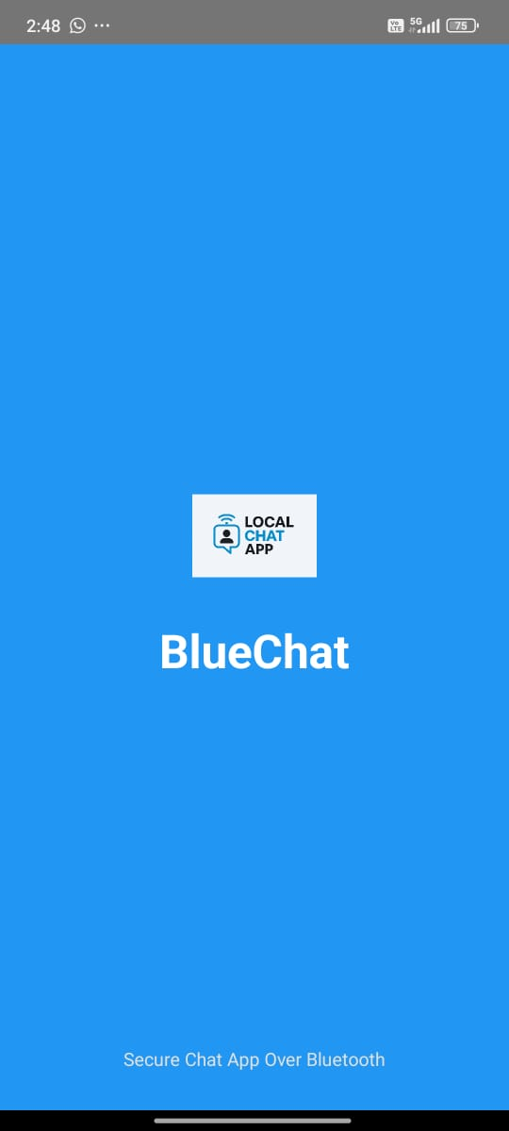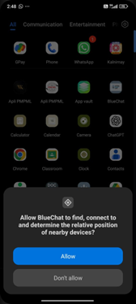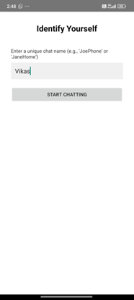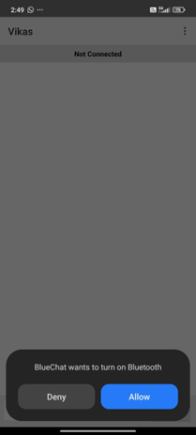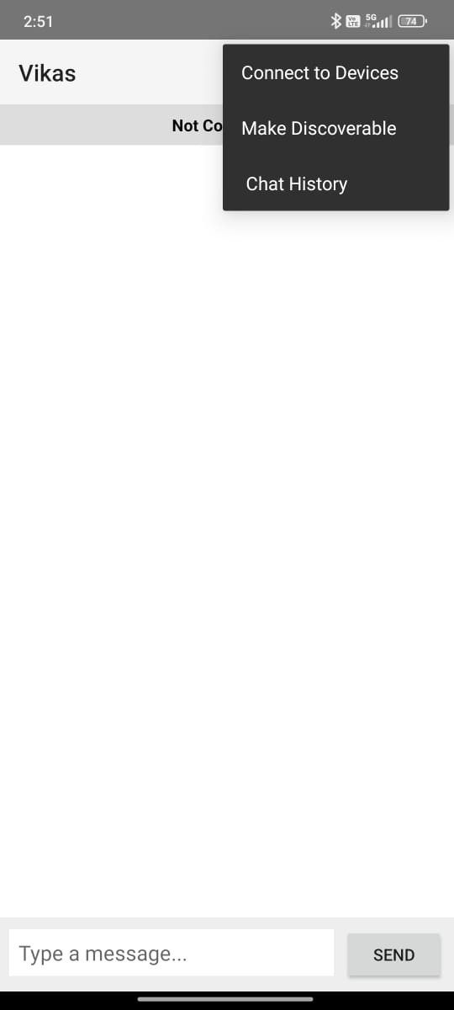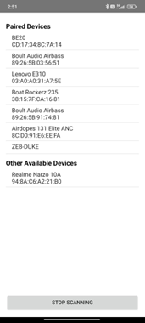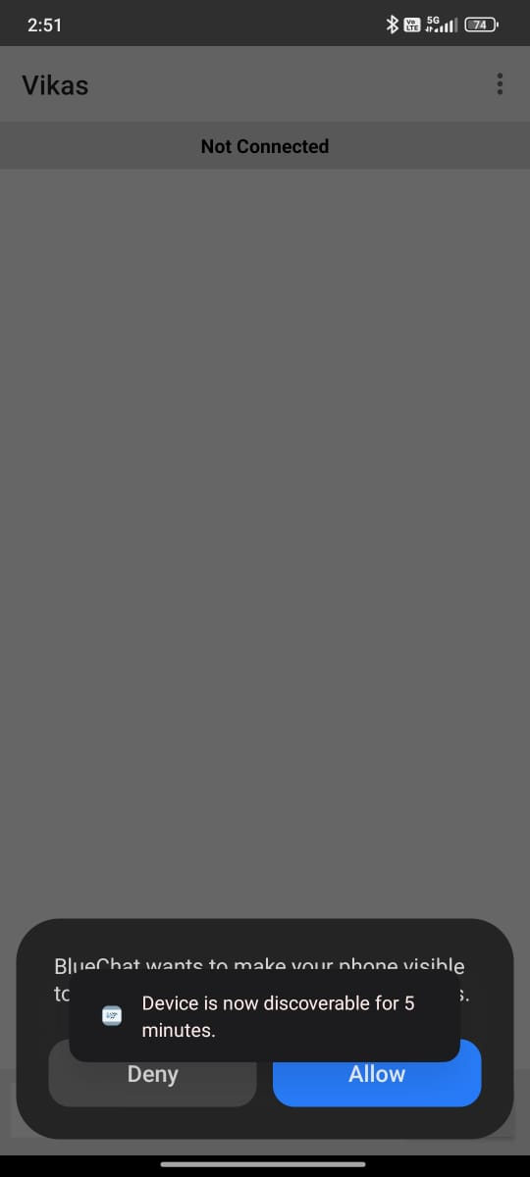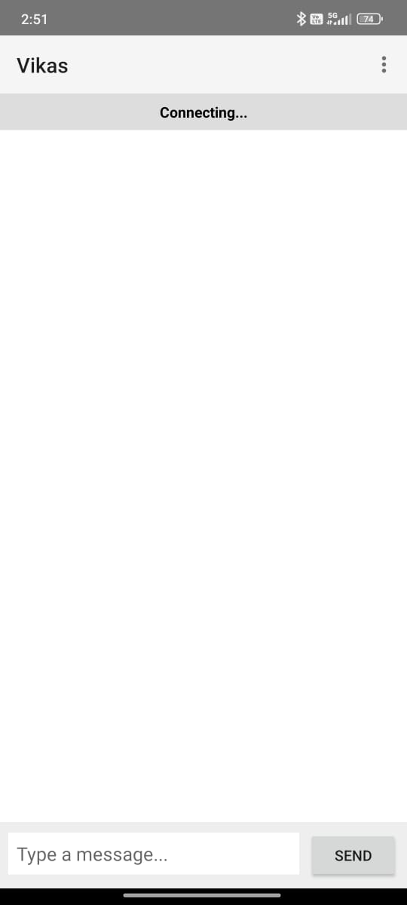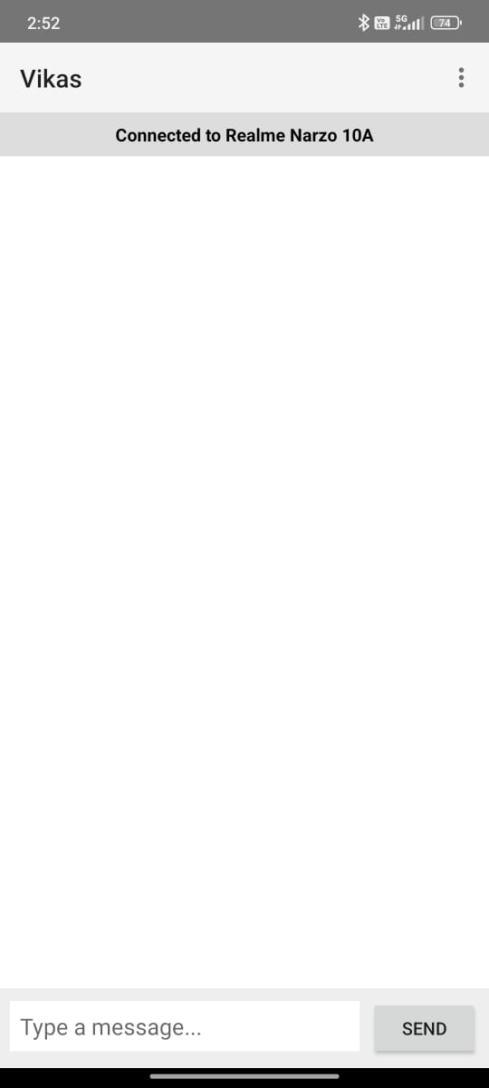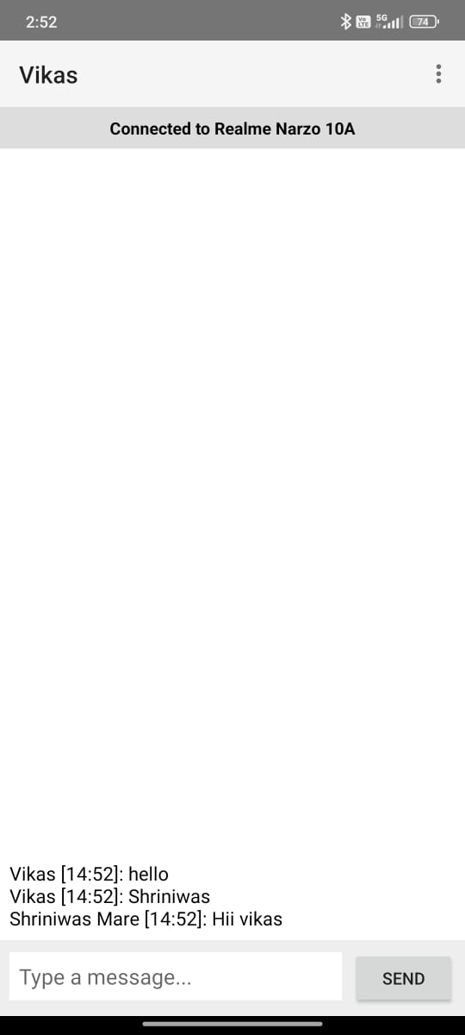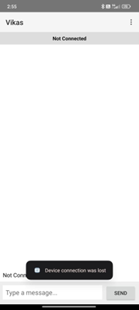

5. Advantages of BlueChat – Secure Chat App Over Bluetooth
- Works Without Internet:
BlueChat enables users to communicate even in areas without mobile data or Wi-Fi, making it ideal for remote or emergency situations.

- Enhanced Privacy and Security:
Messages are exchanged directly between devices using encryption, ensuring that no data passes through external servers.

- Low Power Consumption:
Bluetooth communication uses minimal battery compared to constant internet-based messaging apps.

- No Data Charges:
Since the app operates offline, users can chat and share files without incurring any mobile data costs.

- Easy to Use:
The app features a simple and intuitive interface that allows quick device pairing and effortless chatting.

- Reliable Short-Range Communication:
Provides stable, real-time communication within the Bluetooth range, making it suitable for small groups or nearby users.

6.Future Scope
- Internet-Based Expansion:
Future versions of BlueChat can include optional internet connectivity to extend communication beyond Bluetooth range while maintaining end-to-end encryption for privacy.
- Cloud Backup and Synchronization:
Integration with cloud platforms like Firebase or Google Drive could allow chat history and user preferences to be securely backed up and restored across multiple devices.
- Cross-Platform Compatibility:
Developing iOS and desktop versions of BlueChat would enable seamless communication between users on different platforms.
- Group Chat and Broadcast Features:
Upcoming updates can support group conversations and broadcast messaging, allowing multiple users to connect and communicate simultaneously.
- File Sharing Enhancements:
Future versions can expand support for multimedia sharing (images, audio, video) with improved compression for faster Bluetooth transfer.
- Stronger Encryption and Security Features:
Incorporating advanced encryption standards (AES, RSA) and secure key exchange mechanisms will enhance privacy and protect messages against unauthorized access.
- User Profile Customization:
Adding features such as profile pictures, status updates, and nicknames will make chatting more interactive and personalized.
- Offline Message Storage and Delivery:
A store-and-forward mechanism can be introduced to ensure that messages are delivered automatically once the recipient reconnects.
• UI/UX Improvements and Themes:
Offering customizable themes, fonts, and chat backgrounds will improve the app’s appearance and user engagement.

7.Course Level Outcomes Achieved:
CO1: Describe features of Android operating system.
CO2: Setup and configure the Android development environment.
CO3: Design user-friendly graphical interfaces.
CO4 : Build Android applications using standard UI components.
CO5: Develop Android applications with integrated database functionality. CO6: Deploy Android application

8.Skills Developed
- Android Development: Hands-on experience using Android Studio, Java, and XML.
- Database Management: Implemented SQLite for data storage and CRUD operations.
- UI/UX Design: Created responsive, user-friendly interfaces with Material Design.
- Debugging & Testing: Improved app performance and resolved functional issues.
- Problem-Solving: Applied logical thinking to implement app features efficiently.

9. References o Android Developer Documentation
https://developer.android.com/docs o Java Programming Documentation
https://docs.oracle.com/en/java/ o SQLite Documentation
https://www.sqlite.org/docs.htm

10.Conclusion

The development of BlueChat – Secure Chat App Over Bluetooth was a successful initiative aimed at creating a reliable and privacy-focused offline communication platform. It allows users to exchange messages and share files securely without relying on internet connectivity, making it highly useful in areas with limited or no network access.
This project strengthened my understanding of Bluetooth communication, Android development, secure data transmission, and UI design principles. Implementing real-time messaging and encryption mechanisms enhanced my technical and problem-solving skills.
Overall, BlueChat stands as a practical, user-friendly, and secure messaging solution that bridges the communication gap in offline environments. It demonstrates how technology can ensure private, efficient, and accessible communication anytime, anywhere.

