**Lab 1**

Setting Up a J2EE Development Environment and Building a Simple Servlet Application Using GitHub, Eclipse, Apache Tomcat, MySQL, and Podman

1. **Setting up the Development Environment:**

GitHub Desktop:

Eclipse:

TomCat Server:  
  
MySQL:

WSL and Podman:

Setting WSL version to WSL 2

Installed Ubuntu as preferred Linux distribution

Podman installation successful – Performing version check:

**2. Creating and Testing a Simple Servlet Application:**

**Project Setup:  
  
**

**Welcome Servlet:**

**

**3. Using GitHub for Version Control:**

**Created Repository:**

Link:[**https://github.com/samruddhi1499/SimpleServletApp.git**](https://github.com/samruddhi1499/SimpleServletApp.git)

**Pushed Code:**

**Branching:**

Changed the Welcome Message:

Output:

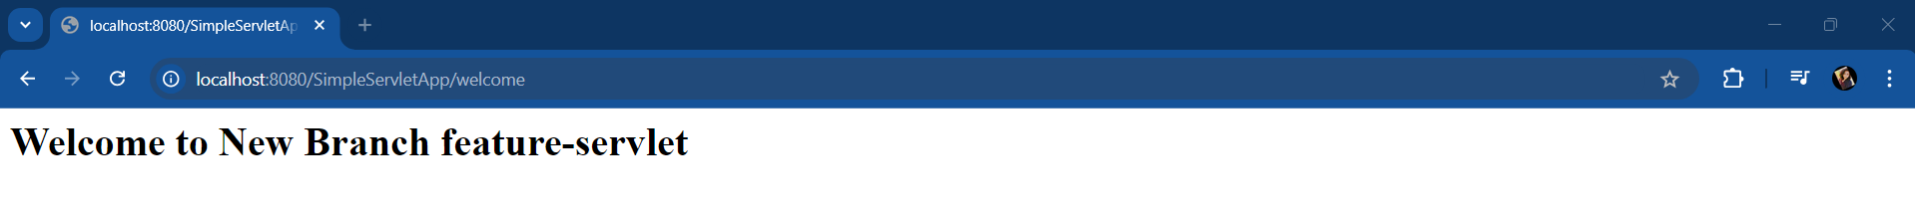

Pushing on new branch:

**4. Deploying the Servlet Application with Podman:**

Creating Image of TomCat Server and creating container while performing port forwarding:

Copying Servlet Project to container and checking logs:

Checking Pod Status

Testing using CURL command in WSL environment:

Testing in Browser:

Note: Welcome message was changed to perform GitHub branching.