**1. PROJECT DESIGN:**

NETWORK TOPOLOGY:

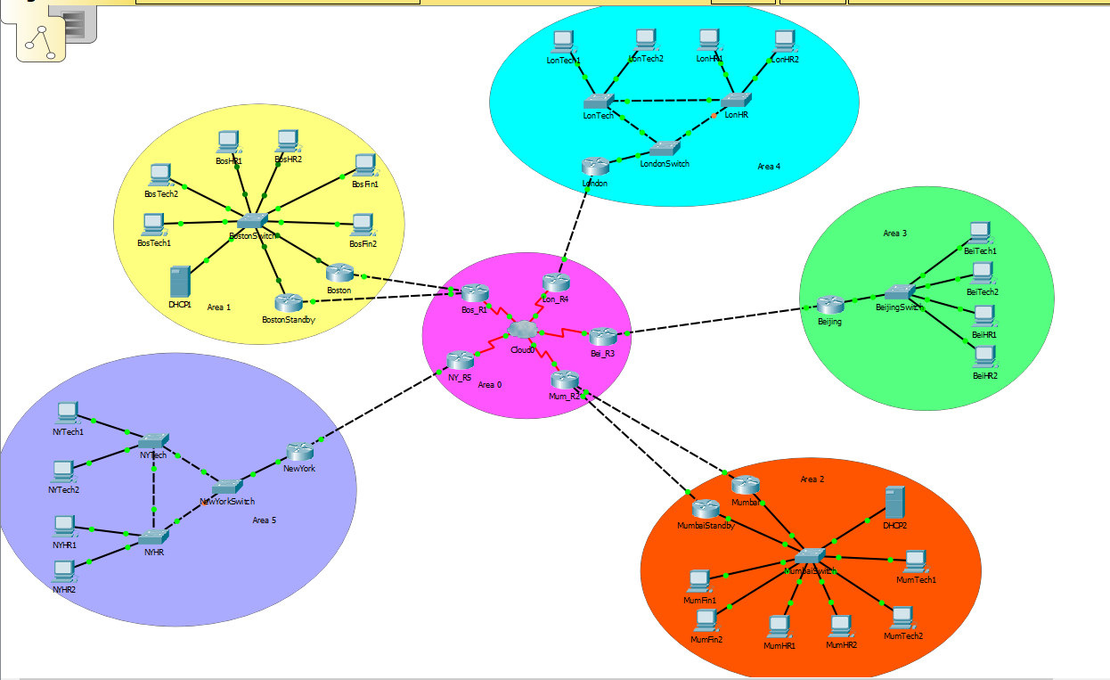

COST ESTIMATION:

|  |  |  |  |
| --- | --- | --- | --- |
| Device | Cost per unit | Count | Total |
| Router 2911 | 850 | 12 | 10200 |
| Switch WS-C2960-24TT | 250 | 9 | 2250 |
| DHCP Server | 2000 | 2 | 4000 |
| Cloud | 5000 | 1 | 5000 |
| TOTAL | | | 21450 |

**2. NETWORK OPTIMIZATION**:

* COST OPTIMIZATION OF NETWORK:

Taking the cost into account, the network has fewer numbers of switches and routers. For each department in a city, a VLAN (virtual LAN) is created which reduces the use of a switch and a router for each department. Moreover, we used Router 2911, which is cheaper and has both FastEthernet and Gigabit Ethernet ports.

* DETAILED NETWORK ARCHITECTURE:

Area 0:

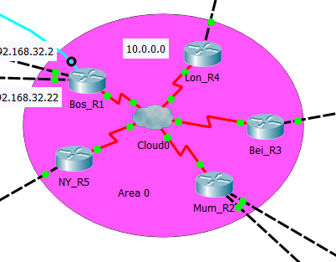

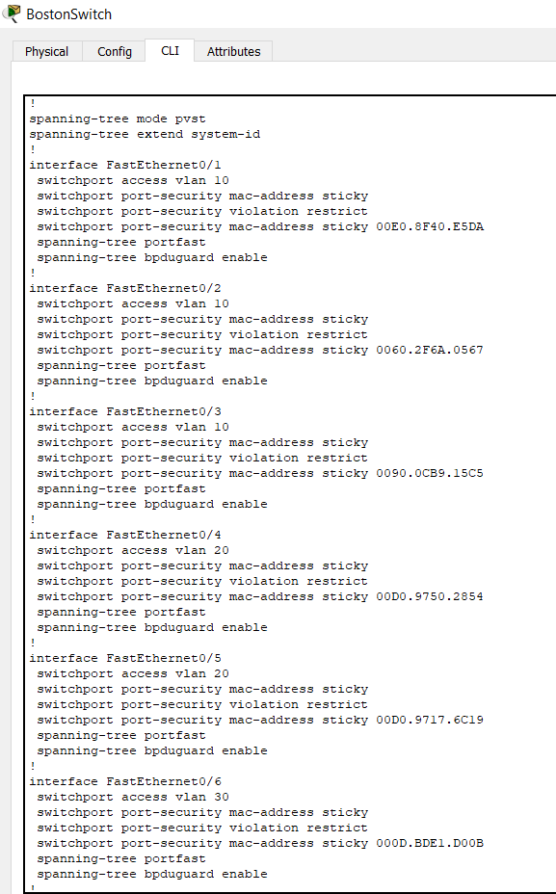BostonSwitch

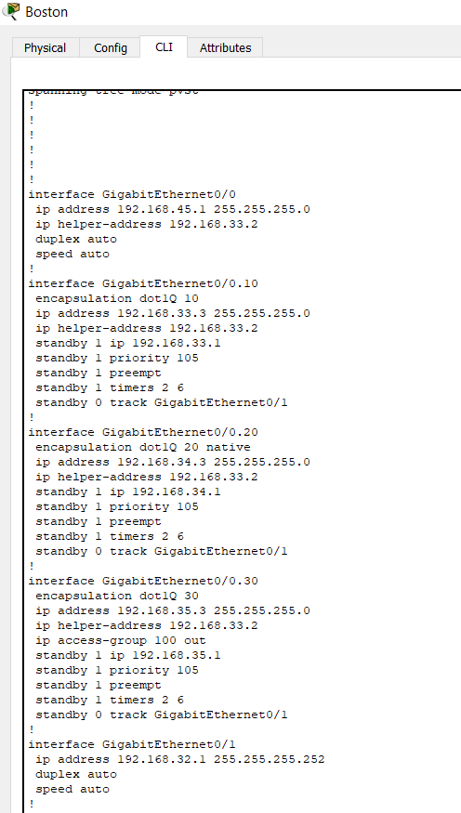Boston Router:

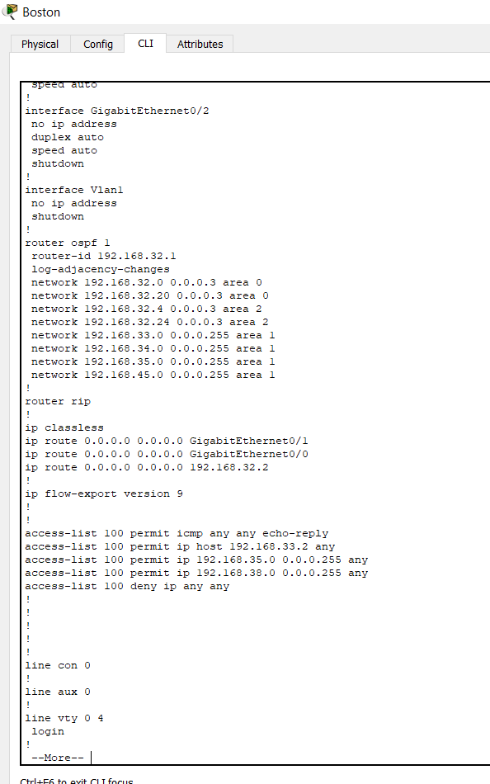

DHCP1:

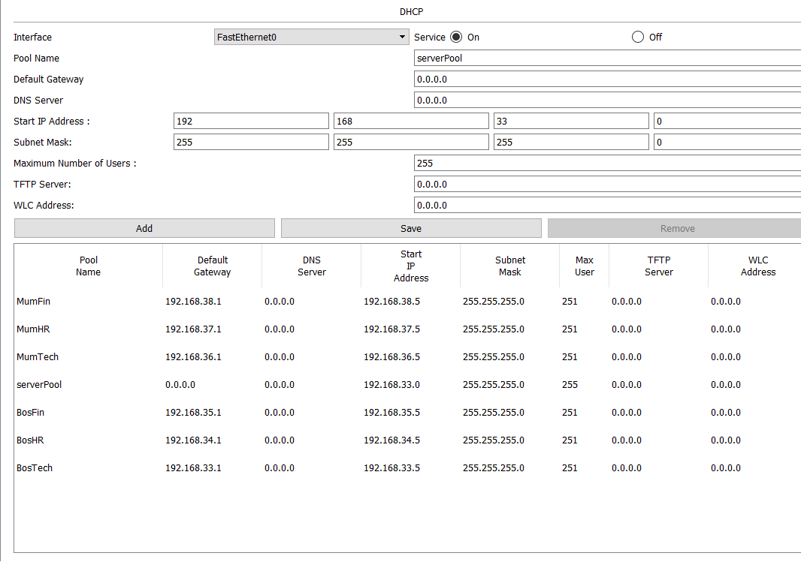

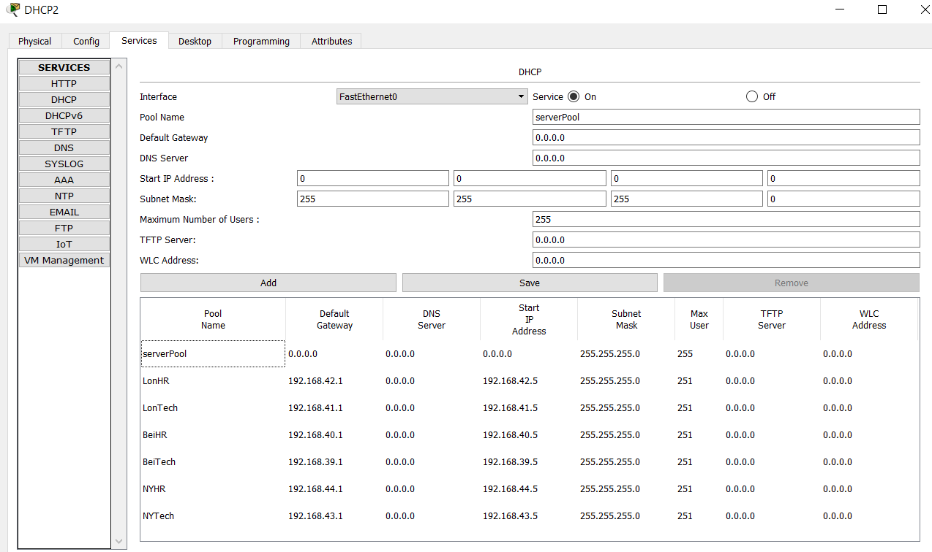DHCP2:

HSRP:

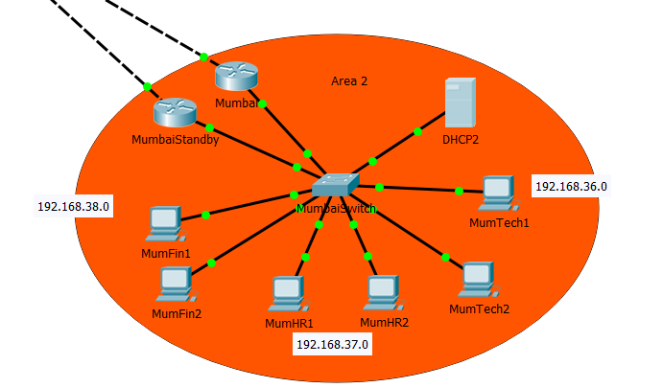

STP:

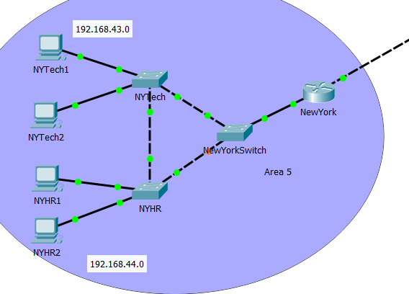

Multilayer Switch:

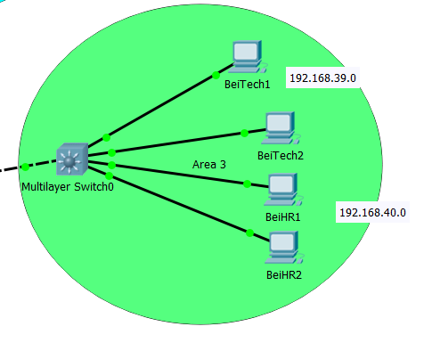

* Since, the router and switch are connected at interface G0/0 at the router, the vlans for the departments are created as subinterfaces of the interface GigabitEthernet 0/0.
* The respective interfaces at the switch are given access to the vlan 10, 20, 30. The interface going to the router is trunk.
* Command used:

Switch:

*en*

*conf t*

*int f 0/1*

*switchport mode access*

*switchport access vlan 10*

*no shut*

Router:

*en*

*conf t*

*int g 0/0.10*

*encapsulation dot1Q 10*

*ip address 192.168.33.3 255.255.255.0*

*ip helper-address 192.168.33.2 #IP address of DHCP 1*

*no shut*

* DHCP pools were created at the DHCP server for each department.
* Frame relay and OSPF was implemented for the routing.
* Commands used:

OSPF at Boston:

*en*

*conf t*

*router ospf 1*

*router-id 192.168.32.1*

*network 192.168.32.0 0.0.0.3 area 0*

*network 192.168.32.20 0.0.0.3 area 0*

*network 192.168.32.4 0.0.0.3 area 2*

*network 192.168.32.24 0.0.0.3 area 2*

*network 192.168.33.0 0.0.0.255 area 1*

*network 192.168.34.0 0.0.0.255 area 1*

*network 192.168.35.0 0.0.0.255 area 1*

*network 192.168.45.0 0.0.0.255 area 1*

OSPF at Bos_R1:

*en*

*conf t*

*router ospf 2*

*router-id 192.168.32.2*

*network 192.168.32.0 0.0.0.3 area 0*

*network 192.168.32.4 0.0.0.3 area 0*

*network 10.0.0.0 0.255.255.255 area 0*

*network 192.168.32.20 0.0.0.3 area 0*

*network 192.168.32.24 0.0.0.3 area 0*

Frame-Relay:

At the cloud dlci were created on the respective ports and frame-relay was configured. Router:

*en*

*conf t*

*int se 0/3/0*

*frame-relay map ip 10.0.0.2 102 broadcast*

*no shut*

* After, frame-relay and OSPF were implemented, DHCP servers were able to assign IP addresses to the PCs in all cities.
* HSRP was implemented at Boston and Mumbai.
* The default gateways of the departments were taken as the virtual gateways for implementing HSRP.
* A standby router was placed at both locations with similar configurations.
* Commands used:

Router:

*en*

*conf t*

*int g 0/0.10*

*standby 1 ip 192.168.33.1*

*standby 1 priority 105*

*standby 1 preempt*

*standby 1 timers 2 6*

*standby track g 0/1*

*no shut*

Standby Router:

*en*

*conf t*

*int g 0/0.10*

*standby 1 ip 192.168.33.1*

*no shut*

* The next implementation was Rapid STP in the London and New York offices.
* Three switches were implemented instead of one. The interfaces going to other switches and router were all trunk and the ones going to the PCs were all in access mode.
* Commands used:

*en*

*conf t*

*int range f 0/3-4*

*spanning-tree mode rapid-pvst*

*spanning-tree link-type point-to-point*

*no shut*

* MAC flooding was defended at the headquarters and native VLAN was changed to that of HR department for all the offices.
* The interfaces were implemented with portfast and BPDU that were connected to the host machines.
* An access list was implemented for Finance department at both locations, due to which no other department can access Finance department, but Finance is able to access all the departments.
* A console wire was connected from the BosTech1 to Boston router.
* The router and switch at Beijing office was replaced by a multilayer switch.
* The whole network is now running as per the requirements.
* 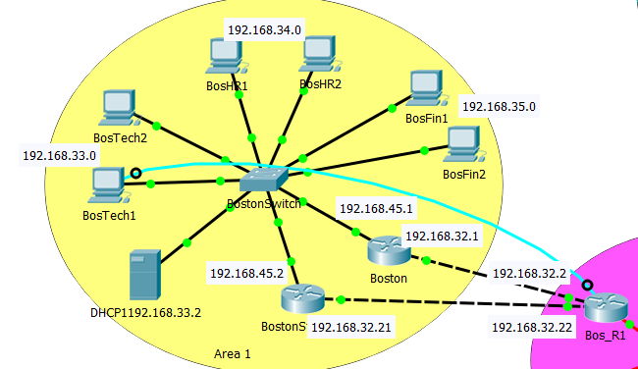BOSTON NETWORK ARCHITECTURE:
* MUMBAI NETWORK ARCHITECTURE:

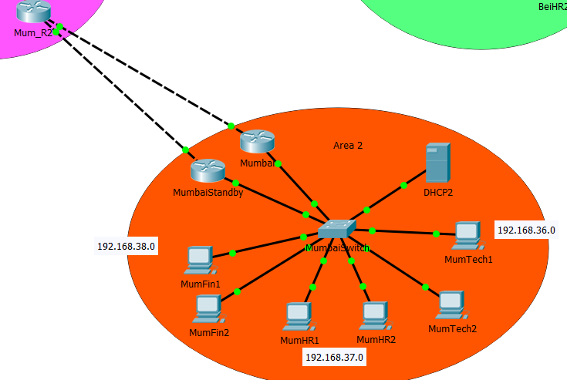

* ASSIGNMENT OF IP ADDRESS WITH 75% REDUNDANCY:

|  |  |  |  |  |
| --- | --- | --- | --- | --- |
| City | Department | Subnet | Gateway | VLAN |
| Boston | Technical | 192.168.33.0 | 192.168.33.1 | 10 |
| HR | 192.168.34.0 | 192.168.34.1 | 20 |
| Finance | 192.168.35.0 | 192.168.35.1 | 30 |
| Mumbai | Technical | 192.168.36.0 | 192.168.36.1 | 10 |
| HR | 192.168.37.0 | 192.168.37.1 | 20 |
| Finance | 192.168.38.0 | 192.168.38.1 | 30 |
| Beijing | Technical | 192.168.39.0 | 192.168.39.1 | 10 |
| HR | 192.168.40.0 | 192.168.40.1 | 20 |
| London | Technical | 192.168.41.0 | 192.168.41.1 | 30 |
| HR | 192.168.42.0 | 192.168.42.1 | 40 |
| New York | Technical | 192.168.43.0 | 192.168.43.1 | 10 |
| HR | 192.168.44.0 | 192.168.44.1 | 20 |

**3. TAKEAWAY QUESTIONS:**

1a.

* In large networks, RIP is better than OSPF. But, OSPF is better than RIP in many other aspects.
* OSPF is better as it uses bandwidth or metric to determine the shortest path and RIP uses number of hops.
* When using OSPF, the number of packets lost are less as compared to that in the RIP.
* OSPF uses Dijkstra algorithm whereas RIP uses Bellman-ford algorithm.

1b.

* We use area concept in OSPF for simple administration, resource utilization and traffic optimization. The routers are divided into groups, where they have the same topology tables.
* Moreover, if number of devices increase in a network, the router has to maintain the devices on its own link state routing table, dividing the network into areas can simplify the routing tables of the routers.

1c.

* In OSPF, we use star-topology network configuration, of which backbone is generally the center of the topology. Hence, area 0 was chosen for the backbone as all areas are connected to the backbone network.

1d.

Types of OSPF LSA:

* LSA Type 1: Router LSA
* LSA Type 2: Network LSA
* LSA Type 3: Summary LSA
* LSA Type 4: Summary ASBR LSA
* LSA Type 5: Autonomous System External LSA
* LSA Type 6: Multicast OSPF LSA
* LSA Type 7: Not-so-stubby area LSA
* LSA Type 8: External Attribute LSA for BGP

2.

The Spanning Tree Protocol searches for redundant paths to reach the destination and then selects the best path. In the beginning, all ports are in the forwarding or loading mode till STP finds the best path. Once it identifies the best path, the ports are kept in forwarding mode. The redundant links are moved to the blocking mode. This process helps STP to avoid looping.

3.

STP: This is the original version of Spanning Tree Protocol

PVSTP: This is a Cisco Proprietary protocol. In this protocol, each vlan can run its own spanning trees in a network.

MSTP: In this protocol, STP is applied to each VLAN separately in a network.

4.

Security Plan:

The first goal is to prevent MAC flooding at the headquarters. When defending MAC flooding, the unauthorized systems are not allowed to connect to the VLAN network.

The second goal is to secure Finance Department from other departments. Hence, we make sure that no other department can access the Finance department but Finance department is allowed to access all the departments.

Redundancy Plan:

Firstly, we have used HSRP in the headquarters to maintain the redundancy of the routers. If one of the routers go down due to some reason, the standby router will become active and take the responsibilities.

Secondly, the spanning tree protocol is used in the London and New York offices where we use three switches. When one of the link within the switches goes down, the route is changes to the next best path.

**4. TEST CASES:**

Test VLAN:

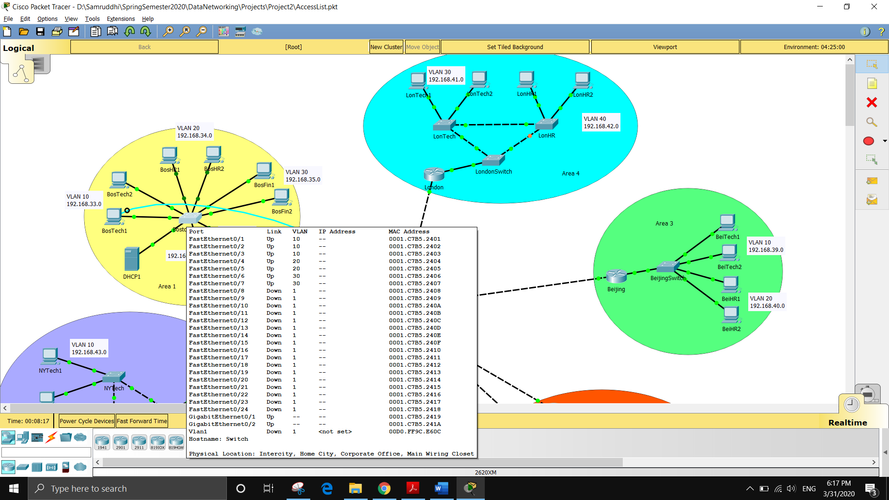There are 3 vlans in the Boston area viz 10, 20, 30 for Technical, HR and Finance departments respectively.

Test IP Routing:

To test the routing, we check to see if the Boston router can ping the Mumbai router. We can see in the image below that the ping was successful.

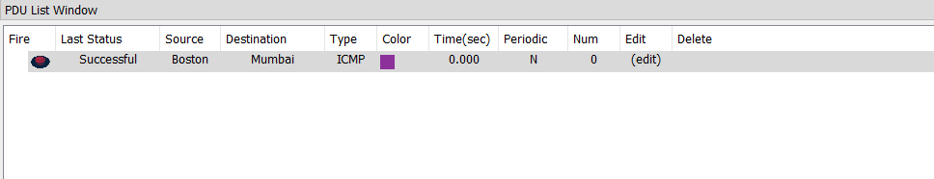

Test Security Plan:

To check the security plan, we check if the Finance department is secure from the other departments.

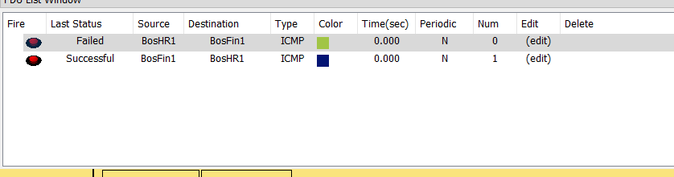

Test Redundancy Plan:

To test the redundancy, we check if the switch takes a different path after the link is closed. In the first instance, we can see that the STP has selected the best path. But in the second instance, when the link is down, the STP selects the next best path.

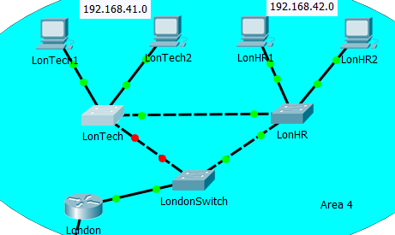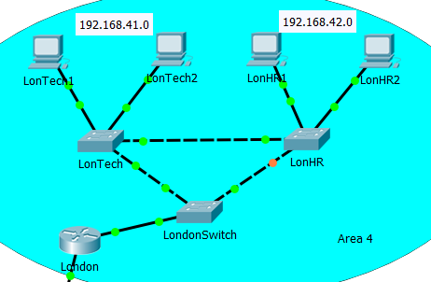

Test Multilayer Switch:

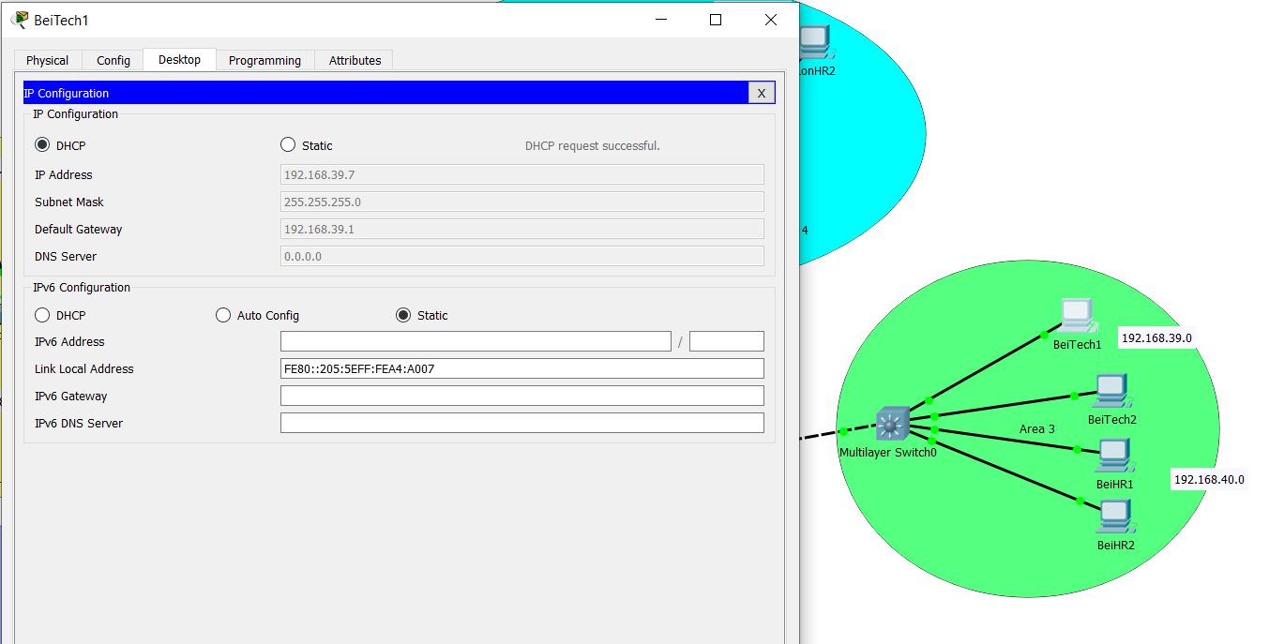For testing the multilayer switch, we check if the PC from the department is able to get an IP address using DHCP.

**5. CONCEPTS LEARNED DURING THIS PROJECT:**

Throughout the project, I learn many new protocols like OSPF, Frame Relay, HSRP along with the actual working of protocols such as DHCP, STP and so on. I was able to learn different functions of the Cisco Packet Tracer and troubleshoot a lot of the common problems while implementing a network configuration.

**6. CONCLUSION:**

A functional inter-networking network with multiple locations is created successfully. A successful simulation for a small organization is carried out using Cisco Packet Tracer.