DSA Mini Project

Group members: Mrudula Kalyankar( COA252 )

Bhagyashree Jagdale( COA249 )

Samruddhi Kharade( COA259 )

Code:

import random

class SnakeLadders:

def __init__(self):

self.snakes = {

16: 6, 47: 26, 49: 11, 56: 53,

62: 19, 64: 60, 87: 24, 93: 73,

95: 75, 98: 78

}

self.ladders = {

3: 22, 8: 30, 28: 84, 58: 77,

75: 86, 80: 99, 90: 91

}

self.player_positions = [1, 1] # Both players start at position 1

self.current_player = 0 # Player 1 starts

def roll_dice(self):

return random.randint(1, 6)

def move_player(self, player):

roll = self.roll_dice()

print(f"\n🎲 Player {player + 1} rolled a {roll}")

current_position = self.player_positions[player]

new_position = current_position + roll

if new_position > 100:

print(f"❌ Roll exceeded 100. Player {player + 1} stays at {current_position}")

return

if new_position in self.snakes:

print(f"🐍 Oh no! Landed on a snake at {new_position}. Going down to {self.snakes[new_position]}")

new_position = self.snakes[new_position]

elif new_position in self.ladders:

print(f"🪜 Yay! Found a ladder at {new_position}. Climbing up to {self.ladders[new_position]}")

new_position = self.ladders[new_position]

self.player_positions[player] = new_position

print(f"📍 Player {player + 1} is now at position {new_position}")

def play_game(self):

print("🎮 Welcome to Snake and Ladders!")

print("First to reach exactly 100 wins the game.\n")

while True:

input(f"Player {self.current_player + 1}, press Enter to roll the dice...")

self.move_player(self.current_player)

if self.player_positions[self.current_player] == 100:

print(f"\n🏆🎉 Player {self.current_player + 1} wins the game! 🎉🏆")

break

self.current_player = 1 - self.current_player # Switch player

# Start the game

if __name__ == "__main__":

game = SnakeLadders()

game.play_game()

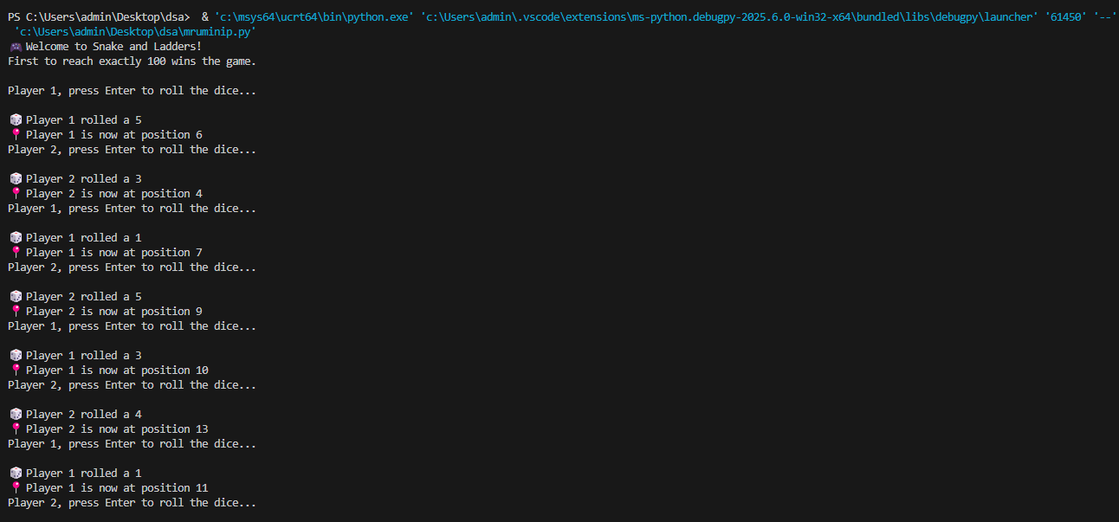Output:

