Sant Dnyaneshwar Shikshan Sanstha's
Annasaheb Dange College of Engineering & Technology, Ashta
(NAAC A++) (An Autonomous Institute)
Department of Artificial Intelligence & Data Science

ACTIVITY REPORT
E-Governance Service Dashboard

Student Name | ____________________
Roll Number | ____________________
Class | ____________________
Branch | Artificial Intelligence & Data Science
College | Annasaheb Dange College of Engineering & Technology, Ashta
Subject | Data Warehousing & Business Intelligence
Subject Code | 1ADPE404
Activity | ISE-I Activity 2 – Dashboard Development
Academic Year | 2026-27
Topic | E-Governance Service Dashboard

Faculty: Prof. Prajakta S. Dabade

2. Aim
To design and develop an interactive Business Intelligence dashboard for E-Governance services that analyses citizen applications and shows useful insights using KPIs, charts and filters.

3. Objectives
- To understand the role of Business Intelligence dashboards in decision-making.
- To study the E-Governance dataset and identify important attributes and KPIs.
- To clean the data by handling missing values, duplicate records and inconsistent values.
- To create charts (bar, doughnut and line) that show service demand and performance.
- To add interactive filters so that the user can explore the data easily.
- To find meaningful results and findings from the data.

4. Introduction
E-Governance means using computers and the internet to provide government services to citizens. Instead of visiting government offices again and again, a citizen can apply for certificates, pay taxes or apply for scholarships online or through a Common Service Centre (CSC). Every application creates data such as the service type, district, date, status and processing time.
Business Intelligence (BI) is the process of converting this raw data into useful information. A dashboard is a single screen that shows the most important numbers (KPIs) and charts, so that officers can understand the situation quickly. In this activity a dashboard is created using HTML, CSS, JavaScript and Chart.js, along with an Excel workbook.

5. Problem Statement
Government departments receive a large number of applications every month for many services. If this data is only stored in tables, it is difficult to see which service has more demand, which district needs more staff, how long applications take and whether citizens are satisfied. A simple dashboard is needed to analyse this data quickly.

6. Need for E-Governance Dashboard
- To know the total number of applications and their status (approved, rejected, pending) at one glance.
- To find the services and districts with the highest demand so that resources can be planned.
- To find services that take more time, so that delays can be reduced.
- To measure citizen satisfaction and improve service quality.
- To compare online, CSC and office channels and promote digital services.
- To help officers take decisions based on data instead of guesswork.

7. Dataset Description
A sample E-Governance dataset was created for this activity. It represents citizen applications for 8 government services in 5 districts of Maharashtra (Sangli, Kolhapur, Satara, Pune and Solapur) from January 2026 to August 2026. The names of citizens are fictional. Two files are used:
File | Records | Purpose
raw_e_governance_data.csv | 94 | Original data with some data-quality problems
cleaned_e_governance_data.csv | 90 | Data after cleaning, used in the dashboard

8. Attribute Description
Attribute | Meaning | Example
Application_ID | Unique number of the application | EG2026-001
Citizen_Name | Name of the applicant | Amit Patil
District | District of the applicant | Sangli
Service_Type | Government service applied for (8 types) | Income Certificate
Application_Channel | How the application was submitted (Online / CSC Center / Government Office) | Online
Application_Date | Date of application | 2026-03-14
Status | Current status: Approved, Rejected or Pending | Approved
Processing_Days | Number of days taken to process the application | 6
Service_Fee | Fee paid in rupees | 30
Satisfaction_Rating | Citizen rating from 1 (poor) to 5 (excellent) | 4

9. Data Understanding
The cleaned dataset has 90 records and 10 attributes. District, Service_Type, Application_Channel and Status are categorical (text) attributes. Application_Date is a date attribute. Processing_Days, Service_Fee and Satisfaction_Rating are numeric attributes. Application_ID is a unique key for each record. For pending applications, Processing_Days shows the days passed since the application was submitted.

10. Business Questions
- Which district receives the most applications?
- Which service receives the most applications?
- Which service has the highest approval rate?
- How many applications are approved, rejected and pending?
- What is the average processing time?
- Which service takes the most time to process?
- Which service has the highest citizen satisfaction?
- How do applications change month by month?

11. KPI Identification
KPI | How it is calculated
Total Applications | Count of all records
Approved Applications | Count of records with Status = Approved
Rejected Applications | Count of records with Status = Rejected
Pending Applications | Count of records with Status = Pending
Approval Rate | Approved / Total × 100
Average Processing Days | Average of Processing_Days
Average Satisfaction Rating | Average of Satisfaction_Rating

All KPI values in the dashboard are calculated from the filtered data. They are not typed manually.

12. Data Preparation
The raw dataset was intentionally created with some small problems to demonstrate data cleaning. The steps followed were:
- Study the raw data and count missing values.
- Find and remove duplicate records.
- Correct inconsistent district names.
- Fill the missing values using median or mode.
- Check that the cleaned file has no missing values and save it as cleaned_e_governance_data.csv.

13. Missing Value Handling
Column | Missing Values Found | Method Used | Value Filled
Service_Type | 2 | Mode (most frequent value) | Property Tax
Processing_Days | 3 | Median | 6
Satisfaction_Rating | 3 | Median | 4

Median was used for numbers because it is not affected by very large or very small values. Mode was used for the text column because the missing value is a category.

14. Duplicate Removal
4 duplicate records were found (same Application_ID with all other values also the same): EG2026-006, EG2026-029, EG2026-047, EG2026-072. Only the first copy of each was kept. A duplicate application would be counted twice and give wrong KPI values, so it must be removed. Inconsistent district values were also corrected: kolhapur → Kolhapur, SANGLI → Sangli, 'Pune ' (extra space) → Pune, Sholapur → Solapur.

15. Data Cleaning Summary
Item | Count
Original Records | 94
Duplicate Records Removed | 4
Missing Values Found | 8
Missing Values Handled | 8
Inconsistent District Values Corrected | 4
Records After Cleaning | 90

16. Dashboard Design
The dashboard is a single web page (dashboard/index.html) with a simple light layout. From top to bottom it contains: (1) title and short description, (2) seven KPI cards, (3) filters with Reset Filters and Choose CSV buttons, (4) seven charts and (5) a table of the filtered records. Simple colours are used: blue for general data, green for approved, red for rejected and amber for pending. The page is responsive and works on laptop and mobile screens.
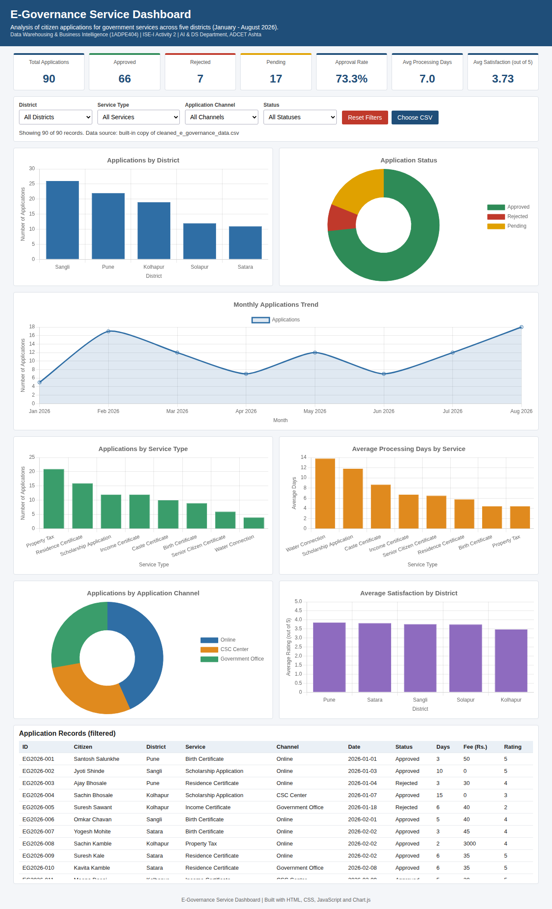
Figure: Dashboard preview

17. Visualizations Used
Chart | Type | Why this chart
Applications by District | Bar | Compares districts easily
Application Status | Doughnut | Shows share of Approved / Rejected / Pending
Monthly Applications Trend | Line | Shows change over time
Applications by Service Type | Bar | Compares demand of services
Average Processing Days by Service | Bar | Compares time taken by services
Applications by Application Channel | Doughnut | Shows share of each channel
Average Satisfaction by District | Bar | Compares ratings of districts

18. Interactive Filters
Four filters are provided: District, Service Type, Application Channel and Status. They can be used together. When any filter is changed, the KPI cards, all seven charts and the records table are recalculated from the selected data. For example, selecting District = Sangli shows only the Sangli applications everywhere. The Reset Filters button sets all filters back to 'All'. The Choose CSV button allows a different CSV file with the same columns to be loaded.

19. Results
The values below were calculated from the cleaned dataset (all filters set to All):
KPI | Value
Total Applications | 90
Approved Applications | 66 (73.3%)
Rejected Applications | 7 (7.8%)
Pending Applications | 17 (18.9%)
Approval Rate | 73.3%
Average Processing Days | 7.0
Average Satisfaction Rating | 3.73 / 5

District | Applications | Avg Satisfaction
Sangli | 26 | 3.77
Pune | 22 | 3.86
Kolhapur | 19 | 3.47
Solapur | 12 | 3.75
Satara | 11 | 3.82

Service | Applications | Approval Rate % | Avg Days | Avg Rating
Property Tax | 21 | 66.7 | 4.4 | 3.62
Residence Certificate | 16 | 81.2 | 5.8 | 4.06
Scholarship Application | 12 | 75.0 | 11.8 | 3.58
Income Certificate | 12 | 91.7 | 6.7 | 3.75
Caste Certificate | 10 | 40.0 | 8.7 | 3.6
Birth Certificate | 9 | 100.0 | 4.4 | 4.11
Senior Citizen Certificate | 6 | 33.3 | 6.5 | 3.0
Water Connection | 4 | 100.0 | 13.8 | 4.0

Month (2026) | Applications
January | 5
February | 17
March | 12
April | 7
May | 12
June | 7
July | 12
August | 18

20. Key Findings
- A total of 90 applications were analysed after cleaning. Out of these, 66 (73.3%) were approved, 7 (7.8%) were rejected and 17 (18.9%) are still pending.
- Sangli received the highest number of applications (26, 28.9% of all), followed by Pune (22). Satara received the fewest (11).
- Property Tax was the most demanded service with 21 applications. Water Connection was the least demanded with 4 applications.
- The overall approval rate is 73.3%. Birth Certificate and Water Connection had a 100% approval rate, while Senior Citizen Certificate (33.3%) and Caste Certificate (40.0%) had the lowest approval rates.
- The average processing time is 7.0 days. Water Connection took the longest (13.8 days on average), followed by Scholarship Application (11.8 days). Birth Certificate and Property Tax were the fastest (4.4 days).
- Online was the most common channel with 39 applications (43.3%), followed by CSC Center (26) and Government Office (25).
- The average citizen satisfaction rating is 3.73 out of 5. Pune had the highest district average (3.86) and Kolhapur the lowest (3.47).
- By service, Birth Certificate had the highest satisfaction (4.11) and Senior Citizen Certificate the lowest (3.0).
- Monthly applications were highest in August (18) and lowest in January (5). February also showed a high count (17).
- The total service fee collected from these applications is Rs. 37,345.
Note: the dataset is small (90 records), so the percentages for individual services are based on few applications and are only for learning purposes.

21. Conclusion
The E-Governance Service Dashboard was successfully developed. The raw data of 94 records was cleaned to 90 records by removing duplicates, correcting district names and filling missing values. The dashboard shows 7 KPIs, 7 charts and 4 interactive filters. It shows that Sangli had the highest demand, Property Tax was the most applied service, 73.3% of applications were approved and the average processing time was 7.0 days. Such a dashboard helps government officers to monitor services, reduce delays and improve citizen satisfaction.

22. Future Scope
- Use a real dataset from a government portal instead of sample data.
- Add more filters such as month range, taluka or department.
- Add more services and more districts.
- Show a map of districts.
- Connect the dashboard to a live database for automatic updates.
- Add the option to download the filtered data and charts.
- Build the same dashboard in Power BI or Tableau.

23. Viva Questions
Viva questions with simple answers are given in the separate file Viva_Questions_and_Answers.md. Some important questions are:
- What is a KPI?
- What is the difference between raw data and cleaned data?
- Why are missing values handled?
- Why are duplicate records removed?
- Why was a line chart used for the monthly trend?
- How do the filters work?
- What are the main findings?

