COVER PAGE
Student Name: Samruddhi Karpe
Student ID: 24050214
7322 Unlocking the Power of Big Data
Major: Master’s in Business Analytics and Data Science
Prof. Hachem Sfar

Table of Contents
Problem Statement 4
Physical Diagram 5
Database Schema 6
Data Loading 8
Views Creation 9
Analytic Query Results & Analysis 13
CRUD Operations 18
Conclusion 22

Problem Statement
E-commerce Order Management System
- Questions I wanted to answer:
I wanted to find out which products made the most money and how different cities contribute to overall revenue. For instance, are consumers in Munich buying more than Nuremberg.
- Reason to chose this:
To understand sales patterns – products popularity, customer geographic traction, and buying preferences.

Physical Diagram
- Screenshot of DrawDB diagram with 4 tables

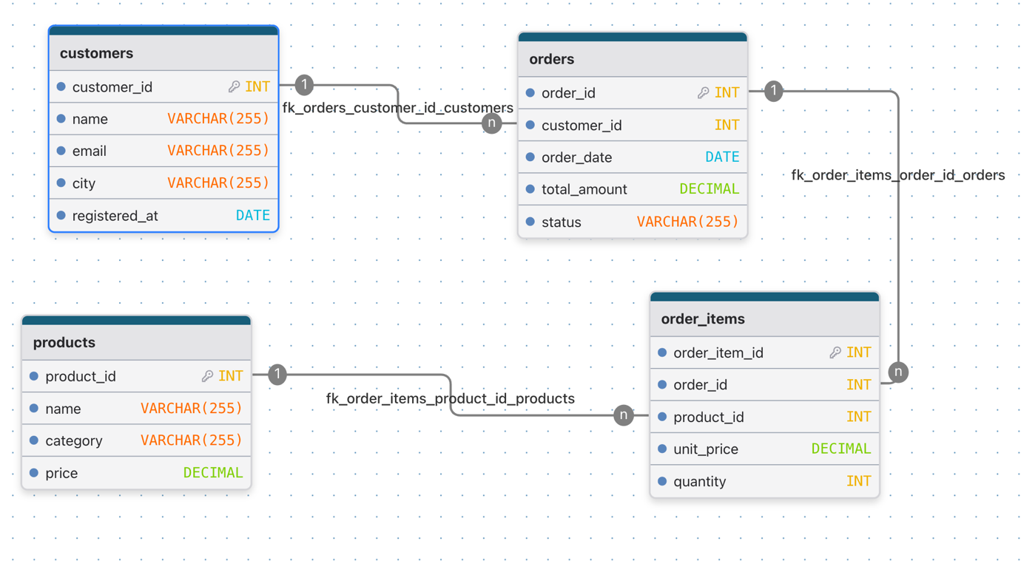

Database Schema
CREATE TABLE customers (
customer_id INT PRIMARY KEY,
name VARCHAR(255) NOT NULL,
email VARCHAR(255) NOT NULL,
city VARCHAR(255),
registered_at DATE
);

CREATE TABLE products (
product_id INT PRIMARY KEY,
name VARCHAR(255) NOT NULL,
category VARCHAR(255) NOT NULL,
price DECIMAL(10, 2) NOT NULL
);

CREATE TABLE orders (
order_id INT PRIMARY KEY,
customer_id INT NOT NULL,
order_date DATE NOT NULL,
total_amount DECIMAL(10, 2) NOT NULL,
status VARCHAR(255) NOT NULL,
FOREIGN KEY (customer_id) REFERENCES customers(customer_id)
);

CREATE TABLE order_items (
order_item_id INT PRIMARY KEY,
order_id INT NOT NULL,
product_id INT NOT NULL,
unit_price DECIMAL(10, 2) NOT NULL,
quantity INT NOT NULL,
FOREIGN KEY (order_id) REFERENCES orders(order_id),
FOREIGN KEY (product_id) REFERENCES products(product_id)
);

Data Loading
I ran into problems while I was trying to load CSV files in pgAdmin. I was trying the COPY command directly but kept getting file not found errors on Mac. The path '/Users/samruddhisubhashkarpe/Downloads/' was not working with the server-side COPY command. After some researching, I realized pgAdmin has a built-in Import/Export option. That made the process simplier to browse for files and not deal with paths.

Here's what I loaded:
✓ customers.csv → 3 rows
✓ products.csv → 4 rows
✓ orders.csv → 4 rows
✓ order_items.csv → 5 rows

Total: 16 records

- All the foreign key constraints worked correctly during import - no errors thrown.
- Each table properly linked to the others through the primary and foreign keys
- I defined in the schema.

Views Creation
VIEW 1: vw_customer_orders_detail
- Purpose: I wanted to view all the information at one place without the need to use the same JOIN query. The view helps me bring together consumer, product, their order and items together.
- The view shows; consumer name, city, id, order id, and date, product name and its category, cost paid and for what quantity. In addition, it also shows calculated line total.
- Reason to build this: In place of using 4 tables every time I want order details, I will just use select from the view as can be seen in second picture below. Additionally, the line total calculation is automatically done for me, removing the need to recalculate it.
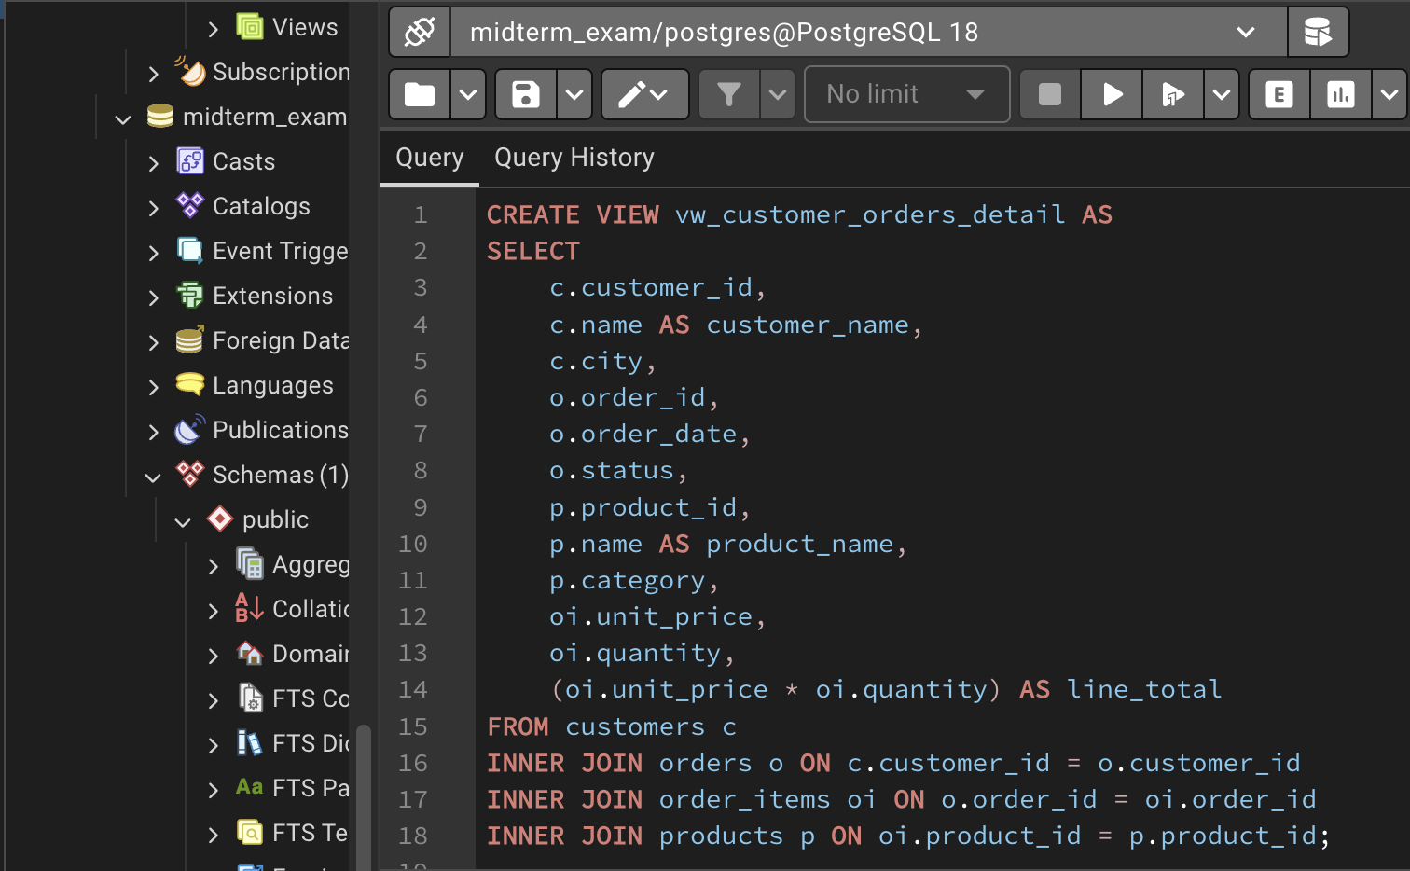
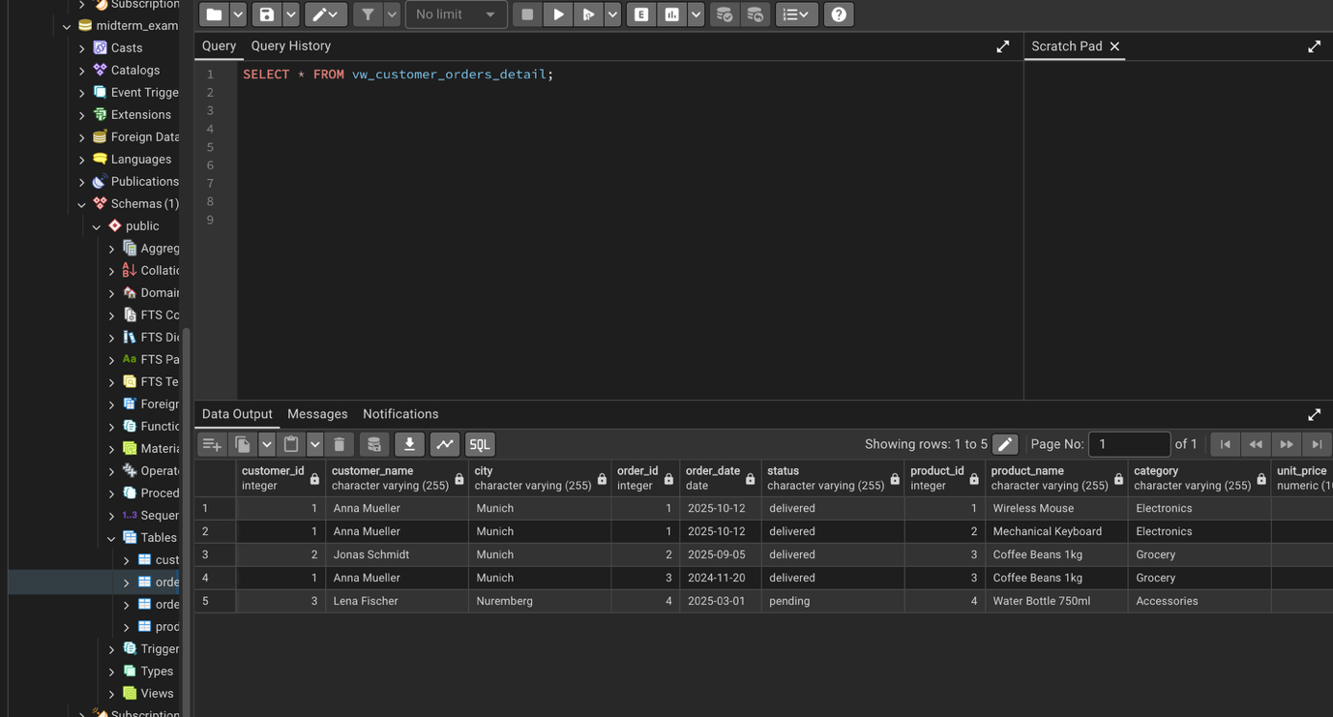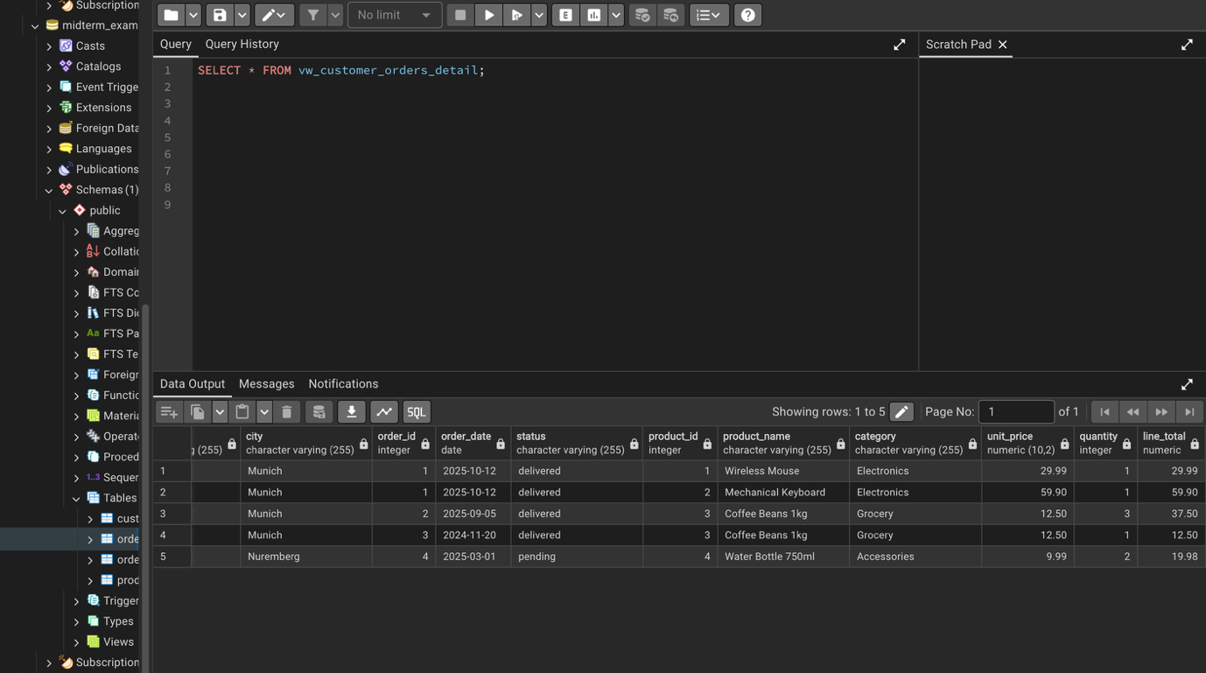

VIEW 2: vw_revenue_by_product
Purpose: I wanted to summarize product performance. In place of looking at individual order items, I brought together by product to see overall trends.
What the view calculates:
- How many units of each product sold
- Total revenue each product generated
- Breaks down by product category
- Shows product price
Why this matters: I can quickly see which products are actually making money and which one are losing sales. Sometimes they’re different, coffee beans had 4 sales but mechanical keyboard made more money.
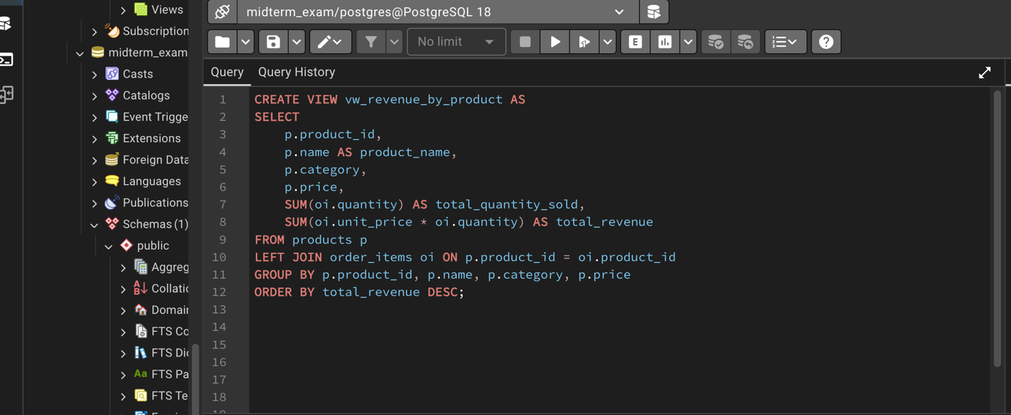
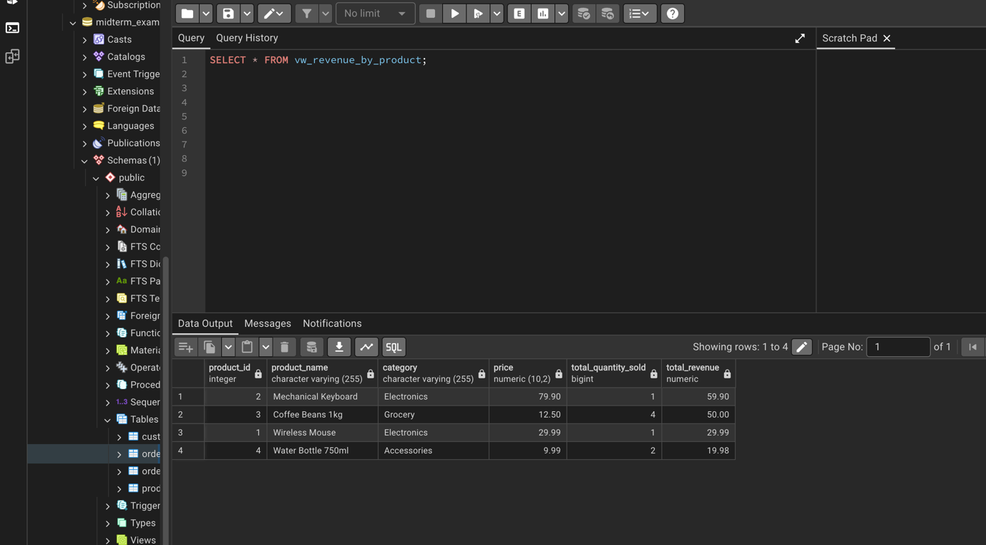

Analytic Query Results & Analysis
Query 1: Who are the best customers?
- Business Question: Which consumer needs more focus? What is the buying preference?
- My approach: I added up all spending per customer, counted their orders, and identified average order amount. After which it was sorted by total spending.
- Key Finding:
  - Anna Mueller is the top consumer spending $102.39 placing 2 orders.
  - Jonas Schmidt spent $37.50 for 1 order
  - Lena Fischer spent $19.98 for 1 order
  - The top customers come from Munich, which indicates our top priority can be Munich as compared to Nuremberg.

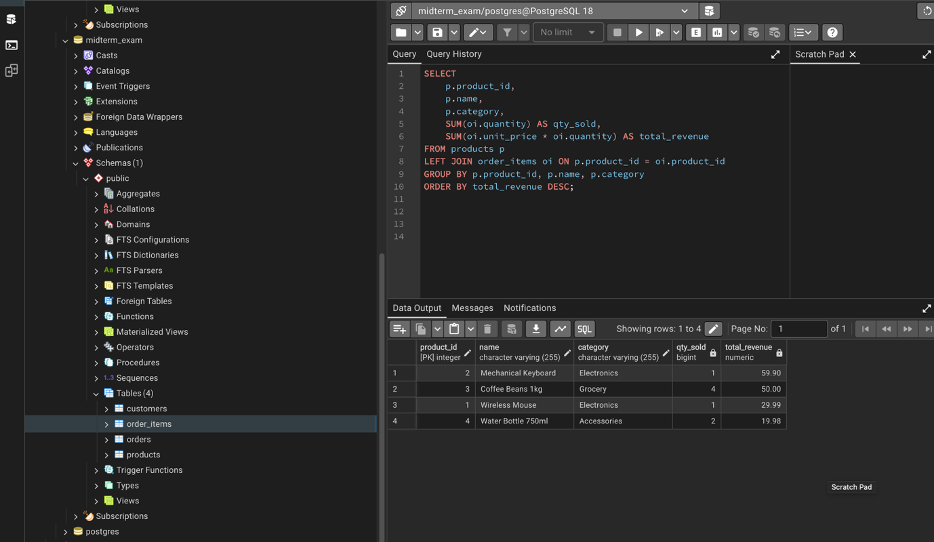

Query 2: Which products make the most money?
- Business Question: Are some products better at making more money?
- My approach: I grouped all orders by product and calculated total units sold and total revenue for each one.
- Key Finding:
  - Mechanical keyboard made most of the money but were sold only one piece. It capped at $59.90.
  - Coffee beans made $50.00 but were sold in 4 units.
  - This insight shows us that mechanical keyboard is expensive and profitable, but coffee beans has volume among consumers.
  - Wireless mouse and water bottle garnered $29.99 and $19.98 respectively.
  - The pricey electronics make more money per unit but coffee beans is selling in more quantity.
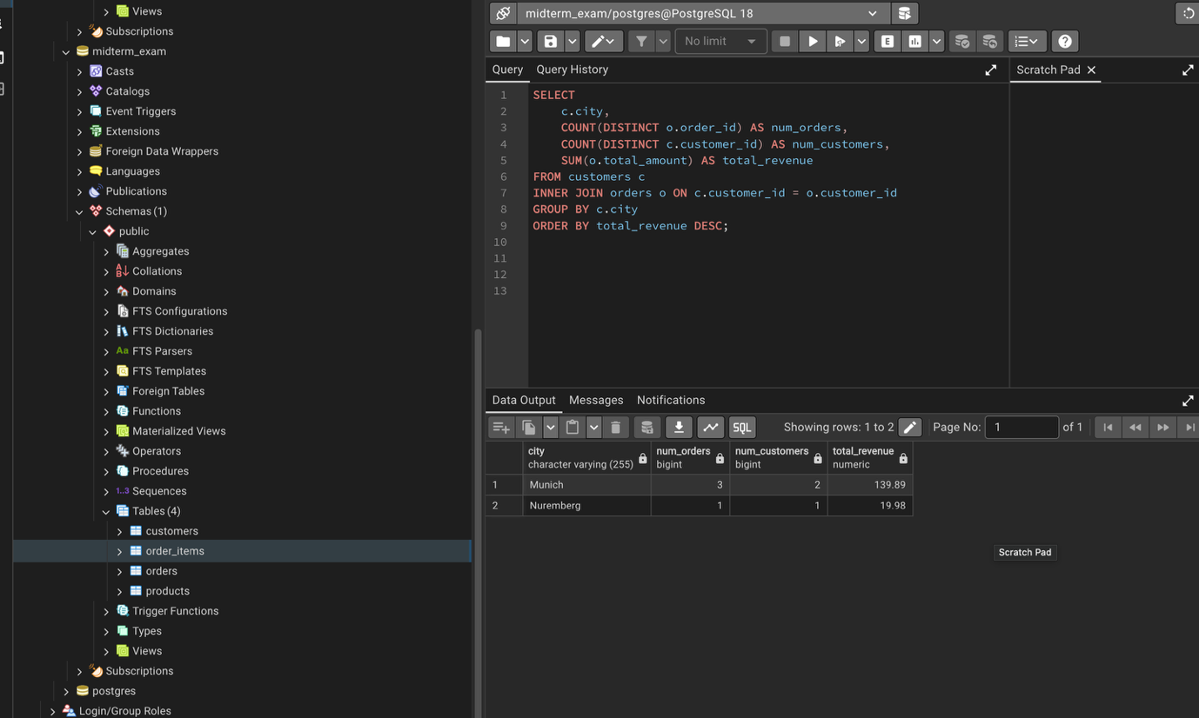

Query 3: Where are our customers?
- Business Question: Are we making money from all geographic sections or just one place?
- My approach: I grouped all orders by city and calculated how much money came from each location.
- Key Finding:
    - Munich garnered $139.89 from 3 orders and 2 customers. This shows that basically 87.5% came from only Munich.
    - Nuremberg contributed only $19.98 with 1 order and 1 consumer.
- This suggests that we are completely dependent on Munich for revenue. We should be tapping the untapped market in Nuremberg. 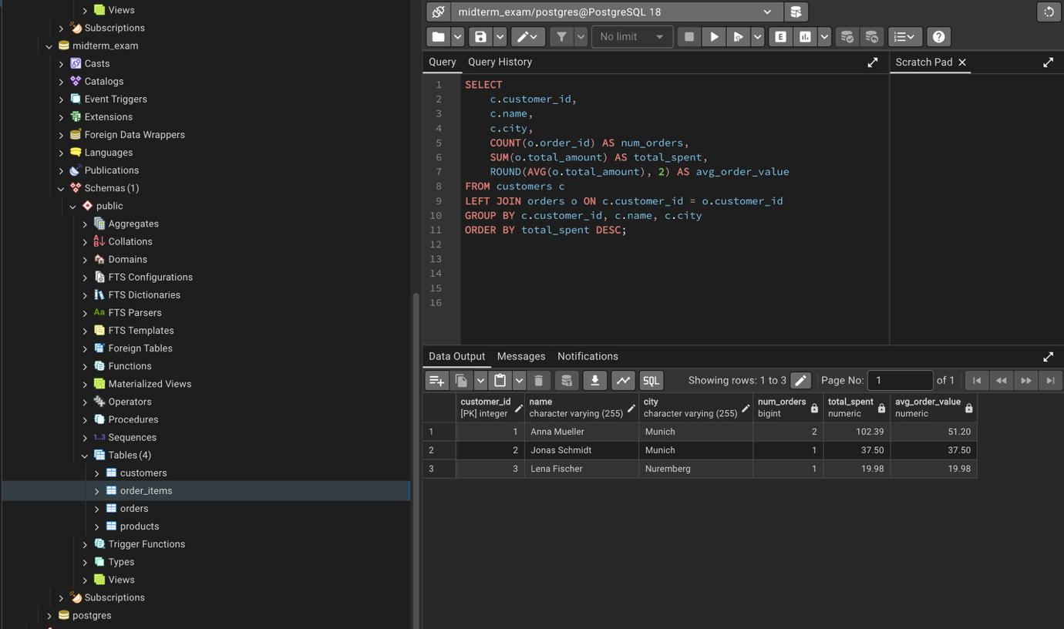

Query 4: How many different people are buying each product?
- Business Question: Are the same consumers buying every product or are we reaching to different consumers with different products?
- My approach: I tracked unique consumers for every product to see diversity in sales.
- Key Finding:
    - Mechanical Keyboard: 1 unique consumer, 1 unit, $59.90
    - Coffee beans: 2 different customers, 4 units, $50.00
    - Wireless Mouse: 1 unique consumer, 1 unit, $29.99
    - Water Bottle: 1 unique consumer, 2 units, $19.98
- This insights demonstrate only coffee beans has variety of customers, while other products have reached only one person. From this insight, we can promote more about other products.
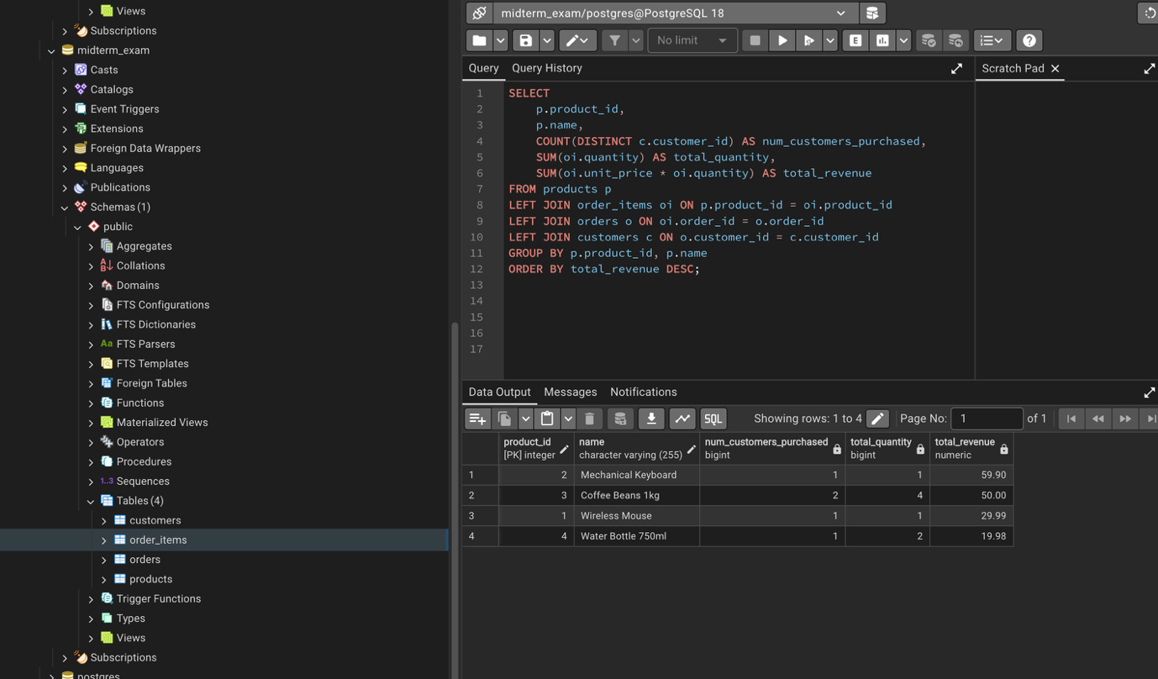

CRUD Operations
INSERT
- Adding a new consumer: I added a new customer to see if INSERT command works.
- The result was inserted without any errors with all the required fields filled in correctly. The database accepted my new records and validates data types and constraints that I set up in schema.
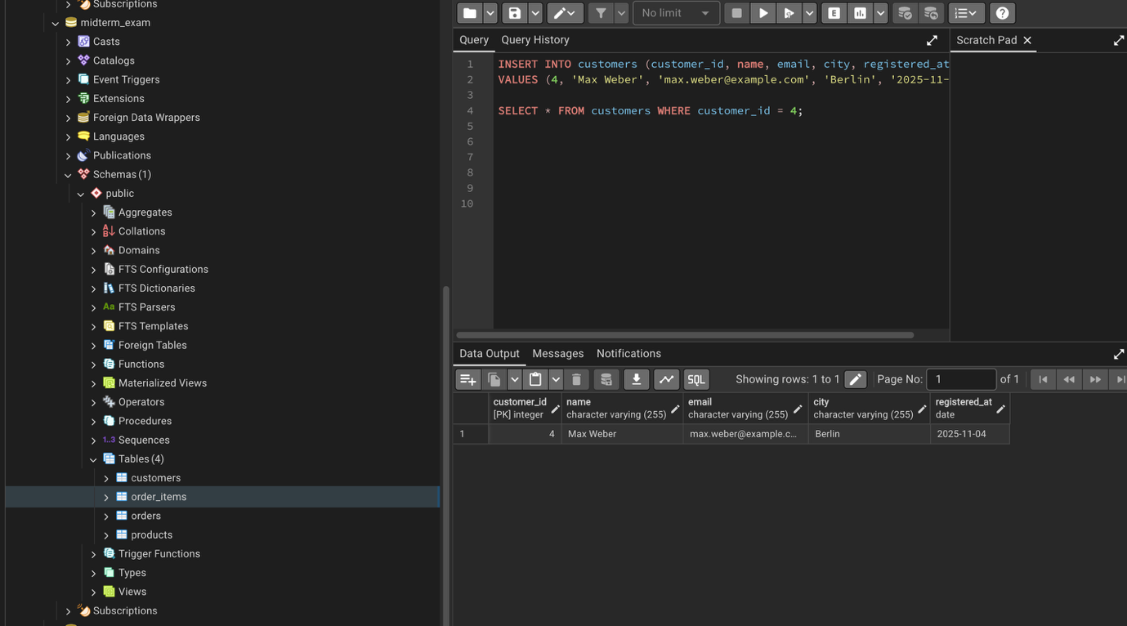

SELECT
- Reading data from Munich: I wanted to only read Munich data to test the JOIN and WHERE clause.
- It returned 3 orders: 2 orders from Anna Mueller, 1 order from Jonas Schmidt. All results from Munich, sorted by most recent first. The JOIN and WHERE clause worked correctly and the sort order is too right.
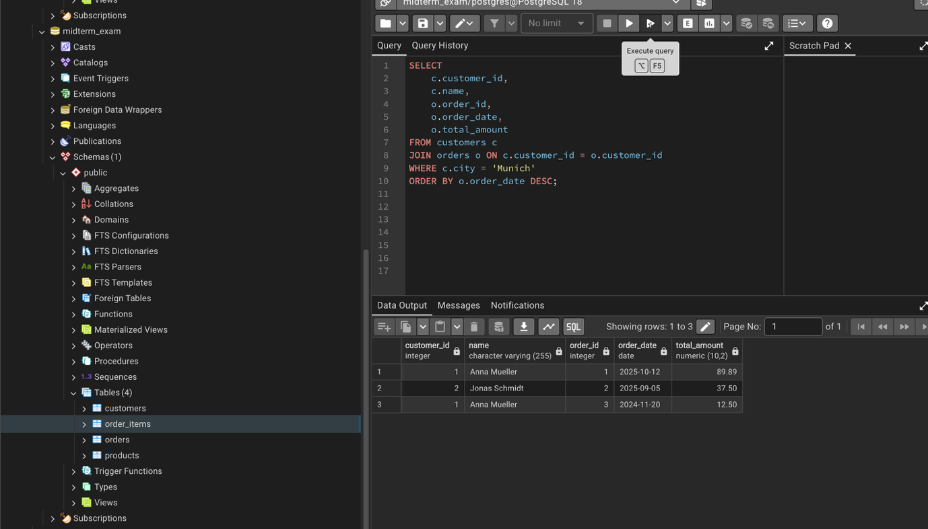

UPDATE
- Changing an order status: I changed an order status to test if UPDATE works
- The status changed from ‘cancelled’ to ‘pending’. When I selected the record again, it showed new status. The UPDATE command works correctly, the WHERE clause targets the right record and the database accepts the change.
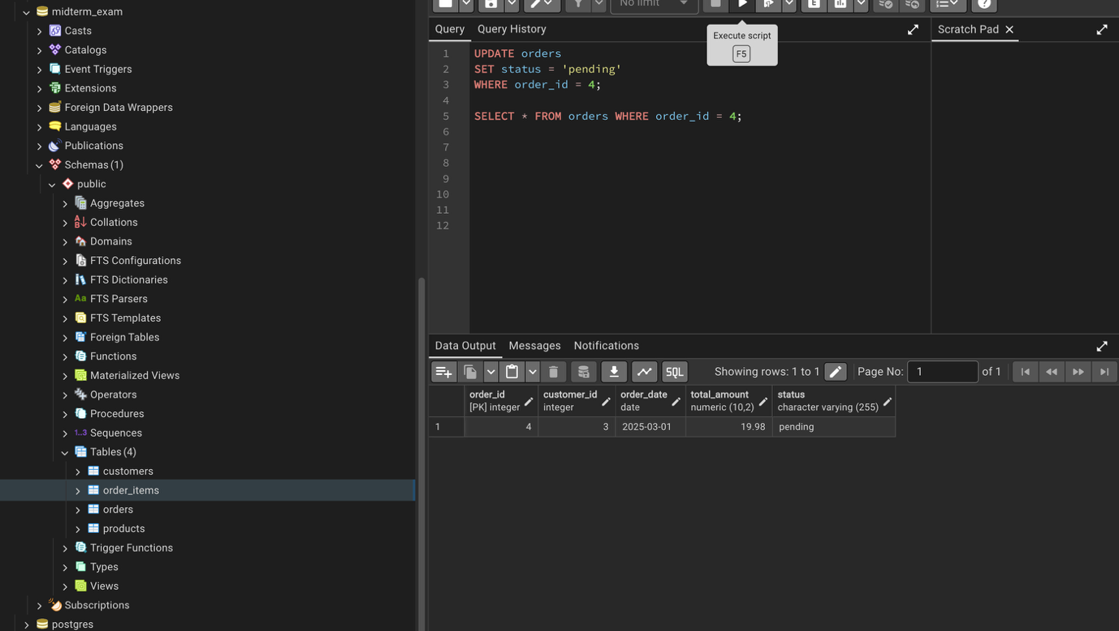

DELETE
- Removing a customer: I deleted customer 4 and all their orders to test delete and referential integrity. Also, we can’t just delete the customer because the orders still reference them. So deleting in right order is mandatory. First delete from order_items, then delete from orders, and finally delete from customers.
- Everything successfully deleted. Customer count went from 4 to 3. The database does not directly delete data showcasing referential integrity. It shows us to think about dependencies.
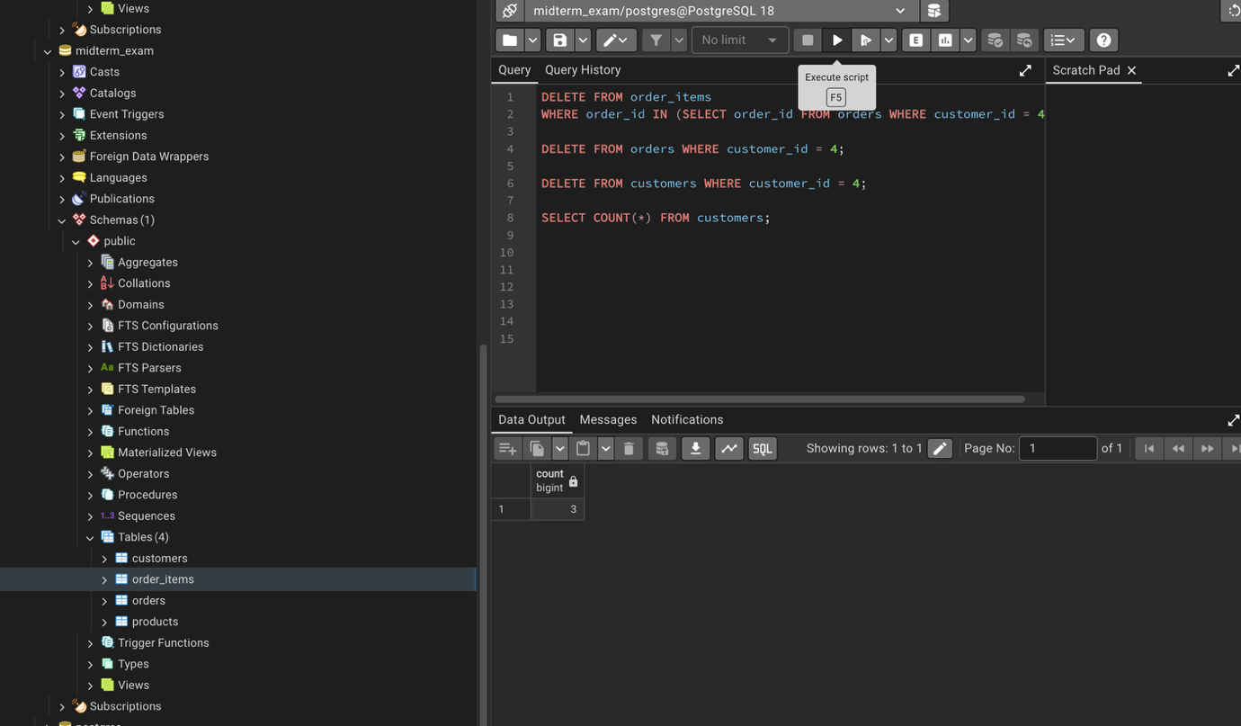

Conclusion

Through this project, I learned about database design and SQL. I started with a simple question (how do we analyze orders?). Further I designed the right schema to store the data. Finally, I wrote queries to get answers.
Key things I accomplished: Created a normalized database schema that does not duplicate data, 2 views making easy queries, wrote 4 separate queries that answer real world business questions, tested all CRUD operations, and learned about referential integrity.
Additions in future projects: More data addition to make analysis more insightful, would try to make an inventory table to track stock levels, add payments table to record payment methods and dates, and set up automated reports instead of manual queries
Overall, this was helpful for understanding how real databases work and why proper design matters before you start coding.

