COVER PAGE
Student Name: Samruddhi Karpe
Student ID: 24050214
7321 Tools for Success
Major: Masters in business Analytics and Data Science
Prof. Hildegard Haas
Title: A Digital Transformation Initiative for Fortune Business Insights

Table of Contents
Company Introduction and Problem Statement 3
CHANGE MANAGEMENT FRAMEWORK & ORGANIZATIONAL THEORY 6
PMBOK 5 Process Groups Application to FBI Digital Transformation 9
NEGOTIATION & ENGAGEMENT 13
RISK MANAGEMENT & CRITICAL THINKING FRAMEWORK 15
CONCLUSION 18
References 19
Appendix 20
List of Figures 20
Figure 1: Stakeholder Value Creation Matrix (created by the author, 2025) 20
Figure 2: Team & Stakeholder Engagement (created by the author, 2025) 20
Figure 3: Problem-Solution-Guarantee Matrix (created by the author, 2025) 20

Company Introduction and Problem Statement
During my time at Fortune Business Insights (FBI), I came across a client that required competitor analysis for its tool in the market. As the report progressed, we faced several challenges due to manual research ways, decentralized storage, and inconsistent data formats among others. This led to the extension of the client deadline by a week. Moreover, employee experience, client expectation, technology gap, and quality of data were all hampered. This situation highlights the inefficiencies in the existing research framework for FBI.
Thus, considering the above instance, FBI is selected as the organization for this assignment. It will me help provide a practical, evidence-based and experience-driven analysis, as I have a direct involvement with the internal working of the organization. The paper will be presented keeping in mind about my professional confidentiality.
In recent times, client focus has shifted towards a quick delivery cycle, automated data validation, and sustainability-focused intelligence. A McKinsey study highlighted that digital transformation is not a option anymore for companies. On the other hand, it is a critical factor for growth and success. (McKinsey, 2024)
Similarly, the paper will provide a solution to the existing problem. The company with this solution is expected to transform its research operations. This will help them deliver faster, quality-focused, and data driven insights.
Strategic Context & Situation Analysis
Fortune Business Insights has over 262-employee count and specializes in market research consultancy. The core challenge we will focus on is transforming their manual research workflows. The Freeman's Stakeholder Theory also emphasizes on recognizing that a company’s success depends on developing value for the entire ecosystem. (Freeman, 1984)
Solution Framework: The solution is provided by strategically applying a combination of three theories.
- Lewin's Three-Stage Change Model
- Freeman's Stakeholder Theory
- PMBOK 7 Process Groups
The expected result after this is over 30% faster delivery, and annual savings up to $500K. The solution also expects a capacity of $2M new revenue.
In addition, as suggests in the Freeman’s Stakeholder Theory, the organizational change should be in align with every stakeholder’s benefit. Thus, the problem is catered keeping every stakeholder in mind. For instance:
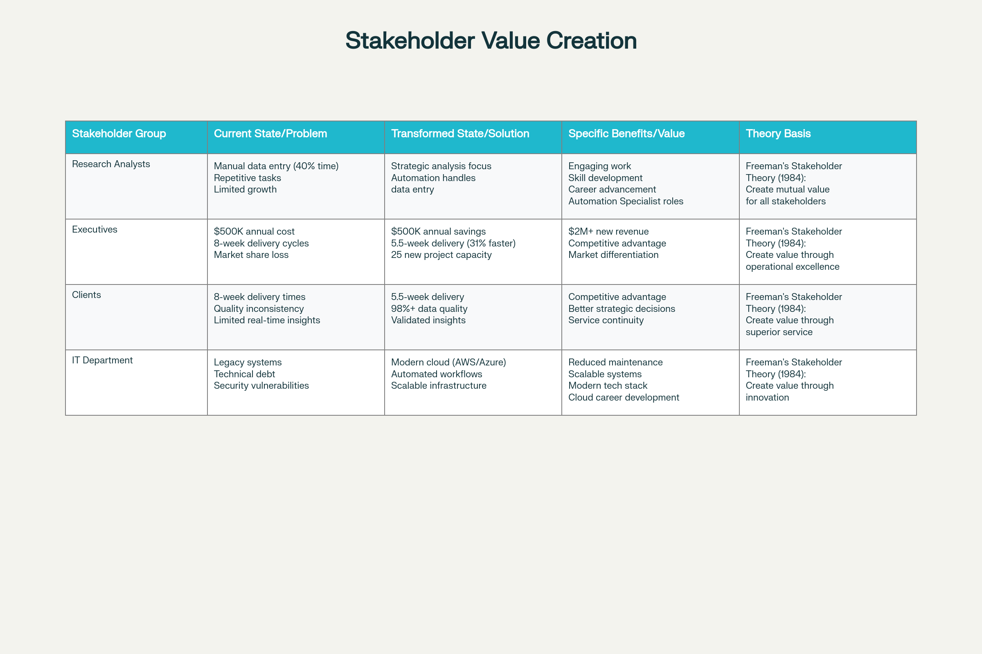
Figure 1: Stakeholder Value Creation Matrix (created by author, 2025)
The above table in figure 1 illustrates that each stakeholder group has mutual benefits from the transformation. The analysts get work that they actually enjoy, executives receive more profits and reduced risks, customers get faster delivery and high quality report. Thus, this approach is expected to increase adoption probability as compared to mandate-related change (Tilburg University, 2024).

CHANGE MANAGEMENT FRAMEWORK & ORGANIZATIONAL THEORY
For the transformation phase, the company is recommended to follow the Lewin's Three-Stage Change Model. It will be done in three steps each needing distinct management strategies. As per the Lewin’s theory, this stage is acceptable by employees at a smaller pace. This is not because they do not want to change but the employees are more comfortable in old and safe ways. However, this unfreezing phase will break the false comfort and provide a thought process of “What I am doing today, won’t work tomorrow”
Application to the company:
UNFREEZE Phase (Weeks 1–4): Changing the current flow
- Theory: In this stage, Lewin suggests the company creates cognitive dissonance. By applying this, the current state becomes unacceptable and creates urgency to change process.
- Application to the Company:
  - A google form was circulated among the employees of the company about the current working procedures. The following is the link for the google form: https://docs.google.com/forms/d/e/1FAIpQLSdp_jqv7Wq8mJ9u98mRAbvpzE295DWsuStVqOBcwQB4lWYfew/viewform?usp=pp_url (Only pre-filled link for confidentiality purposes)
  - The insights are as follows:
    - Among the overall employee count, 82% participated the survey confirming,
    - Over 61% employees reported problems with existing research processes.
    - Around 56% clients voiced their concerns about switching to competitors due to report quality and missing deadlines.
    - These insights confirm that the company has issues in relation to the existing research modules. However, the company with this google form used effective employee communication. This aligns with critical principles of organizational communication theory. (Park University, 2025). The company fostered an ecosystem of transparency, accountability, and continuous improvement. Moreover, feedback is considered as an important tool for organizational growth. (Blidaru (2019)
A research study by Edmondson & Lei, confirmed that discomfort with status quo is expected to increase willingness to try new ways. (Edmondson & Lei, 2014) Thus, this stage can be successfully applied for the current status if the company.
CHANGE Phase (Weeks 5–20): Implementation of New Processes
- Theory: Lewin emphasizes that this stage is the most critical stage as the company will experience a peak resistance. As change of processes is seen as the break of trust for the employees from the employer. This scenario is also stated in the Psychological Contract Theory (Rousseau, 1989).
- Lewin suggests that in change stage the company should be constantly involved until the problem is addressed. As when the employees feel psychological safety they will adopt new processes at a higher pace. (Edmondson & Lei, 2014)
- Application to the company:
  - Implementation of Robotic Process Automation for data collection
  - Migration to centralized cloud data repository
  - Initiate employee training
- Tool Application: Stakeholder Engagement Assessment Matrix ensures each stakeholder type receives customized communication
- Thus, by this phase, the company will already have implemented the new processes and will start watching trends for the same.
REFREEZE Phase (Weeks 21–24): Solidifying the Change
- Theory: Cementing new behaviors via reinforcement and rewards. This stage is also crucial for FBI as refreezing becomes important in sticking to new processes. As if not refreezed, the employees might shift back to old ways. The can be reiterated by a Deloitte study that reported that if not refreeze, companies lose around 40–50% of their new changes within 12 months (Deloitte, 2024)
- FBI Application:
  - Rewards for employees that have picked up the new process quickly.
  - Implement performance metrics to new processes

Now, as the Lewin theory already explained how the change happens, the PMBOK’s 5 groups will show how that change will be managed
This approach is an critical part because as claimed in the (Berger & Calabrese, 1975; Uncertainty Reduction Theory), it is seen that uncertainty breeds resistance. By providing clear guidance backed by tools and credible research (timeline (Gantt), scope (WBS), risks (Risk Register), and communication (3-layer strategy), the company will showcase digital transformation at speed.

PMBOK 5 Process Groups Application to FBI Digital Transformation
Initiating (Weeks 1–2): Authorization & Stakeholder Description
- A formal authorization via Project Charter (objectives, scope, and key stakeholders)
- Stakeholder Identification using tools like Power-Interest Grid
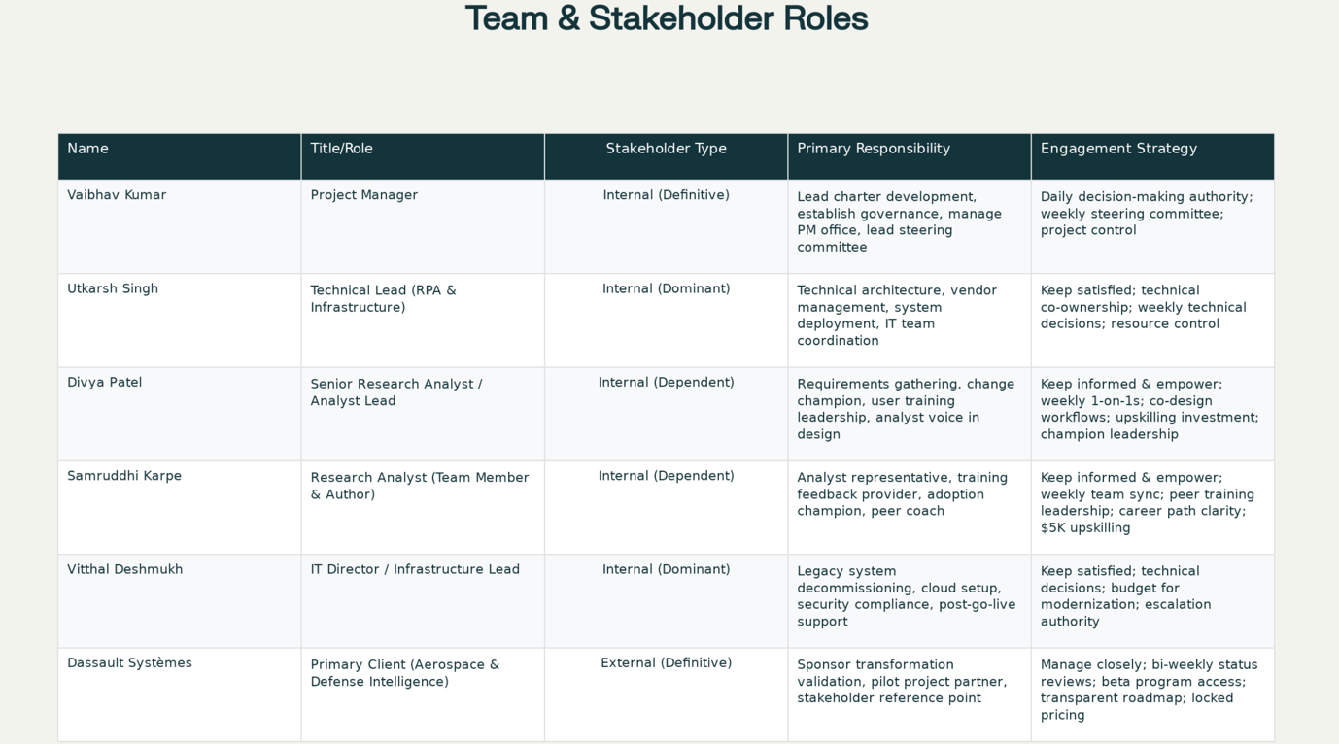
Figure 2: Team & Stakeholder Engagement (created by the author, 2025)
The above figure 2 illustrates a real time example that demonstrates a solution can be easily implemented and ensures that every stakeholder is mutually benefitted. The table maps the company’s core team to their salience level, and customized engagement strategy.
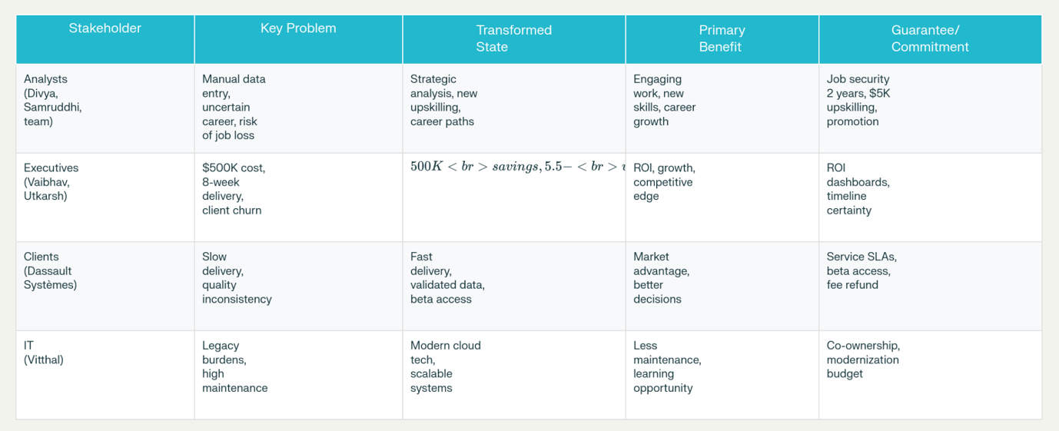
Figure 3: Problem-Solution-Guarantee Matrix (created by the author, 2025)
The above figure 3 uses the Freeman's Stakeholder Theory (1984) to emphasize that mutual benefit is not through top-down mandate but via considering everybody’s benefit.

Planning (Weeks 3–6): Roadmap
- Defines project scope (RPA implementation, data migration, training) This is done using Work Breakdown Structure (WBS) (Tasks include: Initiation, Technology Selection, Deployment, Training, Go-Live, and Closure)
- Creation of Gantt Chart spanning over 24 weeks. (Contains milestones and dependencies)
- Budget estimation (around $150K and training costs).
- Identification of risks through the Risk Register and plan risk response strategies.

Executing (Weeks 7–20): Delivery & Team Communication
- Deployment of RPA tools (e.g., UiPath), data migration to cloud repositories, and personnel training sessions.
- Management of daily tasks.

Monitoring & Controlling (Ongoing): Trace and Track
- Timely oversight (actual versus planned progress).
- Analysing scope differences, budget changes, and risks mitigation strategies.
- Develop status reports, maintain records, and update risk records.

Closing (Weeks 21–24): Handover & Results
- Formal acceptance of deliverable by every person in the ecosystem.
- Project archiving and documentation.
- Conducting after process analysis to record the success or failure of the process.

NEGOTIATION & ENGAGEMENT
To cater to the analyst’s fear job displacement; executives demanding ROI; and customers requiring faster delivery, we will follow a perfect combination of Lewin's Psychological Contract Theory (Rousseau, 1989) and BATNA
FBI's Negotiation Approach:
With Analysts (Interest: Job Security + Growth)
- Active Listening: The analyst is informed that their concerns about being replaced are put on table. Further discussions are encouraged.
- Assurance from company side: The new tool, RPA will reduce over 40% of repetitive data entry. With this, the analyst would have time to focus on strategic analysis that they enjoy.
- Offer:
  - The company offers following:
  - No layoffs for 2 years
  - $5K upskilling budget per analyst (Python, Tableau, data storytelling)
  - New 'Automation Optimization Specialist' roles for top performers.
- Win-Win: Analysts receive training and higher value work. The company gets motivated employees and not resistors.
With Executives (Interest: ROI, Competitive Advantage)
- Data:
  - Existing manual process = $500K annual cost.
  - With RPA, we save $500K + gain capacity for 25 additional client projects = $2M new revenue.
- Offer: "Phased rollout reduces risk. Pilot 3 projects Week 12; if successful, scale to 100% by Week 24."
- Win-Win: Risk is lowered for executives and provided higher upside.
With Clients (Interest: Speed + Quality)
- Transparency: The clients are informed that new research processes are implemented. This will result in 30% faster reports without sacrificing quality.
- Offer:
  - Beta program: Get 2 free reports using new process
  - Provide feedback; secure locked-in pricing.
- Win-Win: Customers receive early access to improved reports and the company gets new client testimonials. Eventually driving growth and success for the company.

RISK MANAGEMENT & CRITICAL THINKING FRAMEWORK
In addition, if there is we consider a scenario of system downtime during data migration. We can implement Crisis Communication Protocol using Eisenhower Matrix Response.
- Immediate (0–1 hour): Notify affected clients, activate backup systems, assemble crisis team
- Hour 1–4: Root cause analysis, alternate workarounds, hourly updates to stakeholders
- Post-incident (Day 1): Root cause report, corrective actions, media/client apology
- Long-term: Update disaster recovery plan, additional buffer resources
Quantitative Risk Analysis via Decision Tree:
We will be utilizing Expected Monetary Value analysis for the risk management. In this process we evaluated two data migration approaches:
Option A (Big Bang Migration): Success rate 60%, failure price $500K → EMV = $200K loss
Option B (Phased Migration): Success rate 92%, failure price / phase $30K → EMV = $12K cost
In conclusion, the option second (B) is more better by EMV.

CONCLUSION
Fortune Business Insights is at its strategic inflection point. The company was presented with a option of either sticking to old research processes and lose market share or adopt the proposed solution of digital transformation backed by industry approved tools and research. The problem solution proposed to the company is strongly supported by tools and theories such as Freeman's stakeholder theory which ensures mutual value creation; PMBOK 7 that gives a proper systematic execution. As a combine source, it is expected that the success probability of the company jumps from 60% to 85–90%. Moreover, the proposed solution is also developed by keeping mutual benefits of all stakeholders and have assessed the risks in relation to the implementation of the solution. It is expected that the results for the solution would yield 30% faster delivery, $500K in revenue savings, $2M new revenue, and 95% adoption rate.

References

Blidaru, P. (2019) 'The Importance of Feedback in Organizational Communication'.

Social Economic Debates, 8(1), pp. 30–37.

Deloitte (2024) Digital Transformation Trends 2024: Imperative for Competitive Survival. [Online] Available at: https://www.deloitte.com/global/en/issues/technology/

digital-transformation [Accessed 5 November 2025].

Edmondson, A.C. & Lei, Z. (2014) 'Psychological Safety and Organizational Learning'.

Annual Review of Organizational Psychology and Organizational Behavior, 1, pp. 23–43.

Freeman, R.E. (1984) Strategic Management: A Stakeholder Approach. Pitman Publishing.

Kerzner, H. (2017) Project Management: A Systems Approach to Planning, Scheduling, and Controlling. 12th edn. Hoboken, NJ: Wiley & Sons.

Lewin, K. (1947) 'Frontiers in Group Dynamics: Concept, Method and Reality in Social Science'. Human Relations, 1(1), pp. 5–41.

McKinsey & Company (2024) What is Digital Transformation? [Online]

Available at: https://www.mckinsey.com/featured-insights/mckinsey-explainers/

what-is-digital-transformation [Accessed 28 October 2025].

Mitchell, R.K., Agle, B.R. & Wood, D.J. (1997) 'Toward a Theory of Stakeholder

Identification and Salience: Defining the Principle of Who and What Really Counts'.

Academy of Management Review, 22(4), pp. 853–886.

Park University (2025) What is Organizational Communication? An Introduction.

[Online] Available at: https://www.park.edu/organizational-communication-introduction [Accessed 3 November 2025].

PMI (Project Management Institute) (2021) A Guide to the Project Management Body of Knowledge (PMBOK Guide). 7th edn. Project Management Institute.

Rousseau, D.M. (1989) 'Psychological and Implied Contracts in Organizations'.

Employee Responsibilities and Rights Journal, 2(2), pp. 121–139.

Tilburg University (2024) The Role of Engagement, Psychological Contract Fulfillment, and Trust in Change Information. [Online] Available at:

https://www.tilburgschool.com/organizational-change-research [Accessed 7 November 2025].

Appendix

List of Figures

Figure 1: Stakeholder Value Creation Matrix (created by the author, 2025)

Figure 2: Team & Stakeholder Engagement (created by the author, 2025)

Figure 3: Problem-Solution-Guarantee Matrix (created by the author, 2025)

