Introduction
In the retail as well as e-commerce industry, analysis of customer behavior plays a significant role that assists the businesses in making effective as well as calculated business decisions. Trends and patterns are identified by the businesses from the data, which they implement to refine their business strategies. This process becomes pivotal in driving business growth and success positively. The conclusions obtained from well-crafted data visualization can be leveraged to enhance customer loyalty, optimize revenue, and maintain a competitive advantage. The report offers an overview of conclusions that were drawn from the dataset with approximately 9,000 consumer records having 15 essential attributes. The primary attributes are purchasing history, consumer demographics, loyalty program membership, etc. The key purpose of this report is to extract meaningful information from the data and utilize it for the enhancement of business strategies, sales, and overall business performance. The report will offer data regarding what kind of visualization is employed, what kind of information is extracted from the visualization, and offer strategic suggestions for the company. The data is cleaned and uploaded in Google Looker Studio, where various types of visualizations were created to derive insights. The right type of data visualization was chosen to best represent the data that is to be communicated.
Visualization Process, Insights, and Recommendations
We have chosen the following four major visualizations using Google Looker Studio:
- Bar Chart: Customer Segmentation by Region and Gender.
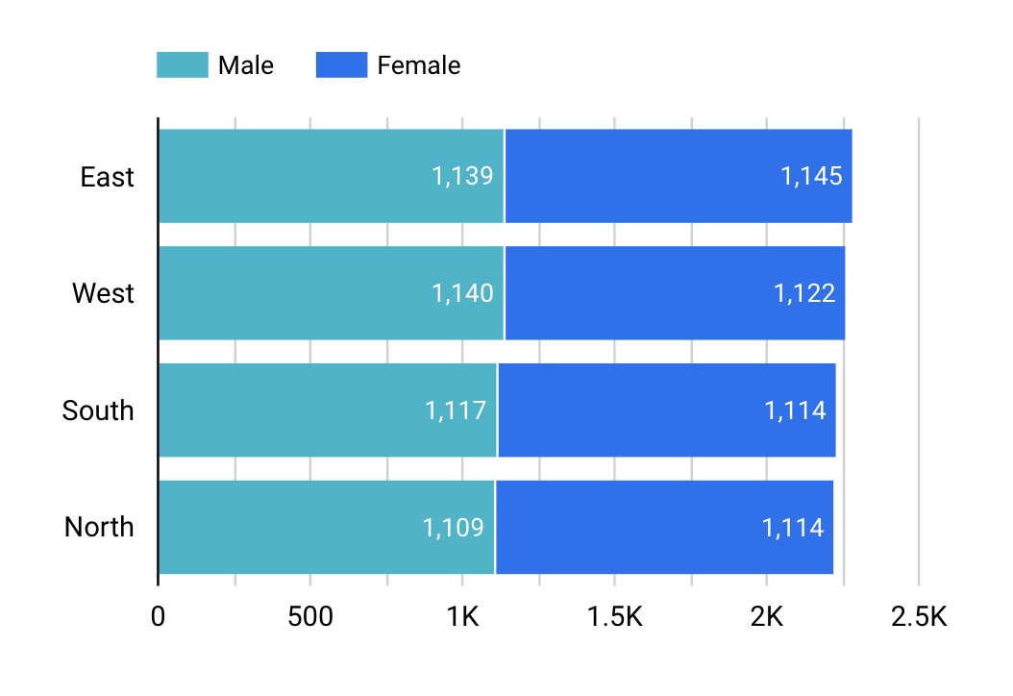

Chart selection: A bar chart is an ideal option for the provided data as it shows an easy comparison of consumer distribution across regions and genders. In addition, the bar chart effectively summarizes a large data set into meaningful data.
Expected insights: The expected result from using these attributes (region and gender) was to highlight which consumer groups come from what particular regions. Moreover, the combination of these data points is most important because consumer behavior tends to differ by region based on economic conditions, cultural variations, etc. The desired outcome of this chart and data is to realize that customer distribution makes it possible for more targeted marketing campaigns.
Chart Description: The chart depicts customer distribution by gender (male and female) across four regions, which are East, West, North, and South. The count ranges from 0 to 2.5K. According to the chart, the East and the West regions showcase a large portion of customers. On the other hand, the gender distribution is relatively equal across all the regions.
Recommendations: With the resulting insights, companies can enhance localized marketing strategies in high-density regions like East and West, whereas they explore untapped growth opportunities in lower-density areas. The latter include North and South.
- Scatterplot: Highlighting Satisfaction Vs. Return Rate
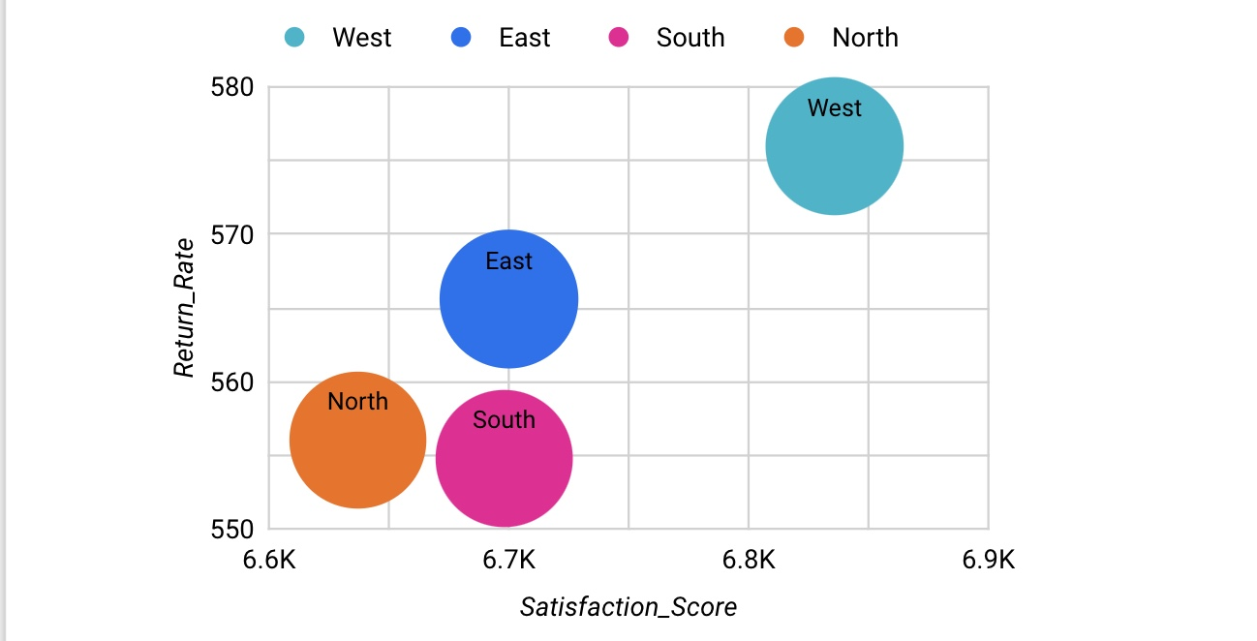
Chart selection: A scatter plot is used as it will show the correlation between the satisfaction score and return rate of customers. The aim of selecting a scatter plot was to easily compare attributes at a glance. The regions are represented as a bubble, which makes it easy for the readers to compare which region performs well across satisfaction and return rates.
Expected insights: The expected insights are expected to show which region performs better or worse in terms of return and satisfaction rates. Additionally, the insights will recommend companies to identify potential gaps, help in refining marketing strategies, improve product quality, etc. Moreover, an important point to consider will be to improve customer support or product descriptions.
Chart Description: On the X axis, there is a satisfaction score ranging from over 6.6K to 6.9K. On the Y-axis, there is a return rate that ranges from 550 to 580. The satisfaction score and return rate are set to sum, and the product category is set to count. As per the chart, the west region has the highest satisfaction and return rate score, indicating consumers in this region are highly satisfied. However, they are still returning products on a higher scale. Moreover, the east region has a slightly lower satisfaction score, which indicates moderate performance. For the north and south regions, both the satisfaction and return rate scores are low. This indicates that these regions might require improvements in product quality or customer experience.
Recommendations: Companies can see if their logistics, product mismatch, policies, etc., are mismatched and can rectify that for a high return and satisfaction score rate. The company can focus on personalizing promotions and adjusting inventory for the low-performing regions (North and South).
- Stacked Bar Chart: Comparing Sentiment Distribution
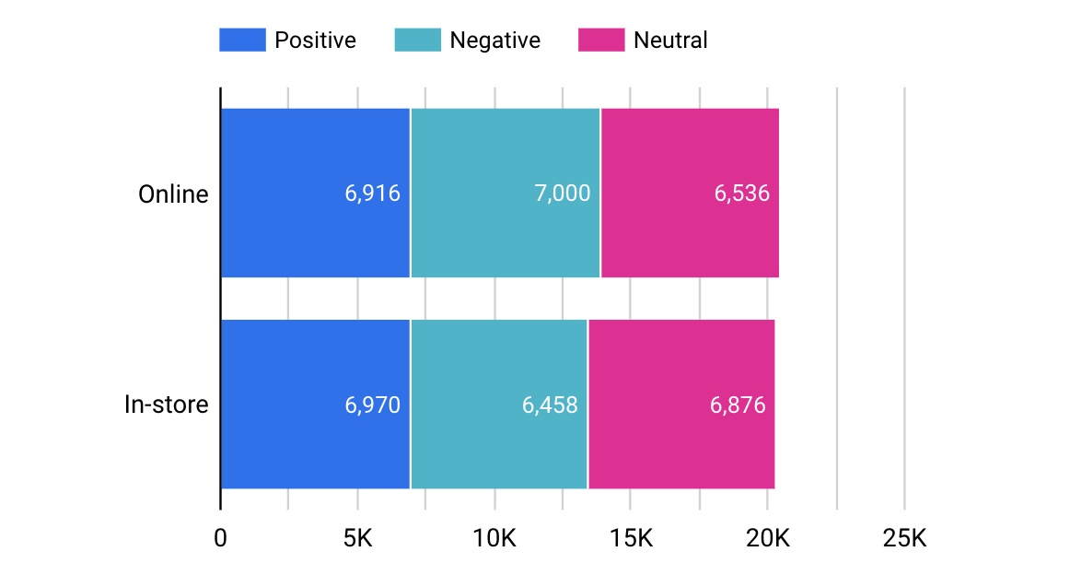
Chart selection: A stacked bar chart compares sentiment distribution (positive, negative, and neutral) across two purchasing channels (online vs. in-store). It becomes easier with a stacked bar chart to visualize the breakdown of each sentiment category while keeping the entire volume to compare at a glance.
Expected insights: The expected insights will help in comparing customer sentiment between online and in-store purchases. Online shopping in this chart has showcased higher negative sentiment compared to in-store shopping. This indicates that there are potential issues like delivery delays, return policies, or product quality mismatches.
Chart Description: The chart's responses range from 0 to 25K. The chart depicts that in-store shopping has a slightly better sentiment balance. It has more positive feedback and fewer negative responses than online shopping. This suggests in-person experiences may be more satisfying, potentially due to better services, hands-on product evaluation, or instant issue resolution.
Recommendations: Companies can address the high negative sentiment by refining delivery, return, and product expectations of customers. In addition, the company can maintain strong service standards while leveraging in-store strengths in online platforms (live support, virtual try-ons). The company can convert neutral experiences into positive ones via targeted engagement strategies like personalized recommendations.
Conclusion
The above-described customer behavior analysis report gives meaningful insights into purchasing behavior, engagement tactics, and interests of the consumer base. The assistance of the right data visualizations assists us in understanding the purchase frequency, regional population, spending behaviors, and return on marketing campaigns. Organizations can make use of the data to push consumer retention, sales, and long-term business development. It is hence essential to choose proper data visualization to get meaningful data and utilize it in taking well-informed business decisions.

