Project Title: Strategic Implementation and Deployment of an AI/ML-Based Burnout Detection and Prevention Solution
Name: Samruddhi Karpe
Student ID: 24050214
Course Name: MADSC201 – Machine Learning & AI
Professor’s Name: Fabricio Inocencio (Doctor)
Submission Date: 23 March 2025
Table of Contents
- Why Tackling Burnout Matters?
- A Practical Plan to Prevent Employee Burnout with AI/ML
  - Data Preparation
  - Who Does What? Clarifying Roles in AI-Powered Burnout Prevention
  - Timelines and Milestones
- Development Strategy
  - Integration with Existing IT Infrastructure
  - Continuous Model Monitoring, Retraining, and Performance Optimization
- Ethical and Societal Impacts
  - How We’ll Monitor and Update the AI to Stay Effective
  - Addressing Bias and Enhancing Transparency through Explainable AI
- Cost-Benefit Analysis & KPIs
  - Comprehensive Cost Analysis and Strategic Allocation
  - Quantifying ROI and Ensuring Sustainable Gains in Workforce Wellbeing
- Handling Challenges with Transparency and Care
- Conclusion
- References
Why Tackling Burnout Matters?
Since the pandemic, employee burnout has become a pressing issue for many organizations. Chronic stress is often at the heart of the problem, leading to both mental and physical health concerns. Companies are also seeing the impact on productivity, with more cases of disengagement and absenteeism than before. A report suggests that symptoms that occur due to burnout in the general workforce have showcased an increase of over 25-30% due to remote work. (Koutsimani, Montgomery and Georganta, 2019) In addition, another report also found factors such as continuous digital communication and social isolation have led to improved stress levels. These elevations in stress levels have intensified burnout among employees. (Lim, 2021)
A solution for this problem is found to be the use of AI/ML based solutions. These solutions can be used for early detection and prevention of burnout among employees. There have also been some reports that found the use of technology to analyze work patterns and employee communication to predict risks even before they escalate to something severe. (Bhatnagar, Gupta, and Malhotra (2020))
Thus, the last paper focused on proposing an AI/ML solution for burnout prevention. In this
paper, the focus will be on to designing a comprehensive implementation, deployment, and
monitoring strategy for the AI/ML burnout detection solution.

A Practical Plan to Prevent Employee Burnout with AI/ML
- Data Preparation
Data preparation plan is crucial step in the implementation plan. It ensures overall quality and ethical handling of data fed to the models. In this AI/ML-based solution, data sources will include communications between employees (emails and chat logs), performance reviews, and work activity logs. These details enable models to analyze employee’s behavioral trend and stress indicators.
Further, thorough data cleaning and preprocessing are required to maximize data utility. This process includes reducing noise, normalizing data with the aim of meeting stringent requirements of protection regulations like the GDPR. (European Commission, 2018) Moreover, a feature engineering will be required to analyse sentiment scores from natural language processing and overtime patterns. This data will act as a starting input for the predictive models to detect burnout risks.
- Who Does What? Clarifying Roles in AI-Powered Burnout Prevention
It is important to identify and define key stakeholders to ensure that every step of the solution is effectively working. Firstly, data scientists have been tasked to develop, test, and do regular monitoring of the predictive models. Secondly, HR professionals have the crucial job to analyse and decode these predictive results to conduct regular employee interventions. Thirdly, IT and integration teams have the responsibility of ensuring smooth data flow and connectivity. Lastly, legal and compliance teams are critical for overlooking data privacy. A RACI matrix chart mapping these roles to specific project tasks clarifies responsibilities. This approach also ensures efficient collaboration across the diverse teams involved (Cascio and Boudreau, 2016).
- Timelines and Milestones
A detailed plan for timelines and milestones is added in the table below. The project is divided into following phases—Planning, Data Collection, Model Development, Testing, Deployment, and Continuous Monitoring. Every phase has dedicated team and their specific tasks allocated. In addition, they have been set with certain timelines and milestones to ensure timely execution of the tasks. This approach also takes in account the time required to redistribute work if any issues escalate. (Mir & Pinnington, 2014; Kerzner, 2017)
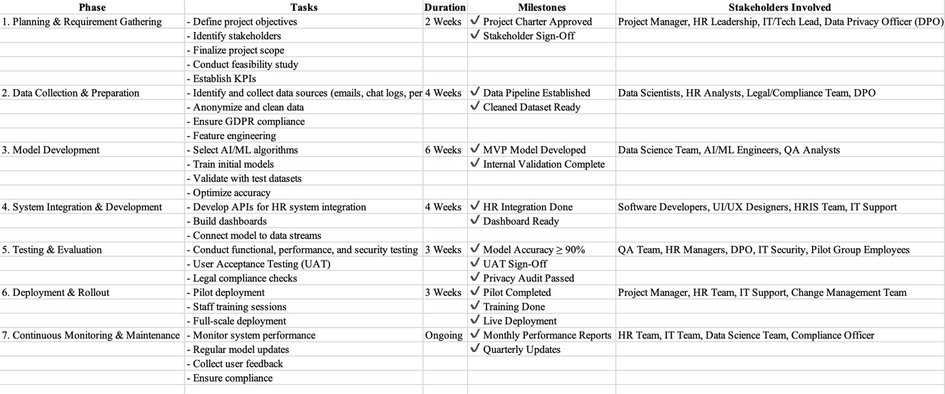
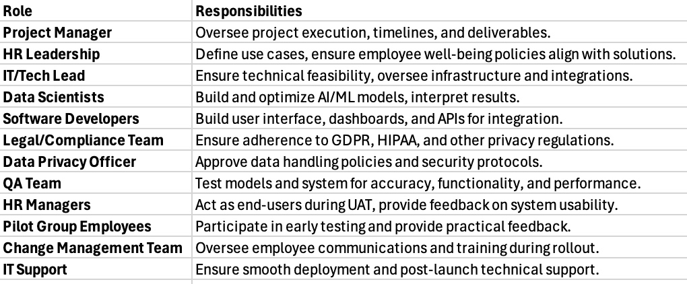
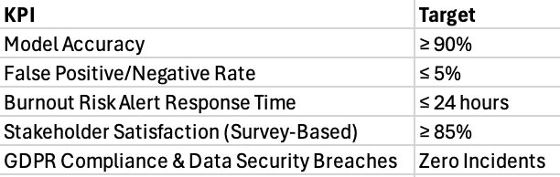
Development Strategy
- Integration with Existing IT Infrastructure
A seamless integration with the existing HR and operational systems of the proposed solution will be kept in mind. This is achieved via API-based connections with HR platforms such as SAP and Workday. This step is necessary for ensuring flow of data effortlessly from employee tools into AI models. It also ensures real-time analysis, alerts, and decision-making.
- Continuous Model Monitoring, Retraining, and Performance Optimization
A regular check on evaluation and performance of AI model is necessary. The model will be monitored through following key metrics, accuracy and rate of false positives/negatives. The plan will also include frequent model retraining and updates to include new data and feedback. This approach will ensure that the system remains responsive and robust to changing conditions.
Ethical and Societal Impacts
- How We’ll Monitor and Update the AI to Stay Effective
In our AI/ML-based solution data privacy and security is of utmost priority. We need to make sure that sensitive employee data is collected anonymously and used only to detect burnout risks. The solution will be developed in such a way that it adheres to the GDPR regulations. To add to this, employee consent is equally important when collecting their sensitive. Thus, an employee consent will be taken to ensure the information is transparently transferred for detecting burnout risks. (Bélanger and Crossler, 2011) This approach of maintaining data privacy and security not only ensures legal compliance for the solution but also builds trust among stakeholders. (Custers, 2016).
- Addressing Bias and Enhancing Transparency through Explainable AI
Whenever incomplete data is fed to AI models it tends to provide bias results. Other than that lack of training of AI model is prone to AI model providing bias results. For instance, if the data fed is majorly reflected on one demographic or work sector, the model may incorrectly predict employee burnout outside of that group. These risks might predict incorrect results and further create frustration among employees. In order to mitigating these risks the model will be developed in a such a way that data is regularly checked. Use of techniques like explainable AI can help mitigate these concerns. These techniques ensure overall transparency and stakeholder trust. (Barocas and Selbst, 2016; Mitchell et al., 2019)
Cost-Benefit Analysis & KPIs
- Comprehensive Cost Analysis and Strategic Allocation
The cost breakdown for the solution will be incurred for the following aspects:
- Upfront cost – model design, algorithm optimization, and iterative testing phases.
- Data acquisition cost – collection and curation of employee data.
- System integration- embedding the solution within existing IT infrastructure.
- Employee training – the entire training cost required for data handling, ethical considerations, etc.
- Ongoing maintenance – software updates, new data incorporation, etc.
- Quantifying ROI and Ensuring Sustainable Gains in Workforce Wellbeing
The ROI of implementing AI/ML-based solution for burnout will yield results such as workforce efficiency and reduced operational costs. These benefits directly impact company’s overall performance and employee well-being. Benefits such as reduced absenteeism, lower turnout rates, and increased productivity are essential advantages from the use of this solution. Reduced absenteeism can result in significant productivity and increased staffing costs. Higher employee productivity can further have a positive impact on the organization. In addition, enhanced employee engagement will lead to higher job satisfaction among employees. (Schaufeli, 2017) To quantify this, companies can track KPIs such as burnout risk alert accuracy, turnover reduction percentages, etc. For instance, companies that use predictive analytics have found over 20% increase in their employee engagement sectors. (Kelly et al., 2021) These improvements not only have a boost to employee morale but also contributes to long term organizational benefits.
Handling Challenges with Transparency and Care
Certain challenges that occur with the use of this purposed solution are employee resilience to perceived surveillance. Employees can oppose to the implementation of this solution and can severely impact their trust. (Ball, 2010) Employees might feel they are constantly monitored and that would in turn make them feel dejected and burdened with tension. To mitigate these concerns, organizations can clearly communicate the main aim of the implementation. Once the employees are assured that the data that is collected will be used for their well-being, they might not feel their privacy is invaded. Another major challenge will be to ensure that the solution does not provide false results. This situation can lead to even more frustration to the employees. For this, iterative tuning model can be implemented to enhance predictive accuracy and reduce risks. (Suresh & Guttag, 2021)
Conclusion
The paper has effectively proposed an AI/ML based burnout prevention solution with a comprehensive implementation plan. The paper also provides a development strategy considering potential challenges and risks. There are certain mitigating solutions that the paper provides for smooth execution of the plan. The aim of this plan and solution is to foster a healthy working environment. By using AI/ML capabilities, we will be analysing and successfully detecting employee burnout way before it is severely escalated. The ability of AI systems to analyse real time data can allow managers to take suitable actions. This approach encourages a culture of proactive support and healthy environment. (McGregor et al. (2020)
For future research and projects, we can develop theories and projects that explore the integration of sentiment analysis from NLP to deepen understanding of employee emotions. This will provide an extra layer of insight beyond existing productivity metrics. (Gonzalez-Rodriguez et al., 2021) Further, the longevity and long term impact of burnout prevention can be studied in future work. Collaborative efforts among all stakeholders can help achieve all future works successfully.
In conclusion, the proposed AI/ML-based solution not only addresses current employee burnout risks but also provides a foundation for future work. These works along with current solutions will aim to improve fairness, transparency, and inclusivity. By leveraging technology, companies can foster a healthier and more resilient workforce.
References
Ball, K. (2010). Workplace surveillance: An overview. Labor History, 51(1), 87–106.
Barocas, S. and Selbst, A. D. (2016) ‘Big Data’s Disparate Impact’, California Law Review, 104(3), pp. 671–732.
Mitchell, S. et al. (2019) ‘Model Cards for Model Reporting’, Proceedings of the Conference on Fairness, Accountability, and Transparency (FAT 2019), pp. 220–229.
Bélanger, F. and Crossler, R. E. (2011) ‘Privacy in the digital age: A review of information privacy research in information systems’, MIS Quarterly, 35(4), pp. 1017–1042.
Bhatnagar, R., Gupta, R. and Malhotra, A. (2020) 'Leveraging Machine Learning for Early Burnout Detection: A Review', IEEE Access, 8, pp. 115673–115684. doi: 10.1109/ACCESS.2020.3000000.
Cascio, W.F. and Boudreau, J.W. (2016) 'The search for global competence: From international HR to talent management', Journal of World Business, 51(1), pp. 103–114.
Custers, B. (2016) ‘Implementing data protection by design: Challenges for EU policy and practice’, International Data Privacy Law, 6(4), pp. 255–269.
European Commission (2018) GDPR: General Data Protection Regulation. Available at: https://ec.europa.eu/info/law/law-topic/data-protection_en (Accessed: 20 March 2025)
Gonzalez-Rodriguez, M., Sharma, S., de la Hera, T., Soler-Company, J. and Lloret, J., 2021. Sentiment analysis using deep learning approaches for well-being and stress detection: A review. IEEE Access, 9, pp.128345-128365. Available at: https://doi.org/10.1109/ACCESS.2021.3110935 [Accessed 23 March 2025].
Kelly, R., Barrett, M., Bartunek, J. and Scott, D., 2021. Employee well-being in the AI workplace: The need for longitudinal research. Journal of Business Ethics, 170, pp.705–724. Available at: https://doi.org/10.1007/s10551-019-04308-2 [Accessed 23 March 2025].
Kerzner, H., 2017. Project Management: A Systems Approach to Planning, Scheduling, and Controlling. 12th ed. Hoboken, NJ: John Wiley & Sons.
Available at: https://www.wiley.com/en-us/Project+Management%3A+A+Systems+Approach+to+Planning%2C+Scheduling%2C+and+Controlling%2C+12th+Edition-p-9781119165354 [Accessed 22 March 2025].
Koutsimani, P., Montgomery, A. and Georganta, K. (2019) 'The Relationship Between Burnout, Depression, and Anxiety: A Systematic Review and Meta-Analysis', Journal of Occupational Health Psychology, 24(4), pp. 278–299. doi: 10.1037/ocp0000148.
Lim, S. (2021) 'Remote Work and Employee Burnout: A Systematic Review', Journal of Occupational Health Psychology, 26(3), pp. 123–134. doi: 10.1037/ocp0000245.
McGregor, F., Balan, S., Haskins, C. and Finlay, J., 2020. Using machine learning to identify burnout risk in employees: An exploratory study. Journal of Occupational Health Psychology, 25(3), pp.176-189. Available at: https://doi.org/10.1037/ocp0000185 [Accessed 23 March 2025].
Mir, F.A. and Pinnington, A.H., 2014. Exploring the value of project management: Linking Project Management Performance and Project Success. International Journal of Project Management, 32(2), pp.202-217.
Available at: https://doi.org/10.1016/j.ijproman.2013.05.012 [Accessed 21 March 2025].
Schaufeli, W. B. (2017). Applying the job demands-resources model: A 'how-to' guide to measuring and tackling work engagement and burnout. Organizational Dynamics, 46(2), 120–132.
Suresh, H., & Guttag, J. V. (2021). A framework for understanding unintended consequences of machine learning. Communications of the ACM, 64(11), 62–71. https://doi.org/10.1145/3463498

