Experiment no 4

Name: - Samruddhi Devram Khilari
Roll No: - 63
Course: - AIML
Year and Branch: - TY B3
Gr No. 12420020

Lab Document: Dynamic Tabs Website using Bootstrap & jQuery

Title
Design and Development of a Website Using Toggleable/Dynamic Tabs with Bootstrap and jQuery to Demonstrate the Relevance of SDP, EDI, DT, and Course Projects in VIT.

Aim
To design and develop a responsive website using Bootstrap and jQuery featuring dynamic/toggleable tabs to showcase the relevance and importance of SDP, EDI, DT, and Course Projects at Vishwakarma Institute of Technology (VIT).

Objectives
- To understand the implementation of Bootstrap-based tabs for dynamic content display.
- To apply jQuery for enabling interactive UI/UX behavior.
- To present information about SDP, EDI, DT, and Course Projects in a structured format.
- To demonstrate front-end development skills using HTML, CSS, Bootstrap, and jQuery.
- To design an informative academic webpage useful for student reference.

Methodology
- Study Bootstrap components (Tabs/ navigation).
- Implement a responsive webpage layout using HTML and Bootstrap grid system.
- Use Bootstrap’s nav- or nav-tabs classes for toggleable sections.
- Integrate jQuery to enhance switching animations and dynamic content visibility.
- Add content for SDP, EDI, DT, and Course Projects.
- Test the website for responsiveness and smooth interaction.

Requirements

Hardware Requirements
- Computer/Laptop with minimum 4GB RAM
- Stable Internet connection

Software Requirements
- Code Editor (VS Code / Sublime / Notepad++)
- Web Browser (Chrome / Firefox / Edge)
- Bootstrap CDN
- jQuery CDN
- HTML5 & CSS3 support

Technology Stack
- HTML5 – Page structure
- CSS3 – Styling
- Bootstrap 4/5 – Responsive layout, tabs/
- jQuery – Dynamic interactions & animations
- JavaScript – Optional enhancements

Steps to Perform the Experiment
- Create a project folder.
- Create an index.html file inside the project.
- Add Bootstrap and jQuery CDN links to the HTML head section.
- Design a navigation bar containing tabs labeled as:
  - SDP
  - EDI
  - DT
  - Course Projects
- Create corresponding content sections using Bootstrap’s .tab-content and .tab-pane classes.
- Initialize jQuery functions to toggle content dynamically.
- Insert academic content for all four sections.
- Apply CSS styling for a clean UI.
- Run the file in a browser and validate working.
- Record observations and take screenshots of working tabs/.

Output / Results
- Successfully designed a responsive web page with dynamic tabs/.
- Smooth switching between all sections (SDP, EDI, DT, Course Projects).
- Webpage demonstrates the academic relevance of each component using structured content.
- Interactivity enhanced through jQuery animations.
- All content loads without page reload, showing dynamic UI behavior.

Conclusion
The experiment successfully demonstrates how Bootstrap and jQuery can be used to build a dynamic, responsive, and interactive webpage. The designed system efficiently highlights the relevance of SDP, EDI, DT, and Course Projects at VIT through toggleable content sections.

Screenshots
- Screenshot 1: Homepage

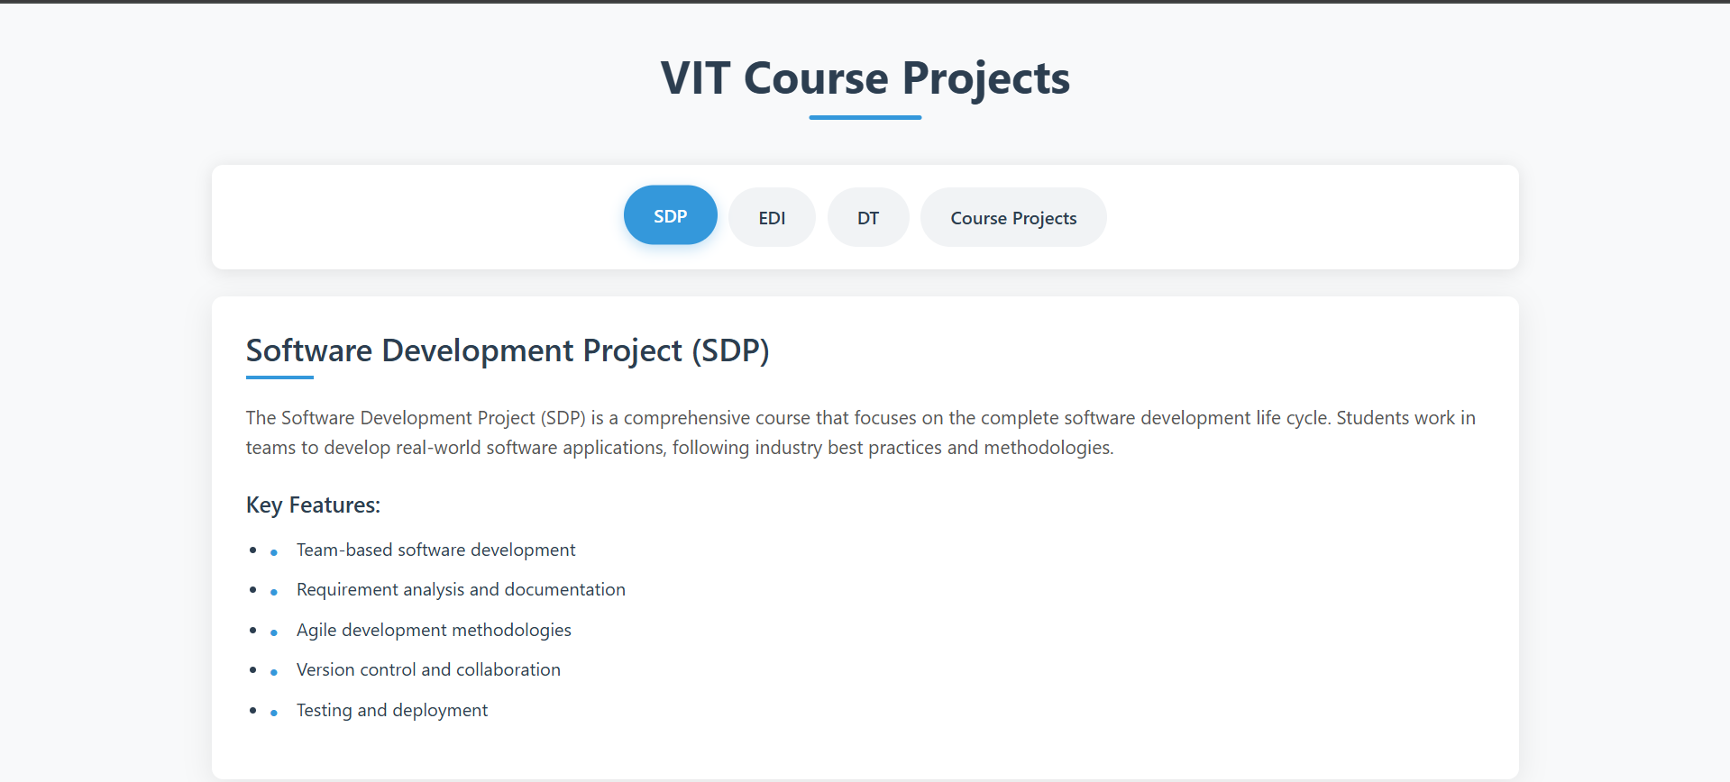

- Screenshot 2: SDP Tab


- Screenshot 3: EDI Tab
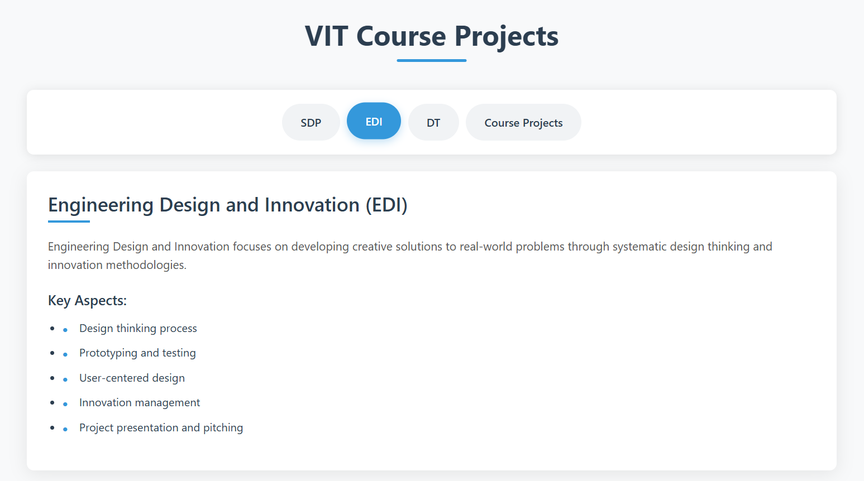

- Screenshot 4: DT Tab

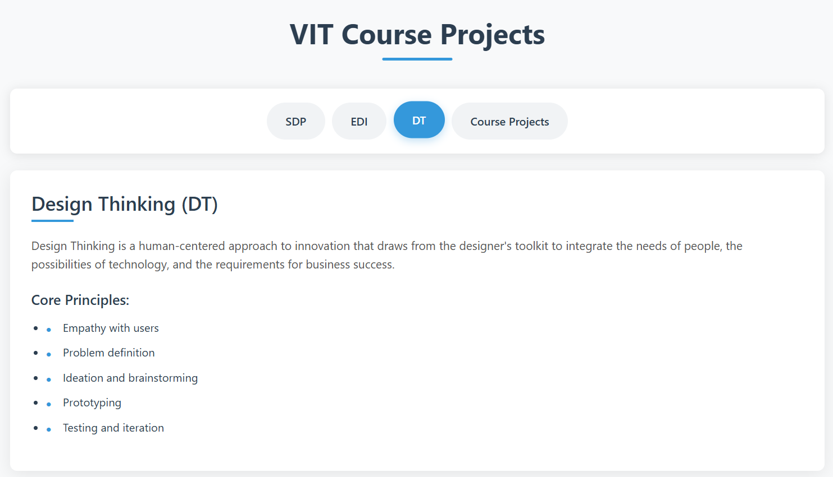

- Screenshot 5: Course Projects Tab

