Advanced Data Analysis and Visualization in Logistics
Week 3 Task — Exploratory Analysis of a Simulated Logistics Operations Dataset
Prepared using Python (pandas, numpy, matplotlib, seaborn)
Report Date: September 2026

1. Executive Summary
This report presents an end-to-end exploratory data analysis (EDA) of a simulated logistics operations dataset covering 5,000 shipments across a full calendar year. The objective is to demonstrate how data-driven analysis and visualization can surface operational bottlenecks, cost drivers, and service-quality issues in a logistics network, and to translate those findings into actionable recommendations.
Key findings from the analysis:
- The network's overall on-time delivery rate is 64.5%, but this average masks a severe seasonal collapse: on-time performance falls from a stable ~70-75% for most of the year to just 26-29% in November-December, driven by holiday-season volume surges.
- Transportation cost is most strongly correlated with distance (r = 0.46) rather than shipment size, indicating that route efficiency and mode selection are bigger cost levers than shipment consolidation alone.
- Air freight delivers the best on-time rate (71.0%) and lowest damage rate (1.4%) but costs roughly 4-6x more per shipment than Road, Rail, or Sea — a clear cost/service trade-off.
- Sea freight has both the lowest on-time rate (59.7%) and the highest damage rate (5.5%), making it the weakest link in the network for cargo integrity and schedule reliability.
- Delivery delay and damage are the two strongest negative drivers of customer satisfaction (r = -0.54 and r = -0.51 respectively with customer rating), more influential than cost or shipment size.
These findings point to a clear priority: stabilizing peak-season (Nov-Dec) capacity and shoring up Sea-freight reliability would deliver the largest improvement in customer experience per dollar invested.

2. Methodology

2.1 Data Simulation
Because a live logistics dataset was not available for this exercise, a realistic synthetic dataset was generated in Python (NumPy/pandas) to model a mid-size parcel and freight delivery network. The simulation encodes realistic relationships between variables — for example, Air shipments are faster but more expensive, Sea shipments are cheaper but slower and more damage-prone, and a November-December holiday peak introduces additional volume, cost, and delay pressure. This mirrors patterns commonly reported in real-world logistics benchmarking studies.
Dataset structure — 5,000 shipment records, 17 variables:
Variable | Type | Description
shipment_id | Integer | Unique shipment identifier
ship_date | Date | Date shipment left the origin hub (Jan-Dec 2025)
origin_hub | Categorical | Originating distribution center (6 hubs)
destination_region | Categorical | Delivery region (6 regions incl. International)
transport_mode | Categorical | Road / Air / Rail / Sea
carrier | Categorical | Carrier company (4 carriers)
shipment_volume_m3 | Float | Shipment volume in cubic meters
weight_kg | Float | Shipment weight in kilograms
distance_km | Float | Travel distance in kilometers
planned_delivery_days | Integer | SLA-promised transit time
actual_delivery_days | Integer | Actual transit time
delivery_delay_days | Integer | Actual minus planned days (negative = early)
transportation_cost | Float (USD) | Total cost to move the shipment
fuel_surcharge_pct | Float | Fuel surcharge applied (%)
on_time_flag | Binary | 1 if delivered on or before planned date
damaged_flag | Binary | 1 if shipment arrived damaged
customer_rating | Float (1-5) | Post-delivery satisfaction score

# Excerpt: simulating mode-dependent cost & delay behavior
mode_profile = {
"Road": {"speed_kmpd": 700, "cost_per_km": 1.10, "delay_std": 0.9, "damage_rate": 0.020},
"Air": {"speed_kmpd": 4000, "cost_per_km": 3.40, "delay_std": 0.5, "damage_rate": 0.015},
"Rail": {"speed_kmpd": 500, "cost_per_km": 0.55, "delay_std": 1.4, "damage_rate": 0.030},
"Sea": {"speed_kmpd": 350, "cost_per_km": 0.25, "delay_std": 2.5, "damage_rate": 0.045},
}
peak_season = month in (11, 12) # Nov-Dec holiday surge
delay_noise = np.random.normal(1.0 if peak_season else 0.0, profile['delay_std'])
actual_days = max(1, round(planned_days + delay_noise))

2.2 Analytical Approach
The analysis followed a standard EDA workflow using Python's pandas, NumPy, matplotlib, and seaborn libraries:
- Descriptive statistics (mean, median, standard deviation, skew) for all numeric variables.
- Group-by aggregations to compare performance across transport mode, carrier, destination region, and month.
- Pearson correlation analysis among numeric variables to identify relationships and potential cost/quality drivers.
- Seven purpose-built visualizations selected to match the analytical question being asked (distribution, comparison, trend, relationship, and multi-variable correlation).

3. Exploratory Data Analysis

3.1 Descriptive Statistics
Summary statistics for the core numeric variables (n = 5,000 shipments):
Variable | Mean | Median | Std Dev | Min | Max
Shipment volume (m³) | 3.63 | 3.02 | 2.53 | 0.10 | 21.16
Weight (kg) | 544.09 | 436.15 | 417.10 | 9.10 | 3,665.00
Distance (km) | 1,422.37 | 900.70 | 1,671.24 | 50.00 | 10,153.70
Planned delivery (days) | 3.59 | 2.00 | 4.47 | 1 | 30
Actual delivery (days) | 3.79 | 2.00 | 4.59 | 1 | 31
Delivery delay (days) | 0.20 | 0.00 | 1.33 | -8 | 10
Transportation cost (USD) | $1,891.47 | $1,167.75 | $3,197.23 | $87.58 | $38,475.11
Fuel surcharge (%) | 10.41 | 10.20 | 4.29 | 3.0 | 18.0
Customer rating (1-5) | 4.63 | 4.81 | 0.50 | 1.00 | 5.00

Two distributional patterns stand out. First, transportation cost is heavily right-skewed (skew = 6.51) — most shipments are inexpensive, but a long tail of high-distance/international shipments pulls the mean (~$1,891) well above the median (~$1,168). Second, customer rating is left-skewed (skew = -2.00): most deliveries score highly (median 4.81/5), but a meaningful minority of poor experiences drag the distribution's tail downward — these are the shipments logistics managers should focus on.

3.2 On-Time Performance and Damage Rate by Transport Mode
Mode | Shipments | On-Time % | Avg Delay (days) | Avg Cost (USD) | Damage % | Avg Rating
Road | 2,428 | 64.9% | 0.19 | $1,202.46 | 2.51% | 4.68
Air | 925 | 71.0% | 0.28 | $5,359.37 | 1.41% | 4.73
Sea | 894 | 59.7% | 0.17 | $879.63 | 5.48% | 4.41
Rail | 753 | 60.8% | 0.19 | $1,054.42 | 3.59% | 4.60

3.3 Correlation Analysis
Pearson correlation coefficients were computed across all numeric variables (full matrix in Section 4.6). The relationships most relevant to operational decision-making:
- Distance vs. transportation cost: r = 0.46 (moderate positive) — distance is a real but not dominant cost driver, since mode choice and surcharges also matter.
- Delivery delay vs. customer rating: r = -0.54 (moderate-strong negative) — the single largest measurable driver of customer dissatisfaction in this dataset.
- Damage flag vs. customer rating: r = -0.51 (moderate-strong negative) — nearly as damaging to satisfaction as late delivery.
- Shipment volume vs. transportation cost: r ≈ 0.00 (negligible) — in this network, physical shipment size barely affects total cost compared to distance and mode.
- Fuel surcharge vs. transportation cost: r = 0.03 (negligible) — surcharges are currently a minor cost component relative to base distance/mode cost.

4. Visualizations and Interpretation
Each chart below was chosen because its format matches the analytical question being asked: distributions use histograms, categorical comparisons use bar/box plots, trends over time use line charts, bivariate relationships use scatter plots, and multi-variable relationships use a heatmap. Python code excerpts (using matplotlib and seaborn) are included beneath each chart.

4.1 Distribution of Delivery Delay
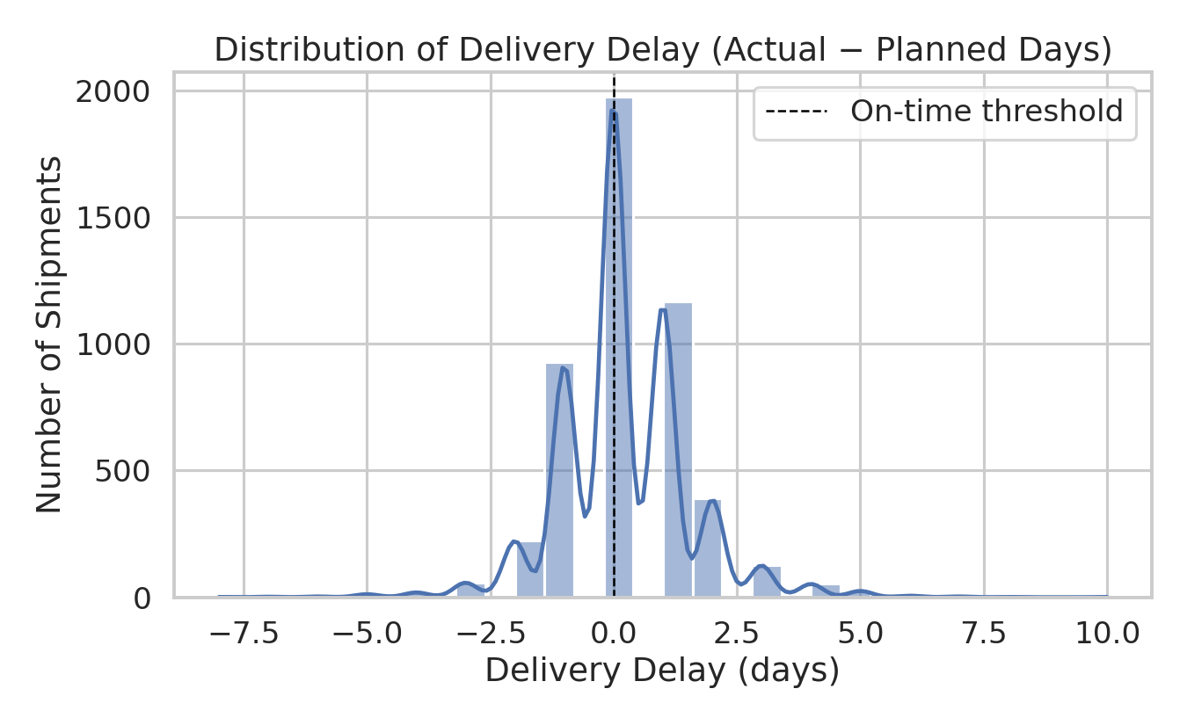
Figure: 4.1 Distribution of Delivery Delay
sns.histplot(df['delivery_delay_days'], bins=30, kde=True)
plt.axvline(0, linestyle='--', label='On-time threshold')
plt.title('Distribution of Delivery Delay (Actual - Planned Days)')
Why this chart: A histogram with a kernel density overlay is the standard tool for examining the shape, center, and spread of a continuous variable, and for spotting skew or outliers that summary statistics alone can hide.
Insight: The distribution is centered near zero but has a distinct right tail extending to +10 days. This tail — rather than the average delay of 0.2 days — represents the shipments doing the most damage to customer experience, and is concentrated in the November-December peak (see Section 4.4).

4.2 Transportation Cost by Transport Mode
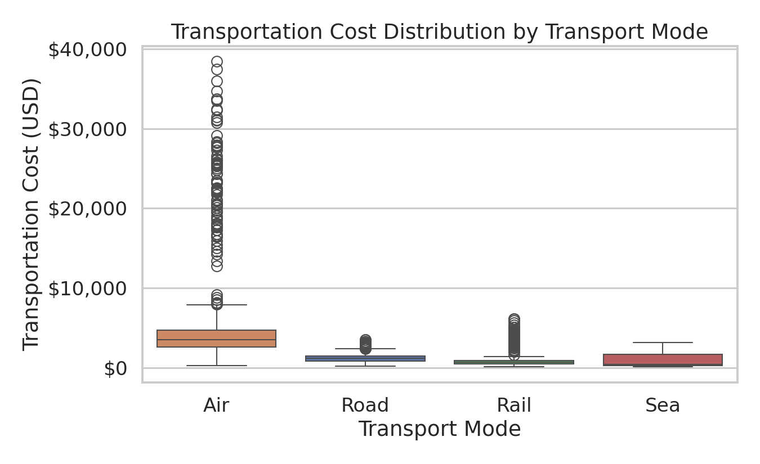
Figure: 4.2 Transportation Cost by Transport Mode
order = df.groupby('transport_mode')['transportation_cost']\
.median().sort_values(ascending=False).index
sns.boxplot(data=df, x='transport_mode', y='transportation_cost', order=order)
Why this chart: Box plots reveal the median, interquartile range, and outliers of a numeric variable across categories simultaneously — far more informative than comparing means alone when a variable is skewed (as cost is here).
Insight: Air freight's cost distribution sits well above the other three modes, with a wide spread and many high-cost outliers (long-haul international air shipments). Road, Rail, and Sea show similar, more compact cost distributions, confirming that mode selection — not shipment characteristics — is the primary cost lever.

4.3 On-Time Delivery Rate by Transport Mode
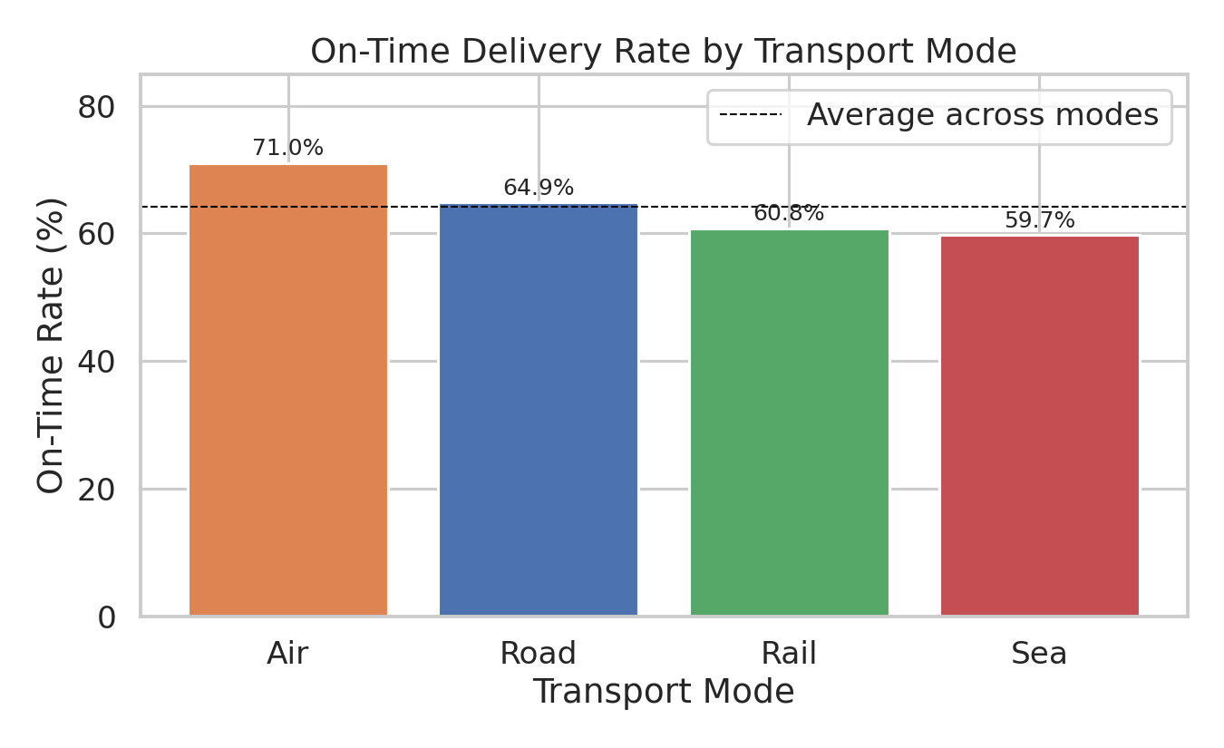
Figure: 4.3 On-Time Delivery Rate by Transport Mode
mode_ontime = df.groupby('transport_mode')['on_time_flag'].mean() * 100
plt.bar(mode_ontime.index, mode_ontime.values)
plt.axhline(mode_ontime.mean(), linestyle='--', label='Average')
Why this chart: A simple bar chart is the clearest way to compare a single performance metric (on-time rate) across a small number of categories (transport modes).
Insight: Air outperforms every other mode at 71.0% on-time, while Sea lags at 59.7%. The 11-point gap between the best and worst mode suggests that shifting time-sensitive, high-value shipments away from Sea freight — or renegotiating Sea carrier SLAs — is a concrete lever for improving overall network reliability.

4.4 Monthly Shipment Volume vs. On-Time Rate (Seasonality)
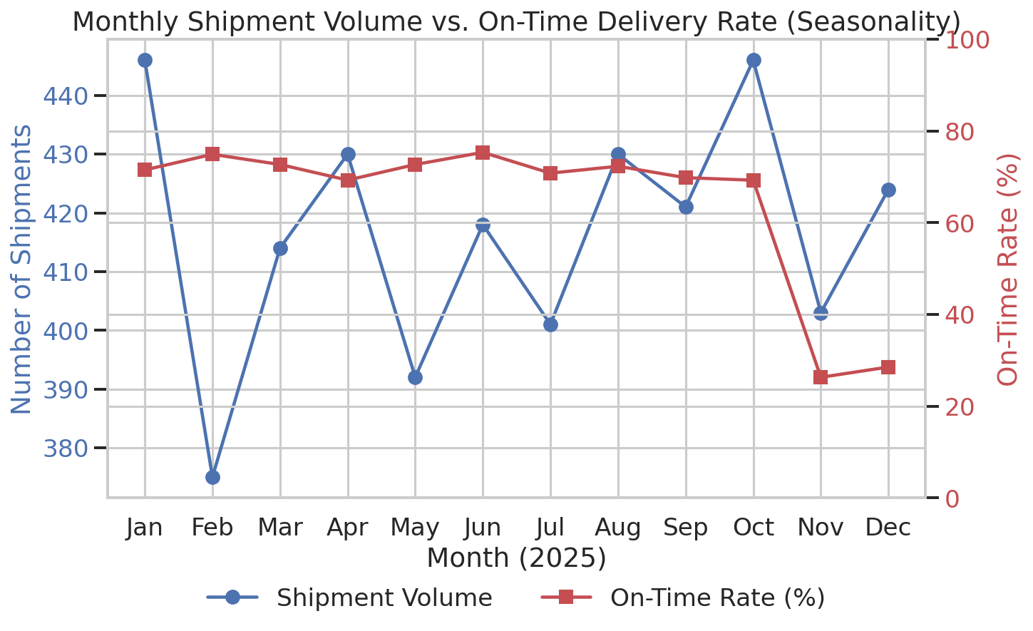
Figure: 4.4 Monthly Shipment Volume vs. On-Time Rate (Seasonality)
monthly = df.groupby('month').agg(shipments=('shipment_id','count'),
on_time_rate=('on_time_flag','mean'))
ax1.plot(months, monthly['shipments']) # left axis
ax2.plot(months, monthly['on_time_rate'] * 100) # right axis
Why this chart: A dual-axis line chart is the right tool for showing how two related metrics move together over time — here, shipment volume and on-time rate across the calendar year.
Insight: On-time performance is remarkably stable (70-75%) from January through October, then collapses to 26.3% in November and 28.5% in December — precisely when shipment volume peaks. This is the single most important finding in the analysis: the network's capacity is not sized for holiday-season demand, and this seasonal surge — not any structural mode or carrier problem — is the dominant driver of the network's mediocre annual on-time average.

4.5 Transportation Cost vs. Distance by Mode
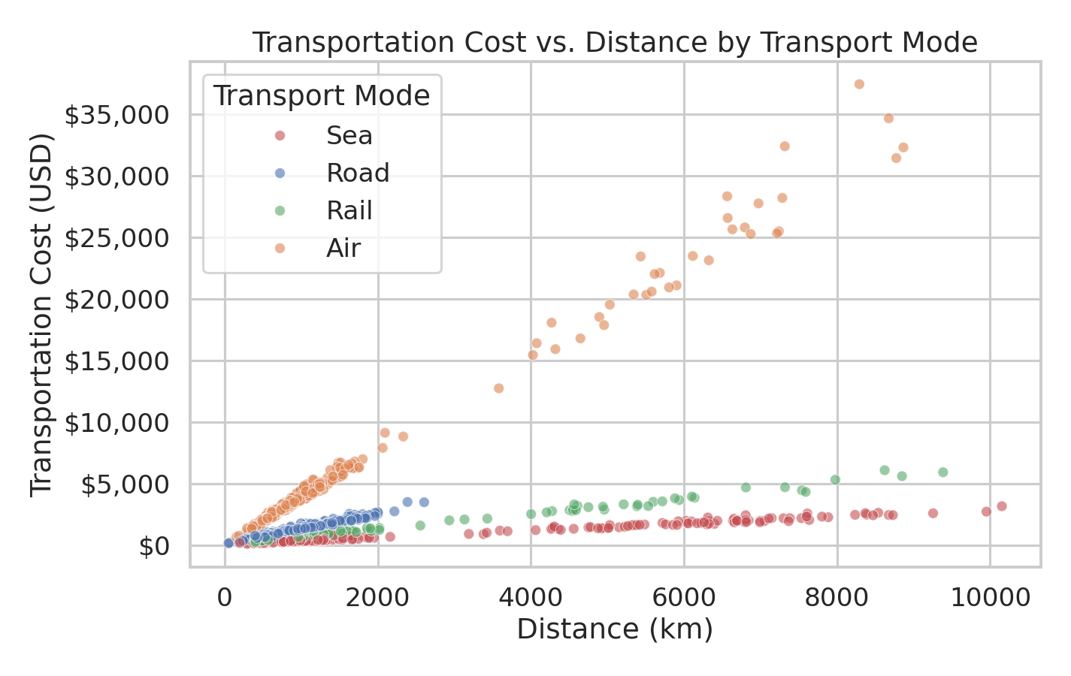
Figure: 4.5 Transportation Cost vs. Distance by Mode
sns.scatterplot(data=sample, x='distance_km', y='transportation_cost',
hue='transport_mode', alpha=0.6)
Why this chart: A scatter plot is the standard way to visualize the relationship between two continuous variables, and coloring by a third categorical variable (mode) shows whether that relationship differs by group.
Insight: All four modes show cost rising with distance, but at very different rates (slopes) — Air's cost line is visibly steeper than Road, Rail, or Sea. This confirms that the moderate overall distance-cost correlation (r = 0.46) is really an average across modes with quite different cost-per-kilometer economics, reinforcing that route/mode assignment decisions should be distance-aware.

4.6 Correlation Heatmap of Key Variables
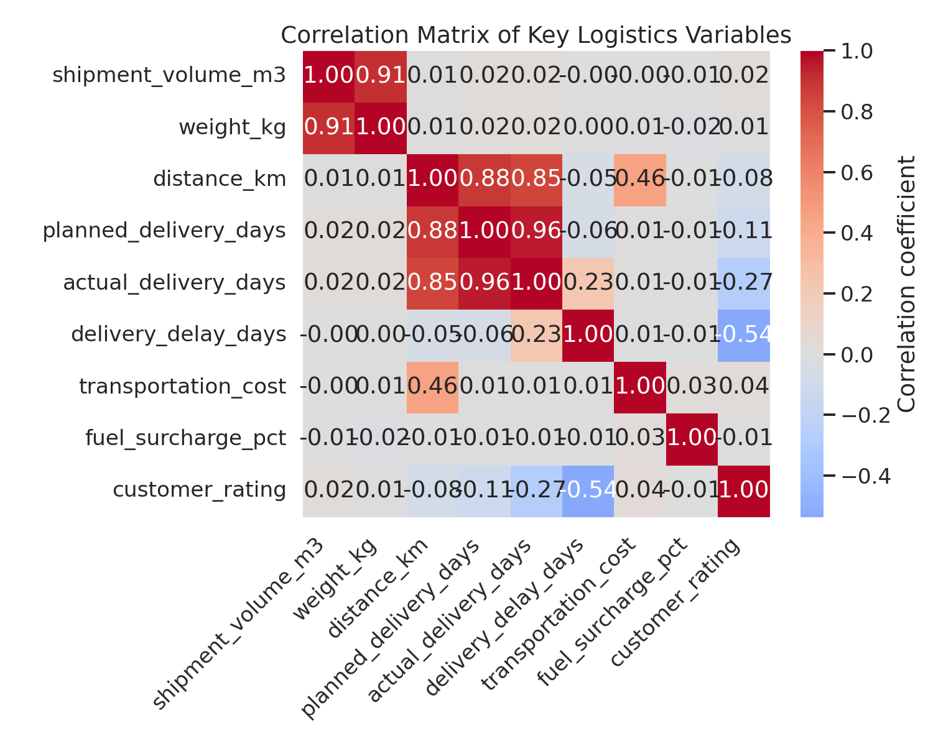
Figure: 4.6 Correlation Heatmap of Key Variables
corr = df[numeric_cols].corr()
sns.heatmap(corr, annot=True, fmt='.2f', cmap='coolwarm', center=0)
Why this chart: A heatmap condenses many pairwise correlations into a single, scannable view — essential once more than 3-4 numeric variables are involved, where individual scatter plots would be impractical to compare.
Insight: The heatmap confirms two clusters: (1) shipment_volume_m3 and weight_kg are highly correlated with each other (r = 0.91) but essentially uncorrelated with cost — a candidate for dimensionality reduction in future modeling; (2) delivery_delay_days and customer_rating form the strongest cross-category relationship (r = -0.54) in the dataset, underscoring that on-time performance — more than cost or size — is what drives customer perception.

4.7 Damage Rate and Customer Rating by Transport Mode
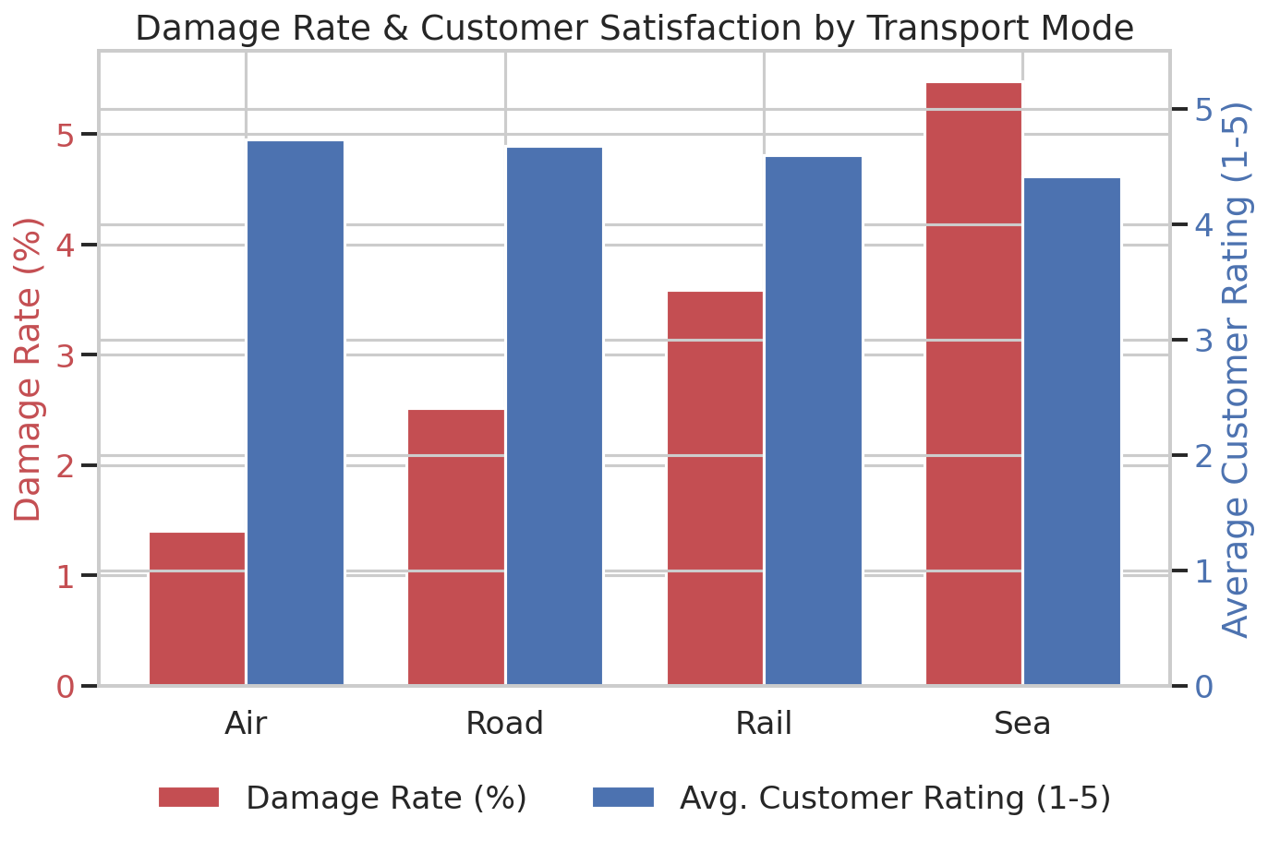
Figure: 4.7 Damage Rate and Customer Rating by Transport Mode
mode_quality = df.groupby('transport_mode').agg(
damage_rate=('damaged_flag','mean'), avg_rating=('customer_rating','mean'))
ax1.bar(x - w/2, mode_quality['damage_rate']*100) # left axis
ax2.bar(x + w/2, mode_quality['avg_rating']) # right axis
Why this chart: A grouped dual-metric bar chart lets us see whether two related quality indicators (damage rate and customer rating) move together across categories, which a single chart of either metric alone would not show.
Insight: Sea freight's damage rate (5.5%) is nearly 4x Air's (1.4%), and its average customer rating (4.41) is the lowest of all four modes — visually confirming the damage-satisfaction relationship identified in the correlation analysis and pinpointing Sea freight handling/packaging as a priority improvement area.

5. Analytical Insights and Recommendations

5.1 Operational Efficiency
- The network's overall 64.5% on-time rate is an average of a stable ~72% baseline and a November-December collapse to ~27%. Treating this as one number obscures the real problem: peak-season capacity planning, not year-round process quality.
- Recommendation: Model peak-season demand explicitly (e.g., using the prior year's Nov-Dec volume as a forecast input), and pre-book additional carrier capacity or temporary cross-docking capacity for those two months rather than relying on average-case staffing and routing plans.

5.2 Cost Drivers
- Distance (r = 0.46) and transport mode are the primary determinants of shipment cost; shipment volume/weight are not (r ≈ 0.00). This means cost-reduction efforts should focus on route optimization and mode-mix decisions rather than load consolidation alone.
- Recommendation: For non-urgent shipments currently routed via Air, evaluate a shift to Road or Rail where transit-time SLAs allow — Air costs 4-6x more per shipment with only a 6-11 point on-time advantage over Road/Rail, a trade-off that may not be worthwhile for all cargo types.

5.3 Bottlenecks and Service Quality
- Sea freight is the weakest link on two independent dimensions simultaneously: lowest on-time rate (59.7%) and highest damage rate (5.5%), and correspondingly the lowest customer rating (4.41/5) of any mode.
- Recommendation: Audit Sea freight packaging standards and carrier handling procedures to reduce damage, and consider tightening or renegotiating Sea carrier SLA terms given the mode's below-average reliability.
- Delivery delay and damage are the two strongest predictors of poor customer ratings in this dataset (r = -0.54 and -0.51), both considerably stronger than the relationship between cost and rating. This suggests that investment in on-time reliability and cargo protection will move customer satisfaction more than price competitiveness will.

5.4 Summary of Recommendations (Priority Order)
- 1. Build a peak-season (Nov-Dec) capacity plan — the single highest-impact fix identified in this analysis.
- 2. Investigate and remediate Sea freight damage causes (packaging, handling, carrier SLAs).
- 3. Reassess Air vs. Road/Rail mode assignment rules to balance the cost/service trade-off shipment-by-shipment rather than by blanket policy.
- 4. Track delivery delay and damage rate as leading indicators of customer satisfaction, rather than relying on cost or volume metrics alone.

6. Conclusion
This analysis demonstrates how a structured EDA workflow — descriptive statistics, group comparisons, correlation analysis, and purpose-matched visualizations — can turn a raw logistics dataset into specific, prioritized operational recommendations. The most actionable finding is that the network's headline on-time rate is driven almost entirely by a predictable seasonal capacity shortfall rather than a chronic, uniform service problem, meaning a targeted seasonal intervention is likely to yield outsized returns relative to broad, network-wide process changes. Secondary findings around Sea-freight damage rates and mode-based cost/service trade-offs provide additional, well-supported levers for continued improvement.

6.1 Tools and Techniques Used
- Python (pandas, NumPy) for data simulation and manipulation.
- pandas groupby/aggregation for categorical performance comparisons.
- Pearson correlation (pandas .corr()) for bivariate relationship analysis.
- matplotlib and seaborn for all visualizations: histogram+KDE, box plot, bar chart, dual-axis line chart, scatter plot, and correlation heatmap.

