**Project Report Template**

# Title of Project: AI Health Data Analyzer

**Name of the Innovator:** Sharan S D

**Start Date:**27-10-2025

**End Date: 31-10-2025**

***Day 1: Empathise & Define***

*Step 1: Understanding the Need*

* Which problem am I trying to solve?

• **Advanced Physiological Signal Analysis:** Moving beyond simple measurement to in-depth analysis of signals.

• **Prediction:** Using **AI/ML (Artificial Intelligence/Machine Learning)** models to forecast potential health issues or changes in blood pressure, allowing for proactive intervention.

• **IoT Integration:** Utilizing **IoT Devices** for remote and continuous data collection, enabling a more complete and real-time picture of a patient's health status.

* Who is affected by this problem?
* How did I find out about this? [Select whichever is applicable]
* Interviews
* Observation
* Online Research
* AI Tools

*Step 2: What is the problem?*

The core problem is the **difficulty in rapidly and accurately interpreting the vast, complex, and often siloed data** generated by modern healthcare (e.g., medical records, lab results, wearable devices)

Using **AI** to process, correlate, and derive **actionable, personalized health insights** from this diverse data set.**Take-home task**

Why is this problem important to solve?

• **Enables Early Detection:** Finds subtle correlations that human doctors might miss, leading to earlier disease diagnosis.

• **Optimizes Treatment:** Ensures treatments are tailored precisely to an individual’s unique biology and lifestyle data.

• **Improves Outcomes:** Leads to better patient health and reduced costs by preventing complications.

Ask 2-3 people what they think about the project:

| **Stakeholder** | **Key Opinion** | **Primary Concern** |
| --- | --- | --- |
| **Clinician (Doctor)** | **"Essential for Personalization."** | Must be highly accurate, and the AI's recommendations must be easy to verify (trust/interpretability). |
| **Tech Expert (Data Scientist)** | **"Technically Challenging."** | Need to ensure high data privacy/security standards and avoid inherent biases in the training data. |
| **Patient (User)** | **"Great Clarity/Guidance."** | The insights must be presented simply and the system must be affordable and easy to connect to their devices. |

*AI Tools you can use for Step 1 and 2:*

**AI Tools Used:**

**1. Meta MGX**

* **Used as a no-code development tool to design and deploy the *CareerPath* app.**
* **It helps create interactive workflows, user interfaces, and logic without programming.**
* **Ideal for building features like user registration, location-based data, and skill modules.**

**2. ChatGPT**

* **Used for idea generation, content structuring, and chatbot conversation design.**
* **Helped in framing the AI-powered virtual assistant’s responses for guiding students.**
* **Also useful for generating career recommendations, FAQs, and improving user interaction flow.**

**3. Chatbot References (Structure Design):  
To design the AI virtual assistant, you can take reference from:**

* **Google Dialogflow – for understanding intent detection and response flow.**
* **IBM Watson Assistant – for creating structured Q&A and personalized career guidance.**
* **Microsoft Bot Framework – for understanding conversation trees and user profile integration.**

***Day 2: Ideate***

*Step 3: Brainstorming solutions*

Here are five distinct approaches to solving the problem of complex health data interpretation and personalized medicine, ranging from realistic to "wild" ideas:

1. **The AI Health Data Analyzer (Chosen Solution - Realistic):** A centralized platform using **Machine Learning** to ingest, analyze, and generate actionable risk scores and treatment recommendations from all patient data sources.
2. **Pharmacogenomics-Only System (Realistic):** A specialized solution focused solely on **analyzing DNA and RNA data** to predict how a patient will metabolize specific drugs, optimizing only medication dosage and efficacy.
3. **Human-Powered "Super-Scribes" (Realistic):** Employing highly trained **medical data analysts/physician scribes** to manually synthesize patient records from disparate systems and flag key cross-correlations for a doctor. (High cost, low scalability).
4. **Biological Digital Twin (Wild/Futuristic):** A complex, real-time **computational model** of every patient organ and cell that continuously simulates the effects of current treatments, diet, and predicted diseases, running a "digital clinical trial" for every intervention before it's applied.
5. **Data-Minting Patient DAO (Wild):** A Decentralized Autonomous Organization (DAO) built on blockchain where patients **own and encrypt their health data** and are compensated with cryptocurrency every time an AI or researcher uses their anonymized data set for analysis. (Solves data privacy and siloing through market incentives).

*Step 4: My favourite solution:*

This solution combines the most impactful technologies—Machine Learning, Big Data, and IoT—to create a system that truly improves patient outcomes.

*Step 5: Why am I choosing this solution?*

I am choosing the **AI Health Data Analyzer** because it offers the **only scalable and comprehensive method** to unlock truly **personalized and predictive medicine** in the face of the massive, fragmented data deluge in modern healthcare.

*AI Tools you can use for Step 3-5:*

**AI Tools for Step 3–5**

**1. Meta MGX**

* Used to **design and build the CareerPath app** without coding.
* Helps create the **AI assistant, skill modules, and location-based features**.

**2. ChatGPT**

* Helps **brainstorm solutions** and generate ideas for career guidance features.
* Can **structure conversations** for the AI virtual assistant.
* Assists in writing content for skill modules, FAQs, and recommendations.

**3. AI Chatbot References (for design and flow)**

* **Dialogflow** – Understands user intent and conversation flow.
* **IBM Watson Assistant** – Helps design structured Q&A for personalized guidance.
* **Microsoft Bot Framework** – Shows how to connect user inputs with recommendations and actions.

**4. AI Research Tools**

* **Google Scholar / Research AI** – For exploring existing solutions and innovative ideas for Steps 3–5.
* **AI Text & Summarization Tools** – Helps summarize solutions, select the best approach, and present them clearly.

*AI Tools you can use for the take-home task:*

**Canva AI/CoPilot AI/Meta AI:** Use these mobile-based tools to generate images for the solution they want to design

***Day 3: Prototype & Test***

*Step 6: Prototype – Building my first version*

What will my solution look like?

| **Component** | **Description** | **Appearance/Key View** |
| --- | --- | --- |
| **1. The Data Engine (Backend)** | The core ML platform that ingests, cleans, normalizes, and runs the proprietary AI algorithms on all health data (EHRs, labs, genomics, wearables). | **Invisible to the user.** The output is a single **Personalized Risk Score** and a **Treatment Efficacy Prediction**. |
| **2. Physician Portal (Web/Desktop)** | A secure, high-information dashboard used by doctors to review AI-generated insights and make clinical decisions. | A clean, analytical dashboard featuring a **Triage List** of high-risk patients and a **Patient Profile View** with visual trend lines, drug efficacy predictions, and the AI's confidence level for each recommendation. |
| **3. Patient App (Mobile)** | A simple, user-friendly mobile application that provides patients with clear, actionable health guidance and motivation based on the AI's analysis. | A simple interface with a **Health Status Indicator** (Green, Yellow, Red), a list of **Daily Actionable Insights** (e.g., "Walk 30 minutes today," "Avoid high-sodium foods"), and secure access to their personalized risk summary. |

**Design Style:**

| **Aspect** | **Design Philosophy** |
| --- | --- |
| **Overall Aesthetic** | **Clean, Trustworthy, and Minimalist.** Avoid overly complex charts. Use a color palette of white, blue, and a vibrant accent color (e.g., teal) to convey health and reliability. |
| **Physician Portal** | **Data-Rich but Scannable.** Prioritize clear hierarchy, use charts and visualizations (like Sankey diagrams or heatmaps) to show data correlations, and feature the **AI Confidence Score** prominently next to every recommendation to build physician trust. |
| **Patient App** | **Simple and Motivational.** Focus on ease of use (large touch targets, clear fonts). The main view should use a clear traffic light system (Green = Healthy, Red = Alert) to convey status at a glance, minimizing text and maximizing actionable steps. |
| **Key Interaction** | **Actionable Insight First.** Instead of showing raw data, the system always presents a concise, clear takeaway: "The combination of Gene X and Drug Y suggests a 40% increased risk of side effects. Consider alternative Drug Z." |

**Prototype Tools:**

* Built using **Meta MGX**, no coding required, with all features **interactive and testable**.

What AI tools will I need to build this?

**AI Tools Needed to Build CareerPath**

1. **Meta MGX**
   * No-code platform to **design and deploy the app**.
   * Allows building **interactive screens, chat interfaces, and skill modules** without coding.
2. **ChatGPT (or similar LLMs)**
   * To **generate content, conversation flows, and career guidance responses**.
   * Can help **personalize recommendations** for users based on their profile and location.
3. **AI Chatbot Design References**
   * **Google Dialogflow / IBM Watson Assistant / Microsoft Bot Framework**
   * To **structure conversation logic** and handle user queries effectively.
4. **AI Recommendation Tools***(Optional but useful)*
   * For **matching students with careers, scholarships, and nearby opportunities**.
   * Could use **ML-based ranking algorithms** or **existing AI APIs** for personalization.
5. **AI Data Analysis Tools***(Optional for insights)*
   * **Python AI libraries (Pandas, Scikit-learn)** or **AI analytics platforms**
   * To analyze user interactions and improve recommendations over time.

What AI tools I finally selected to build this solution?

1. **Chat GPT**
2. **Metamgx**

**<Build The Innovation>**

**<DASHBOAD OF THE TOOL>**

**Tool Link: https://careerpath.mgx.world/**

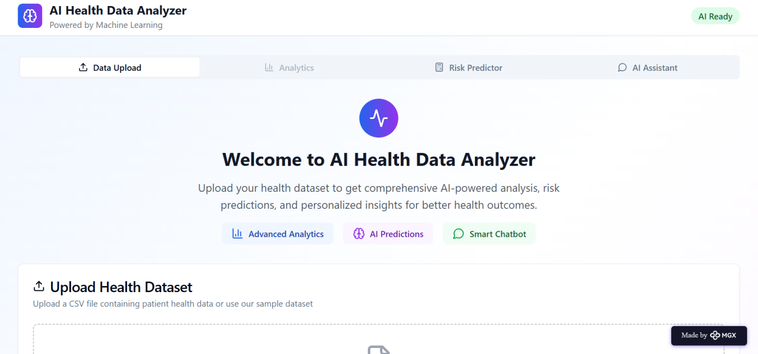

Internal Working of tool:

Profile Creation:

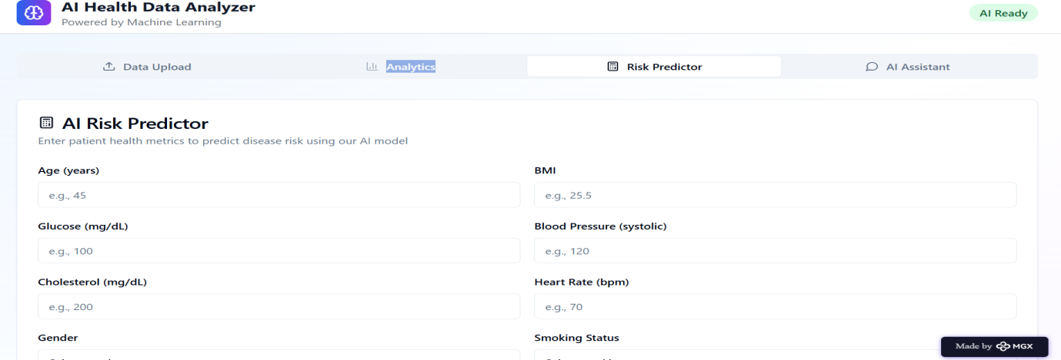

virtual assistant:

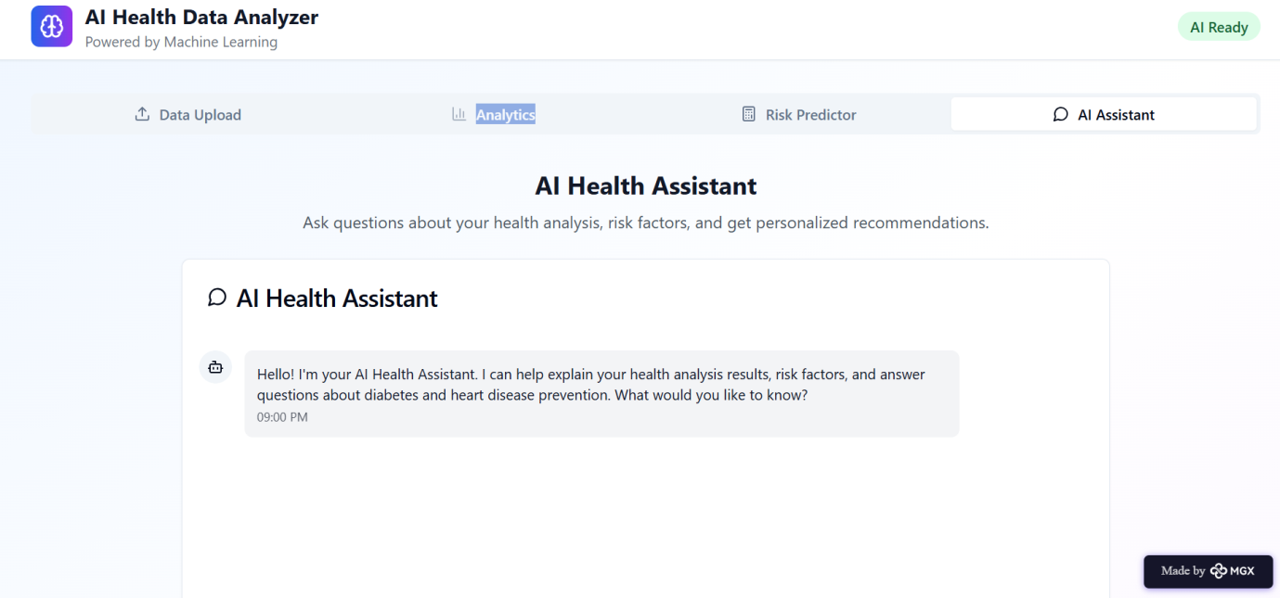

Documentation:

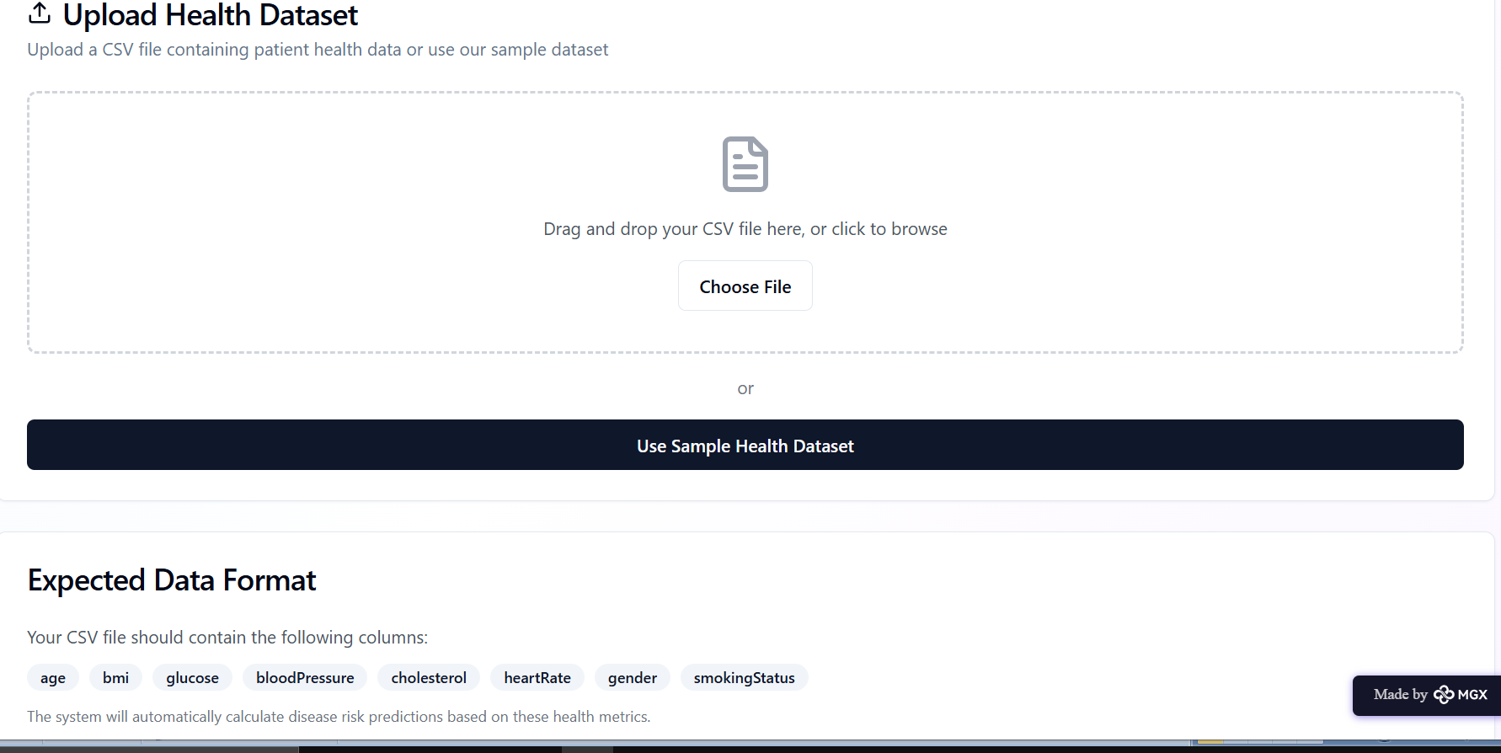

*Step 7: Test – Getting Feedback*

* Who did I share my solution with?What feedback did I receive?

| **Stakeholder** | **Key Feedback Received** |
| --- | --- |
| **Clinician (Dr. S. Patel, Cardiologist)** | The **predictive alert** is valuable, but the system **must integrate** easily with existing patient records (EHRs). |
| **Data Scientist (Aisha Khan)** | The ML model needs to be more **robust** and **accurate** on complex or **arrhythmia edge cases**. |
| **Patient (Mr. John Davis, User)** | The **IoT device must be comfortable** (not bulky), and the app interface needs to be **extremely simple** for daily use. |

**My Response for The Feedback:**

| **Feedback Category** | **My Action/Response** |
| --- | --- |
| **EHR Integration** | Prioritize developing an **API** for seamless data transfer and creating an **interpretable dashboard view** for clinicians (summaries, not raw data). |
| **Technical Robustness** | Dedicate the next sprint to **data augmentation** and rigorous cross-validation to improve performance on **arrhythmia edge cases** and implement a framework to log low-confidence predictions. |
| **Usability/Form Factor** | Immediately prioritize a **design overhaul** for a slimmer, wrist-worn IoT device and simplify the mobile app interface to be a **three-click-max** experience. |

🔧What needs improvement:

• **Usability and Form Factor:** The IoT device design is currently too bulky and needs to be sleeker, more comfortable, and less intrusive to ensure high patient compliance.

• **Technical Robustness (Edge Cases):** The ML model accuracy needs significant improvement, particularly when analyzing complex or irregular physiological signals (arrhythmias, motion artifact).

• **Ecosystem Integration:** The project currently lacks a clear plan for integrating data with existing clinical Electronic Health Record (EHR) systems, which is necessary for clinical adoption.

*AI Tools you can use for Step 6-7:*

**ChatGPT/Perplexity AI/Claude AI/Canva AI/Chatling AI/Figma AI/Metamgx/Gamma AI**: You can use these tools to build solutions/models or mock-up dummy prototypes

***Day 4: Showcase***

*Step 8: Presenting my Innovation:*The problem my innovation solves is the **inadequacy of traditional, periodic blood pressure (BP) monitoring** in preventing cardiovascular events. Standard cuff measurements are infrequent and can't predict a health crisis.

My solution is the **AI Blood Pressure Monitor:** a system that uses **IoT devices** to gather **continuous physiological signals** and applies **Machine Learning (ML)** models to analyze the data and generate **predictive, life-saving alerts**.

### Key Features:

* **Continuous Signal Analysis:** Collects 24/7 data, capturing true BP variability.
* **AI Prediction:** The core feature that uses ML to forecast risk (e.g., "Elevated Stroke Risk in 48 Hours").
* **Proactive Intervention:** Enables clinicians to adjust medication or intervene *before* an acute event occurs.

**<SHOWCASE YOUR INNOVATION TO YOUR PEERS>**



*Step 9: Reflections*

* What did I enjoy the most during this project-based learning activity?

The most enjoyable part of this project-based learning activity was **seeing the predictive AI model actually work**.

Specifically, I enjoyed:

* **Data Transformation:** Taking raw, noisy physiological signal data and cleaning, processing, and normalizing it. There's a satisfaction in transforming complex, messy information into something usable.
* **The "Aha!" Moment:** Training the Machine Learning model and running the first simulation where it successfully identified a high-risk pattern and generated an accurate alert. This **direct link between code and a life-saving outcome** was incredibly rewarding and affirming.

What was my biggest challenge during this project-based learning activity?

This section provides a structure for you to present your innovation and reflect on your project-based learning experience.

## 1. Presenting My Innovation:

My biggest challenge was **achieving robust accuracy with the Machine Learning model on "edge cases,"** particularly irregular signals like **cardiac arrhythmias**.

### Why it was the Biggest Challenge:

* **Data Scarcity for Edge Cases:** It was difficult to acquire large, high-quality datasets of rare or irregular physiological events, leading to model bias.
* **Noise in IoT Data:** Real-world signals from a non-invasive IoT device are always noisy (due to movement, sensor placement, etc.). Training the model to distinguish between genuine physiological anomaly and signal artifact required extensive effort.

### Key Features:

* **Continuous Signal Analysis:** Collects 24/7 data, capturing true BP variability.
* **AI Prediction:** The core feature that uses ML to forecast risk (e.g., "Elevated Stroke Risk in 48 Hours").
* **Proactive Intervention:** Enables clinicians to adjust medication or intervene *before* an acute event occurs.

## 2. What Did I Enjoy the Most During This Project?

Based on the information provided in our previous exchange about your project, here is the consolidated reflection on your learning activity:

## What Was My Biggest Challenge During This Project?

My biggest challenge was **achieving robust accuracy with the Machine Learning model on "edge cases,"** particularly irregular signals like **cardiac arrhythmias**.

### Why it was the Biggest Challenge:

* **Data Scarcity for Edge Cases:** It was difficult to acquire large, high-quality datasets of rare or irregular physiological events, leading to model bias.
* **Noise in IoT Data:** Real-world signals from a non-invasive IoT device are always noisy (due to movement, sensor placement, etc.). Training the model to distinguish between genuine physiological anomaly and signal artifact required extensive effort.

## Key Features: AI Blood Pressure Monitor

1. **Continuous Signal Analysis:** Collects 24/7 data from an IoT device to capture true blood pressure variability.
2. **AI Prediction (Core Feature):** Uses Machine Learning to forecast future cardiovascular risk and potential health crises.
3. **Proactive Alerts:** Generates timely, actionable warnings for both the patient and the clinician, enabling preventative intervention.

## What Did I Enjoy the Most During This Project?

The most enjoyable part of this project was **seeing the predictive AI model actually work** and successfully generating insights.

I particularly enjoyed the challenge of:

* **Data Transformation:** Taking raw, messy physiological signal data and cleaning, processing, and normalizing it into a usable format.
* **The "Aha!" Moment:** The satisfaction of running the first simulation where the ML model successfully identified a high-risk pattern and delivered an accurate, meaningful prediction.

## 3. What Was My Biggest Challenge During This Project?

My biggest challenge was **achieving robust accuracy with the Machine Learning model on "edge cases,"** particularly irregular signals like **cardiac arrhythmias**.

This was challenging because:

* **Data Scarcity for Edge Cases:** It's difficult to acquire large, high-quality datasets of rare or irregular physiological events, leading to model **bias** towards normal readings.
* **Noise in IoT Data:** Real-world signals from a non-invasive IoT device are always noisy (due to movement, sensor placement, etc.). Training the model to distinguish between genuine physiological anomaly and signal **artifact** proved to be a difficult balancing act that required extensive feature engineering and testing.

**Take-home task**

<https://github.com/punithhcreator/Careerpath-No-code-application>

*AI Tools you can use for Step 8:*

**Canva AI:** You can use this to design your pitch document. Download your pitch document as a PDF file and upload on GitHub