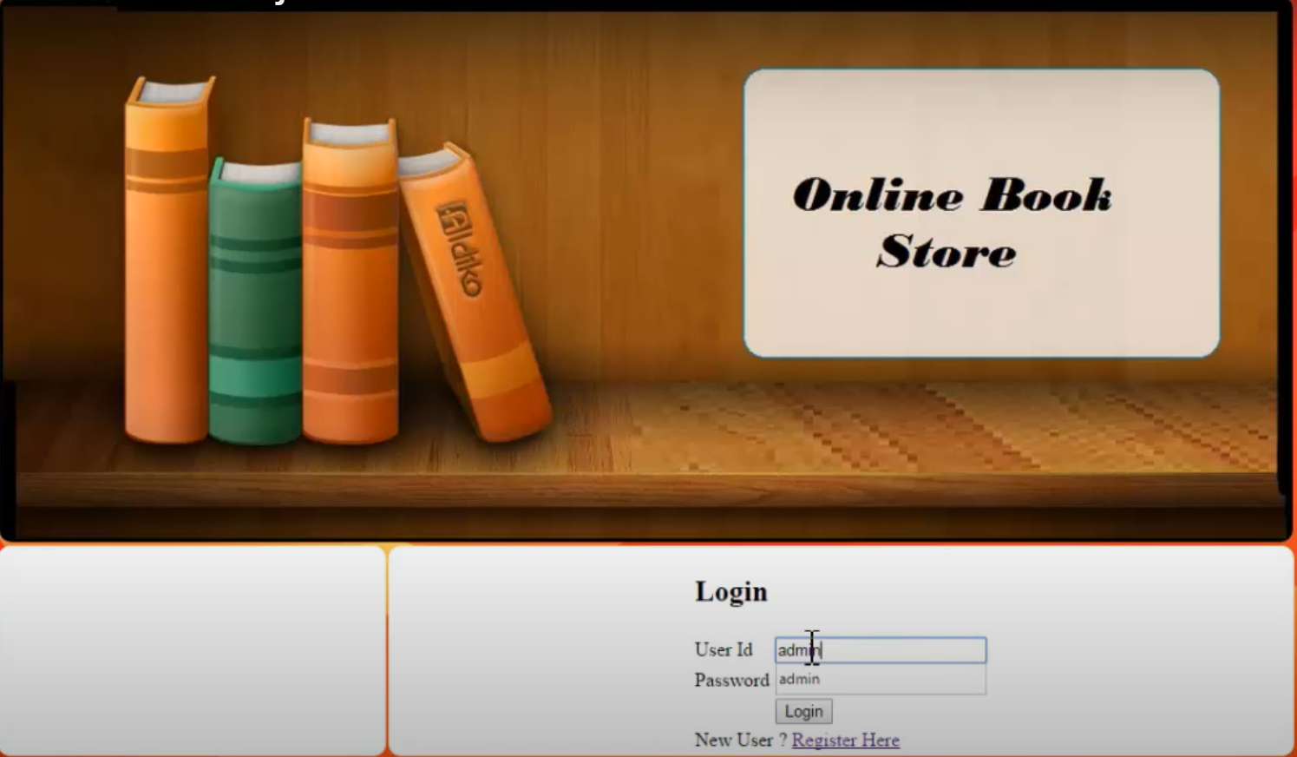

Admin Login:

Product Entry:

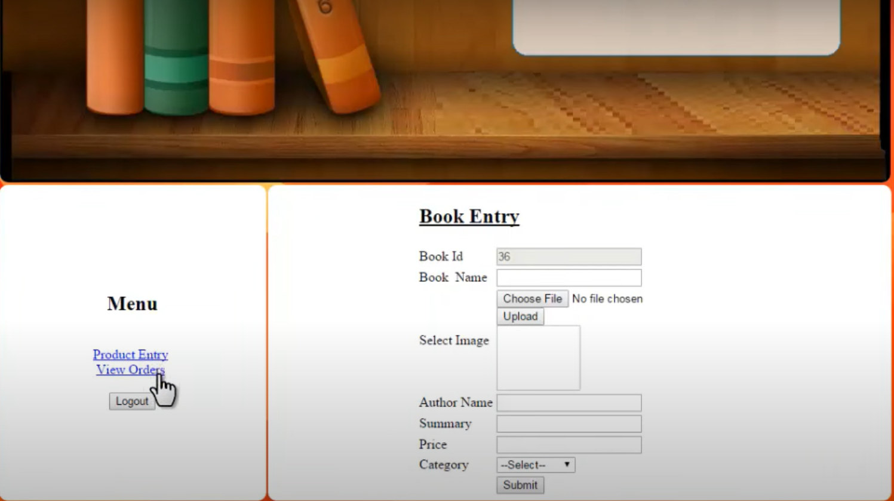

View Order

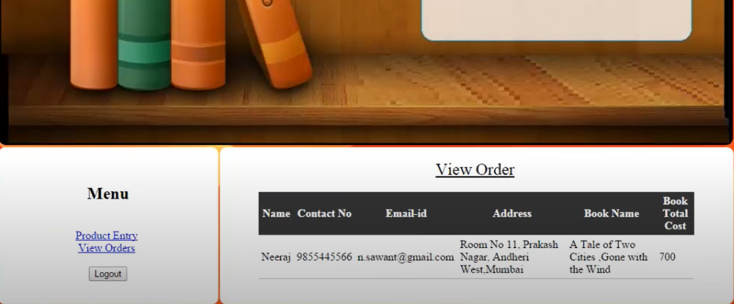

Login as User :

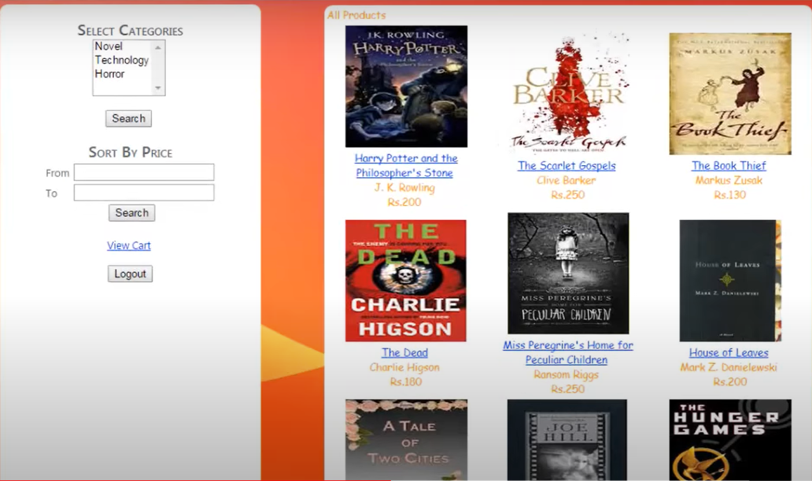

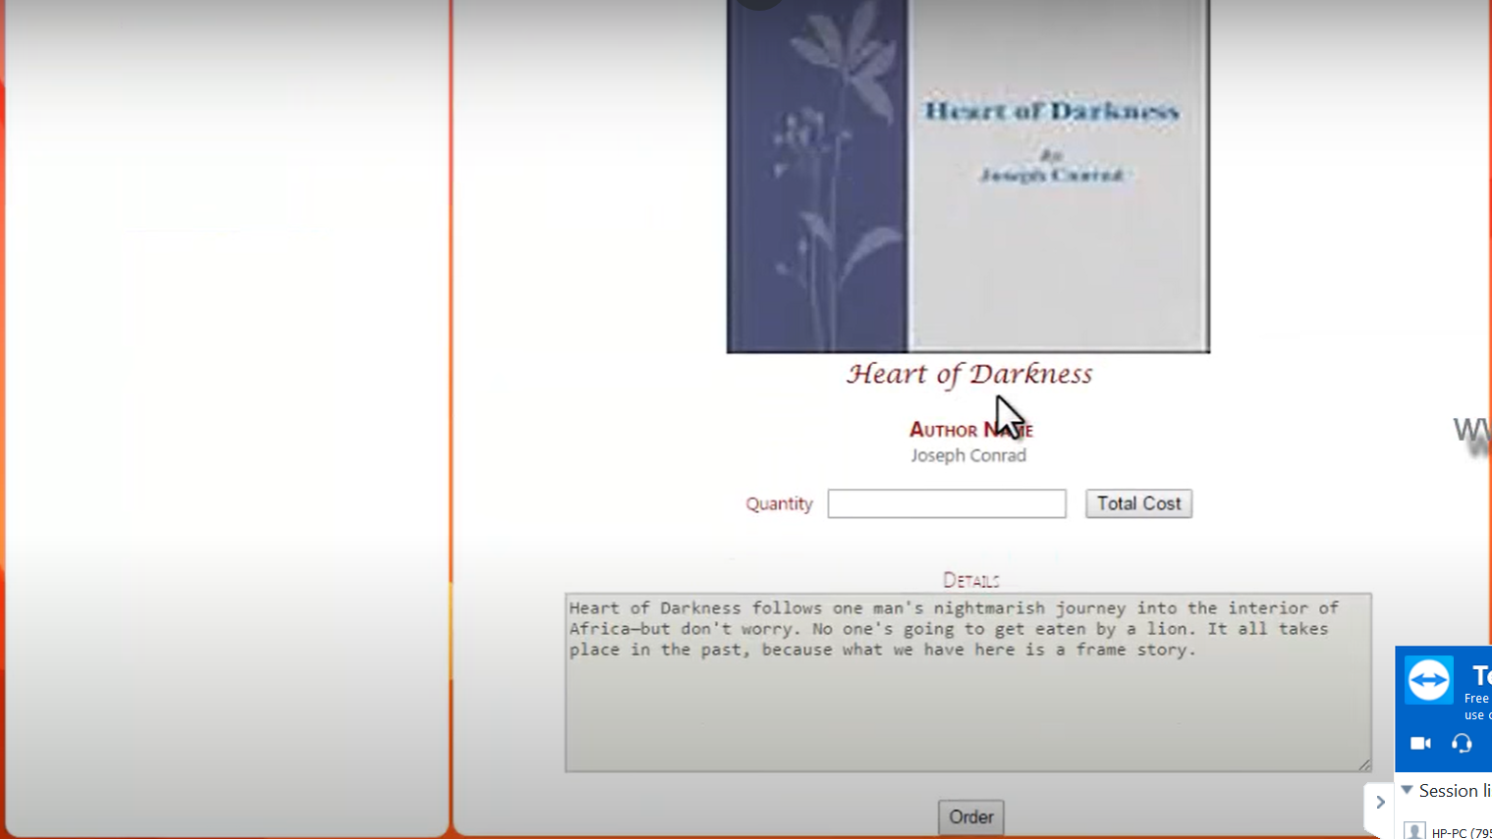

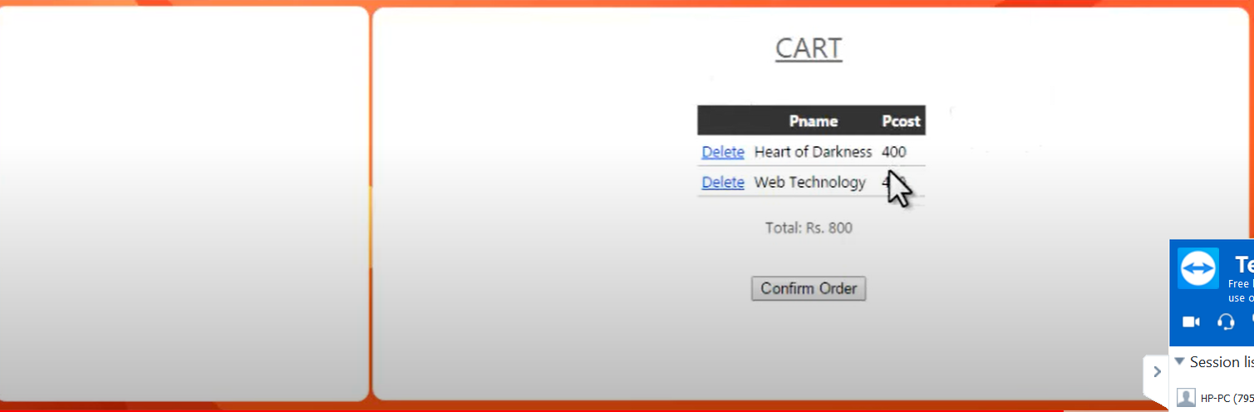



Tables :

Users and Details:

1)Users

UserId

Name:

Surname:

Mobile Number

Address

Email Id

Password

Creation Date

Last Updated Datetime

2) Admin

UserId:1

Books

Book Name:

Author

Book Details

Price

Book Id

Category

Image

Creation Datetime

LastUpdatedDatetime

LastUpdatedId

Quantity

OrderDetail

OrderId

UserId

BookId

Amount

PaymentDate

CartTable (temp)

CartId

BookId