Final Project

Samruddhi Shinde

5/1/2021

Loading packages

library(here)

## here() starts at /Users/SammyShinde/Desktop/GitHub/hw-samruddhis/final_project

library(tidyverse)

## ── Attaching packages ─────────────────────────────────────── tidyverse 1.3.0 ──

## ✓ ggplot2 3.3.3 ✓ purrr 0.3.4  
## ✓ tibble 3.0.6 ✓ dplyr 1.0.3  
## ✓ tidyr 1.1.2 ✓ stringr 1.4.0  
## ✓ readr 1.4.0 ✓ forcats 0.5.1

## ── Conflicts ────────────────────────────────────────── tidyverse_conflicts() ──  
## x dplyr::filter() masks stats::filter()  
## x dplyr::lag() masks stats::lag()

Loading in Dataset

covid_prison_cases <- read_csv(here("data", "covid_prison_cases.csv"))

##   
## ── Column specification ────────────────────────────────────────────────────────  
## cols(  
## name = col_character(),  
## abbreviation = col_character(),  
## staff_tests = col_double(),  
## staff_tests_with_multiples = col_double(),  
## total_staff_cases = col_double(),  
## staff_recovered = col_double(),  
## total_staff_deaths = col_double(),  
## prisoner_tests = col_double(),  
## prisoner_tests_with_multiples = col_double(),  
## total_prisoner_cases = col_double(),  
## prisoners_recovered = col_double(),  
## total_prisoner_deaths = col_double(),  
## as_of_date = col_character(),  
## notes = col_character()  
## )

This dataset explores COVID-19 data in prisons across the United States.

Data Set of Covid-19 Cases for every State in March 2021

march2021_covid_cases <- covid_prison_cases %>%  
 filter(as_of_date == "03/01/2021"|   
 as_of_date =="03/02/2021"|   
 as_of_date =="03/03/2021"|   
 as_of_date == "03/04/2021"|   
 as_of_date =="03/05/2021")

Bar plot Covid-19 Cases for every State in March 2021

march2021_covid_cases %>%  
 ggplot(aes  
 (x = abbreviation,   
 y = total_prisoner_cases,  
 color = abbreviation,  
 fill = abbreviation)) +  
 geom_bar(stat="identity", alpha=.8, width=.6) +  
 theme(axis.text.x = element_text(angle=-90, hjust=0.5, size=7,colour="black")) +  
 ggtitle("COVID-19 Cases in US Prisoners in March 2021") +  
 ylab("Number of Cases") +  
 xlab("State") +  
 theme(legend.title = element_blank())

## Warning: Removed 1 rows containing missing values (position_stack).

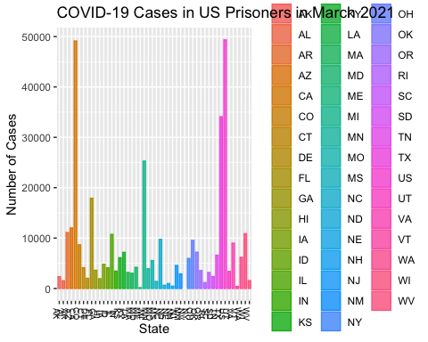 This bar graph shows that California and federal prisons had the highest cases of COVID-19 in prisoners in March 2021.

us_covid_stats <- march2021_covid_cases %>%  
 summarize(Average_Staff_Cases = mean(total_staff_cases, na.rm = TRUE),  
 Min_Staff_Cases = min(total_staff_cases, na.rm = TRUE),  
 Max_Staff_Cases = max(total_staff_cases, na.rm = TRUE),  
 Average_Staff_Deaths = mean(total_staff_deaths, na.rm = TRUE),  
 Min_Staff_Deaths = min(total_staff_deaths, na.rm = TRUE),  
 Max_Staff_Deaths = max(total_staff_deaths, na.rm = TRUE),  
 Average_Prisoner_Cases = mean(total_prisoner_cases, na.rm = TRUE),  
 Min_Prisoner_Cases = min(total_prisoner_cases, na.rm = TRUE),  
 Maz_Prisoner_Cases = max(total_prisoner_cases, na.rm = TRUE),  
 Average_Prisoner_Deaths = mean(total_prisoner_deaths, na.rm = TRUE),  
 Min_Prisoner_Deaths = min(total_prisoner_deaths, na.rm = TRUE),  
 Max_Prisoner_Deaths = max(total_prisoner_deaths, na.rm = TRUE))  
  
tibble(us_covid_stats)

## # A tibble: 1 x 12  
## Average_Staff_C… Min_Staff_Cases Max_Staff_Cases Average_Staff_D…  
## <dbl> <dbl> <dbl> <dbl>  
## 1 2217. 57 15810 4.75  
## # … with 8 more variables: Min_Staff_Deaths <dbl>, Max_Staff_Deaths <dbl>,  
## # Average_Prisoner_Cases <dbl>, Min_Prisoner_Cases <dbl>,  
## # Maz_Prisoner_Cases <dbl>, Average_Prisoner_Deaths <dbl>,  
## # Min_Prisoner_Deaths <dbl>, Max_Prisoner_Deaths <dbl>

This table shows that on average, prisoners have higher case & death rates compared to staff.

Filtering the covid_prison_cases dataset for California statistics Also only looking at staff & prisoner cases/deaths

cali_covid_cases <- covid_prison_cases %>%  
 filter(name == "California") %>%  
 select(total_staff_cases, total_staff_deaths, total_prisoner_cases, total_prisoner_deaths, as_of_date)

Summary table of average & sd of staff cases/deaths and prisoner cases/deaths

cali_covid_stats <- cali_covid_cases %>%  
 summarize(Average_Staff_Cases = mean(total_staff_cases, na.rm = TRUE),  
 Min_Staff_Cases = min(total_staff_cases, na.rm = TRUE),  
 Max_Staff_Cases = max(total_staff_cases, na.rm = TRUE),  
 Average_Staff_Deaths = mean(total_staff_deaths, na.rm = TRUE),  
 Min_Staff_Deaths = min(total_staff_deaths, na.rm = TRUE),  
 Max_Staff_Deaths = max(total_staff_deaths, na.rm = TRUE),  
 Average_Prisoner_Cases = mean(total_prisoner_cases, na.rm = TRUE),  
 Min_Prisoner_Cases = min(total_prisoner_cases, na.rm = TRUE),  
 Maz_Prisoner_Cases = max(total_prisoner_cases, na.rm = TRUE),  
 Average_Prisoner_Deaths = mean(total_prisoner_deaths, na.rm = TRUE),  
 Min_Prisoner_Deaths = min(total_prisoner_deaths, na.rm = TRUE),  
 Max_Prisoner_Deaths = max(total_prisoner_deaths, na.rm = TRUE))  
  
tibble(cali_covid_stats)

## # A tibble: 1 x 12  
## Average_Staff_C… Min_Staff_Cases Max_Staff_Cases Average_Staff_D…  
## <dbl> <dbl> <dbl> <dbl>  
## 1 5035. 9 15810 8.41  
## # … with 8 more variables: Min_Staff_Deaths <dbl>, Max_Staff_Deaths <dbl>,  
## # Average_Prisoner_Cases <dbl>, Min_Prisoner_Cases <dbl>,  
## # Maz_Prisoner_Cases <dbl>, Average_Prisoner_Deaths <dbl>,  
## # Min_Prisoner_Deaths <dbl>, Max_Prisoner_Deaths <dbl>

This table shows that on average, prisoners in California have higher case & death rates compared to staff.

Filtering data to only look at 2020 cases

cali_2020covid_cases <- cali_covid_cases[-c(1:9),]

Scatter Plot for total prisoner cases per date

cali_2020covid_cases %>%  
 ggplot(aes  
 (x = as_of_date,  
 y = total_prisoner_cases)) +  
 geom_point() +  
 theme(axis.text.x = element_text(angle = 90, vjust = 0.5, hjust=1)) +  
 ggtitle("COVID-19 Cases in Califronia Prisoners in 2020") +  
 ylab("Total Number of Cases") +  
 xlab("Date")

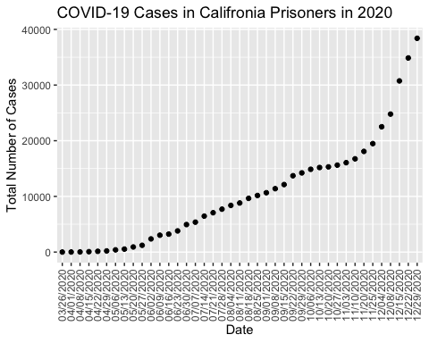

This scatter plot shows the trend of increasing COVID-19 cases in prisoners during 2020.