We, the people of India, having solemnly resolved to constitute India into a SOVEREIGN, SOCIALIST, SECULAR,DEMOCRATIC, REPUBLIC and to secure to all of its citizens;

JUSTICE social, economic and political;
LIBERTY of thought, expression, belief, faith and worship;
EQUALITY of status and of opportunity;and to promote among them all;
FRATERNITY assuring the dignity of the individual and the unity and integrity of the nation;
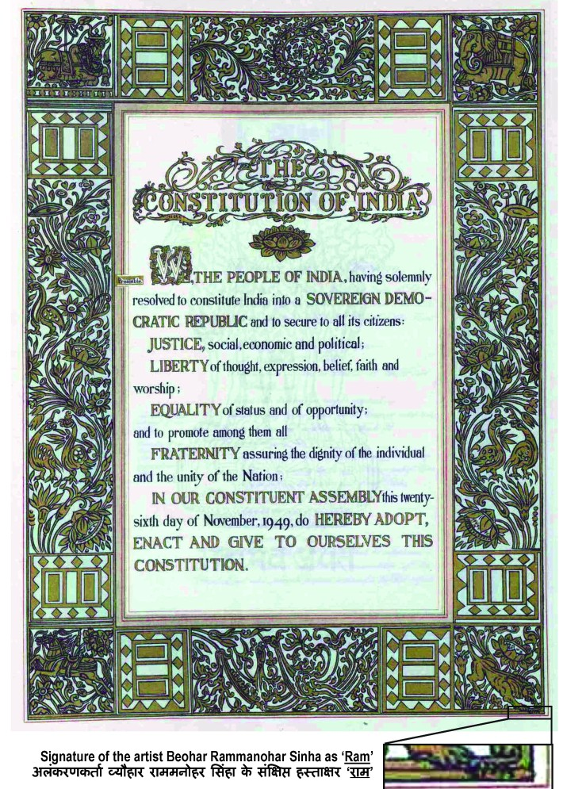
In our Constituent Assembly, this 26th day of November, 1949, do HEREBY ADOPT, ENACT AND GIVE TO OURSELVES THIS CONSTITUTION.

