create table person1

(

driver_id varchar2(10),

name varchar2(20),

address varchar2(15),

primary key(driver_id)

);

create table car1

(

regno varchar2(10),

model varchar2(10),

year number(4),

primary key(regno)

);

create table accident1

(

report_no number(5),

adate date,

location varchar2(15),

primary key(report_no)

);

create table owns1

(

driver_id varchar2(10),

regno varchar(10),

primary key(driver_id, regno),

foreign key(driver_id)references person1(driver_id),

foreign key(regno) references car1(regno)

);

create table participated

(

driver_id varchar2(10),

regno varchar2(10),

report_no number(5),

damage_amt number(7,2),

primary key(driver_id, regno, report_no),

foreign key(driver_id, regno) references owns1(driver_id, regno) on delete cascade,

foreign key(report_no) references accident1(report_no) on delete cascade

);

insert into person1 values('&driver_id', '&name', '&address');

insert into car1 values('&regno', '&model', &year);

insert into accident1 values (&report_no, '&adate', '&location');

insert into owns1 values('&driver_id', '&regno');

insert into participated values ('&driver_id', '&regno','&repost_no', &damage_amt);

select * from person1

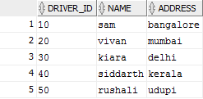

select * from car1

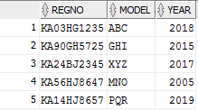

select * from accident1

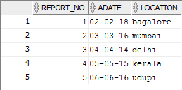

select * from PARTICIPATED

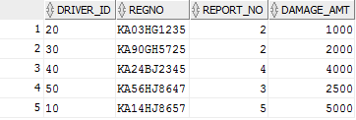

UPDATE PARTICIPATED

SET DAMAGE_AMT=25000

WHERE REPORT_NO =5 AND REGNO='KA14HJ8657';

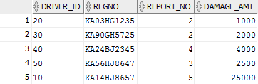

SELECT COUNT(*) FROM ACCIDENT1

WHERE ADATE LIKE '__-__-16';



SELECT COUNT(A.REPORT_NO)

FROM ACCIDENT1 A, PARTICIPATED P, CAR1 C

WHERE A.REPORT_NO=P.REPORT_NO

AND

P.REGNO=C.REGNO

AND

C.MODEL='ABC'

