

American International University-Bangladesh (AIUB)  
**Department of Computer Science  
Faculty of Science &Technology (FST)  
Spring 20 21**

**< One-time renting app >**

Software Requirement Engineering

Sec: **B**

Project submitted

By

*Sams,A.B.M. Toufiqul Alam (19-39297-1)*

*Rana Md. Ratan (18-37631-1)*

*Arumoy Das Gupta (17-35765-3)*

*Mahfujur Rahman (17-35094-2)*

The project will be evaluated for the following Course Outcomes

1. **PROBLEM DOMAIN**
   1. **Background to the Problem**

* In our daily life we need many products for one time using. And we waste money to buy those products for only one time use. For that reason, some people we cannot save money for their future. So, we want to build an app that can save their money and time.
* One of the most common reason is we want to make our life faster, easier, cheaper, or less frustrating to get something done. For better life we waste money and time it brings happiness for some time but after some time those products have no value for us, but can be useful for others and by selling or rent those products everyone can be benefited. So, this problem is important.
  1. **Solution to the Problem**
* OTR is one-time renting app. One-time renting mean you can take or give rent something. Here will be two actor one is owner and another one is customer. You can act like both. Stack holders could be AIUB student, administration, Nearby shops that will give rent.
* This little app will be your money saver and let you have what tool you need for that very moment. You need something just for few mints but you can’t avoid it because it’s really important for that moment its expensive as well so let’s rent it. On the other hand, you have something that’s really no more useful for you anymore or it may need but for this time been its useless for you so give it as rent.
* Existing studies are about rent house app or online old product sell and buy app; one time rent app is the new app we want to build.

1. **SOLUTION DESCRIPTION**
   1. **System Features**

* Open the app and will see our fast page where you have to sign up if you are fast time in this app and also you have to verify that you are AIUBian. This app is only for IUBian. your AIUB identity will be our security asset. What if you took a product and ran away?
* After you login you can choice you want to rent or want to take rent.
* If you chose to give rent then it will ask for the picture of your product and details. Give it and post it ok you done now wait for customer.
* If you are customer then you can search, view product and make your order.
* You gave order! Great now wait for confirmation from owner if it confirms then you will get the product and bill.
* You can pay cash or Bkash.
  1. **UML Diagrams (Optional)**
* use-case diagram: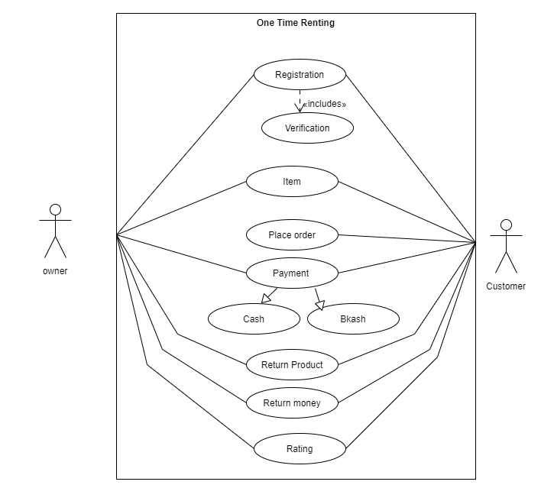
* activity diagram: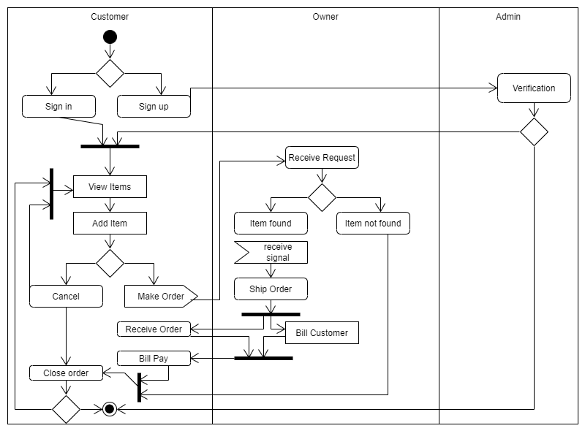
* class diagram: 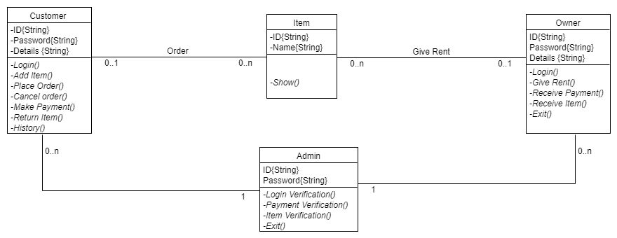
* E-R diagram: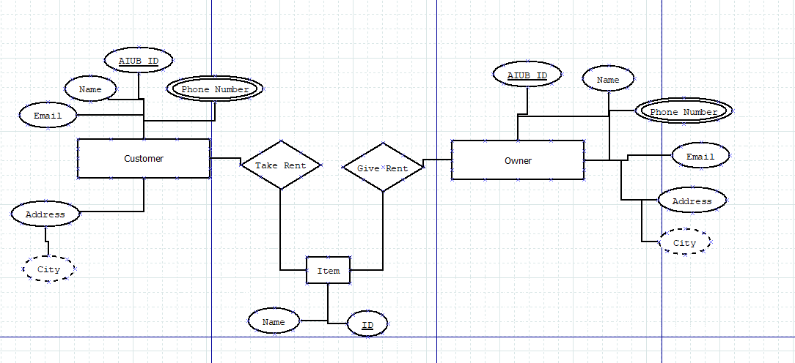

1. **Social Impact**

Rent app has a great impact on the society. Rent app products have been known to save time and money of users. According to a study conducted by a newspaper, 95% people have to buy many products for one or two time using. This app can help them to rent product for some hour or days which they prefer. As a result, they can save their money and they can use product that they need. You can rent your thing and you can have some if you need. It also can give you some money as well if we want to give your product in rent. We can also minimize the wastes because we don’t have buy product for one time using. Besides that, lower income people have to think many times for buy product which they need for some time, they are available to rent product from this app. Sometimes it is seen that elderly people can’t walk properly as a result if they any product for one time use, it’s a realistic solution for them to use this app. This are the social impact of our product.

1. **Development Plan**

**SDLC:** SDLC is a process followed for a software project, within a software organization. It consists of a detailed plan describing how to develop, maintain, replace, and alter or enhance specific software. The life cycle defines a methodology for improving the quality of software and the overall development process.

A typical Software Development Life Cycle consists of the following stages: -

* Planning and Requirement Analysis.
* Defining Requirements.
* Designing the Product Architecture.
* Building or Developing the Product.
* Testing the Product.
* Deployment in the Market and Maintenance.

**Planning and Requirement Analysis:** Requirement analysis is the most important and fundamental stage in SDLC. It is performed by the senior members of the team with inputs from the customer, the sales department, market surveys and domain experts in the industry. This information is then used to plan the basic project approach and to conduct product feasibility study in the economical, operational and technical areas.

Planning for the quality assurance requirements and identification of the risks associated with the project is also done in the planning stage. The outcome of the technical feasibility study is to define the various technical approaches that can be followed to implement the project successfully with minimum risks.

**Designing the Product Architecture:** Once the requirement analysis is done the next step is to clearly define and document the product requirements and get them approved from the customer or the market analysts. This is done through an SRS (Software Requirement Specification) document which consists of all the product requirements to be designed and developed during the project life cycle.

**Defining Requirements:** SRS is the reference for product architects to come out with the best architecture for the product to be developed. Based on the requirements specified in SRS, usually more than one design approach for the product architecture is proposed and documented in a DDS - Design Document Specification. This DDS is reviewed by all the important stakeholders and based on various parameters as risk assessment, product robustness, design modularity, budget and time constraints, the best design approach is selected for the product. A design approach clearly defines all the architectural modules of the product along with its communication and data flow representation with the external and third-party modules. The internal design of all the modules of the proposed architecture should be clearly defined with the minutest of the details in DDS.

**Building or Developing the Product:** In this stage of SDLC the actual development starts and the product is built. The programming code is generated as per DDS during this stage. If the design is performed in a detailed and organized manner, code generation can be accomplished without much hassle.

Developers must follow the coding guidelines defined by their organization and programming tools like compilers, interpreters, debuggers, etc. are used to generate the code. Different high level programming languages such as C, C++, Pascal, Java and PHP are used for coding. The programming language is chosen with respect to the type of software being developed

**Testing the Product:** This stage is usually a subset of all the stages as in the modern SDLC models, the testing activities are mostly involved in all the stages of SDLC. However, this stage refers to the testing only stage of the product where product defects are reported, tracked, fixed and retested, until the product reaches the quality standards defined in the SRS.

**Deployment in the Market and Maintenance:** Once the product is tested and ready to be deployed it is released formally in the appropriate market. Sometimes product deployment happens in stages as per the business strategy of that organization. The product may first be released in a limited segment and tested in the real business environment. Then based on the feedback, the product may be released as it is or with suggested enhancements in the targeting market segment. After the product is released in the market, its maintenance is done for the existing customer base.

SDLC provides a series of steps to be followed to develop a software product efficiently. SDLC framework includes the following steps:

**Communication:** This is the first step where the user initiates the request for a desired software product. He contacts the service provider and tries to negotiate the terms. He submits his request to the service providing organization in writing.

**Requirement Gathering:** This step onwards the software development team works to carry on the project. The team holds discussions with various stakeholders from problem domain and tries to bring out as much information as possible on their requirements. The requirements are contemplated and segregated into user requirements, system requirements and functional requirements.

**Feasibility Study:** After requirement gathering, the team comes up with a rough plan of software process. At this step the team analyzes if a software can be made to fulfill all requirements of the user and if there is any possibility of software being no more useful. It is found out, if the project is financially, practically and technologically feasible for the organization to take up. There are many algorithms available, which help the developers to conclude the feasibility of a software project

**System Analysis:** At this step the developers decide a roadmap of their plan and try to bring up the best software model suitable for the project. System analysis includes Understanding of software product limitations, learning system related problems or changes to be done in existing systems beforehand, identifying and addressing the impact of project on organization and personnel etc. The project team analyzes the scope of the project and plans the schedule and resources accordingly.

**Software Design:** Next step is to bring down whole knowledge of requirements and analysis on the desk and design the software product. The inputs from users and information gathered in requirement gathering phase are the inputs of this step. The output of this step comes in the form of two designs; logical design and physical design. Engineers produce meta-data and data dictionaries, logical diagrams, data-flow diagrams and in some cases pseudo codes.

**Coding:** This step is also known as programming phase. The implementation of software design starts in terms of writing program code in the suitable programming language and developing error-free executable programs efficiently.

**Testing:** An estimate says that 50% of whole software development process should be tested. Errors may ruin the software from critical level to its own removal. Software testing is done while coding by the developers and thorough testing is conducted by testing experts at various levels of code such as module testing, program testing, product testing, in-house testing and testing the product at user’s end. Early discovery of errors and their remedy is the key to reliable software.

**Integration:** Software may need to be integrated with the libraries, databases and other program(s). This stage of SDLC is involved in the integration of software with outer world entities.

**Implementation:** This means installing the software on user machines. At times, software needs post-installation configurations at user end. Software is tested for portability and adaptability and integration related issues are solved during implementation.

**Operation and Maintenance:** This phase confirms the software operation in terms of more efficiency and less errors. If required, the users are trained on, or aided with the documentation on how to operate the software and how to keep the software operational. The software is maintained timely by updating the code according to the changes taking place in user end environment or technology. This phase may face challenges from hidden bugs and real-world unidentified problems.

**Figure of Scheduling**

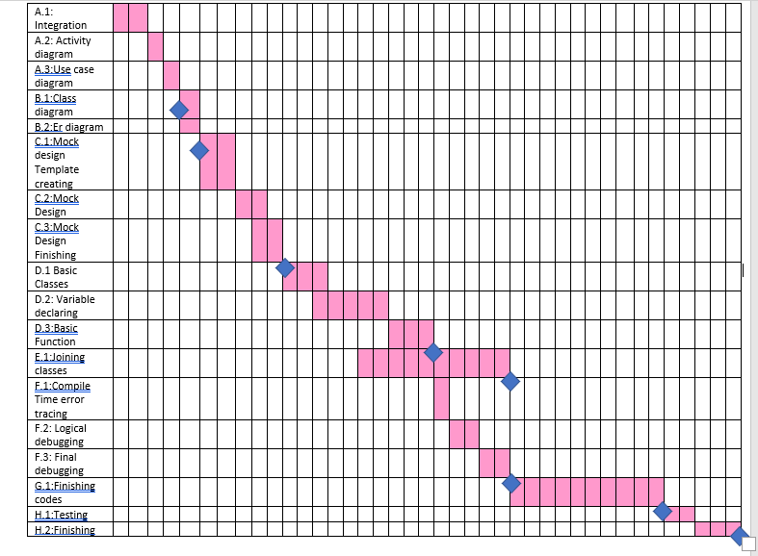

1. **Marketing Plan**

We have more than one main goal for our online marketing: -

* We want to draw the attention of software companies.
* Try to influence students.

**Short term plans:** Short-term marketing, is a plan for up to one year. This method is typically implemented to promote sales and promotions, new products and services and other events foreseen in the next month to 12 months.

* **Reduced pricing promotions:** Limited time price reductions encourage customers to act. Our likely have individuals within our sales funnel who intend to rent or buy but haven’t yet pulled the trigger. Lowering the price will give them an incentive to rent or purchase.
* **Trade shows:** Trade show marketing refers to an exhibition where we can demonstrate our new product and services. Trade shows are normally only open to those people who register, company representatives or members of the press.

**Long term plans:** Long term marketing plan covers a time which is long enough to provide the marketing management with an opportunity to anticipate future problems and thus to have a greater freedom of action to resolve them in an orderly manner.

* **Social Media Marketing:** For an online market place like one-time renting app, Social Media Marketing is the most important thing. Social media mainly consists of Facebook, Instagram, twitter, snap chat etc. It’s a media by which you can get a huge number of crowds very easily. We can create Fan Club group on Facebook, where customers can chat with the officials regarding their complains and suggestions.
* **Content Marketing:** There are different forms of content marketing and depending on strategy formation, could achieve a number of different goals. For example, we can use eBooks, articles and other longform content to attract signups, conversions and downloads or we can use an on-site blog to invite more inbound traffic to our site.

**Continuous plan:** A marketing continuity plan is a document that outlines how marketing will continue operating during an unplanned disruption in service. Continuous plan is a form of quality management that focuses on making small incremental improvements to a process, rather than trying to achieve major changes.

* **Research:** Before we start any marketing campaign, we should always understand our audience, our competitors, our product’s strengths and weaknesses and our value proposition. In a continuous marketing improvement loop, the research stage helps deliver new insights into our market at the start of each campaign.
* **Feedback & iterate:** Website and social media data are great at the feedback stage. Information on bounce rates, social shares and comments are all vital to help us assess how well our campaign is doing. Measure the performance of each tactic to decide which should be improved, dropped or pushed harder. By doing more of what works and less of what doesn’t we are utilizing the lean principles that work for other successful brands.

1. **Cost and Profit Analysis**

**Cost**:

Source lines of code, SLOC=12000.

We know Effort =PM=Coefficient*(SLOC/1000) ^ P.

For organic project type,

Coefficient = 2.4, P = 1.05, T = 038.

So

Effort =PM =2.4*(12) ^ 1.05 [SLOC/1000=12000/1000=12]

=32.61 staff-months

=33 staff-months

Development time = DM = 2.50*(PM)^T

= 2.50*(33) ^ 0.38

= 9.44 month

Let take it as 9 months

Required number of people=ST=PM/DM

= 33/9=3.67 = 4   
Working hours per day for a single person=8 hours

Per person salary in a month=85,000

Per hour salary for a person in a month=85,000/180 [In a month working hours= 180]

=472.22

In 9 months, number working days=180

Hours =180*8

=1440 hours  
So, Charge for the project 1440*472.22

=679996=680000

Requirement analysis =15days*8hours

=120hour

Charge for requirement analysis=120*300=36000

Travel expense=20000

Office rent expense=30000*9=270000.

Electricity & Gas bill=2000*9=18000

Training and hardware cost=100000

Maintenance for 9 months=9*8=72 hours

Maintenance cost=72 hours*1500

=108000

Utility cost:

Per month cost 5000 tk

Total = 9 months*5000 =45000 tk

Total cost=680000+36000+20000+270000+18000+100000+108000+45000

=1007000

**Profit**: 201400

marketing cost = 10070.

Bill=Total cost+20%=1007000+201400=1208400

**Profit analysis**: It is a form of cost which is used for fundamental instruction and short run decisions. It helps to widen the use of information provided by break even analysis. In this project, our total cost is 1007000. But our profit is 201400 which helps to benefit our project and extend the useful information.

**Conclusion:** This project helps us to may ways. This project demonstrates a small app which helps to save your money and maintain your product useful. This small app can be a media for a renting your one time goods. We can share help and earn by this app.

In this app this a very small start up. The condition is if it work smoothly we will update this. But this app is now only Aiubian. However, we will make it for some specific areas in future. Moreover, we will add buying selling option in here as well.

At the end, we get chance to learn about software requirements in this project. How a software creates. The software analysis and requirements. In addition, we learn how to estimate the budget and the system for a start up. So we can make a startup in software field with proper basic idea.

****** THE END ******