**Chapter 1 Terms**

**Morality:** the set of standards everyone (every rational person at his/her rational best) wants everyone else to follow even if their following them means having to do the same

**Moral Theory:** way of defining morality

**Divine Command Theory:** God and only God decrees what is right and wrong

**Cultural Relativism:** no way to compare cultures with respect to morality: no universal morality

**Virtue Theory:** Plato then Aristotle; virtue more about the nature of the person making the decision than the decision

**Virtues:** intellectual from formal education and moral by practice

**Ideal Mean:** middle ground when one considers all factors; relative to person and situation

**Consequentialism:** consequence matters over motive; G. E. M. Anscombe

**Utilitarianism:** consequentialist; Bentham, John Stuart Mill;

**Utilitarian Calculus:** process of calculating action which maximizes happiness

**Act Utilitarianism:** whether or not action maximizes happiness compared to other options

**Rule Utilitarianism:** set act of rules; for greater people because of less Utilitarian Calculus

**Kant, Immanuel:** German philosopher; focus of Deontological Ethics; “nothing can be good but good will**”**

**Deontological Ethical Theory:** focuses on rights, duties, obligations, and rules. Hence, according to these theories, some rules must be followed, even if following a particular rule would result in a bad end.

**Good Will:** the will of a person to act solely according to a code of morality based purely in reason

**Categorical Imperative:** rule that must always be followed by all rational beings. Kant’s 2:

**Principle of the End in Itself:** treat humans as ends in themselves, not as the means to an end

**Universal Law of Nature:** act only according to maxims that could be adopted as universal laws

**Hobbes, Thomas:** English philosopher; formed Contractarianism

**Contractarianism:** people are rational beings who wish to promote their own self-interests, and the best way of doing that is to promote the common interests of society.

**Game Theory:** branch of mathematics; choices

**Prisoner’s Dilemma:** both testify 5 years, neither 6 months, one free other 10 years

**Practical Reason:** reasoning used to make decisions

**Pure Reason:** reasoning to find the truth

**Noddings, Nel:** Ethics of Caring

**Ethics of Caring:** impartiality impractical; no general or universal way to judge an action

**One-Caring:** caregiver role does this

**Rawls, John:** Contractarian; theory of justice

**Rawls’s Theory of Justice:** as much freedom as possible, equal opportunity to reach desirable positions in society,

**Impartiality:** everyone treated equal, no preferential treatment

**Universality:** a decision reached by applying the theory should be correct for everyone

**Veil of Ignorance:** from birth, all people would agree on his two principles:

1. Each person should have as extensive a set of basic freedoms as possible, as long as it does not prevent others from having the same freedoms.
2. Social and economic inequalities are justified only if difference principle

**Difference Principle:** all socio-economic differences are of the most benefit to the least advantaged

Study your summary tables at the end of Chapter 1.

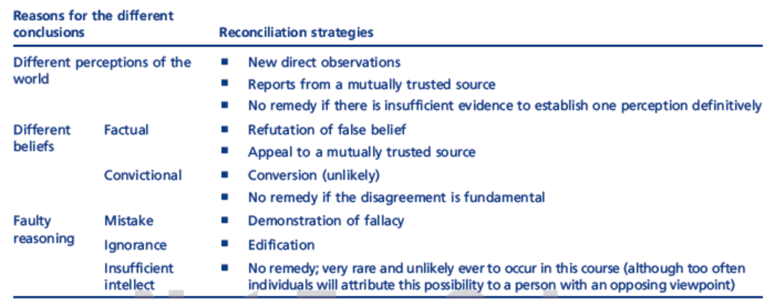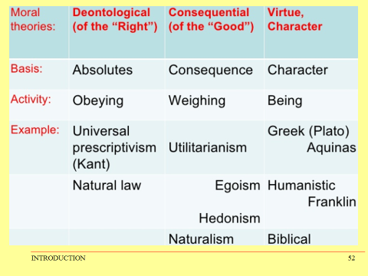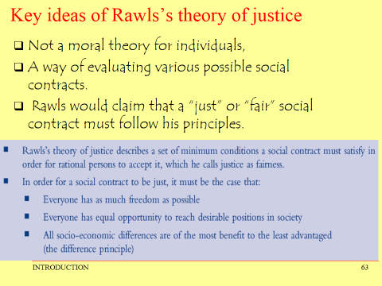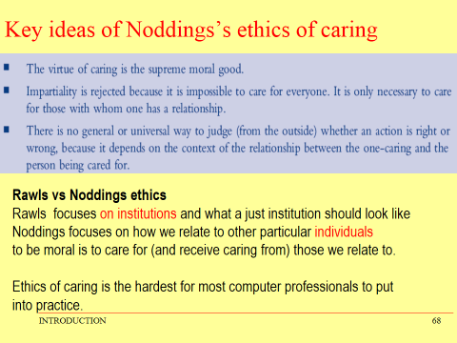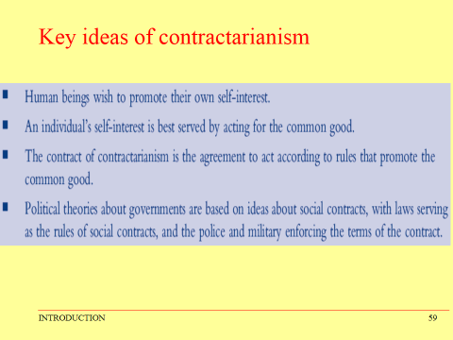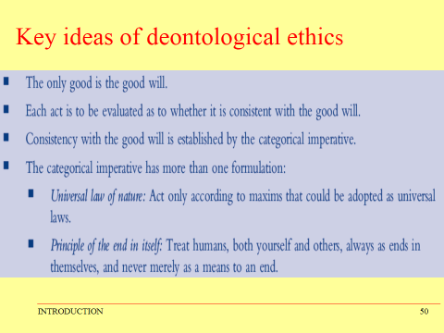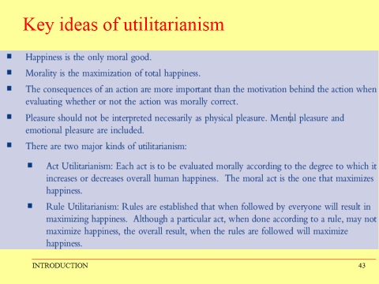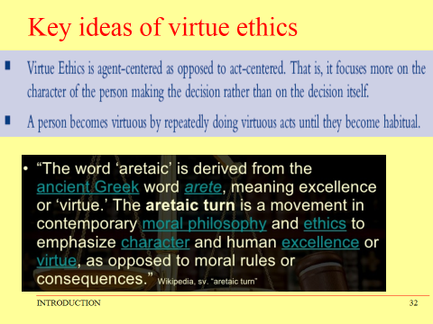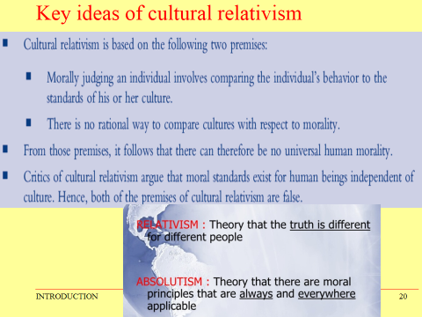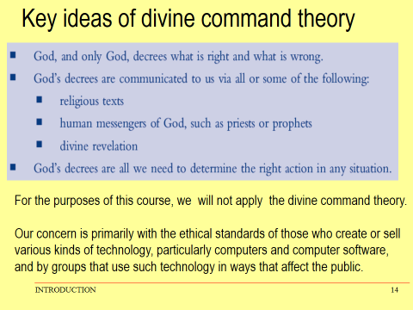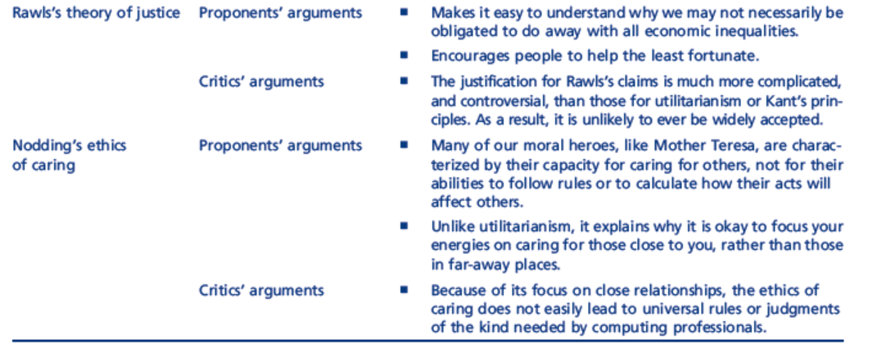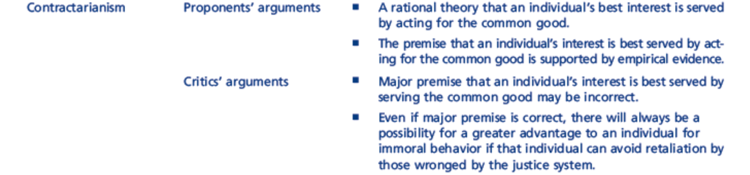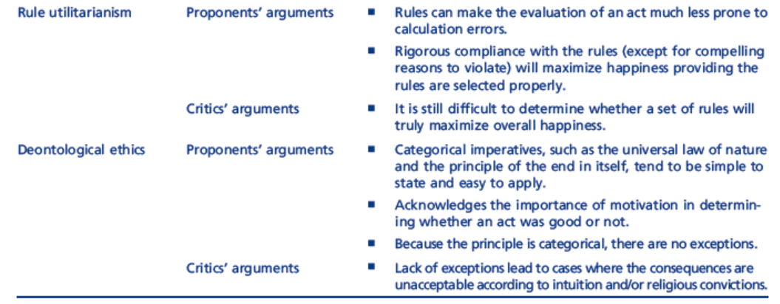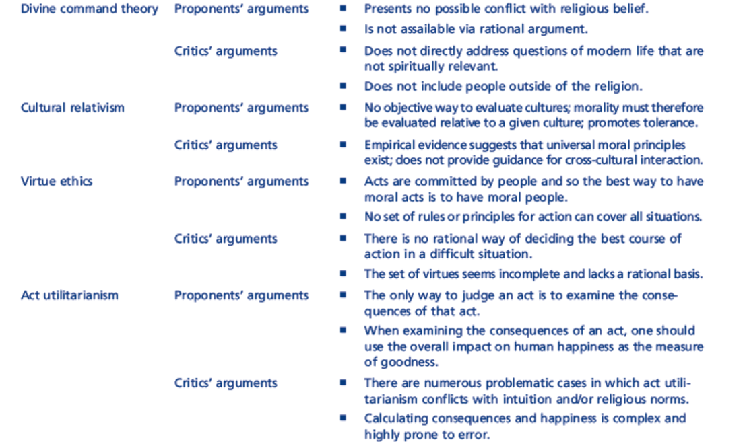

**Chapter 2 Terms**

**Ethics:** set of morally permissible standards of a group that each member wants every other member to follow even if their doing so would mean that he/she must do the same.

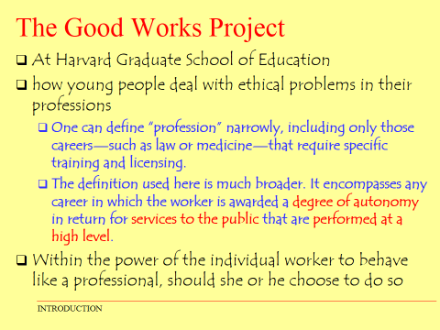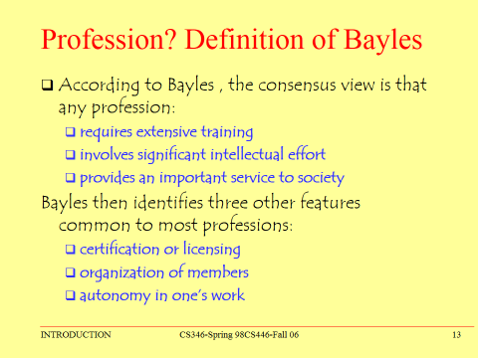**Bayles, Michael Good Works Project**

**Kultgen, John:** Kultgen’s Wheel of Attributes of Professions

**Moral Ideal:** a state of affairs that, though not morally required, wants everyone else to approach, all else being equal. Moreover, everyone wants that so much that they are willing to reward, assist, or at least praise such conduct if that is the price for others to do the same.

**Rules:** tell us certain things we must do (obligations) and things we must not do (prohibitions).

**Principles:** truths to be consistently maintained unless there is a compelling reason otherwise.

**Ideals:** goals that are inherently good to achieve. However, failure to achieve them is not necessarily wrong. Sometimes an ideal actually cannot be fully achieved, but even then it is good to strive to achieve it.

**Association for Computing Machinery:** adopted ACM/IEEE Software Code of Ethics and Professional Practice

**Institute of Electrical and Electronics Engineers:** adopted ACM/IEEE Software Code of Ethics and Professional Practice

**System Administrator:** has control of the server

**Asimov, Isaac:** three laws: don’t hurt humans, obey unless 1, protect self unless 1 or 2

**Chapter 3 Terms**

**Privacy:** seclusion; secrecy or concealment; freedom from intrusion.

**Right:** a liberty or entitlement owed to a person simply because he or she is a person

**Posner, Richard:** judge who hates privacy; had 3 reasons privacy is overrated:

1. Pre-modern peoples (living in small villages or tribal cultures) had no real ability to conceal anything about themselves, and therefore no privacy. It is perfectly natural for people to live with little or no privacy.
2. Contemporary people are willing to give up their private information, and become transparent, in return for very small financial incentives or improvements in convenience. This proves that we do not value individual privacy.
3. Concealment is most useful to criminals, and least useful to honest people.

**Privacy as concealment:** thing Judge Posner said about privacy meaning concealment

**Solove, Daniel:** Solove’s Taxonomy of Privacy Problems;

* **top-down:** starting with a single clear definition, and then discovering that not all privacy problems are covered by the definition
* 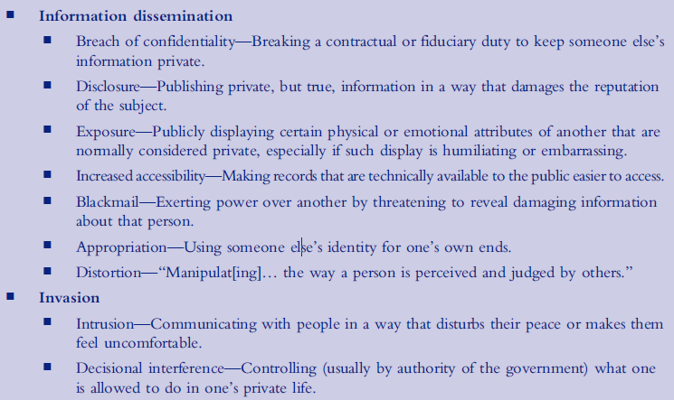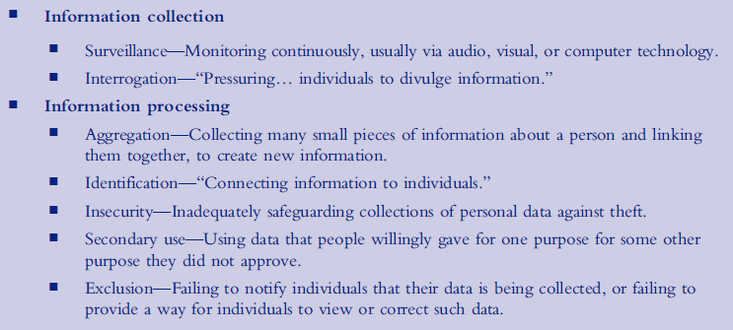**bottom-up:** starting with a list of the common kinds of privacy problems and building a definition up

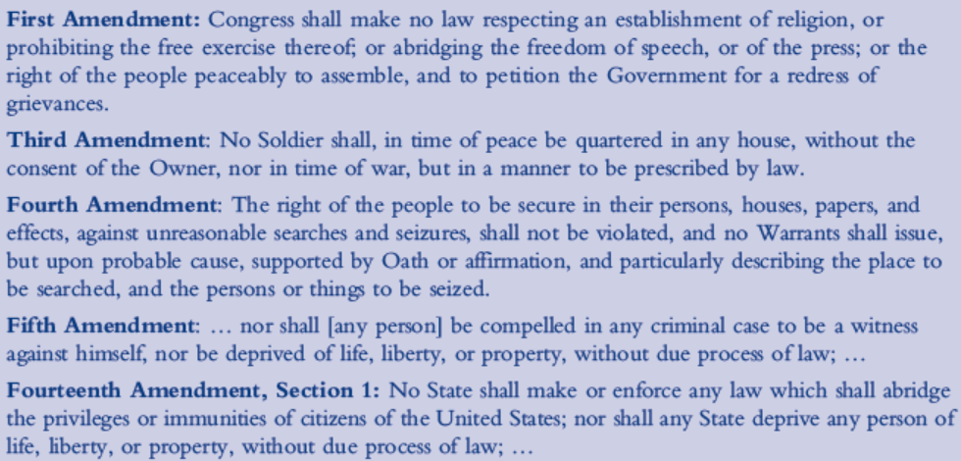

**Right to privacy:**  Constitution 🡪

**Libel:**  publishing or broadcasting false statements about another person, usually with the intent of harming the other person’s reputation

**Michel Foucault:** Panopticism

**Chilling effect:** pressure not to do something

**Chapter 4 Terms**

**Piracy:** the intentional illegal copying of copyrighted material

**Copyright:** the main mechanism for protecting creative works such as art, music, and writing in the US

**Author:** term used for all creators (including artists, choreographers, architects, etc.) in the US

**Fair use:** criticism, comment, news reporting, teaching, scholarship, or research

1. purpose and character of the use (i.e. commercial nature or nonprofit educational)
2. the nature of the copyrighted work
   1. Pubished vs unpublished
   2. Fiction vs nonfiction
3. substantiality of the portion used in relation to the copyrighted work as a whole
4. the effect on the potential market for or value of the copyrighted work

**Doctrine of first sale:** states authors are not entitled to a second royalty

**Digital rights management (DRM):**  a collection of technologies that work together to ensure that copyrighted content can be only viewed by the person who purchased it

**Digital Millennium Copyright Act (DMCA):** law passed by US Congress in 1998 to deal with modern copyright issues

**Contributory infringement:** occurs when an infringement committed by another person would not have happened without your help

**Vicarious infringement:** involves an infringement that occurs in an area under your supervision, and when you should have been policing and preventing such acts

**BitTorrent:** PeerToPeer

**Copyright term:** duration of copyright

**Orphaned work:** within term but no owner

**Trademark:** a legally registered word, phrase, symbol, or other item that identifies a particular product, service, or corporation

**Trade dress:**  involves the look and feel of a product or its packaging

**DeCSS:** removes copy protection from DVDs

**Digital watermarking:** embedding small errors into a digital image so that someone viewing the image cannot see the errors with the naked eye, but a special computer program can use the errors to identify the source of the image

**Key server:** a computer on the Internet that provides the key to unlock the file to authorized users

**Rootkit:** a piece of software that allows an unauthorized user to override security and get administrator access to a computer

**Chapter 5 Terms**

**Safety-critical software:** software that may affect someone’s safety if it fails to work properly

**Decision point:** a place in computer code where the next instruction executed depends on input data

**Control program:** controls some sort of machinery

**Multi-process:** programs that execute at the same time as one or more other programs

**Real time:** a program must do something within a specific amount of time

**Assembly language:** low-level, similar to machine language

**Malware:** malicious software

**Hackers:** write and deploy malware

**Phishing scam:** tricking people into being stupid with money

**Floating point:** 64-bit number

**Zero day attack:** attacks previously unidentified vulnerability

http://quizlet.com/13983091/cs340-test-1-flash-cards/