# Name: ____________________________

# CSE 262: Technology, Ethics, and Global Society

# Fall 2014 Quiz 3 - 09/18

**1. (1.5 pts)** According to dictionaries, list the three definitions of privacy.

*½ pt each*

*1) seclusion (which means being set apart or out of view)*

*2) secrecy or concealment*

*3) freedom from intrusion*

**2. (1.5 pts)** In 1890, a debate was going on about whether the right to privacy existed or not. Who championed the right to privacy in 1890? What phrase was use to define privacy in their article and explain that phrase?

*½ pt Louis Brandeis and Samuel Warren popularized the right to privacy.*

*½ pt a “right to be let alone” was used to define privacy.*

*½ pt The phrase focuses on the grievance felt by the harmed party and on actions that directly make them feel harassed, embarrassed, or exposed*

**3. (2 pt)** Who believes there is no right to privacy? Explain the three main points for his argument against the right to privacy.

*½ pt Judge Posner believes that there is no fundamental right to privacy*

*½ pt Pre-modern peoples (living in small villages or tribal cultures) had no real ability*

*to conceal anything about themselves, and therefore no privacy. It is perfectly natural for people to live with little or no privacy;*

*½ pt Contemporary people are willing to give up their private information, and become transparent, in return for very small financial incentives or improvements in convenience. This proves that we do not value individual privacy;*

*½ Concealment is most useful to criminals, and least useful to honest people. Therefore privacy is mostly a social harm that reduces safety, not a social good. .*

**4. (2 pts)** Who wrote about the persistent surveillance on society and compared modern society to the modern prison? What term was used for the modern prison and list two of its key ideas?

½ pt Foucault

½ pt Panopticism

½ pt each for any two of the following

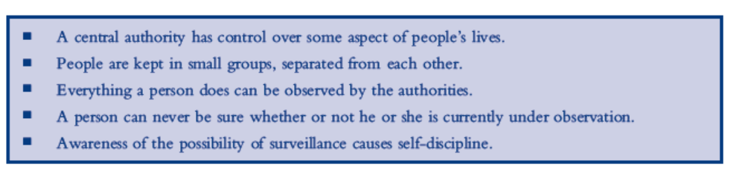

**5. (1.5 pts)** Define the following privacy problems. Who developed the bottom up approach to understanding privacy issues?

½ pt 

½ pt 

Could also define it as “identity theft”

½ pt Solove developed the bottom up approach to understanding privacy issues.

**6. (1.5 pts)** Explain two amendments of the U.S. Constitution and their relationship to privacy issues. Which amendment is more controversial with respect to protecting privacy?

½ pt for describing any two of the following amendments (in own words okay) and its relationship to privacy

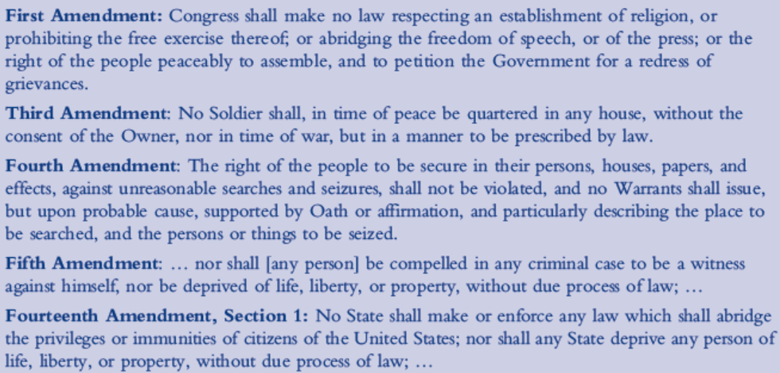

**First Amendment** guarantees a certain level of “privacy” in the practice of religion, in that the government cannot prevent a person from practicing his or her particular religion.

**Third and Fourth** Amendments together guarantee a very limited right to privacy in the home.

**Third** says that soldiers will not be quartered in one’s house (which would certainly be an invasion

of privacy),

**Fourth** guarantees that a person’s private papers and effects will not be violated by the government without judicial oversight.

**Fifth Amendment** can be viewed as providing citizens with privacy of their thoughts and knowledge, at least in cases where exposure would lead to a criminal conviction.

**½ pt Fourteenth Amendment** to protect privacy is more controversial than the others. Though it does not explicitly address privacy, many justices would argue that one of the liberties the Fourteenth Amendment addresses is Warren and Brandeis’s “right to be let alone.”

OKAY IF USE 14th amendment twice as long as they correctly explained it relationship to privacy.