**Eight Queens – Genetic Algorithm**

*“One general law, leading to the advancement of all organic beings, namely, multiply, vary, let the strongest live and the weakest die.”****Charles Darwin, The Origin of Species***

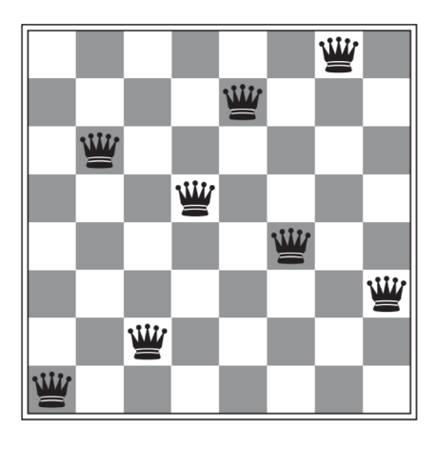

Figure file:///C:/Users/SAB68/repos/samsambutdifferent/eight-queen-problem/documents/Artificial_Intelligence_a_Modern_Approach,_EBook,_..._----_(4._Beyond_Classical_Search).pdf) shows a completed eight queen puzzle

Darwin’s theory of natural selection (**Charles Darwin, The Origin of Species**) was revolutionary in defining and understanding how the forces of nature guide and shape the evolution of species through generation to generation. With **Gregor Mendel’s** (**?????**) later work we were able to understand the how the genetic code played it’s part in this selective process of adaptation.

The genetic algorithm, first proposed by **Holland (1975)** takes inspiration from this natural process, applying a similar pattern as seen in natural selection to seek an optimum solution. Here I will apply the genetic algorithm to the Eight Queens Problem, first with a basic implementation and then with a more optimised solution.

**The Eight Queen’s Problem:**

The Eight Queen problem is a puzzle which involves the placing eight queens onto a board without any queens being attacked by another. A completed puzzle is shown in **fig. ???**.

**Basic** **Implementation**

The basic genetic algorithm implementation generally follows the pattern described in (**Artificial_Intelligence_a_Modern_Approach**) Here I will briefly describe each element, the full code and a more detailed breakdown can be seen in the accompanying jupyter notebook.

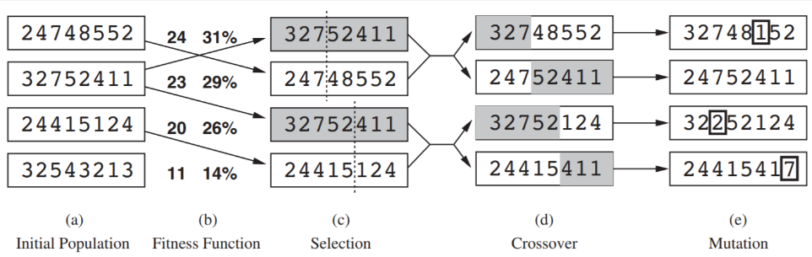

***Fig. 2 from (******file:///C:/Users/SAB68/repos/samsambutdifferent/eight-queen-problem/documents/Artificial_Intelligence_a_Modern_Approach,_EBook,_..._----_(4._Beyond_Classical_Search).pdf******)*** *shows the genetic algorithm pattern applied to the eight queens problem*

The **genetic algorithm**  is made up of the following steps:

1. **Initial Population:** an initial population of genotypes or board states is created as an array of integers, the index of the integer indicates the column that the queen is on and the value indicates the row. Note I have included a zero value for the first row as opposed to a one shown in **fig 2**.
2. **Fitness Function:** a fitness function calculates the fitness score of each genotype
3. **Selection:** pairs of parents are selected using a roulette wheel selection mechanism; any genotype can be selected but the chance of being selected is proportional to their fitness score and each pair will have a unique genotype
4. **Crossover:** random crossover points are selected for the pairs of parents and they are crossed at this point
5. **Mutation:** each phenotype in the genotype is subjected to a chance mutation; where it’s value can be changed to any other value (except itself), the chance it will change is defined by the **mutation frequency**

The combinations of all these steps is a **generation**, it is repeated until a perfect state is achieved.

**Results**

To fairly compare different implementations of the algorithms I have created a test population of 100 randomly generated populations these can be run against different variations of the algorithms to test performance. In **fig. ???** you can see the parameters chosen for the test and the mean and standard deviation for the elapsed time and number of generations. The parameters were chosen after a series of tests to find the best performing ones. For **fig ???**  the elapsed times are rounded down to whole integers (i.e. a time of 0.35s becomes 0) and plotted compared to their count in the results.

**Mean no. of generations: 4851.55**

**Standard deviation no. of generations: 4955.57**

**Mean elapsed time: 15.587s**

**Standard deviation elapsed time: 16.882s**

**Range ?? skewness ?? to show the**

**Number of queens: 8**

**Size of population: 19**

**Mutation frequency: 1/15**

Figure ??????

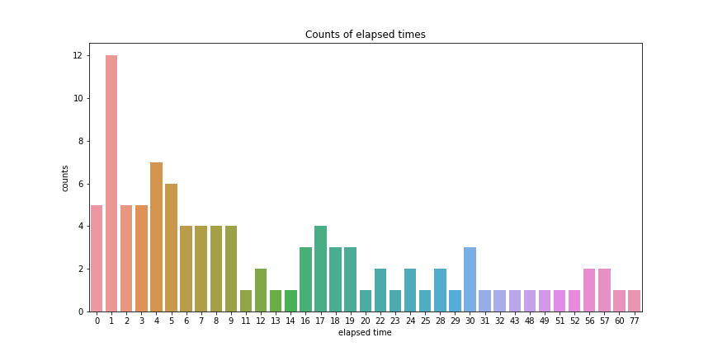

Figure ??????

The algorithm is able to find a solution from all of the generated populations, the most common range of elapsed time is between 1-2 seconds with a mean of 15.587. However the standard deviation is very high at 16.882 and as can be seen in **fig. ???** there are multiple populations which took much longer complete with many over 30 seconds to.

It appears that populations may become stuck, with states which have a relatively high fitness but are not able to be solved easily by crossover.

Increasing the likelihood of mutations 1/8 the effectiveness of the algo????

**TODO** – CHECK terminology genotype / phenotype for GA algorithm

**Optimised Implementation:**

The main issues with the basic implementation of the algorithm are a low mean speed and a high variance in the completion time, to tackle this I have implemented several extensions and adaptation.

The low speed is due to a low likelihood of the algorithm to find the solution through crossover and mutation, this can be inferred by the effect of increasing the mutation rate in the basic algorithm, which up to a point greatly increased the speed of the algorithm. Based on work by **REFERENCE???** I have chosen to change the selection mechanism from the roulette wheel selection to an adaptation of tournament selection which has been shown to be more performant.

I have combined this new selection method with an updated crossover mechanism based on two points as compared to one in the basic algorithm. Two point mutation increases the number of potential combinations that the algorithm can produce given the mating of two parents. (**REERENCE??**)

I have also implemented elitism which bypasses the selection and crossover process for a number of the original population, those with the highest fitness score, in each generation (**REFERENCE???**).

The high variance in the amount of time it takes for the algorithm to find the optimal solutions is due to premature convergence, overtime the algorithm will make the population more homogenous, if the algorithm is unable to easily find the solution, by crossover or mutation, from the now homogeneous population it may take many generations for random combinations to create a finished state. The use of tournament selection and two point crossover will allow for greater variance in the population. I have also increased the size of the population to 500 this higher population means there is greater variance and it will maintain a more heterogenous data set for more generations. (**REFERENCE??**)

An overview of the optimised process can be seen in **fig ???**. and there is a more detailed description of the updated and new components of it below.

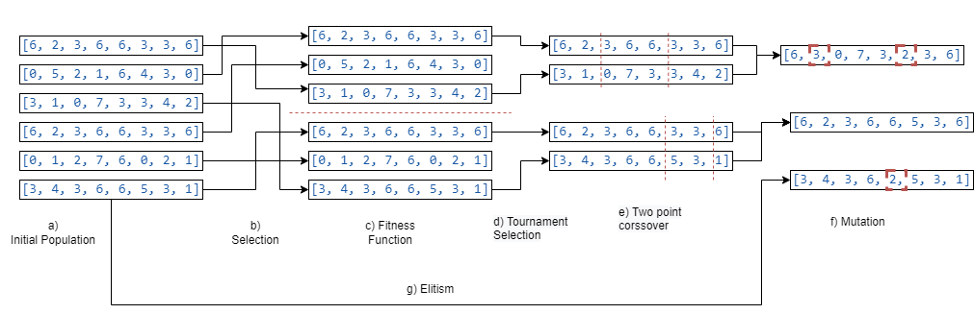

Figure ??????

**b) Selection** the population is split into multiple tournament populations the number of genotypes in each is defined by the **tournament population size**

**d) Tournament Selection** the fitness function is utilised to calculate the fitness score and the two winners, those with the highest score, of each tournament population are selected as parents for the next generation. Note each tournament produces one offspring so the number of tournaments will be equal to the size of the population

**e) Two point cross over** two random points are selected and the parents are spliced, with the external values of one parent and the internal values of the other chosen

**g) Elitism** a number of values defined by the **elitism ratio** are passed to the final stage, these also undergo the mutation operator with a chance at mutating at any phenotype

**Results**

**Mean no. of generations: 132.88  
Standard deviation no. of generations: 192.37  
Generation range: 1093  
Mean elapsed time: 0.694s  
Standard deviation elapsed time: 0.915s  
Elapsed time range: 4.752**

**Number of queens: 8**

**Size of population: 500**

**Mutation frequency: 1/8**

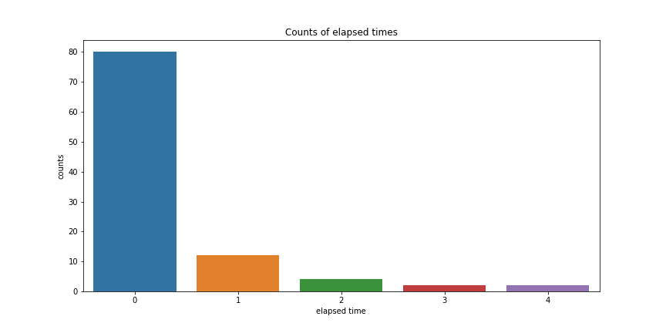

* Extensions: e.g. n -Queens for n != 8, multiple crossover points, varying parent numbers n != 2 (can do a sexual reproduction i.e. n = 1) note asexual reproduction means it is stochastic beam ??? (<file:///C:/Users/SAB68/repos/samsambutdifferent/eight-queen-problem/documents/Artificial_Intelligence_a_Modern_Approach,_EBook,_..._----_(4._Beyond_Classical_Search).pdf>)
* Metrics and results

**References:**

J. H. Holland, "Adaptation in Natural and Artificial Systems: An Introductory Analysis with Applications to Biology" in Control and Artificial Intelligence, U Michigan Press, 1975.