Health Management System

Developed by: Sam Schaefer
Webpage: https://github.com/samscha15/Final-Project-C451.git
Demolink:

With this Health management system, we wanted to make a quick and easy portal for both hospital employees and patients to help guide them and store their schedules, appointments, and health records. Above all, since this deals with sensitive personal information like the health records and financial documents, we wanted this to be secure as well. It is more of a desktop application at the moment that is removed from the internet and is based only inside the hospital. This prevents any outside hacking of the system and makes it more secure to fit our coding abilities.

Features:
- Role based login system- based on the different role you are assigned, such as doctor, nurse, patient, or administrator, you will have access to different windows and options.
- Patient Record and Appointment Access- will be able to see patient history, doctor notes, and appointments.
- Employee Schedule- Employee’s will be able to access their schedule to see which hours and days they work
- Customizable User Accounts

System Requirements:
- Windows
- Java JDK with FX
- SQLite
- 4GB RAM
- 500MB disk space

Block Diagram
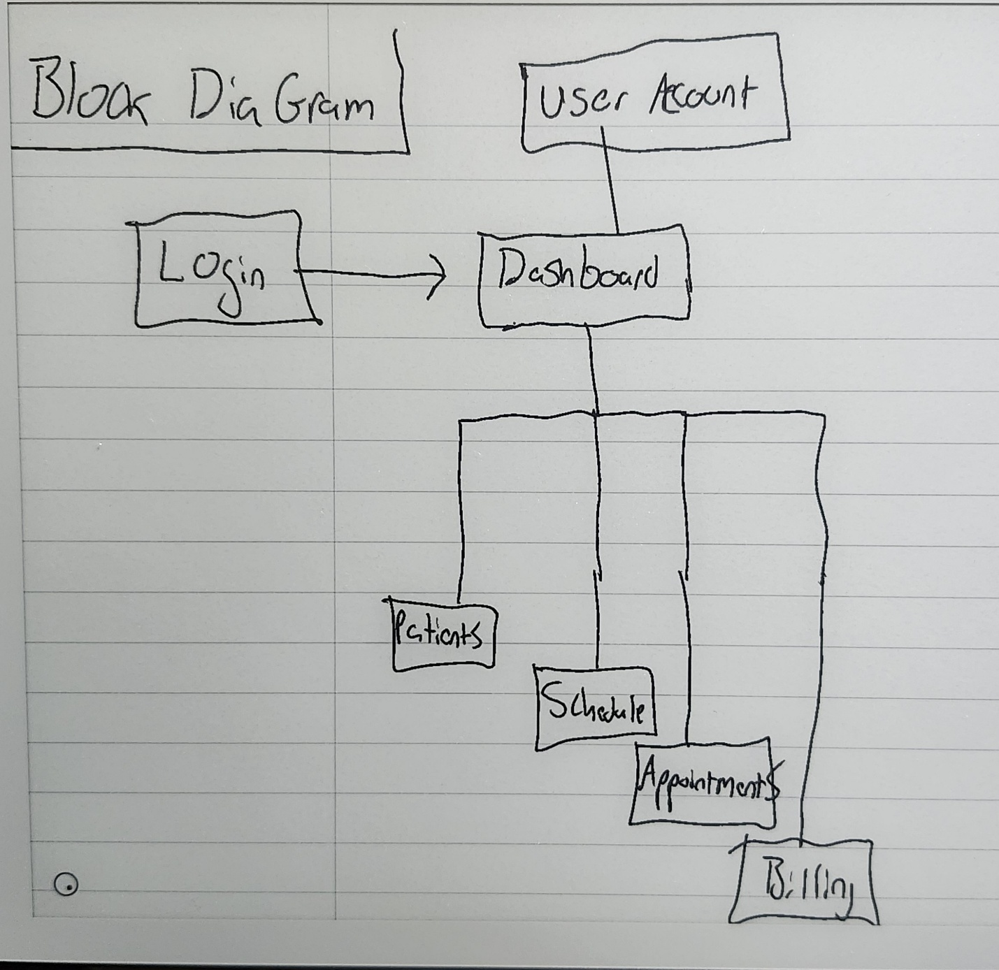

Snapshots
