# Using the “Search By Tags” Feature

The “Search by tags” feature allows users to find pages that contain any number of selected tags. The user can navigate to the “search by tags” page, click on tags, and hit search to produce pages that contain ALL the selected tags.

## Usage:

As any signed in user, select the “Search by tags” link in the nav bar.

This opens the “Search by Tags” page. Select any number of the displayed tags.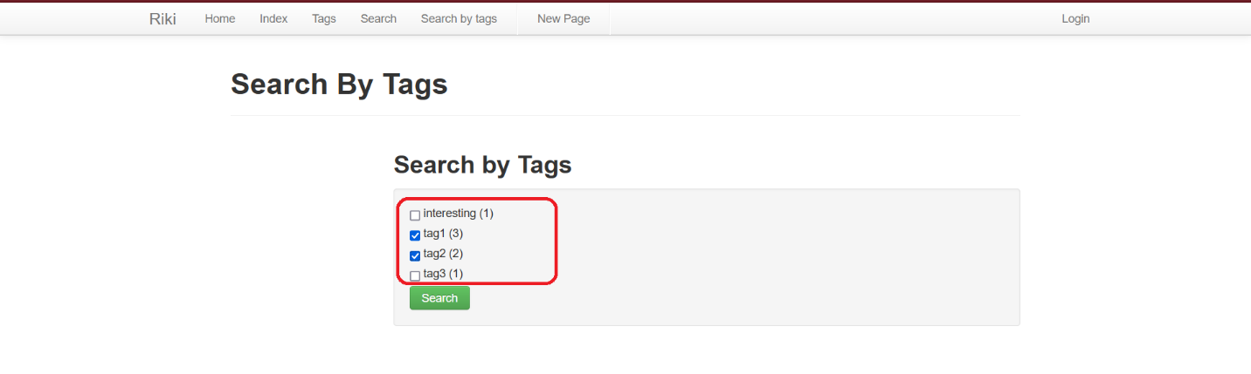And then click the “search” button

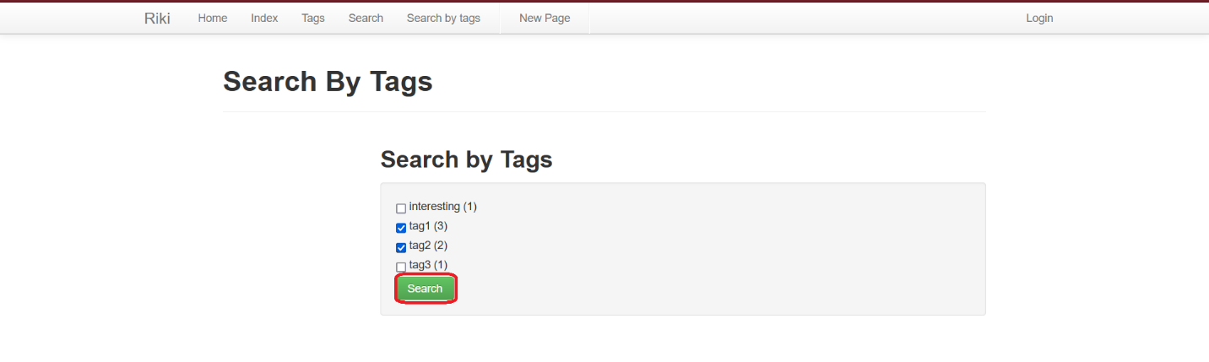

This will result in a display of all the pages containing the selected tags. Click on the links to navigate to those pages.

