LAB Logbook

GitHub URL: <https://github.com/samsenthil10/samsenthil10-neural_computing_and_deep_learning_tutorial>

Lab 1

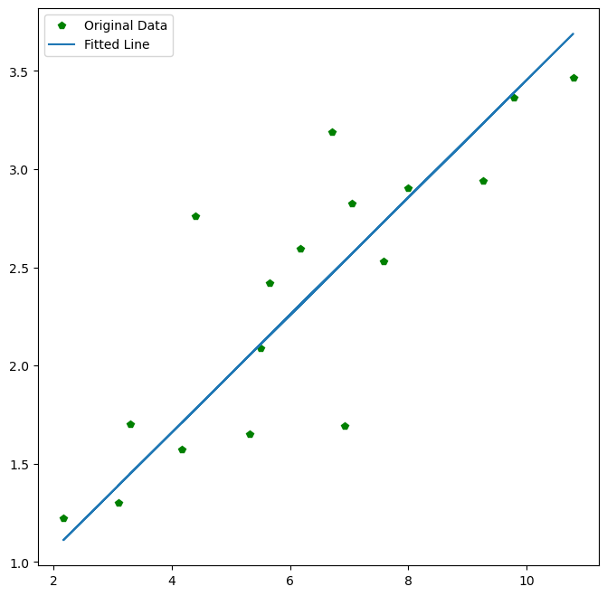

Lab 2

Task1: “0.953”

Task2: “0.8142744457617634”

Lab 3

Test accuracy: 0.8629000186920166

Model: "sequential_1"

_________________________________________________________________

Layer (type) Output Shape Param #

=================================================================

flatten_1 (Flatten) (None, 784) 0

dense_4 (Dense) (None, 18) 14130

dense_5 (Dense) (None, 20) 380

dense_6 (Dense) (None, 18) 378

dense_7 (Dense) (None, 10) 190

=================================================================

Total params: 15078 (58.90 KB)

Trainable params: 15078 (58.90 KB)

Non-trainable params: 0 (0.00 Byte)

_________________________________________________________________

None

Lab 4

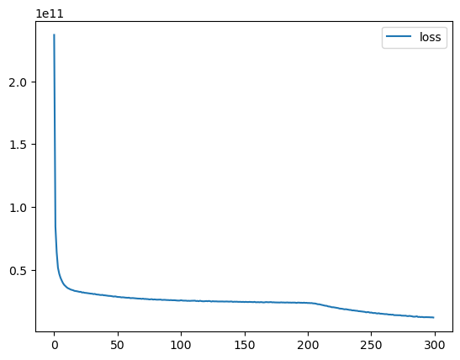

Layer (type) Output Shape Param #

=================================================================

dense (Dense) (None, 120) 2400

dense_1 (Dense) (None, 60) 7260

dense_2 (Dense) (None, 30) 1830

dense_3 (Dense) (None, 60) 1860

dense_4 (Dense) (None, 15) 915

dense_5 (Dense) (None, 1) 16

=================================================================

Total params: 14281 (55.79 KB)

Trainable params: 14281 (55.79 KB)

Non-trainable params: 0 (0.00 Byte)

Lab 5

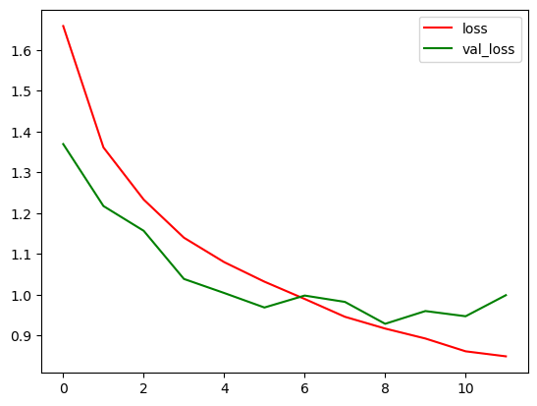

Optimal number of epochs: 6

Lab 6

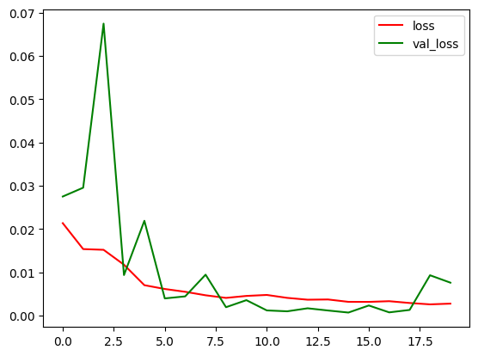

Optimal number of epochs: 15

Lab 7

Task 1:

Encoder:

Model: "sequential"

_________________________________________________________________

Layer (type) Output Shape Param #

=================================================================

flatten (Flatten) (None, 784) 0

dense (Dense) (None, 588) 461580

dense_1 (Dense) (None, 392) 230888

dense_2 (Dense) (None, 196) 77028

dense_3 (Dense) (None, 98) 19306

dense_4 (Dense) (None, 50) 4950

dense_5 (Dense) (None, 25) 1275

=================================================================

Total params: 795027 (3.03 MB)

Trainable params: 795027 (3.03 MB)

Non-trainable params: 0 (0.00 Byte)

Decoder:

Model: "sequential_1"

_________________________________________________________________

Layer (type) Output Shape Param #

=================================================================

dense_6 (Dense) (None, 50) 1300

dense_7 (Dense) (None, 98) 4998

dense_8 (Dense) (None, 196) 19404

dense_9 (Dense) (None, 392) 77224

dense_10 (Dense) (None, 588) 231084

dense_11 (Dense) (None, 784) 461776

reshape (Reshape) (None, 28, 28) 0

=================================================================

Total params: 795786 (3.04 MB)

Trainable params: 795786 (3.04 MB)

Non-trainable params: 0 (0.00 Byte)

_________________________________________________________________

Autoencoder:

Model: "sequential_2"

_________________________________________________________________

Layer (type) Output Shape Param #

=================================================================

sequential (Sequential) (None, 25) 795027

sequential_1 (Sequential) (None, 28, 28) 795786

=================================================================

Total params: 1590813 (6.07 MB)

Trainable params: 1590813 (6.07 MB)

Non-trainable params: 0 (0.00 Byte)

_________________________________________________________________

Task 2:

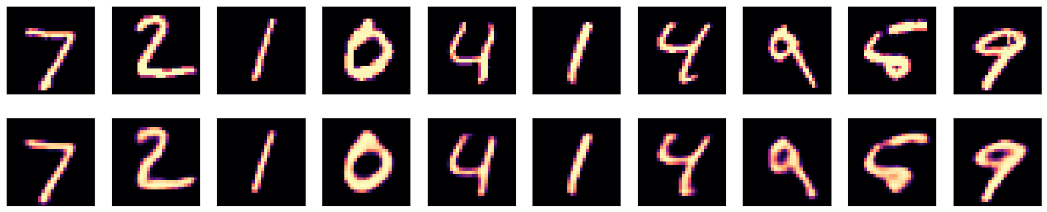

Lab 8

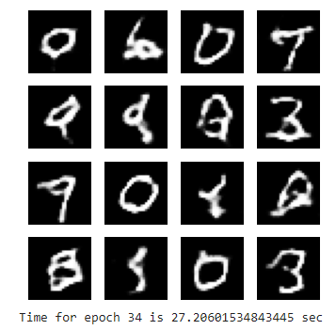

Lab 9

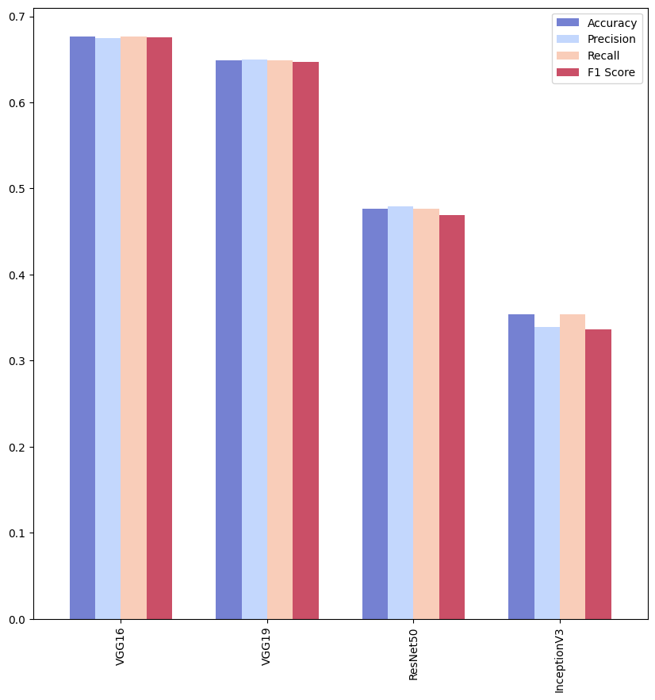

Lab 10

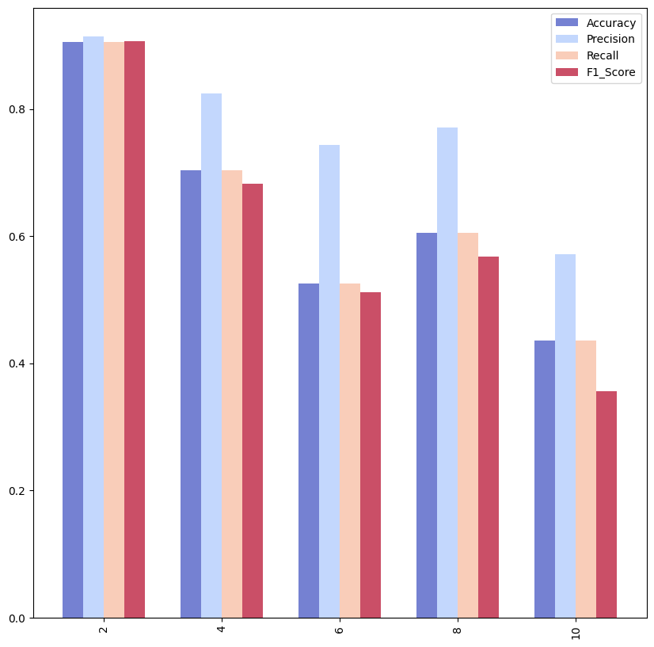

Lab 11

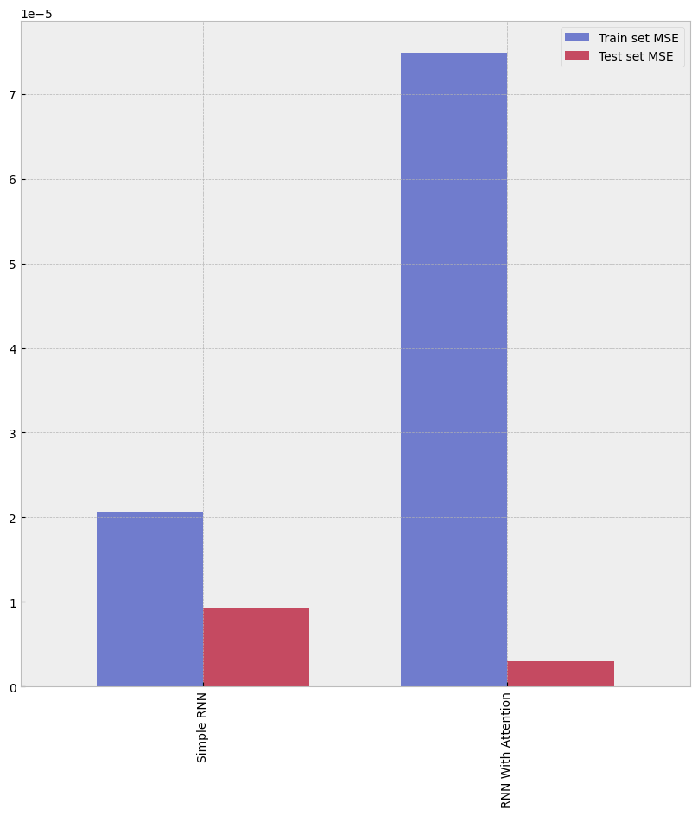

Lab 12