A Personalized Digital Intervention for Promoting Mindful Eating Through Real-time Behavioral Analysis and Adaptive Feedback

**Mindful Eating**

**Md Samshad Rahman**

January – April 2025

**Master of Applied Computer Science**

**Faculty of Computer Science**

**Dalhousie University**

**Supervisors:** Dr. Rita Orji & Dr. Oladapo Oyebode

# Abstract

Ever think about how your personality might affect your eating habits? We did, and it led us to this project focused on building healthier eating patterns. We aimed to create a mobile app that helps with mindful eating by providing daily tips customized to each user. It works by looking at your personality traits (using the Big Five personality traits) and the specific eating habits you tell it you want to work on.

Behind the scenes, we fine-tuned two AI models (LLMs). The first figures out your big5 personality values from how you answer questions, and the second generates tips specifically for the behavior you've selected – maybe it's snacking, maybe it's eating too fast. We trained them using existing public essay data along with a set of 1,500 custom tips we developed. We built the app using React Native for the front end and FastAPI for the back end, including features people expect like food logging, choosing behaviors, and setting goals. Our own ranking based tests showed the generated tips were relevant about 88% of the time.

While this is still a prototype, we see it as a neat first step in using both personality science and AI to help people with mindful eating. We're already thinking about what's next: adding more eating patterns, using AI to analyze meal photos, and creating a way for users to chat directly with the system for personalized advice.

Table of Contents

Abstract 2

Table of Tables and Figures 5

1 Introduction 6

1.1 Background and Motivation 6

1.2 Problem Statement 7

1.3 Research Objectives 7

1.4 Contributions 7

1.5 Report Organization 7

2. Methodology 8

2.1 Project Overview 8

2.1.1 Motivation 8

2.1.2 Technical Approach 8

2.1.3 System Workflow 9

2.1.4 Datasets 10

2.1.5 Personality‑Prediction Model Fine‑Tuning 10

2.1.6 Database schema 12

3. Evaluation 13

3.1 Quality of Tips Generation 13

3.2 Detailed walkthrough of the App 16

3.2.1 Registration Page 16

3.2.2 Login Page 17

3.2.3 Profile Setup – Basic Information 18

3.2.4 Profile Setup – Food Identity & Preferences 19

3.2.5 Profile Setup – Snacking and Emotional Eating Habits 20

3.2.6 Profile Setup – Big Five Personality Assessment 21

3.2.7 Profile Setup – Eating Behavior Selection and Habit Description 22

3.2.8 Dashboard – Personalized Daily Hub 23

3.2.9 Food Logging - Image and Description Upload 24

3.2.10 Profile Page – Personalization Summary and Settings 25

3.2.11 Chat Interface – Direct LLM Support 26

3.3 API Design and Integration 27

3.3.1 Overview 27

3.3.2 Authentication Endpoints 27

3.3.3 Questionnaire and Personality Trait Assessment 28

3.3.4 Eating Behavior Selection and Goal Management 28

3.3.5 Food Logging and Updates 29

4. Conclusion and Future Work 30

References 31

# Table of Tables and Figures

Table 1: Sample generated tips 13

Figure 1: System workflow diagram 9

Figure 2: LoRA Adapter Configuration for LLM Fine-tuning 10

Figure 3: Initializing an SFTTrainer for Supervised Fine-tuning 11

Figure 4: Database schema 12

Figure 5: Registration page where new users create an account by entering their credentials 16

Figure 6: Login screen for returning users to access their personalized mindful eating journey 17

Figure 7: First step in profile creation, collecting demographic and lifestyle details 18

Figure 8: Capturing dietary context, eating frequency, and mindful eating focus areas 19

Figure 9: Capturing snacking habits and emotional eating patterns 20

Figure 10: Big Five personality trait questions 21

Figure 11: Users describe their habits and select key eating behaviors 22

Figure 12: Main dashboard showing daily goal, personalized tip, and food journaling interface 23

Figure 13: Interface for adding food updates with description and meal photos 24

Figure 14: Profile page showing user details, personality breakdown, and current focus behaviors 25

Figure 15: Built-in chat feature allowing users to ask the LLM questions about eating behaviors and receive real-time responses 26

# 1 Introduction

## 1.1 Background and Motivation

Despite increased access to nutritional knowledge, diet-related chronic illnesses such as obesity, type 2 diabetes, and cardiovascular disease are on the rise. Research shows that how we eat (mindfulness, pace, emotional state) can be as important as what we eat [1]. Mindful eating programs focus on internal hunger cues, sensory experience, and emotional triggers, leading to better weight management and psychological well-being [2].

However, participation with existing digital methods is often limited. Nutrition applications often see dropout rates of more than 60% during the first month due to generic, one-size-fits-all suggestions that do not apply to all users [3]. They’re not just about statistical number, but about how we interpret feedback, handle emotions, and stick to routines.

This is where human personality comes in. An individual's Big Five personality traits (conscientiousness, extraversion, agreeableness, neuroticism, and openness) influence a user's interpreting feedback and maintaining daily activities, according to a behavioral study [4] [5]. People with high openness tend to go for balanced, healthy diets that correspond to their age. Similarly, a conscientious individual will plan their routine according to their habit and strictly follow that while high Conscientiousness and low Neuroticism are associated with more attentive eating patterns and healthier weight control [6] [7]. By understanding a person's dominant traits, we can give them more personalized support and help them build better mindful eating habits.

Improving awareness about eating patterns is important not only for better health, but also for detecting early indicators of disordered eating. [8] By guiding users in reflecting on their eating habits and emotions on a regular basis, it is possible to encourage healthier, more conscious connections with food. Disordered eating patterns (e.g., frequent dieting, emotional eating, or irregular meal habits) are often neglected despite their harmful impact on a person's well-being. [9] These activities are surprisingly common and may be considered "normal" habits. We can also see that even minor changes in eating habits, such as emotional eating, restricted dieting, or compulsive snacking, can have a significant influence on mental and physical health over time. [10] Providing daily actionable suggestions and mindful eating practices can help users have a healthier connection with food from the start.

## 1.2 Problem Statement

Current eating or nutrition apps rarely give tailored, customized suggestions to a user’s personality. An individual’s dominant personality and eating behavior (e.g., emotional eating, regular vs irregular eating, portion control) play a vital role in their life. This gap leaves users not feeling personal and not motivated enough.

## 1.3 Research Objectives

This project addresses the gap by developing an AI-powered mobile system that:

* Analyzing the Big Five personality traits from users’ questionnaires and eating habits.
* Generating daily, behavior-specific tips aligned with the user’s dominant Big Five trait.
* Delivers these tips within a React Native app that encourages photo logging, goal setting, and motivating users with actionable customized tips.

## 1.4 Contributions

* A reproducible pipeline for training lightweight LoRA‑based personality and tip‑generation models.
* A curated dataset of 1500 domain‑expert‑inspired mindful‑eating tips mapped to 10 eating behaviors × 5 personality traits and 30 tips for each.
* A proof‑of‑concept mobile application demonstrating real‑time personalization.
* An empirical evaluation showing 88% accuracy in generating tips.

## 1.5 Report Organization

Section 2 details the methodology, including data collection, model fine-tuning, and system architecture. Section 3 presents results, sample outputs, and UI screenshots. Section 4 concludes with limitations and opening the door for future research.

# 2. Methodology

## 2.1 Project Overview

### 2.1.1 Motivation

Unhealthy or unreflective eating patterns like: emotional eating, distracted snacking, irregular meals remain widespread despite decades of nutritional education. Although there is a significant correlation between mindful eating and the personality of an user, there aren't many digital resources that can customize advice based on a person's personality and particular eating habits. Leveraging recent advances in large language models (LLMs) and behavioral science, this project delivers a mobile system that:

* Learn the user’s eating habits and personality traits using a questionnaire.
* Users will select up to three priority eating behaviors to work on, and they can be changed anytime.
* Generates daily, bite-sized tips that align both with the selected behavior and the personality trait that is dominant for the user.

### 2.1.2 Technical Approach

* For Big Five traits ground truth data, use the public essays dataset and get Big Five trait values for them from Symanto’s NLP API.
* Using this dataset, fine-tune the Llama 3.2 model to analyze the user’s trait values.
* Generating a tips dataset based on eating behavior and dominant personality trait.
* Validating the dataset from dietitian and psychologist.
* Fine-tuning another Llama3.2 model using this dataset to generate customized actionable tips for the users.
* Building a mobile application using React Native and Expo. The backend will be FastAPI, and the database will be PostgreSQL.

### 2.1.3 System Workflow

The end to end pipeline (Figure 1) consists of three phases:

1. Data Acquisition & Labelling. 2467 essays ➝ Symanto API ➝ Big Five scores.
2. Model Fine Tuning. Unsloth LoRA training on Google Colab T4 GPUs produces two task specific models.
3. App Delivery. Users complete onboarding questionnaires, then the backend calls the LLMs to serve daily customized actionable tips.

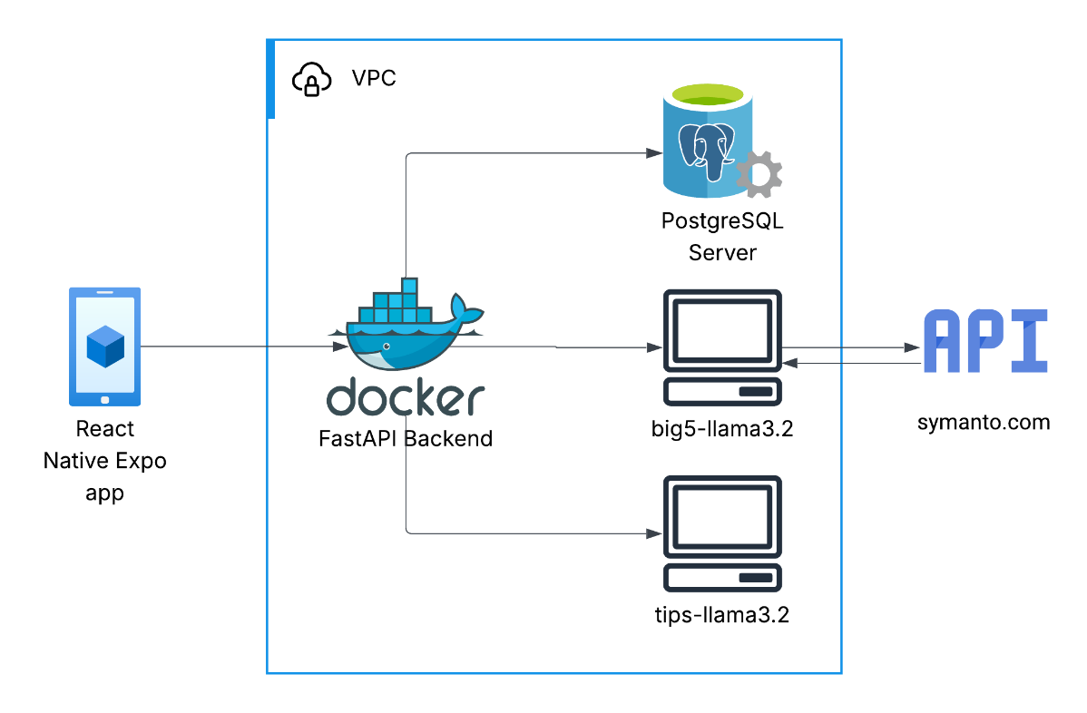

Figure 1: System workflow diagram

### 2.1.4 Datasets

* Essay corpus (2467 instances). Publicly available English essays collected from personality-prediction-from-text (https://github.com/jkwieser/personality-prediction-from-text/tree/master).
* Big Five trait scores. Traits for each essay were obtained through the Symanto NLP API (paid tier). Each essay is labelled with continuous scores for Openness, Conscientiousness, Extraversion, Agreeableness, and Neuroticism in the range 0–1.
* Mindful‑eating tips (1500 rows). A synthetic dataset linking one dominant Big Five trait × one of ten target eating behaviors to 30 actionable tips. Tips were manually authored and refined with ChatGPT‑4o; domain validation by a dietitian and psychologist.

### 2.1.5 Personality‑Prediction Model Fine‑Tuning

Fine‑tuned Meta Llama 3.2 (3B) using LoRA adapters via Unsloth on Google Colab (single NVIDIA T4 / 16 GB VRAM). A fixed 80 % train / 20 % validation split was created with random_state = 3407.

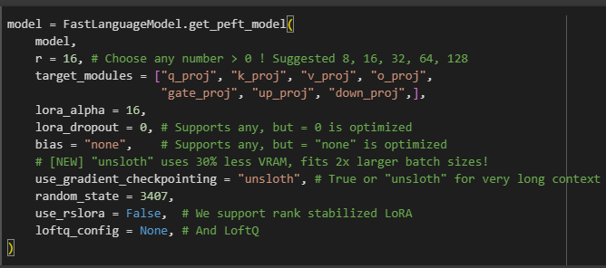

Figure 2: LoRA Adapter Configuration for LLM Fine-tuning

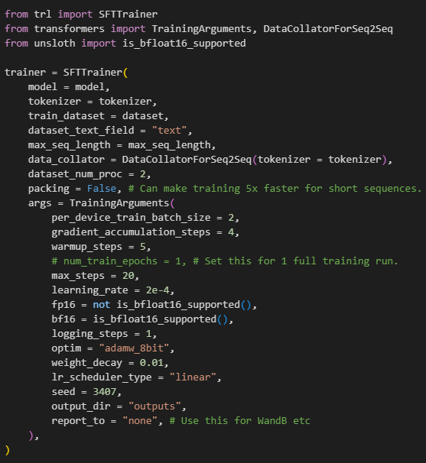

Figure 3: Initializing an SFTTrainer for Supervised Fine-tuning

### 2.1.6 Database schema

Figure 4: Database schema

# 3. Evaluation

We generated three independent batches of 100 samples (tips) each (300 samples total) for testing or evaluating the quality of the fine-tuned model. Every instance was rated for relevance on a scale of 5 points. 1 indicated "not relevant" and 5 for "highly relevant." Tips receiving a rating from 3 to 5 were marked as accepted. As a result, this evaluation gave us on average 88% accuracy across the batches.

## 3.1 Quality of Tips Generation

The tips‑llama3.2 model reliably produces suggestions aligned with both the dominant trait and selected eating behavior. Qualitative examples are:

Table 1: Sample generated tips

|  |  |
| --- | --- |
| Input | Output |
| {'Eating Behavior': 'Speed of Eating', 'Dominant Big5': 'Neuroticism'} | Individuals high in neuroticism tend to be more sensitive to their eating environment, so try slowing down your eating pace to savor each bite. Pay attention to the flavors and textures of your food when you eat faster, as slowing down can help reduce stress and anxiety related to eating. Also, practice mindful eating by turning off distractions such as TV or phone while eating, as this can help you focus on your body's hunger and fullness cues. Additionally, try chewing each bite thoroughly before swallowing to fully appreciate the experience of eating. |
| {'Eating Behavior': 'Emotional Eating', 'Dominant Big5': 'Agreeableness'} | Emotional Eating requires an understanding of your emotional triggers and hunger cues, Agreeable individuals tend to be more cooperative with their eating habits when they can prioritize others' feelings. Practice mindful self-reflection before meals to recognize and acknowledge your emotions, allowing you to make a conscious decision about whether food is truly needed or just used as an emotional coping mechanism. By being aware of these patterns, you can develop healthier relationships with food and your body's hunger signals. |
| {'Eating Behavior': 'Portion Control', 'Dominant Big5': 'Conscientiousness'} | To effectively practice portion control, start by paying attention to the serving sizes of your meals and snacks, as individuals with high conscientiousness tend to be more attuned to details. Use a food scale or measuring cups to gauge your portions and adjust as needed. When dining out, choose restaurants that offer healthy portion options, and avoid eating from large plates to reduce mindless snacking. Additionally, make a plan for meal prep ahead of time to ensure you're only serving yourself controlled amounts. By doing so, you can develop healthier habits tied to your conscientious nature. |
| {'Eating Behavior': 'Portion Control', 'Dominant Big5': 'Extraversion'} | Portion control can be challenging, but as an extraverted individual, you tend to enjoy trying new things and socializing with others. To implement portion control effectively, try tracking your food intake using a mobile app or a notebook, allowing you to monitor your consumption without drawing attention from others. Be mindful of your hunger and fullness cues, stopping when satisfied rather than stuffed, and practice eating slowly to enhance savoring the experience. Additionally, share your goals with friends and family who tend to be extraverted like you, asking them to hold you accountable by occasionally inquiring about your food intake. |
| {'Eating Behavior': 'Emotional Eating', 'Dominant Big5': 'Openness'} | Practice mindful eating when experiencing emotional cravings, savoring each bite, and acknowledging your emotions without judgment. This will help you develop a healthier relationship with food and reduce emotional eating. Additionally, explore new recipes that cater to your openness for trying novel flavors and cuisines, which may help broaden your palate and reduce impulsive snacking. Keep a journal to track your emotional triggers and patterns to better understand and address underlying emotions driving your eating behavior. By acknowledging and addressing your emotional eating, you'll become more attuned to your hunger cues and develop healthier eating habits that align with your openness for new experiences. |

## 3.2 Detailed walkthrough of the App

This section will give a screen-by-screen walkthrough of the app. Users will start their journey on the app by registering themselves first. Following successful registration, they will log in, and for the first time, they will be prompted with a diverse questionnaire to create their profile. Screenshots of the app UI are provided below, along with brief descriptions about their functionality.

### 3.2.1 Registration Page

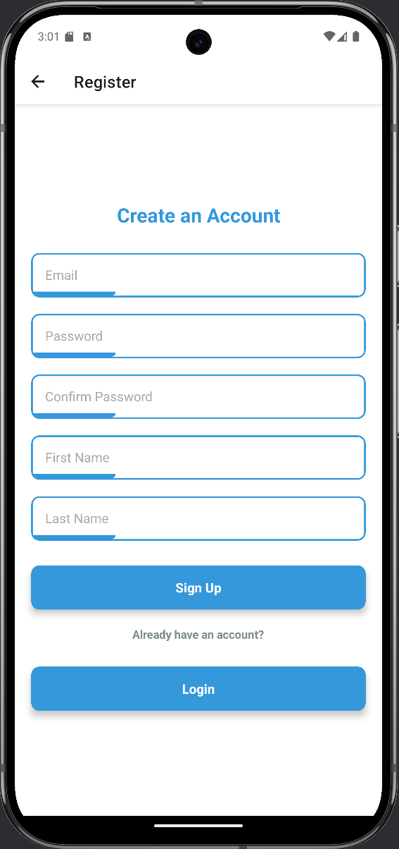

Figure 5: Registration page where new users create an account by entering their credentials

The registration process starts with a clean registration screen (Figure 5). New users need to set up an account by entering their email address, a password (with confirmation), and their first and last name.

The layout employs a basic and user-friendly design pattern to reduce friction and feels easy and fast for account creation. Input fields are properly defined and spaced for easy input on mobile devices.

There are two buttons as well. New users can sign up, while already registered users can log in. This ensures a seamless experience whether they are joining for the first time or returning to continue their mindful eating journey.

### 3.2.2 Login Page

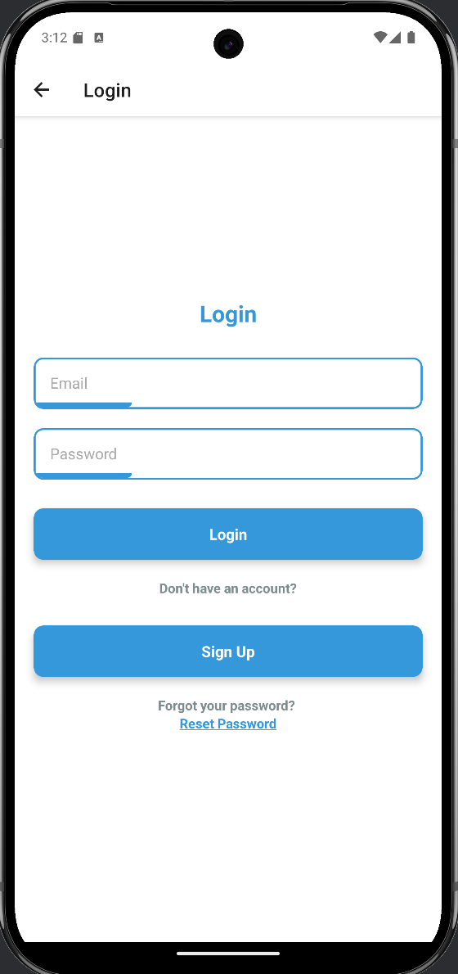

Figure 6: Login screen for returning users to access their personalized mindful eating journey

The login screen (Figure 6) offers a simple interface for already registered users to log in to their accounts. It requires users to enter their email and password.

For convenience, the screen includes two additional options: a Sign Up button for users who haven’t yet created an account and a Reset Password link for those who may have forgotten their password.

### 3.2.3 Profile Setup – Basic Information

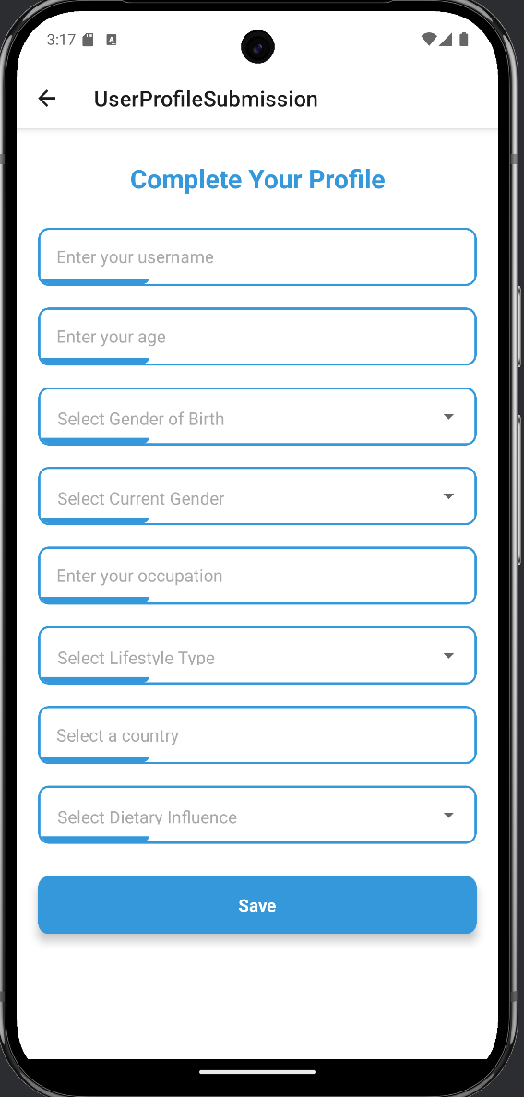

Figure 7: First step in profile creation, collecting demographic and lifestyle details

When a user login for the first time, they are prompted to complete a series of questions to personalize their experience. The first screen in this sequence (Figure 7) collects essential demographic and lifestyle information. Users are asked to enter a username and age, along with gender-related details (both gender at birth and current gender identity) to ensure inclusivity.

Additional fields include occupation, lifestyle type (e.g., sedentary, active), country of residence, and any dietary influences such as halal, vegetarian, or cultural restrictions. These inputs allow the system to tailor food-related suggestions and tips personalized for the users.

### 3.2.4 Profile Setup – Food Identity & Preferences

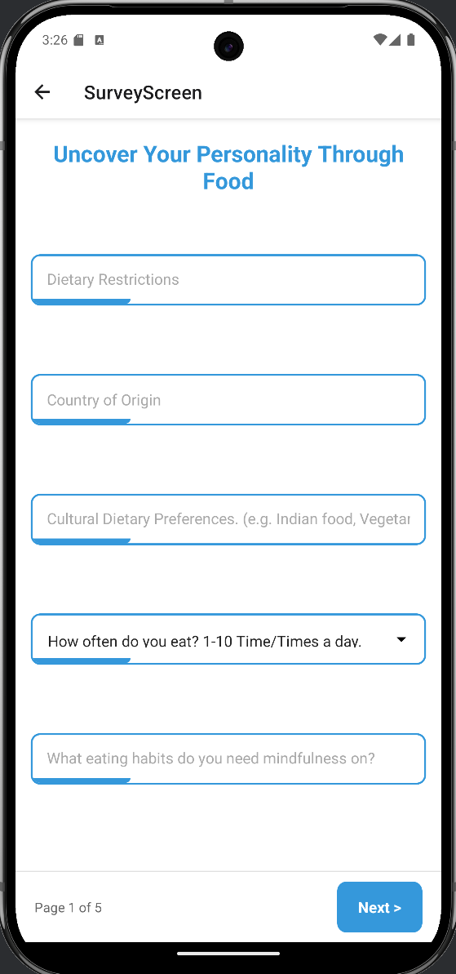

Figure 8: Capturing dietary context, eating frequency, and mindful eating focus areas

On this page (Figure 8), we are gathering food-related identity and behavior inputs. Users are asked to specify any dietary restrictions (e.g., allergies, religious or medical exclusions), their country of origin, and cultural dietary preferences such as common cuisines, traditional meals, or preparation methods.

By understanding cultural background and personal food boundaries, helping to offer tips that are both personal to the individual. For example, a user from South Asia observing halal or vegetarian guidelines will receive recommendations aligned with their habits and values.

### 3.2.5 Profile Setup – Snacking and Emotional Eating Habits

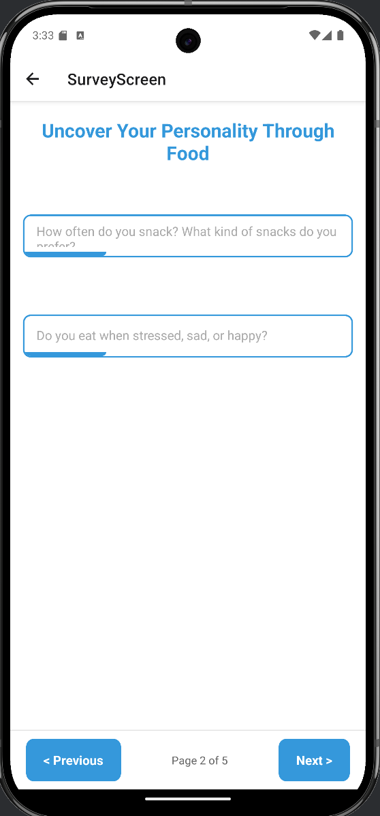

Figure 9: Capturing snacking habits and emotional eating patterns

Users are asked how frequently they snack and what types of snacks they usually enjoy (Figure 9). Additionally, users are asked to provide their emotional eating behaviors by indicating whether they eat when stressed, upset, or happy. Recognizing emotional triggers is essential for identifying vulnerable moments during mindful eating.

### 3.2.6 Profile Setup – Big Five Personality Assessment

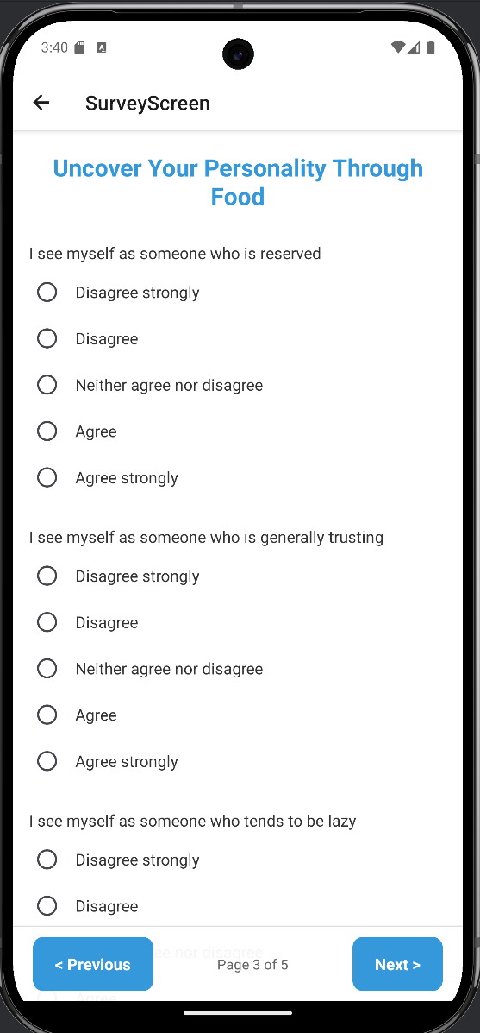

Figure 10: Big Five personality trait questions

Users will be prompted with 10 validated questionnaires to evaluate their Big Five personality traits (Figure 10). The questionnaire gives us values of Big Five traits: openness, conscientiousness, extraversion, agreeableness, and neuroticism.

### 3.2.7 Profile Setup – Eating Behavior Selection and Habit Description

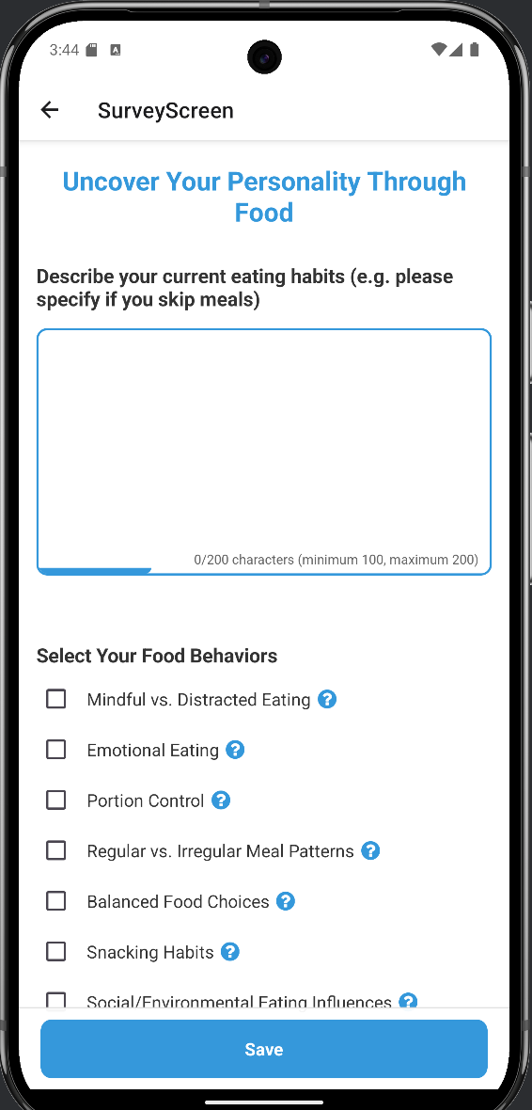

Figure 11: Users describe their habits and select key eating behaviors

Users describe their current eating habits in their own words (100 to 200 characters) and select the specific behaviors they would like to improve or be more mindful about.

Below the text box, users can choose from ten predefined eating behavior categories, including “Mindful vs. Distracted Eating,” “Emotional Eating,” “Portion Control,” “Snacking Habits,” and more. Then, if they selected more than 3 behaviors, users will get prompted with the initially selected behavior and asked to select the most relevant ones, up to 3.

### 3.2.8 Dashboard – Personalized Daily Hub

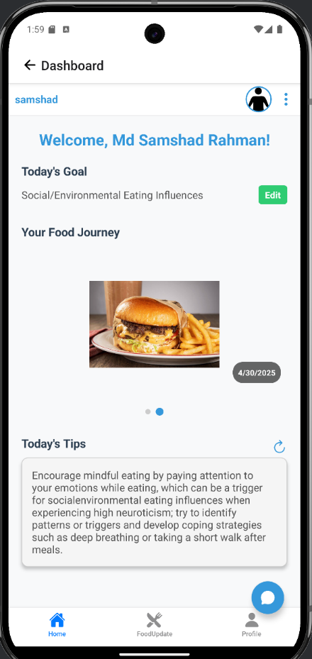

Figure 12: Main dashboard showing daily goal, personalized tip, and food journaling interface

After the questionnaire submission is complete, users are directed to the app dashboard (Figure 12). At the top, users are welcomed by their name, along with their current daily goal, an eating behavior they’ve chosen to focus on for the day. The goal can be edited anytime by tapping the green “Edit” button on the side.

Your Food Journey section allows users to track their eating history by uploading images of their meals. On the bottom, the Today’s Tips area displays a tailored actionable message based on the user’s selected behavior and dominant Big5 trait. These tips are designed to be practical, psychologically informed, and individual's eating behavior-specific.

### 3.2.9 Food Logging - Image and Description Upload

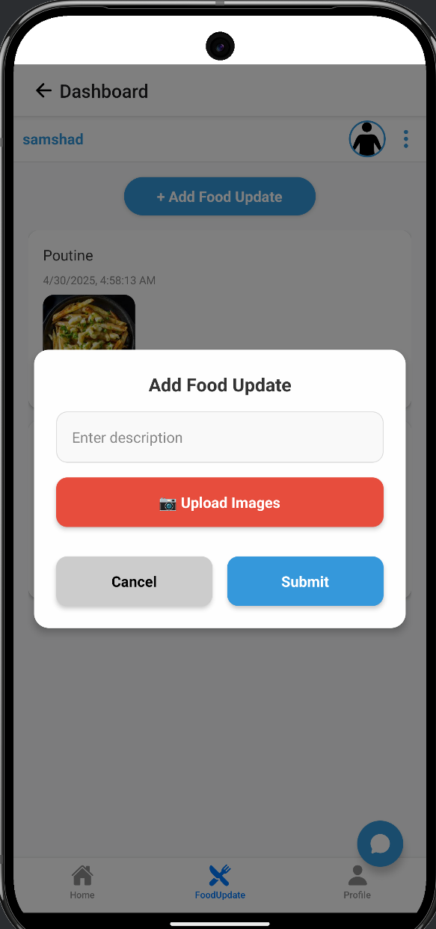

Figure 13: Interface for adding food updates with description and meal photos

As shown in Figure 13, users can add food images and enter a short description to log their food intake. In the description, users can mention what they're eating, how it tasted, and also how they emotionally felt eating this meal.

### 3.2.10 Profile Page – Personalization Summary and Settings

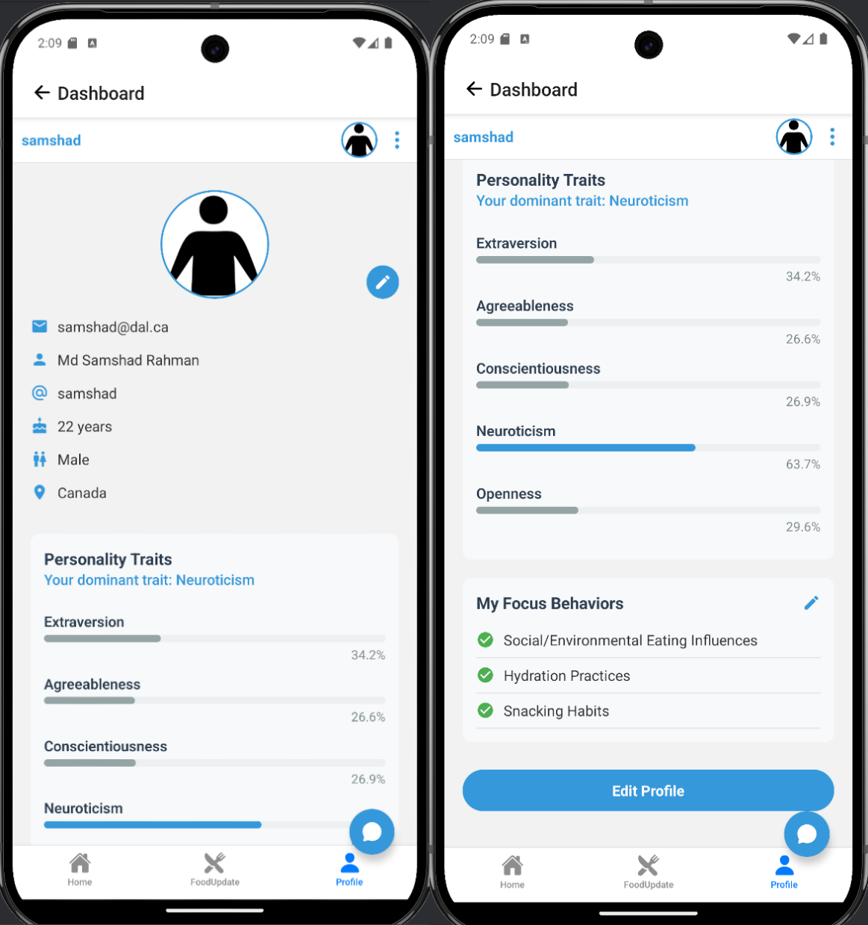

Figure 14: Profile page showing user details, personality breakdown, and current focus behaviors

Figure 14 demonstrate the profile page to view/modify user's demographic details, big5 personality trait values, and selected focus eating behaviors. Users can modify/update their demographic details by clicking on the "Edit Profile" button. Additionally, users can modify or change their selected eating behavior as well but they only can select up to 3 at a given time.

### 3.2.11 Chat Interface – Direct LLM Support

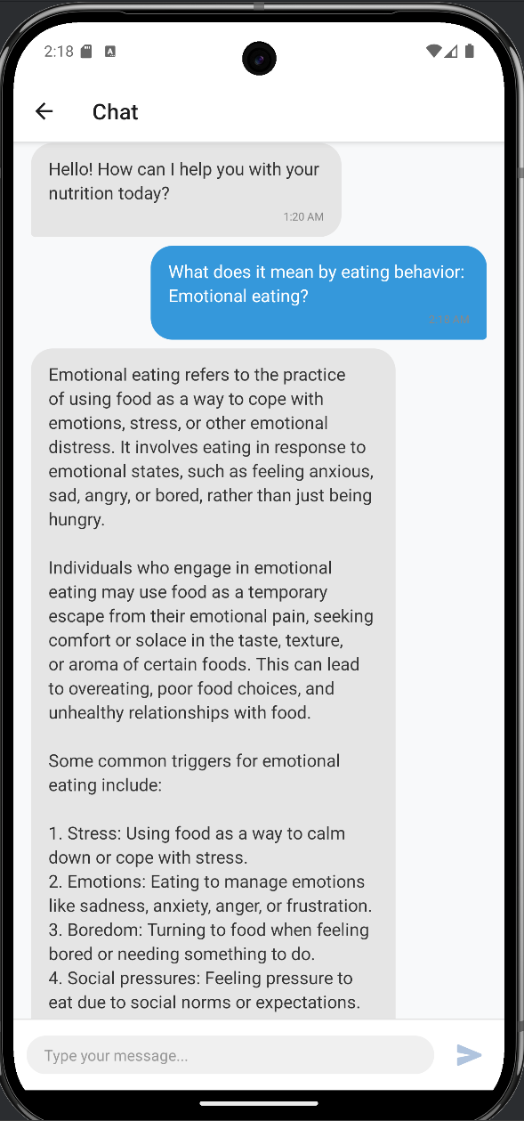

Figure 15: Built-in chat feature allowing users to ask the LLM questions about eating behaviors and receive real-time responses

The mindful eating app has an integrated chat feature that allows users to interact directly with the fine-tuned large language model (LLM) (Figure 15). Users can ask questions related to eating behaviors, dietary habits, or big5 personality traits.

## 3.3 API Design and Integration

### 3.3.1 Overview

The backend for the mindful eating app is built using FastAPI, providing a modular and scalable architecture to support authentication, user profiling, behavioral assessments, and personalized tip delivery.

### 3.3.2 Authentication Endpoints

* POST /auth/register

Registers a new user account using email, password, and name fields.

* POST /auth/login

Authenticates the user and returns an access token used for future requests.

* POST /auth/update-profile

Updates extended profile fields such as country, gender, lifestyle, and dietary influences.

* GET /auth/profile-details

Retrieves the user’s full profile details.

* POST /auth/forget-password & /auth/password-reset

Allows OTP-based password reset via email.

* POST /auth/upload-profile-picture and GET /auth/profile-picture

Upload and fetch base64-encoded profile images.

### 3.3.3 Questionnaire and Personality Trait Assessment

* GET /question/question-list

Retrieves dynamic onboarding questions (demographics, food habits, Big Five personality items).

* POST /question/submit-answers

Submits user responses for personality trait analysis and behavioral mapping.

* GET /question/get-answers

Returns previously submitted answers.

* GET /big-five/get-details

Returns the Big Five personality scores with the dominant trait identified.

### 3.3.4 Eating Behavior Selection and Goal Management

* GET /behavior/behavior-list

Retrieves the list of predefined eating behavior categories (10 total).

* POST /behavior/submit-behavior

Submits selected behaviors with optional priority settings.

* GET /behavior/check-behavior-submission

Verifies user-submitted behavior preferences.

* POST /goal/submit-user-goal

Allows users to submit a daily goal (e.g., mindful eating focus).

* GET /goal/get-user-goal

Fetches the user’s goal for the current day.

* GET /tips/get-user-tips

Retrieves the personalized tip based on current goal and personality.

### 3.3.5 Food Logging and Updates

* POST /food-update/food-update

Allows users to post daily food descriptions and upload meal images.

* GET /food-update/user-food-updates

Returns all food posts submitted by the user.

* GET /food-update/food-update/{id}

Fetches a specific food update with associated images.

* GET /food-update/user-uploaded-images

Returns a gallery view of all user-uploaded food images.

# 4. Conclusion and Future Work

This project explored a novel idea: what if a health app could understand your personality and use that to help you eat more mindfully? We used the Big5 personality traits to personalize daily eating tips based on who the user is and what eating patterns they wanted to focus on. We really wanted to move past generic advice and offer something that resonates on a personal level.

We built the app using standard tools (FastAPI and React Native) which gave us the flexibility to manage users, gather data, and generate those personalized tips. To generate personalized, actionable tips, we fine-tuned an AI model (Llama 3.2) with own dataset. Our initial tests were encouraging, showing around 88% accuracy in rank-based test.

Looking ahead, we've got some clear ideas for improvement:

* We need to ask better, perhaps more, personality questions to get a more nuanced understanding of users.
* It's important to include a wider range of eating behaviors – considering culture, emotions, lifestyle, medical history so the advice feels relevant to everyone.
* Imagine snapping a picture of your meal and getting instant, useful feedback! We want to add AI that can analyze food photos.

We believe this blend of psychology, AI, and user-friendly design is a strong starting point for creating health apps that feel truly individual, personal and supportive.

# References

1. World Health Organization, "Obesity and Overweight," [Online]. Available: <https://www.who.int/news-room/fact-sheets/detail/obesity-and-overweight>. [Accessed: 30-Apr-2025].
2. J. M. L. L. P. L. M. L. R. L. M. E. R. R. S. M. K. A. D. F. J. W. J. H. M. C. L. L. P., "Mindful Eating in Adults," *PMC*, [Online]. Available: <https://pmc.ncbi.nlm.nih.gov/articles/PMC3607652/>. [Accessed: 30-Apr-2025].
3. J. M. L. P. L. S. F., "Emotional Eating Patterns," *PubMed*, [Online]. Available: <https://pubmed.ncbi.nlm.nih.gov/24636206/>. [Accessed: 30-Apr-2025].
4. Schag, K., Teufel, M., & Zipfel, S., "Mindful eating and personality traits in adults with overweight or obesity: A systematic review," *Journal of Internal Medicine*, vol. 295, no. 4, pp. 519-534, 2024. Available: <https://onlinelibrary.wiley.com/doi/10.1111/joim.13699>.
5. Psychology Today, "How What You Eat Reveals Your Personality," [Online]. Available: <https://www.psychologytoday.com/ca/blog/head-games/202412/how-what-you-eat-reveals-your-personality#:~:text=People%20high%20in%20openness%20demonstrate,fear%20of%20eating%20new%20foods>. [Accessed: 30-Apr-2025].
6. EBSCO Research Starters, "Big Five Personality Traits," [Online]. Available: <https://www.ebsco.com/research-starters/social-sciences-and-humanities/big-five-personality-traits>. [Accessed: 30-Apr-2025].
7. Schag, K., Teufel, M., & Zipfel, S., "Mindful eating and personality traits in adults with overweight or obesity: A systematic review," *Journal of Internal Medicine*, vol. 295, no. 4, pp. 519-534, 2024. Available: <https://onlinelibrary.wiley.com/doi/10.1111/joim.13699>.
8. Thrive Wellness, "Assessing Your Eating Behaviors: How to Self-Screen for Signs of Disordered Eating and Eating Disorders," [Online]. Available: <https://www.thrivehere.com/assessing-your-eating-behaviors-how-to-self-screen-for-signs-of-disordered-eating-and-eating-disorders>. [Accessed: 30-Apr-2025].
9. National Eating Disorders Collaboration, "Disordered Eating and Dieting," [Online]. Available: <https://nedc.com.au/eating-disorders/eating-disorders-explained/disordered-eating-and-dieting>. [Accessed: 30-Apr-2025].
10. Verywell Health, "Signs of Disordered Eating," [Online]. Available: <https://www.verywellhealth.com/signs-of-disordered-eating-5095720>. [Accessed: 30-Apr-2025].