3DPawsnToys Safety Sticker (editable)
Sticker size: 80 mm wide x 50 mm tall. To print, set page margins to match or use the supplied PDF. The dashed border shows the cut line; remove or hide it before final printing.
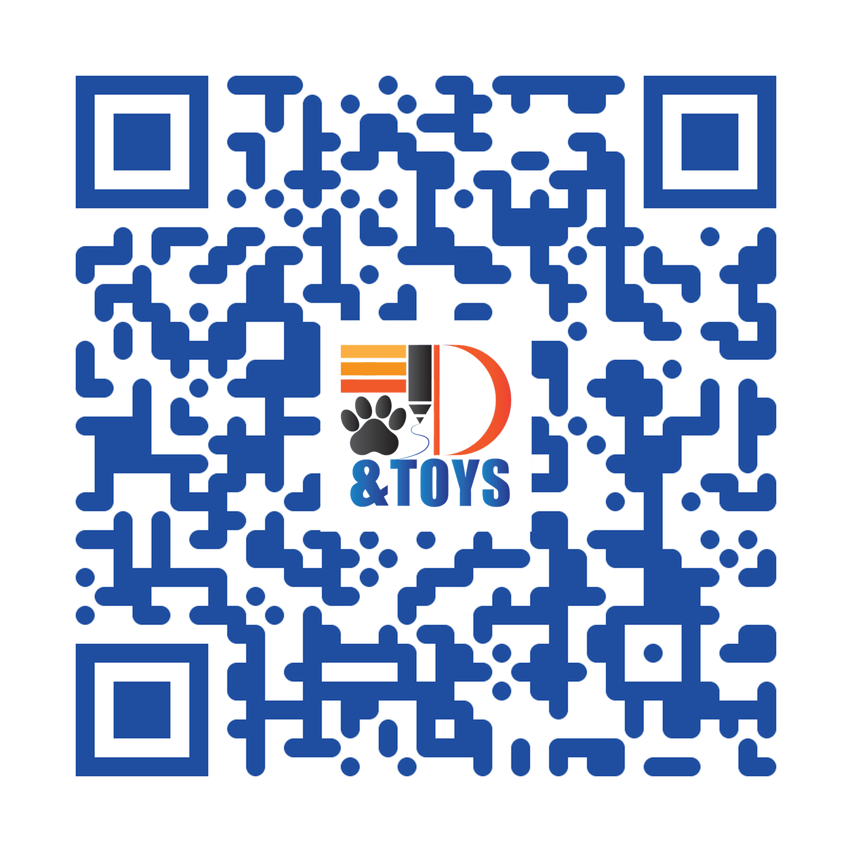  Scan for full safety info | 3DPawsnToys  ⚠ SAFETY WARNING - PLEASE READ  3D-printed pet toy made from PLA / PETG / TPU. Non-toxic, NOT edible. For dogs & cats only - always supervise play. Designed for light-to-moderate chewers; not for power chewers. Choose a size LARGER than your pet's mouth to reduce choking risk. Inspect before & after each use. Discard if cracked, broken, or chewed into pieces - fragments may cause choking, dental injury, or blockage. Not for children under 3. Clean with mild soap & water; keep from heat. Used at owner's risk. Manufacturer not liable for injury from misuse.  samshahdad.github.io/pet-toy-safety | contact@3dpawsandtoys.com

Print tip: when exporting / printing, choose 'Actual size' or 100% scaling, not 'Fit to page'. Always test-scan the QR before printing a full batch.

