To implement the three linked tables from the ERD diagram in figure 1 I first created a Customer Orders table using the following code in *figure 1*.

Figure 1: Create Customer Orders Code

Drop table if exists will delete any table that has the name Customer_Orders to ensure we are not using any legacy data. The PRIMARY KEY constraint on the order number allows you to define a unique column which is usually an integer to identify a row of a table. Also included is a customer id so we can see who this order belongs to.

Figure 2: Create Suppliers code

The Suppliers table was implemented with the same principles as the customer orders table with the extra data shown in *figure 2.*

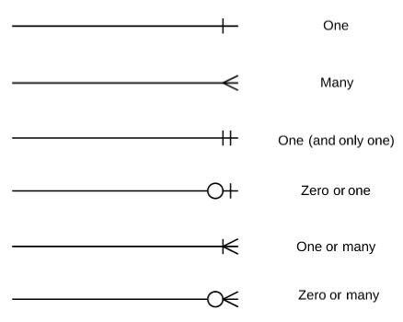

Figure 3: one to many Crowfoot notation

The third table the Customer Orders Products table is linked to both the Customer Orders and suppliers table with a one-to-many arrow shown above in *figure 3.* This indicates one product is linked to many Customer Order Products. Likewise, one Customer Order is linked to many Customer Order Products. Therefore, the Products and Customer Orders have a many to many relationships with each other. This was implemented using the following code in *figure 4*.

Figure 4: Create Customer Order Product code

Constraint keyword is used to allow us to name the constraint, since it has been left blank MySql will auto generate a name for the Foreign key constraint. A list of foreign key columns can then be specified after the Foreign key keywords. In our case we only have a single column order_id for the first constraint and product id for the second. This is then followed by the reference keyword to specify the parent table and the column this foreign key references. Finally, the last two lines determines the actions to take place when the parent key columns are either deleted or updated. In our case they have been instructed to cascade which indicates when the parent row is updated or deleted, the child row is also updated or deleted. Keeping the two sets of linked data the same.