A Hitchhiker's Guide to R

Sam Skinner

10/1/2016

"If confusion is the first step to knowledge, I must be a genius." – Larry Leissner

## Table of Contents

1. Project Overview
2. Results
   * bullet point your steps
   * load a file from internet
   * use 3 different R functions (e.g., plot, cor, pairs, etc.)
3. Summmarize the Results
4. About the Author

## Project Overview

Although not stated explicitly, the goal of this first project was to learn enough R markdown to present project results in a professional manner while also taking the first steps to developing an R project. This included downloading and accessing data files in various formats and then displaying a few descriptive statics.

Specifically, we were charged with:

* creating a markdown file and bullet point the steps
* downloading a file from internet
* using 3 different R functions (e.g., plot, cor, pairs, etc.)
* briefly summarizing the observations
* finding an R data set
* doing three different visuals on the set (barplot, boxplot, etc.)
* finding a graph, image or grapicfile to insert into the markdown
* inserting 3 references (links)
* additionally, I set up an "R publish" account and uploaded this markdown file

The work product is this file itself.

### Input, Output Commands

read.table, read.csv source, dump dget, dput readLines, Writelines save serialize

### Getting Help

?help(method) demo(data.table)

getwd() -get working directory setwd() -set working directory

## R Markdown

This is an R Markdown document. Markdown is a simple formatting syntax for authoring HTML, PDF, and MS Word documents. For more details on using R Markdown see <http://rmarkdown.rstudio.com>.

When you click the **Knit** button a document will be generated that includes both content as well as the output of any embedded R code chunks within the document. You can embed an R code chunk like this:

summary(cars)

## speed dist   
## Min. : 4.0 Min. : 2.00   
## 1st Qu.:12.0 1st Qu.: 26.00   
## Median :15.0 Median : 36.00   
## Mean :15.4 Mean : 42.98   
## 3rd Qu.:19.0 3rd Qu.: 56.00   
## Max. :25.0 Max. :120.00

## Including Plots

You can also embed plots, for example:

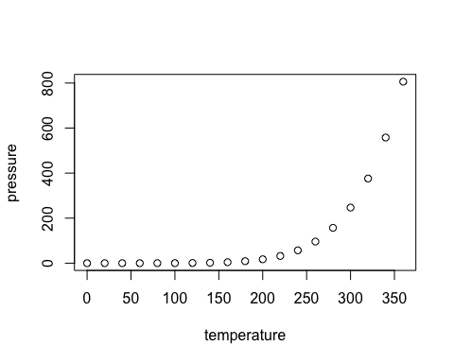 ## Summary

## About the Author

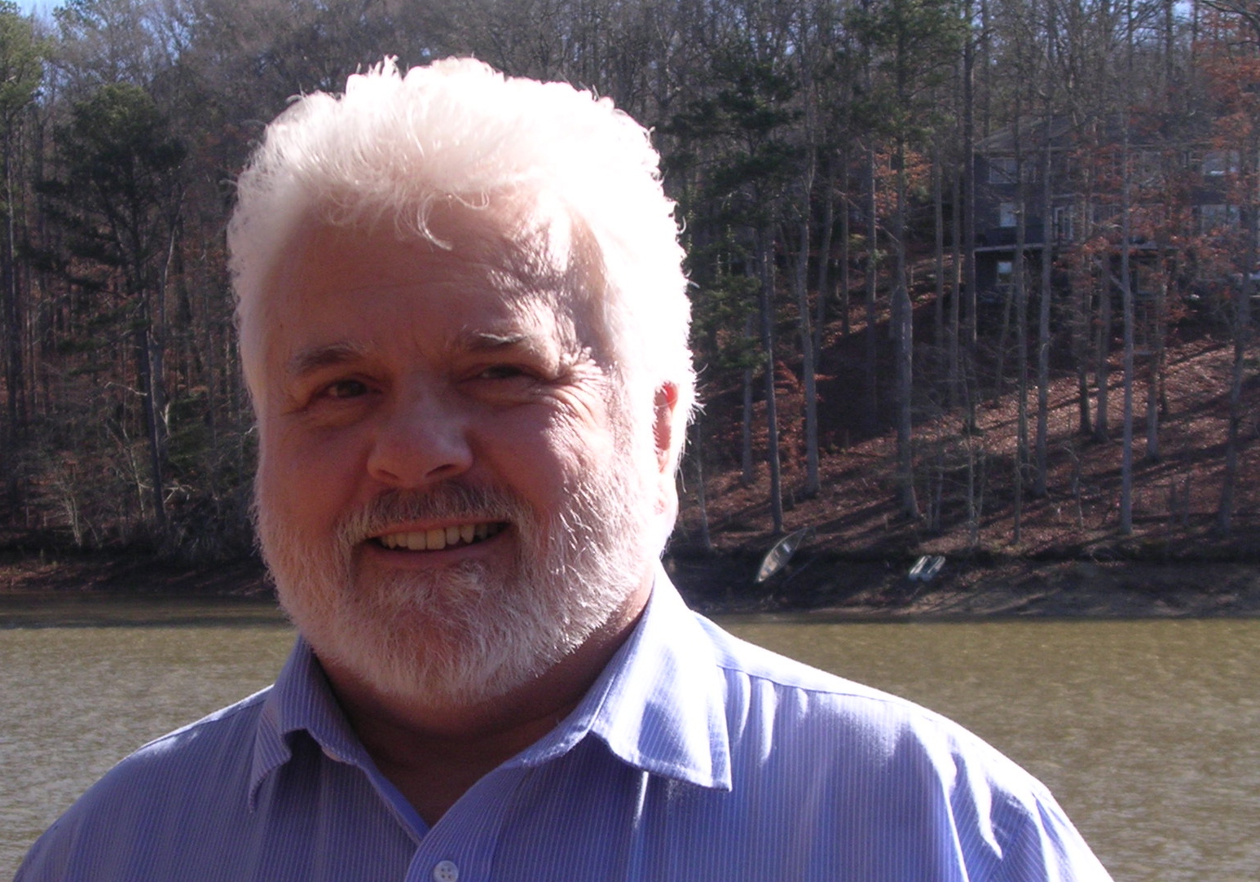 [Sam Skinner](https://www.linkedin.com/in/samskinnerphd)

Skinner is a rambling rube in R-land, hoping to hitch a ride with fellow travelers through the R-landscape.

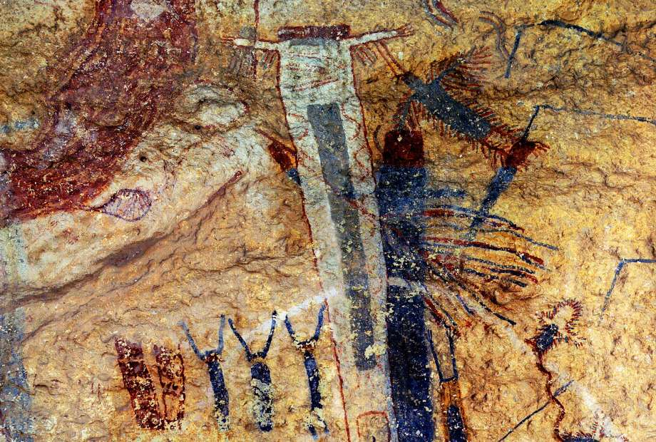 [A Leissner 'landscape', 2016.](http://www.expressnews.com/entertainment/arts-culture/article/S-A-artist-gets-lost-in-abstract-landscapes-6421850.php#photo-8406700)