**Design Thinking Project Workbook**

**" Sentiment Analysis on Movie Reviews"**

**Team - 20**

**Team Name: “ Movie-mood Analytic ”**

**Team Logo (if any):**

**Team Members:**

1. K Sai samskruthi-2320030421(2320030421@klh.edu.in, 6304929826)
2. Hemasai-2320030169(2320030169@klh.edu.in,6301289441)
3. Meghana-2320030261 (2320030261@klh.edu.in,9121228360)
4. Vedavyas-2320030473(2320030473@klh.edu.in,8374751547)

**2. Problem/Opportunity Domain**

**Domain of Interest:**

The domain of interest is the entertainment industry, specifically focusing on film and media. This includes analyzing movie reviews from various platforms to gauge audience sentiment and preferences.

**Description of the Domain:**

The entertainment industry is characterized by its dynamic nature, where audience feedback plays a critical role in the success of films. Key elements include:

* **User-generated Content:** With the rise of social media and review platforms, consumers frequently share their opinions on films.
* **Data Volume:** The sheer volume of reviews presents both a challenge and an opportunity for analysis.
* **Diverse Opinions:** Audience sentiment can vary widely, making it essential to identify trends and patterns.

**Challenges:**

* Accurately interpreting sentiment in reviews that may contain sarcasm, humor, or nuanced language.
* Dealing with the diversity of languages and expressions used by audiences.

**Opportunities:**

* Providing filmmakers and marketers with actionable insights to enhance film promotion and development.
* Enabling better-targeted marketing strategies based on audience sentiment.

**Why did you choose this domain?:**

I chose this domain due to a personal passion for cinema and storytelling. The opportunity to analyze sentiments surrounding films excites me because it merges my interests in technology and entertainment. Additionally, the market potential is significant, as filmmakers increasingly rely on audience feedback to inform decisions. By leveraging sentiment analysis, I aim to contribute to more meaningful engagement between creators and their audiences, ultimately enhancing the film-viewing experience.

**3. Problem/Opportunity Statement**

**Problem Statement:**

The system cannot display to the user a ranked list of movies concerning their ratings. Despite the functionality of the sentiment analysis model in classifying a movie review as either positive or negative, it does not facilitate the need for displaying top-rated movies. This consequently constrains users from easily accessing the top-rated movies, which would be vital in decision-making concerning movie viewing.

**Problem Description:**

The goal of this project is to analyze movie reviews and classify them as positive, negative, or neutral based on the sentiment expressed in the text. Using natural language processing (NLP) techniques, the system will process a dataset of movie reviews, extract relevant features, and apply machine learning algorithms to predict the sentiment. The insights gained can help filmmakers, marketers, and audiences better understand public opinion about films.

**Context (When does the problem occur):**

In the "Sentiment Analysis on Movie Reviews" project, the problem typically occurs when trying to determine whether a given movie review is positive, negative, or neutral based on the text. This involves processing and analyzing large sets of movie reviews to extract sentiments, which may be expressed in various ways—sometimes with sarcasm, ambiguous language, or mixed opinions. The challenge lies in accurately classifying these sentiments using natural language processing (NLP) techniques, as human language can be complex and nuanced. This problem occurs primarily during text preprocessing, feature extraction, and model training stages.

**Alternatives (What does the customer do to fix the problem):**

1.Manual Review and Analysis: Customers may choose to read and analyze reviews themselves, identifying key sentiments and themes through their personal insights.

2.Third-Party Sentiment Analysis Tools: Utilizing existing sentiment analysis software or platforms (like Lexalytics, MonkeyLearn, or IBM Watson) to automate the process and gain insights quickly.

3.Custom Algorithms: Developing custom sentiment analysis algorithms tailored to specific needs, using machine learning techniques to improve accuracy based on unique datasets.

4.Crowdsourced Feedback: Gathering input from a community of users or fans to gain diverse perspectives and sentiments on movies, rather than relying solely on written reviews.

5.Data Visualization Tools: Using tools that visualize sentiment trends over time, making it easier to interpret the overall public perception of a movie based on reviews.

6.Social Media Monitoring: Analyzing sentiments expressed on social media platforms (like Twitter or Instagram) to capture real-time opinions and trends related to movie releases.

7.Recommendation Systems: Employing algorithms that suggest films based on user preferences and past ratings, indirectly addressing sentiment through personalized content.

8.Surveying Audiences: Conducting surveys or polls after screenings to gather immediate reactions and sentiments from viewers.

9.Sentiment Dictionaries: Using pre-built sentiment dictionaries (like SentiWordNet) to enhance the analysis of reviews by assigning sentiment scores to words and phrases.

10.Combining Multiple Approaches: Integrating various methods, such as automated tools for initial analysis and manual verification for accuracy, to ensure a comprehensive understanding of sentiments.

These alternatives can help customers effectively assess and address sentiments in movie reviews, depending on their specific needs and resources.

**Customers (Who has the problem most often):**

In the Sentiment Analysis on Movie Reviews project, customers who most often face the problem are businesses and individuals in the entertainment industry, such as:

**1. Movie Studios and Producers:** They need to understand how audiences react to their films, helping them gauge public sentiment and adjust future marketing strategies.

**2. Streaming Platforms (e.g., Netflix, Amazon Prime):** They seek insights into user reviews to recommend similar content based on sentiment or to improve customer satisfaction.

**3. Film Critics and Review Aggregators:** They require analysis to provide quick overviews of public opinion, saving time on manual review sorting.

**4. Market Researchers and Data Analysts:** They frequently handle large datasets of reviews to predict trends and create audience sentiment reports.

These customers benefit from automated sentiment analysis to make data-driven decisions efficiently.

**Emotional Impact (How does the customer feel):**

In the "Sentiment Analysis on Movie Reviews" project, the emotional impact on customers is significant, as it involves understanding and analyzing their feelings based on the reviews they write. Customers often express their emotions—whether positive, negative, or neutral—through movie reviews. By utilizing sentiment analysis, businesses or platforms can gauge overall customer satisfaction, identify recurring issues, or recognize trends in audience sentiment. This allows them to make data-driven decisions that improve user experiences, cater to preferences, and foster a stronger connection with the audience. Customers ultimately feel understood and valued when their feedback is taken into account.

**Quantifiable Impact (What is the measurable impact):**

1. Financial Losses: Poor sentiment analysis can lead to misjudgment of audience preferences, costing studios millions in marketing and production.

2. Time Wasted: Inefficient analysis may result in prolonged decision-making processes for film releases and promotions.

3.Audience Engagement: Inaccurate insights can reduce effective audience targeting, diminishing viewer turnout by up to 30%.

4.Reputation Impact: Negative reviews misinterpreted as positive can harm a film's reputation, leading to significant box office declines.

5.Resource Allocation: Misguided investments in marketing campaigns based on faulty sentiment analysis can waste resources by 20-40%.

**Alternative Shortcomings (What are the disadvantages of the alternatives):**

Current solutions for sentiment analysis on movie reviews often rely on pre-built libraries and models, which may lack customization for specific genres or contexts. They can struggle with sarcasm, slang, and cultural nuances, leading to misinterpretations. Additionally, many algorithms require extensive labeled datasets for training, which may not always be available, limiting their effectiveness. Some methods may also be computationally intensive, making real-time analysis challenging. Furthermore, black-box models like deep learning offer little transparency, making it difficult to understand or trust their decisions, which can be a significant drawback for stakeholders seeking actionable insights.

1. **Addressing SDGs**

**Relevant Sustainable Development Goals (SDGs):**

The Sentiment Analysis on Movie Reviews project aligns with the following Sustainable Development Goals (SDGs):

1. **SDG 9: Industry, Innovation, and Infrastructure**

This project leverages technology to analyze large sets of data (movie reviews) and extract meaningful insights. By utilizing machine learning and natural language processing, it promotes innovation in digital infrastructure and data-driven decision-making, enhancing industry standards in entertainment, marketing, and consumer feedback.

**2. SDG 12: Responsible Consumption and Production**

Sentiment analysis can help production companies understand audience preferences and reactions, leading to more responsible and audience-driven content creation. It aids in reducing waste by producing films and shows that align with public demand, minimizing financial and resource losses.

**3. SDG 4: Quality Education**

Projects like this promote skills in AI, machine learning, and data analysis, contributing to inclusive and equitable quality education by providing students and professionals opportunities to learn and apply cutting-edge technologies.

**5. Stakeholders**

**1. Who are the key stakeholders involved in or affected by this project?**

The key stakeholders in the "Sentiment Analysis on Movie Reviews" project include data scientists, movie studios, streaming platforms, audience reviewers, and developers, all of whom are affected by the insights gained from analyzing public sentiment on films.

**2.What roles do the stakeholders play in the success of the innovation?**

Stakeholders in the "Sentiment Analysis on Movie Reviews" project, such as data scientists, developers, and end-users, play crucial roles by providing insights, developing algorithms, and giving feedback to ensure the model's accuracy and relevance for better user experience.

**3.What are the main interests and concerns of each stakeholder?**

Stakeholders in a sentiment analysis project include end-users seeking insightful reviews, developers focused on accurate algorithms, and business managers aiming for actionable data to enhance customer satisfaction and drive marketing strategies.

**4 How much influence does each stakeholder have on the outcome of the project?**

In a Sentiment Analysis on Movie Reviews project, stakeholders like data providers, developers, and users greatly influence the outcome; data quality, algorithm design, and user feedback shape accuracy and effectiveness.

**5 What is the level of engagement or support expected from each stakeholder?**

In a Sentiment Analysis on Movie Reviews project, stakeholders like data providers, developers, and users greatly influence the outcome; data quality, algorithm design, and user feedback shape accuracy and effectiveness.

**6 Are there any conflicts of interest between stakeholders? If so, how can they be addressed?**

In a sentiment analysis project on movie reviews, conflicts of interest may arise between stakeholders like developers and marketers. Addressing these requires transparent communication and alignment on project goals and methodologies.

**7 How will you communicate and collaborate with stakeholders throughout the project?**

To ensure effective communication and collaboration, I will schedule regular updates with stakeholders, use collaborative tools like Slack and Trello for feedback and task management, and share progress through detailed reports and presentations.

**8 What potential risks do stakeholders bring to the project, and how can these be mitigated?**

Stakeholders in a sentiment analysis project may introduce risks like unclear requirements or inconsistent data quality. These can be mitigated by establishing clear communication channels, setting precise goals, and ensuring robust data validation.

**6. Power Interest Matrix of Stakeholders**

**Power Interest Matrix:**

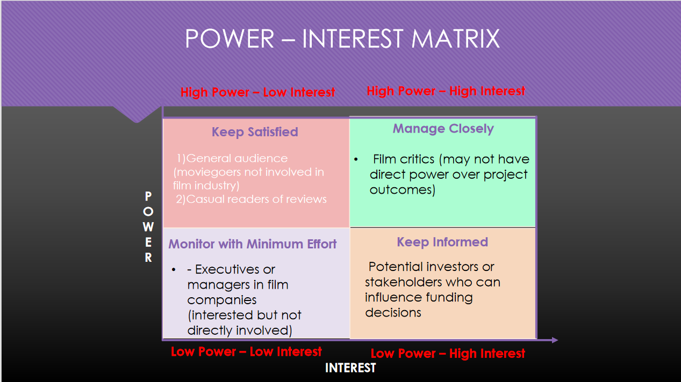

* High Power, High Interest: [Swapna]
* High Power, Low Interest: [Harika]
* Low Power, High Interest: [Manasa]
* Low Power, Low Interest: [Sudha]

1. **Empathetic Interviews**

**Conduct Skilled interview with at least 30 citizens/Users by asking open ended questions (What, why/How etc) and list the insights as per the format below**

|  |  |  |
| --- | --- | --- |
| **I need to know**  **(thoughts, feelings, actions)** | **Questions I will ask**  **(open questions)** | **Insights I hope to gain** |
| Thoughts |  |  |
|  |  |  |
|  |  |  |
| Feelings |  |  |
|  |  |  |
|  |  |  |
| actions |  |  |
|  |  |  |
|  |  |  |

**SKILLED INTERVIEW REPORT**

**(Examples are given. Erase them and fill with your user information.)**

|  |  |  |
| --- | --- | --- |
| **User/Interviewee** | **Questions Asked** | **Insights gained (NOT THEIR ANSWERS)** |
| Abhishek Verma,  Student | Which party do you vote for? | Citizens are not very open about their political preferences |
| Srinivasan P., Parent | How do you feel about the plans for a new capital? | Some citizens are sad that the capital is being relocated from Hyderabad. |
|  |  |  |
|  |  |  |
|  |  |  |

**Key Insights Gained:**

* **Insight 1**
* **Insight 2**

**Empathy Map**

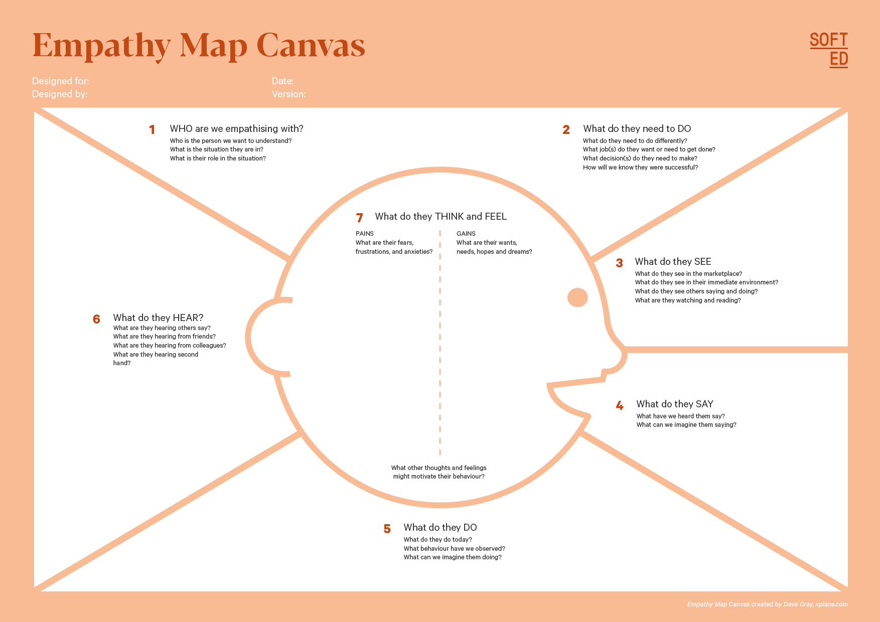

Your Answer:

Your Answer:

Who is your Customer Segment:

Idea/Innovation Title:

Designed By:

Date of Submission:

Your Answer:

Your Answer:

Your Answer:

Your Answer:

Your Answer:

Your Answer:

Your Answer:

1. **Empathy Map**
2. **Who is your Customer?**

**Description: This is where you specify the customer or user you are empathizing with. It could be a specific user persona or a general user segment.**

**Key points:**

* **Define the customer profile clearly (e.g., age, profession, interests).**
* **State their goals and needs related to the innovation or product.**
* **Context in which the user will interact with your solution.**

1. **Who are we empathizing with?**

**Description: This area helps you define who the user is, what their situation looks like, and what role they play. It emphasizes understanding the user’s perspective in depth.**

**Key points:**

* **Define the user's characteristics (e.g., personality, values, and responsibilities).**
* **State the user's goals and challenges in their environment.**
* **What is the user's broader situation (professionally or personally)?**

1. **What do they need to DO?**

**Description: This section identifies what actions or tasks the user needs to perform. It helps highlight the expectations and demands the user faces.**

**Key points:**

* **Clarify the tasks or actions the user needs to complete.**
* **What decisions do they need to make?**
* **How do they define success or failure in their tasks?**

1. **What do they SEE?**

**Description: This focuses on the visual stimuli or environment that the user interacts with. It's important to consider what users see in their immediate surroundings and in their larger world.**

**Key points:**

* **What do users see in their physical and digital environment?**
* **What trends or competitors do they notice?**
* **How do these visual elements influence their behavior?**

1. **What do they SAY?**

**Description: This section captures what the user might say in public, such as comments or feedback they give in conversations or on social media.**

**Key points:**

* **What might users express openly in conversation about their problems?**
* **How do they express their goals or frustrations?**
* **What are their words during customer interviews or feedback?**

1. **What do they DO?**

**Description: This section focuses on what the user does, the actual behaviors they exhibit, and actions they take in different situations.**

**Key points:**

* **What observable actions do users take?**
* **What habits or routines do they follow?**
* **What might users do to try and solve their problems?**

1. **What do they HEAR?**

**Description: This addresses what information the user receives from external sources, such as colleagues, media, or industry trends. It helps map the influences surrounding the user.**

**Key points:**

* **What are they hearing from peers, mentors, or the industry?**
* **What media or channels of information are they exposed to?**
* **Are there any strong influencers guiding their behavior?**

1. **What do they THINK and FEEL?**

**Description: This is one of the most insightful sections, addressing the internal emotions, concerns, and motivations of the user. It helps identify their deep-rooted feelings.**

**Key points:**

* **What are their fears, worries, and anxieties?**
* **What are their motivations and desires?**
* **How do their thoughts and feelings align with their actions?**

1. **Pains and Gains**

**Description: This section focuses on the user’s frustrations and their desired outcomes. It helps to frame the user’s challenges (pains) and the benefits they seek (gains).**

**Key points:**

* **What are the user’s main pain points?**
* **What would make their life easier or more fulfilling?**
* **What benefits do they hope to achieve from your product or solution?**

**9. Persona of Stakeholders**

**Stakeholder Name:**

**Demographics: Key characteristics of your target audience, such as age, gender, income, and location.**

**Goals: What the stakeholders or customers want to achieve in relation to the innovation.**

**Challenges: The obstacles or difficulties faced by stakeholders that the innovation aims to address.**

**Aspiration: The long-term desires or dreams of your target audience related to the innovation.**

**Needs: The essential requirements of your customers or stakeholders that must be met.**

**Pain Points: Specific problems or frustrations experienced by the target audience.**

**Storytelling: A narrative that highlights the journey of the stakeholder or customer, illustrating the problem and how the innovation can solve it.**

**Sample:**

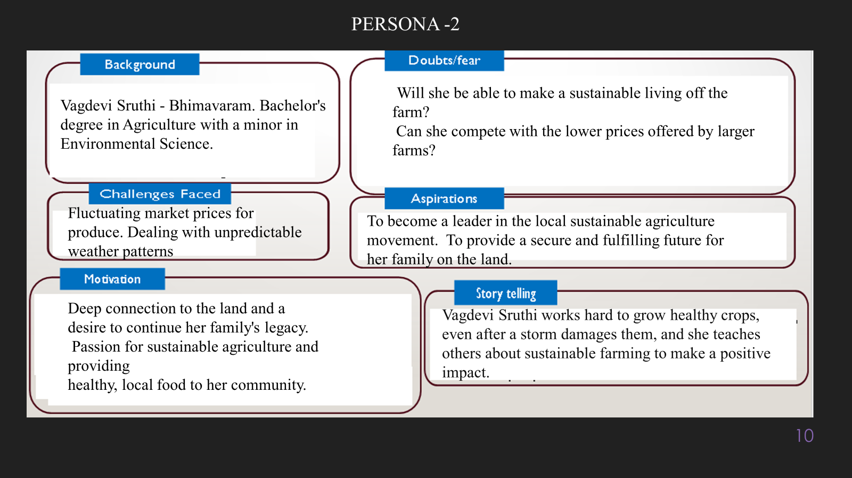

**10. Look for Common Themes, Behaviors, Needs, and Pain Points among the Users**

Analyse the data from your affinity diagram to uncover recurring patterns among your users, helping you better understand their expectations and challenges.

**Common Themes: Identify broad ideas or issues that repeatedly appear across different groups in your affinity diagram.**

**Common Behaviors: Observe how users consistently act or respond in relation to the problem or product throughout their journey.**

**Common Needs: Pinpoint essential requirements or desires that many users share, highlighting what they need for a better experience.**

**Common Pain Points: Look for frustrations or obstacles that frequently hinder the user experience, which your project can address.**

**11. Define Needs and Insights of Your Users**

**User Needs: Define the core requirements your users have in relation to the problem or product. These could be functional, emotional, or societal needs that your solution must address.**

**User Insights: Summarize the key understandings or observations you've uncovered about your users' behaviors, motivations, and pain points. These insights provide a deeper understanding of why users behave the way they do and what drives their decisions.**

**12. POV Statements**

**POV Statements:**

* [User] needs a way to [need] because [insight].

|  |  |  |  |
| --- | --- | --- | --- |
| PoV Statements  (At least ten) | Role-based or Situation-Based | Benefit, Way to Benefit,  Job TBD,  Need (more/less) | PoV Questions  (At least one per statement) |
| (Erase this example) When I drive to work, I want to avoid traffic jams so I don’t get in trouble with my boss for being late. | Situation | Way to Benefit | What can we design that will enable drivers to avoid traffic jams?  What can we design that will enable workers to avoid getting in trouble for being late to work? |
|  |  |  |  |
|  |  |  |  |
|  |  |  |  |
|  |  |  |  |

**13. Develop POV/How Might We (HMW) Questions to Transform Insights/Needs into Opportunities for Design**

Turn your user needs and insights into actionable opportunities by framing them as "How Might We" (HMW) questions. These questions will spark creative problem-solving and guide your innovation process.

1. **How Might We: Based on the needs and insights you've identified, create open-ended questions starting with "How might we...?" These questions should aim to solve user pain points, enhance the experience, or address specific needs.**

**Examples:**

* **User Need: "Users need a quicker way to access customer support."**
  + **HMW Question: "How might we create a more efficient and accessible customer support system?"**
* **Insight: "Users feel overwhelmed by too many options."**
  + **HMW Question: "How might we simplify decision-making for our users?"**

**Task:**

**Write 3-5 "How Might We" questions based on your analysis of user needs and insights. These questions should challenge you to think of innovative solutions that can address user problems in meaningful ways.**

**This task encourages participants to think creatively about solving user problems, transforming challenges into opportunities for innovation.**

|  |  |
| --- | --- |
| User Need/Insight | "How Might We" Question |
| [State the user need or insight clearly] | **How might we... [formulate an open-ended question to address the need or insight]?** |

**14. Crafting a Balanced and Actionable Design Challenge**

The Design Challenge Should Neither Be Too Narrow Nor Too Broad and It Should Be an Actionable Statement with a quantifiable goal. It should be a culmination of the POV questions developed.

**Design Challenge:** [Actionable Statement]

**15. Validating the Problem Statement with Stakeholders for Alignment**

Ensure your problem statement accurately represents the needs and concerns of your stakeholders and users. This involves gathering feedback from these groups to confirm that the problem is relevant and significant from their perspective. By validating early, you can refine the problem statement to better align with real-world challenges, ensuring your solution addresses the correct issues.

**Validation Plan:**

**Stakeholder/User Feedback (Min. 10 Stakeholders/Experts):**

|  |  |  |  |
| --- | --- | --- | --- |
| Stakeholder/User | Role | Feedback on Problem Statement | Suggestions for Improvement |
| [Name/Group] | **[Role/Title]** | **[Does the problem resonate with them? Why or why not?]** | **[Suggestions for refining the problem statement]** |
| [Name/Group] | **[Role/Title]** | **[Does the problem resonate with them? Why or why not?]** | **[Suggestions for refining the problem statement]** |

**16. Ideation**

**Ideation Process:**

|  |  |  |  |
| --- | --- | --- | --- |
| Idea Number | Proposed Solution | Key Features/Benefits | Challenges/Concerns |
| Idea 1 | **[Brief description of solution]** | **[What are the key benefits of this solution?]** | **[What challenges or concerns exist?]** |
| Idea 2 | **[Brief description of solution]** | **[What are the key benefits of this solution?]** | **[What challenges or concerns exist?]** |
| Idea 3 | **[Brief description of solution]** | **[What are the key benefits of this solution?]** | **[What challenges or concerns exist?]** |
| Idea 4 | **[Brief description of solution]** | **[What are the key benefits of this solution?]** | **[What challenges or concerns exist?]** |
| Idea 5 | **[Brief description of solution]** | **[What are the key benefits of this solution?]** | **[What challenges or concerns exist?]** |

**17. Idea Evaluation**

Evaluate the Idea based on 10/100/1000 grams

|  |  |  |  |  |
| --- | --- | --- | --- | --- |
| Idea | Impact (10/100/1000 grams) | Feasibility (10/100/1000 grams) | Alignment (10/100/1000 grams) | Total Weight |
| Idea 1 | **[Assign weight]** | **[Assign weight]** | **[Assign weight]** | **[Sum of weights]** |
| Idea 2 | **[Assign weight]** | **[Assign weight]** | **[Assign weight]** | **[Sum of weights]** |
| Idea 3 | **[Assign weight]** | **[Assign weight]** | **[Assign weight]** | **[Sum of weights]** |
| Idea 4 | **[Assign weight]** | **[Assign weight]** | **[Assign weight]** | **[Sum of weights]** |
| Idea 5 | **[Assign weight]** | **[Assign weight]** | **[Assign weight]** | **[Sum of weights]** |

**Example:**

|  |  |  |  |  |
| --- | --- | --- | --- | --- |
| Idea | Impact (10/100/1000 grams) | Feasibility (10/100/1000 grams) | Alignment (10/100/1000 grams) | Total Weight |
| Idea 1 | **1000** | **100** | **1000** | **2100** |
| Idea 2 | **100** | **1000** | **100** | **1200** |
| Idea 3 | **100** | **100** | **100** | **300** |

Further, use solution concept form to scrutinize the idea

**Solution Concept Form**

**1. Problem Statement:**

* **[State the validated problem your solution addresses.]**

**2. Target Audience:**

* **[Describe the main users or customers who will benefit from this solution.]**

**3. Solution Overview:**

* **[Provide a brief description of the solution concept.]**

**4. Key Features:**

| **Feature** | **Description** |
| --- | --- |
| **Feature 1** | **[Briefly describe the main feature of your solution]** |
| **Feature 2** | **[Briefly describe another key feature]** |
| **Feature 3** | **[Briefly describe a third key feature]** |

**5. Benefits:**

| **Benefit** | **Description** |
| --- | --- |
| **Benefit 1** | **[What value does this solution bring?]** |
| **Benefit 2** | **[How does this solution solve the problem?]** |
| **Benefit 3** | **[What makes this solution stand out?]** |

**6. Unique Value Proposition (UVP):**

* **[Summarize why this solution is unique and why it will appeal to your target audience.]**

**7. Key Metrics:**

| **Metric** | **Measurement** |
| --- | --- |
| **Metric 1** | **[What is the key metric to measure success?]** |
| **Metric 2** | **[What is another key metric for tracking progress?]** |

**8. Feasibility Assessment:**

* **[Provide a brief evaluation of how achievable or practical this solution is (consider resources, time, and technology).]**

**9. Next Steps:**

* **[Outline the next steps for further developing or prototyping this solution.]**