Ubuntucare Testing (production)

Beneficiary
Nnadi onyebuchi and Musa Jumai
5th January 2026

S/N | Feature | Screenshoot | Remarks
1 | Onboarding | 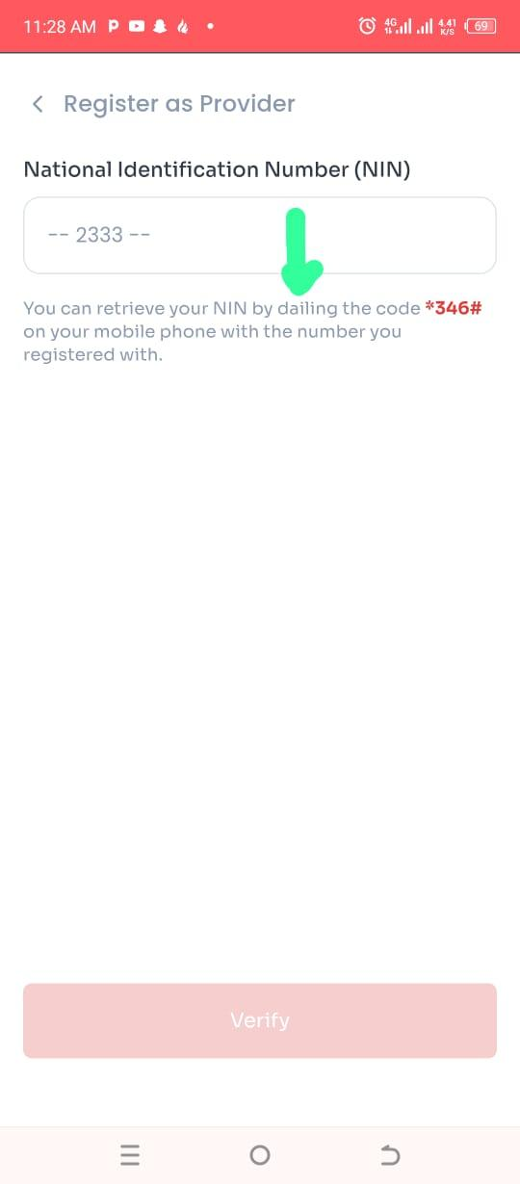 | I encountered spelling error on the register as a provider page. It should be “dialing the code” not "dialing the code”  NOT FIXED (24/1/2026)  FIXED (31/1/2026)
 |  | 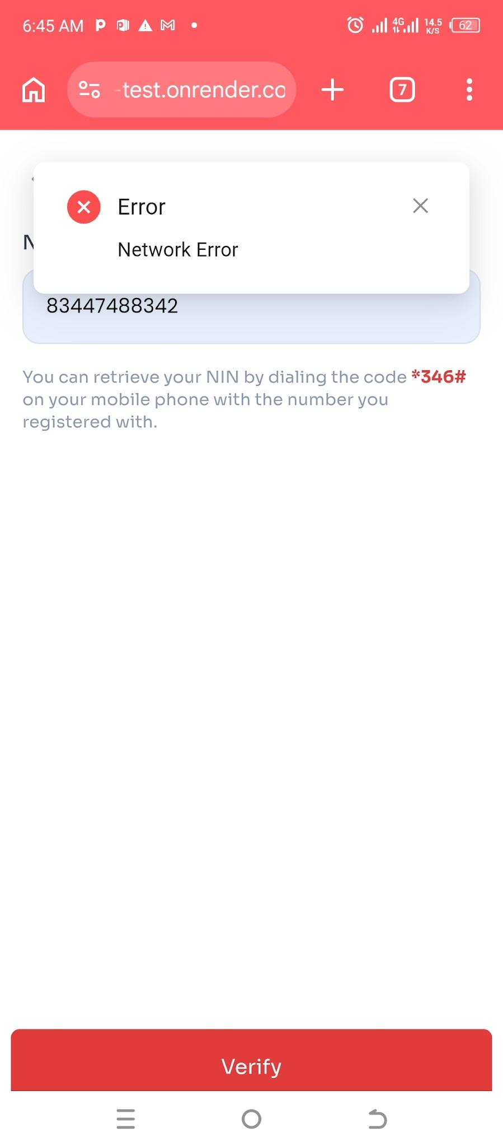 | I want to create new pharmacist account but it keeps showing “Network Error”  FIXED
2 | Repetition | 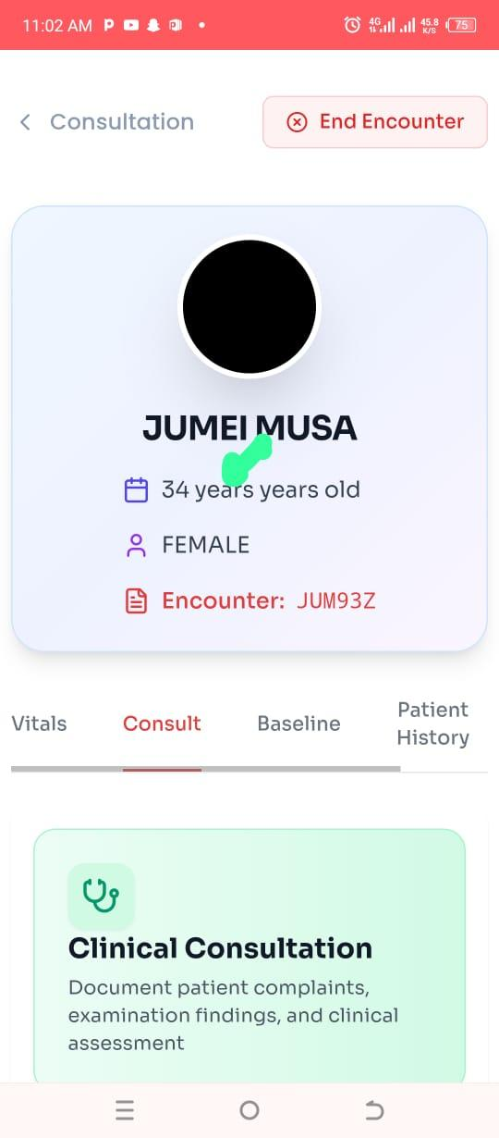 | On the consultation page,”years” was written two times  NOT FIXED (25/1/2026)  FIXED (31/1/2026)
3 | Baseline capture | 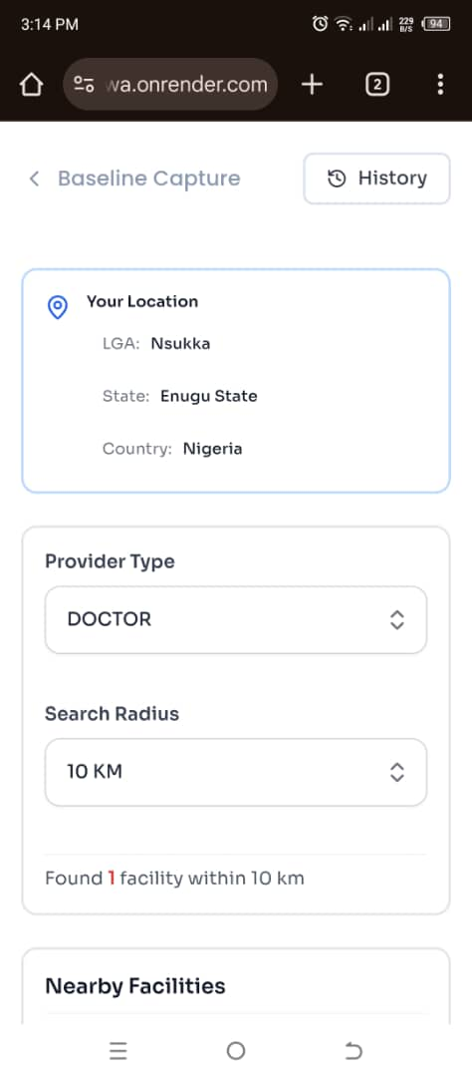 | - During baseline capture, the beneficiary should be able to access nearby facilities.  NOT FIXED (24/1/2026)  FIXED (17/5/2026)  - There should be a function that allows the user to choose from all registered facilities.  NOT FIXED (24/1/2026)  FIXED (17/5/2026)  - The facilities should be displayed in descending order based on distance. The list should start from the closest facility to the farthest.  NOT FIXED (24/1/2026)
 |  | 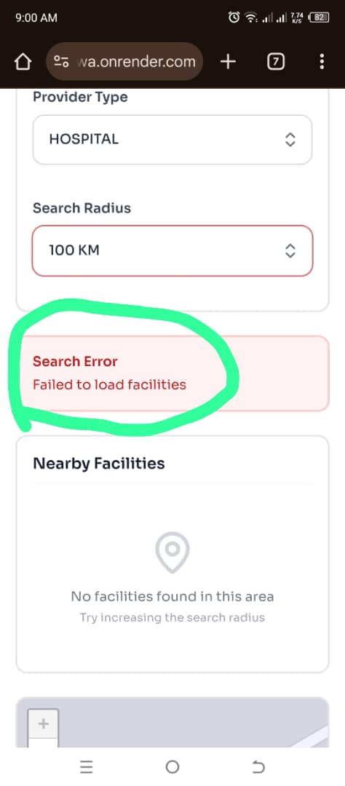 | During the baseline data capture process, when the Hospital option is selected, no information is displayed. Instead, the system returns a “Failed to load facility” error message, even after selecting the designated FADEST facility.  NOT FIXED (24/1/2026)
 |  | 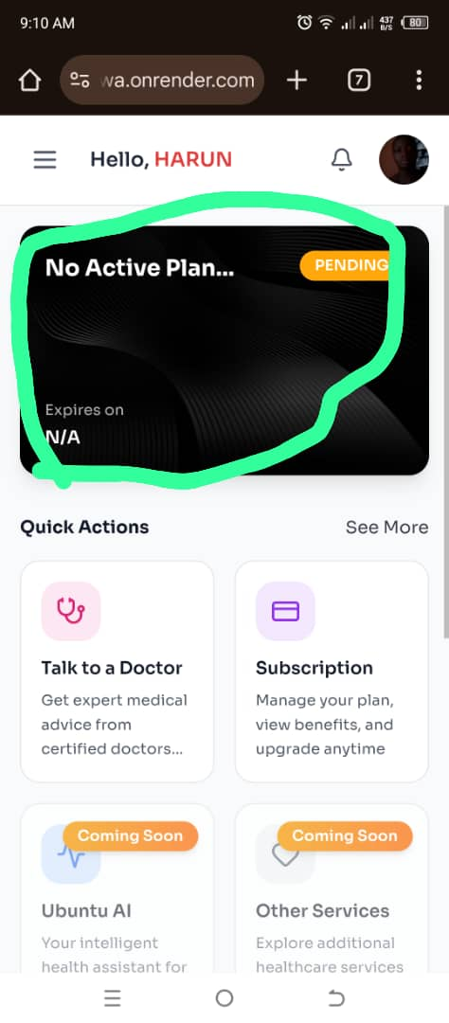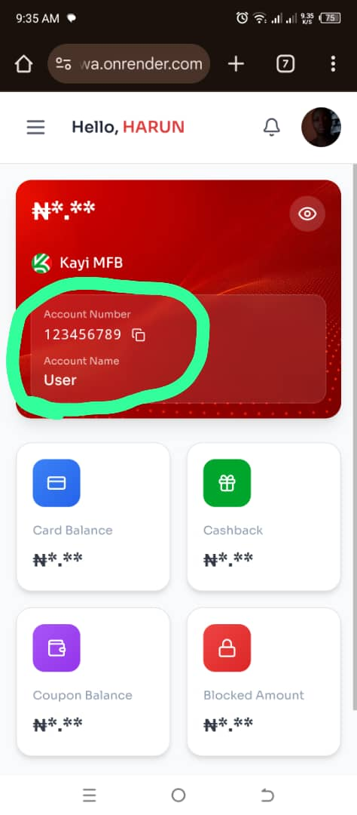  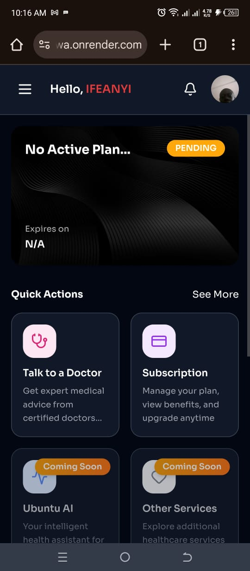 | An account that does not exist as a Kayi account was used, and no account number was initially attached to it. This check was carried out because, during the baseline data capture process, an attempt to complete the capture returned an error indicating that there was no active subscription. When the subscription process was initiated, no account was initially displayed for payment. After some time, an account number 123456789 was displayed and indicated as being linked to Kayi Bank; however, the account number could not be found or validated, making it impossible to proceed with the payment.  NOT FIXED (24/1/2026)  NOT FIXED (31/1/2026)  NOT FIXED (2/2/2026)  FIXED (17/5/2026)
4 | Encounter (book Encounter for self) | 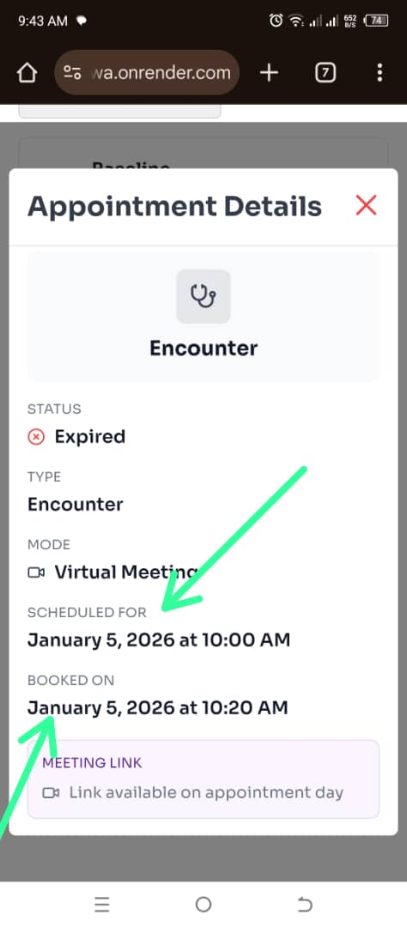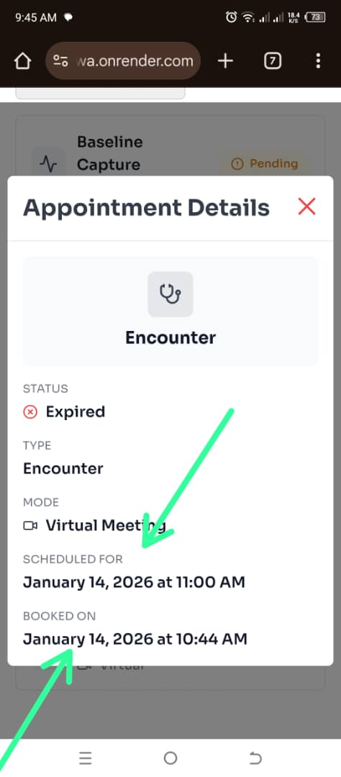  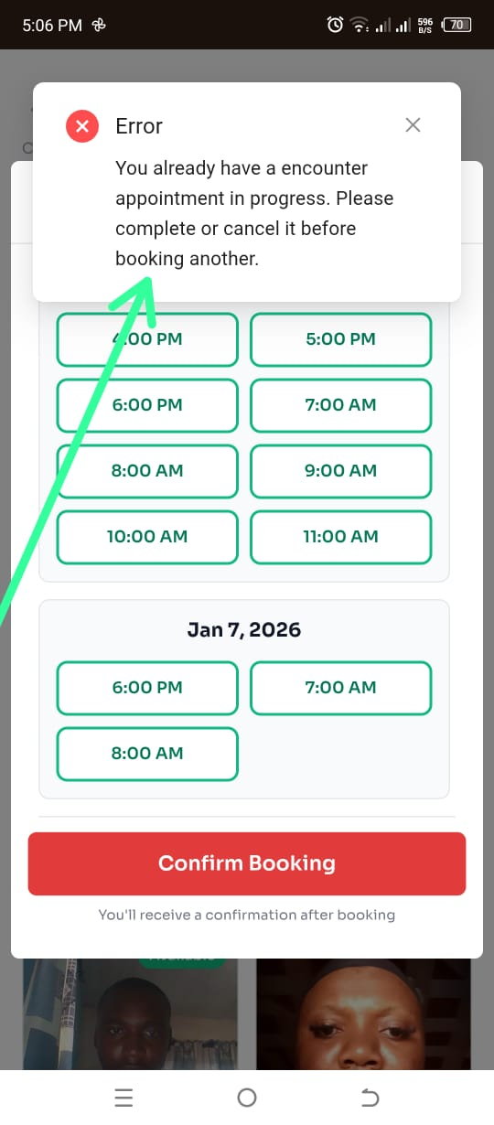 | The doctor’s appointment time is scheduled for 11:00, yet the beneficiary is still able to book the appointment at 11:40, even though the scheduled time has already passed  NOT FIXED (24/1/2026)  - When a beneficiary attempts to book an appointment, the doctor’s availability is not displayed immediately.  NOT FIXED (24/1/2026)  FIXED (31/1/2026)  - This occurs even after the doctor has set their time slots.  NOT FIXED (24/1/2026)  FIXED (25/1/2026)  - The beneficiary is required to refresh the page before the doctor’s availability becomes visible.  NOT FIXED (24/1/2026)  FIXED (25/1/2026)
- There is no Cancel Encounter button available on the Encounter Dashboard, making it impossible to cancel an encounter.
NOT FIXED (24/1/2026)
7 | Baseline capture | 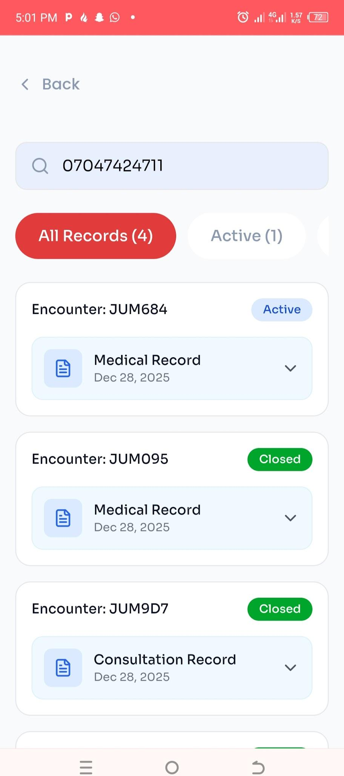 | The system allows a beneficiary to book appointment without conducting a baseline capture  NOT FIXED (24/1/2026)
8 | Change of password | 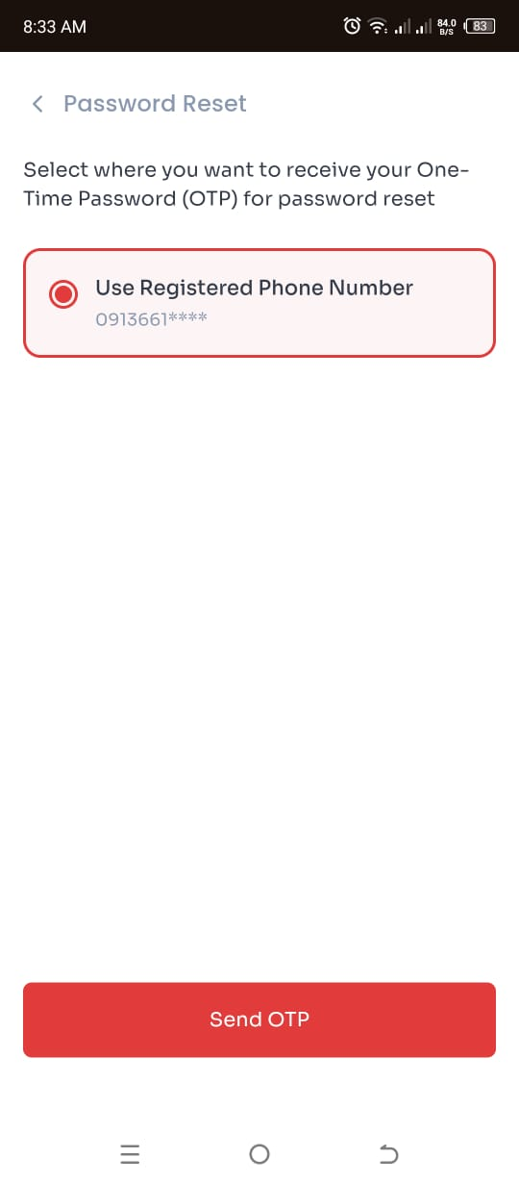  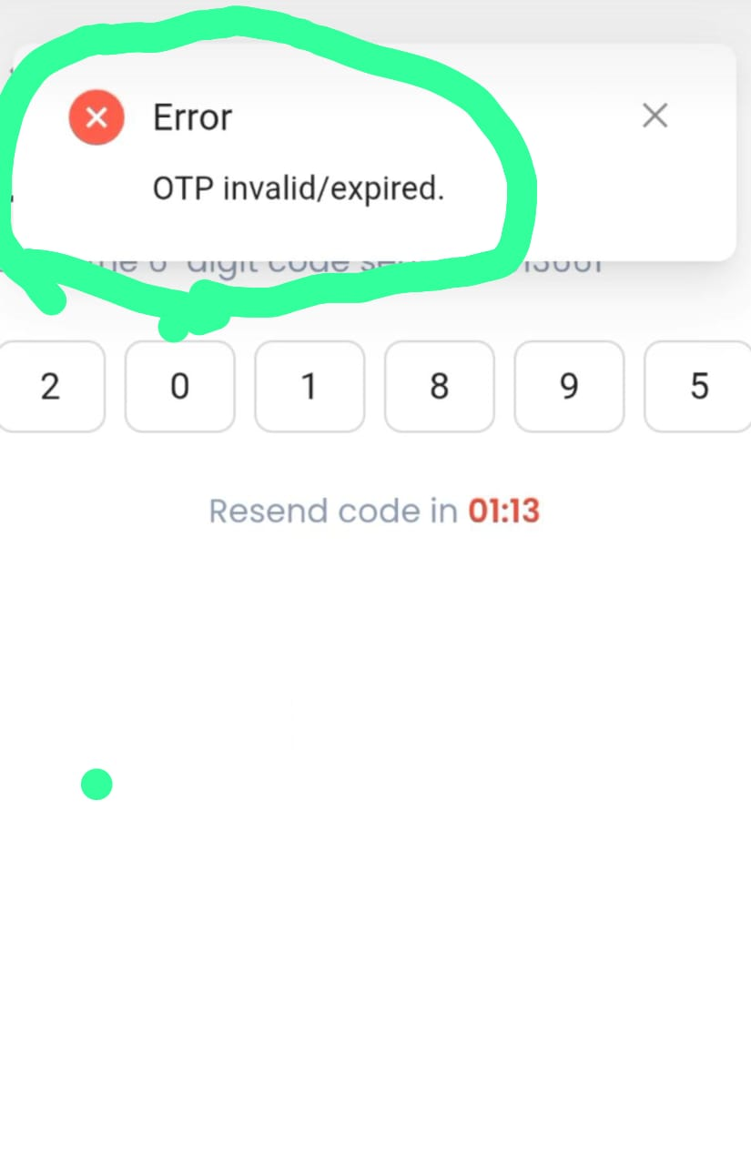  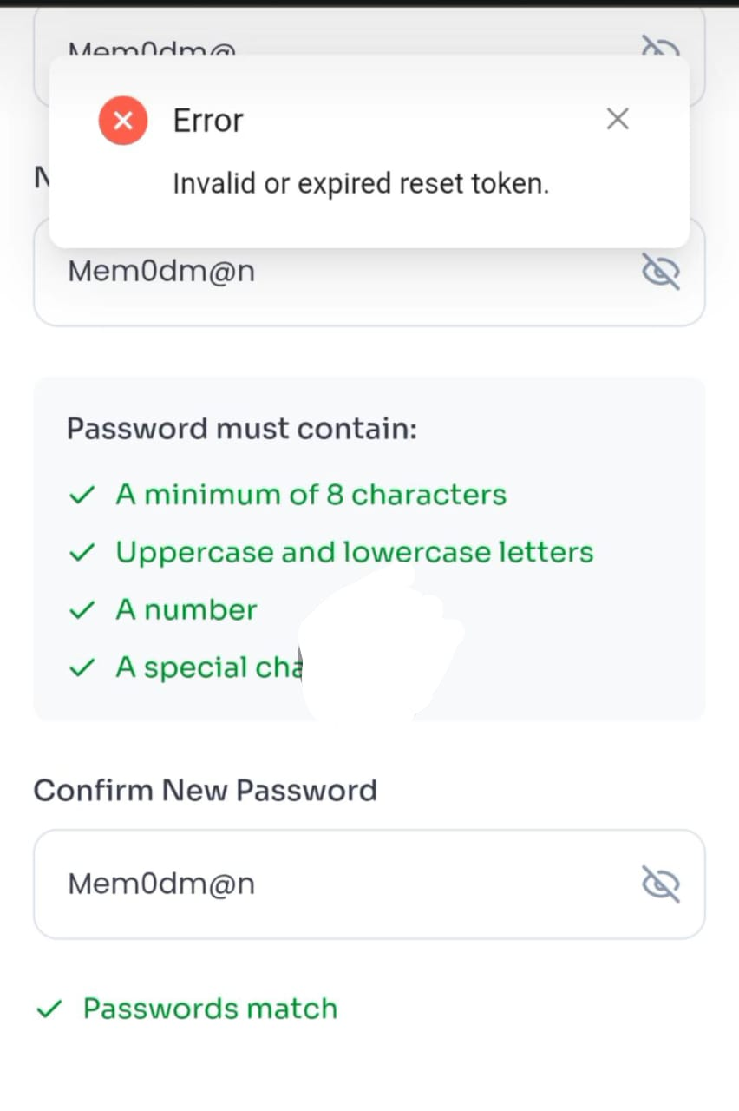  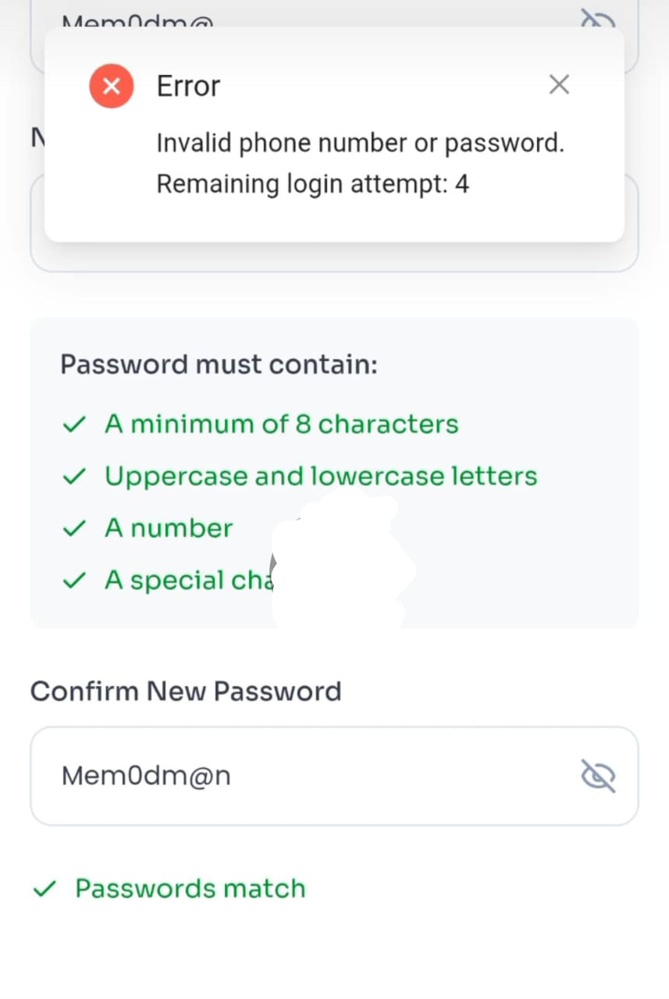  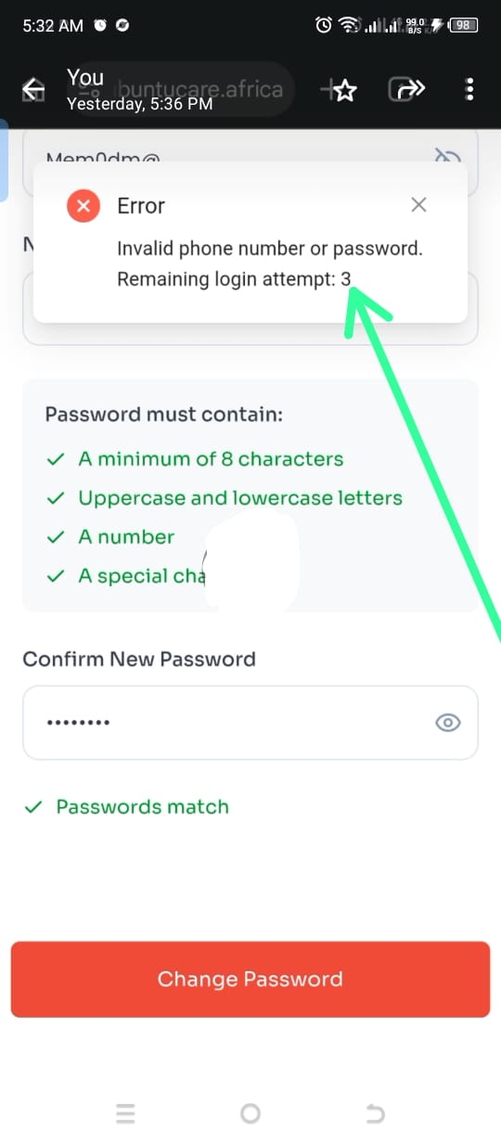 | The OTP for changing passwords takes too long. It would be faster to ask the user for their current password and let them change it right away.  NOT FIXED (25/1/2026)  NOT FIXED (31/1/2026)  - The reset password process has been updated, but it is still not properly optimized. There is no real need to send an OTP before resetting a password because the user already has an existing password. Using OTP for password reset makes the process slower and less convenient.  There are also situations where the user may not have access to the phone number linked to the account, such as when the phone is unavailable or the SIM card has been lost. In such cases, the user would be unable to receive the OTP and reset the password.  Instead, it would be faster and more user-friendly to ask the user to provide their current password before allowing them to change it directly.  NOT FIXED (16/5/2026)  - When the user is waiting for the OTP and leaves the OTP verification screen, the 5-minute countdown timer pauses until the user returns to that screen. This affects the consistency of the OTP verification process  NOT FIXED (16/5/2026).  FIXED (17/5/2026)  - Another issue is that after the OTP is sent, entering the OTP within the valid time range still sometimes returns an “OTP expired” error message even though the countdown timer has not yet expired. This suggests that the expiration time allocated for the OTP is either too short or starts counting down before the OTP is successfully delivered to the user.  - Additionally, when a user successfully uses the OTP and proceeds to the reset password page, then later returns to the “Send OTP” page, the previous countdown timer is still running even though the OTP has already been used. Once an OTP has been successfully verified and used, the countdown should automatically terminate and reset, making the system ready to send a new OTP when required.  NOT FIXED (16/5/2026)  - The OTP validity duration should be increased and made to last longer to improve user experience. The countdown should begin only after the OTP has been successfully delivered, not while it is still being processed or delayed in delivery.  NOT FIXED (16/5/2026)  - While still logged into the account and trying to change the password, the system displayed an error message stating “Invalid or expired reset token.” This should not happen because the user is already authenticated and actively logged into the account.  NOT FIXED (16/5/2026)  - When an incorrect password is entered, the error message displayed says “Invalid phone number or password.” However, in this case, the phone number is already correct and the issue is specifically with the password.  The error message should therefore be more specific, such as “Incorrect password,” to give clearer feedback to the user.  NOT FIXED (16/5/2026)  - After the system displayed the “Invalid reset token” error message, I logged out and logged back into the application. While trying to reset the password again using an incorrect current password, another error message was displayed stating, “Invalid phone number or password, remaining login attempt is 3.”  This indicates that the system did not properly refresh or reset after logout. The total allowed attempts are 5, so after making one failed attempt, the remaining attempts should have been 4, not 3. Instead, the system still counted the failed attempt made before logging out, showing that the previous session data or attempt counter was not properly cleared or refreshed after logout.  NOT FIXED (16/5/2026)  FIXED (17/5/2026)
9 | Encounter(Encounter booked for a beneficiary by a chemist) | 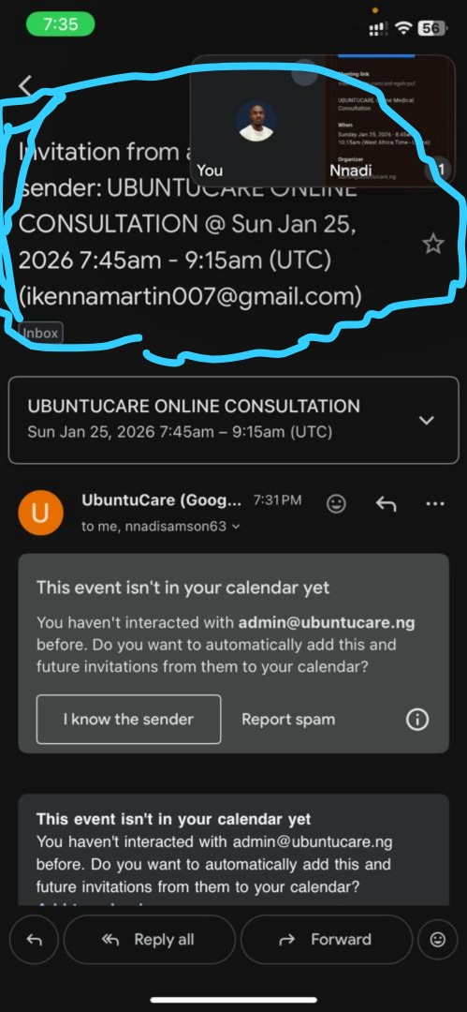 | After a chemist schedules an encounter for a beneficiary, the email sent to the beneficiary shows the wrong time. For example, if the chemist selects 8:00, the email shows 7:45–9:15 instead. The scheduled time does not match what the chemist booked.  NOT FIXED (24/1/2026)
10 | Recent Activity | 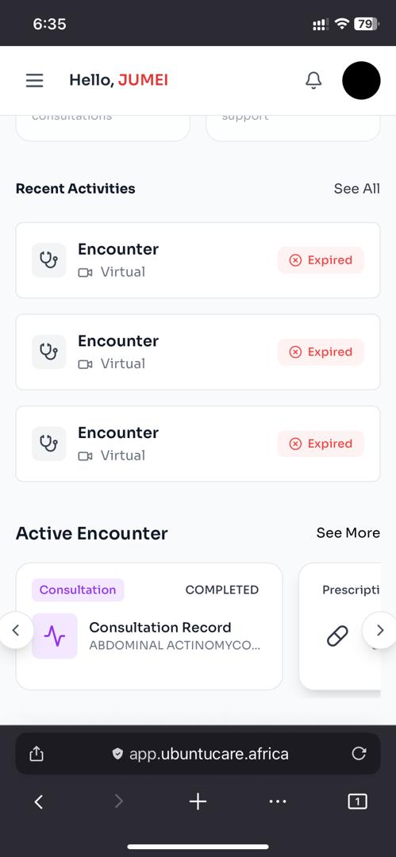 | Recent activities don't reflect an ongoing encounter or nurse triage even when the consultation is active, also acknowledged by the active encounter section.  NOT FIXED (27/01/2026)
11 | Email(After booking Encounter) | 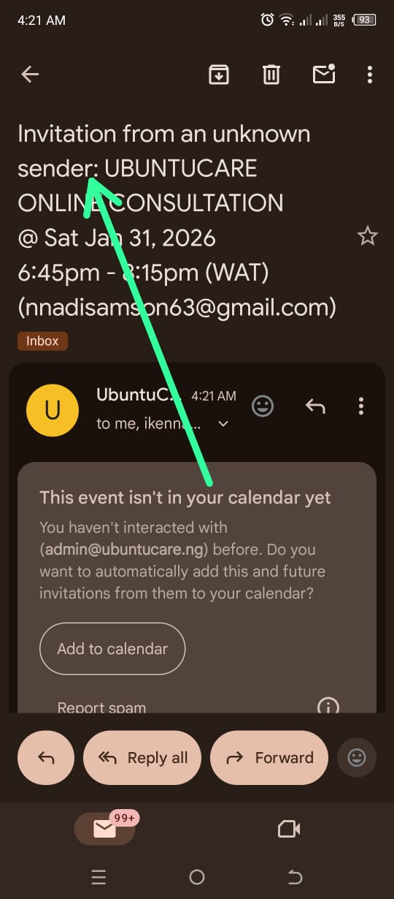 | An email invitation was received and flagged as coming from an unknown sender. However, despite being marked as unknown, the email explicitly displayed the sender name as UBUNTUCAREONLINE CONSULTATION, creating an inconsistency between the sender identification and the system’s classification of the email source.  NOT FIXED (31/01/2026)
12 | Subscription | 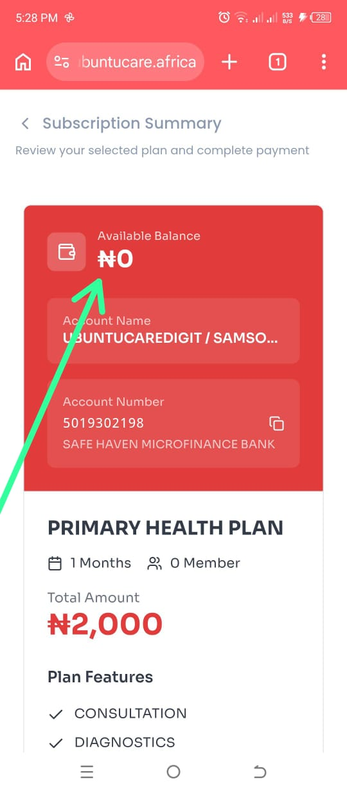  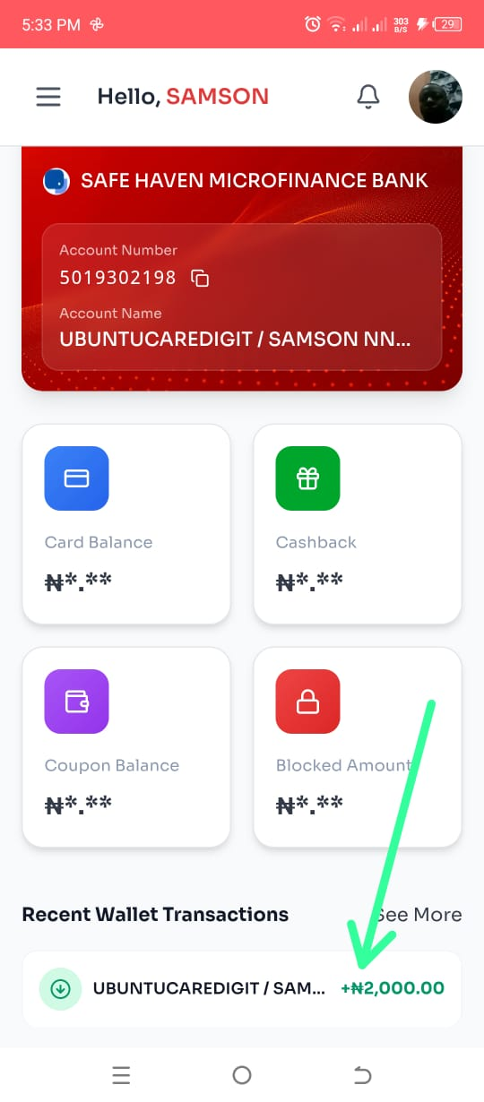 | Under the subscription section, after making a payment, the amount paid does not immediately reflect in the account balance. However, the transaction appears in the transaction history below. After some time, the balance eventually updates and reflects the payment.  The balance should update immediately once the payment is successful to ensure consistency between the account balance and transaction history.  NOT FIXED (17/5/2026)
13 | Email(Send OTP for reset password) | 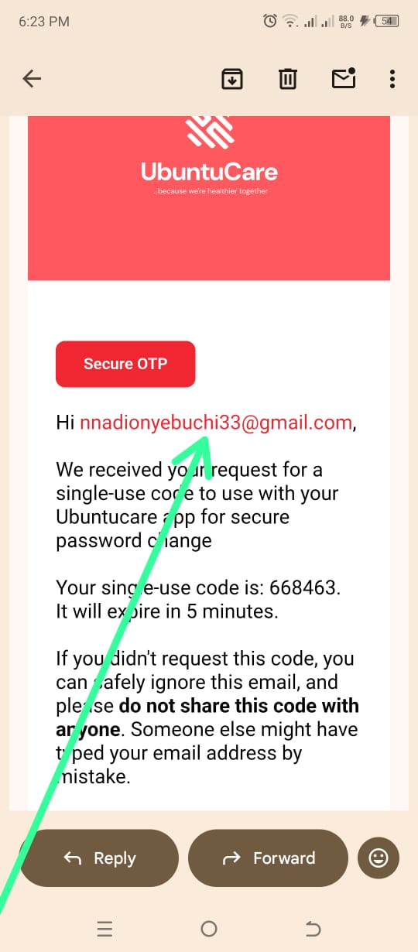 | In the email sent during the OTP process, the greeting currently displays the user’s email address instead of the user’s actual name. For example, instead of saying “Hi [User Name],” it displays “Hi [Email Address].”  The system should display the user’s registered name in the greeting section of the email to make the message more personalized and professional.  NOT FIXED (17/5/2026)
14 | Wallet history | 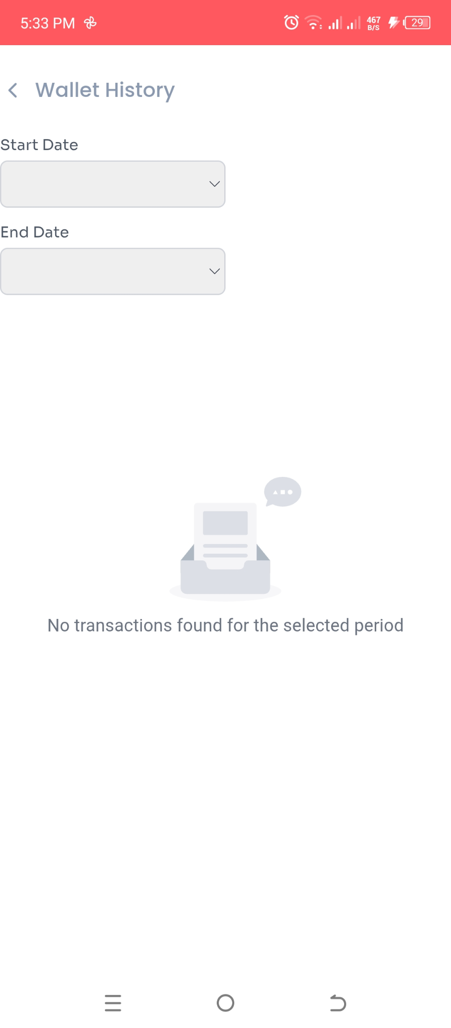 | The wallet history section is currently not displaying transaction records. Instead, it shows the message “No history found for the selected time.”  The system should display the current transaction history by default when the page is opened. After that, the user can choose to adjust the date or time range by either increasing or decreasing it to view specific transactions.  NOT FIXED (17/5/2026)

Doctor - Service provider
Nnadi onybuchi
5th January 2026

S/N | Feature | Screenshot | Remarks
1 | Login |  | After a doctor creates an account and logs in for the first time without setting up time slots, a reminder should be displayed prompting the doctor to set up their available time slots.  NOT FIXED (24/1/2026)
3. | Profession certifications verification |  | On the registration page where certificate upload is required, the system only checks the image size and does not validate the authenticity or type of the document being uploaded. As a result, any image can be uploaded and accepted as a certificate.  NOT FIXED (24/1/2026)
4 | Notification | 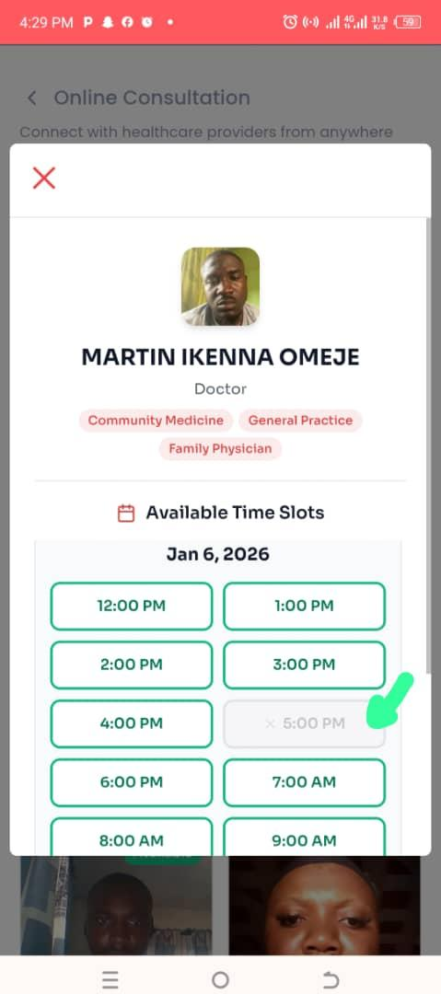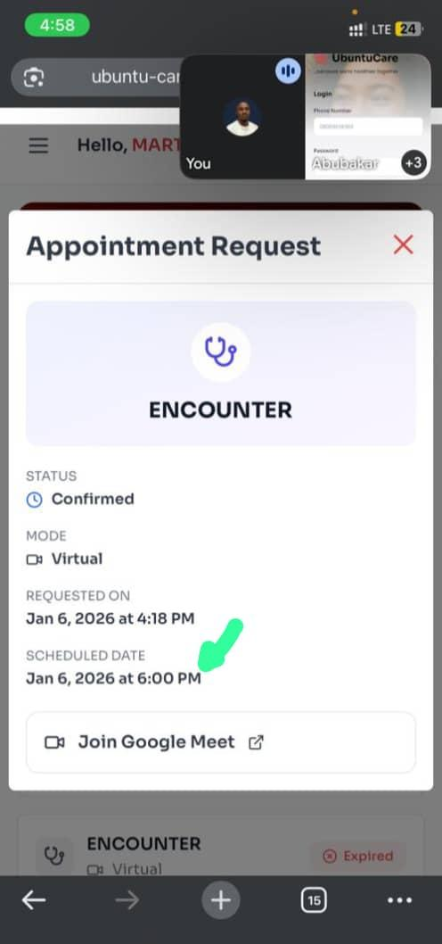 | On the doctor's page, the notification for online consultation doesn't show the same scheduled date chosen by the beneficiary  FIXED (25/1/2026)
5 | Encounter | 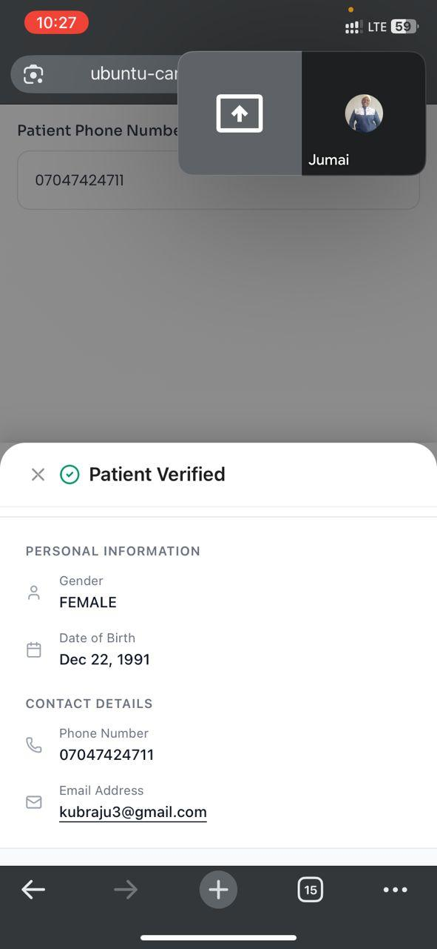  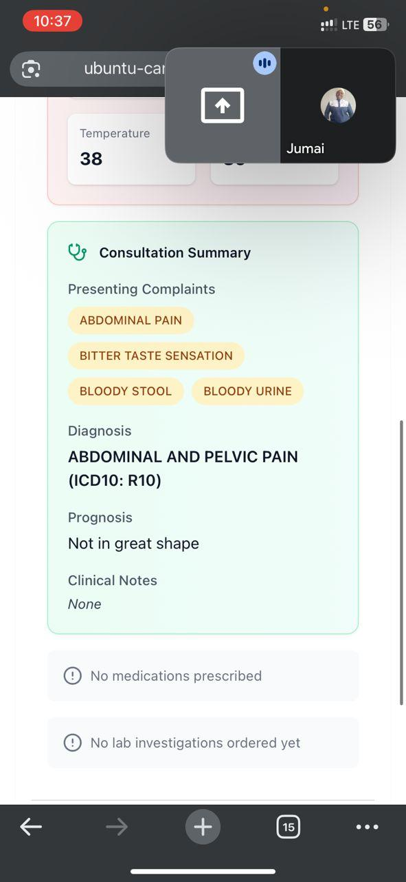 | No email notification is sent when an encounter is booked with a doctor.  FIXED (25/1/2026)  When an appointment request is sent, there is no way to identify the person that sent the request. For example, the name of the person that sent the request  NOT FIXED (25/1/2026)  NOT FIXED (31/1/2026)  NOT FIXED (9/2/2026)  The consultation summary shows "no medication prescribed" and "no lab investigation ordered yet" because there are no buttons to input medication prescription and order lab investigation  FIXED (25/1/2026)
6 | Google meet link | 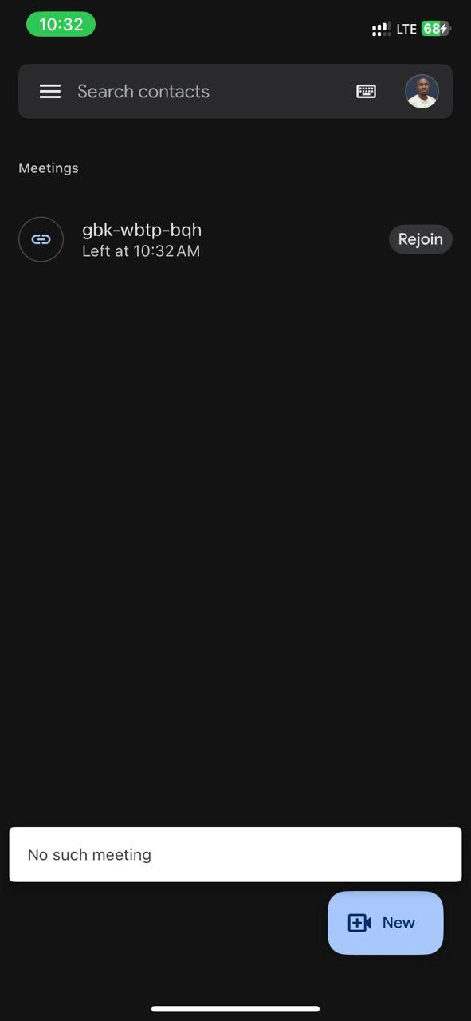 | Google meet link is not active which means encounter from this end is a failure or it doesn't work  FIXED (25/1/2026)
7 | Appointment request | 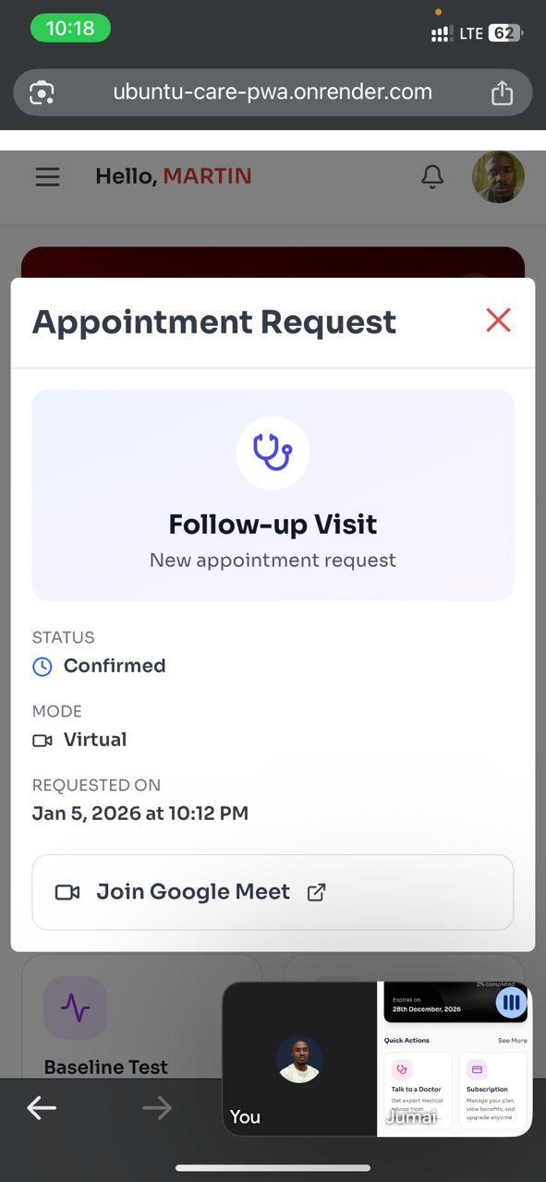 | This information is displayed, which is limited as doctors or other service providers will find it difficult to differentiate encounters.  NOT FIXED (25/1/2026)
8 | Lab results upload | 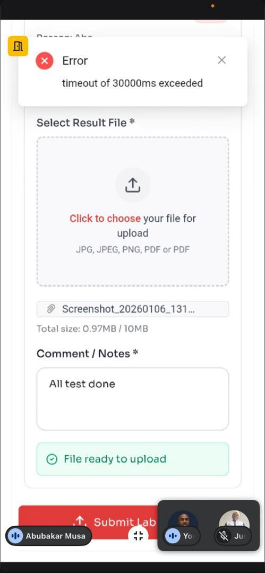 | Lab scientists encounter this error on lab results upload.  NOT FIXED (25/1/2026)  FIXED
9 | Available time slots | 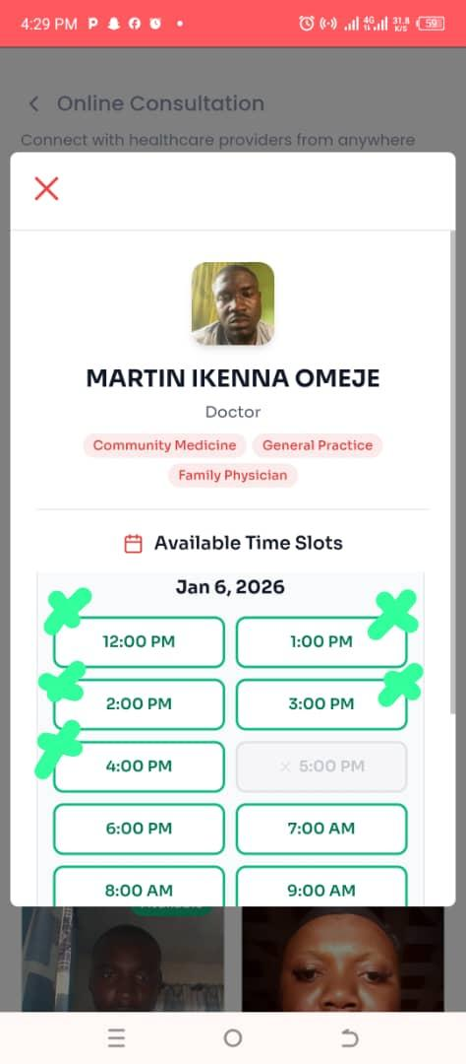 | It's not supposed to be showing a time that has passed. It's supposed to be showing a time that is ahead. Again any time that has passed is not supposed to be on the slot  FIXED (25/1/2026)
11 | Encounter  [appointment request] | 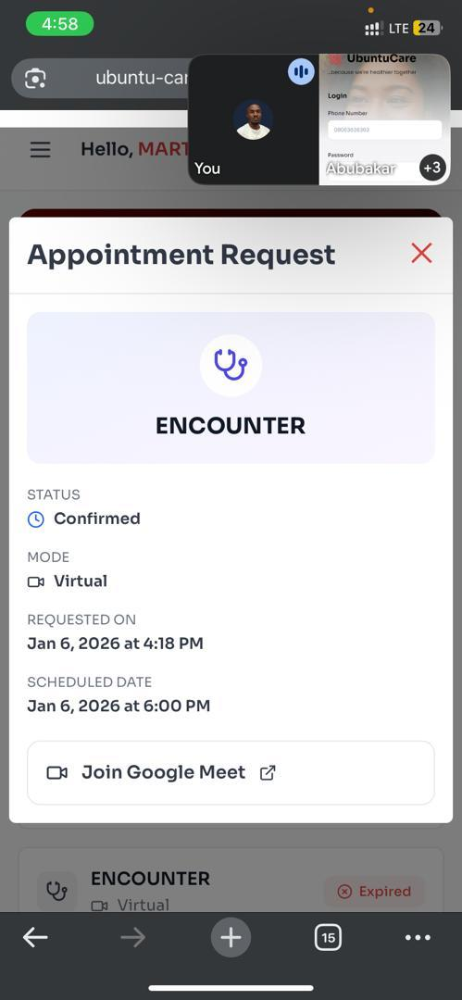 | An appointment was booked for 5pm and a doctor received it as 6pm appointment  It happens that if someone has an appointment by 5pm when the person comes he will not see the doctor.  FIXED (25/1/2026)
13 | Patient encounter history | 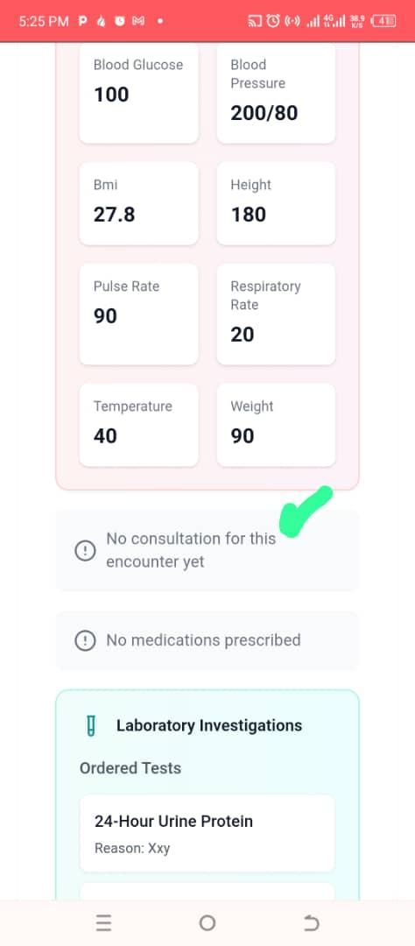 | It shows "no consultation for this encounter yet” even after a person has ordered test  FIXED (25/1/2026)
14 | Encounter (Follow-up visit) | 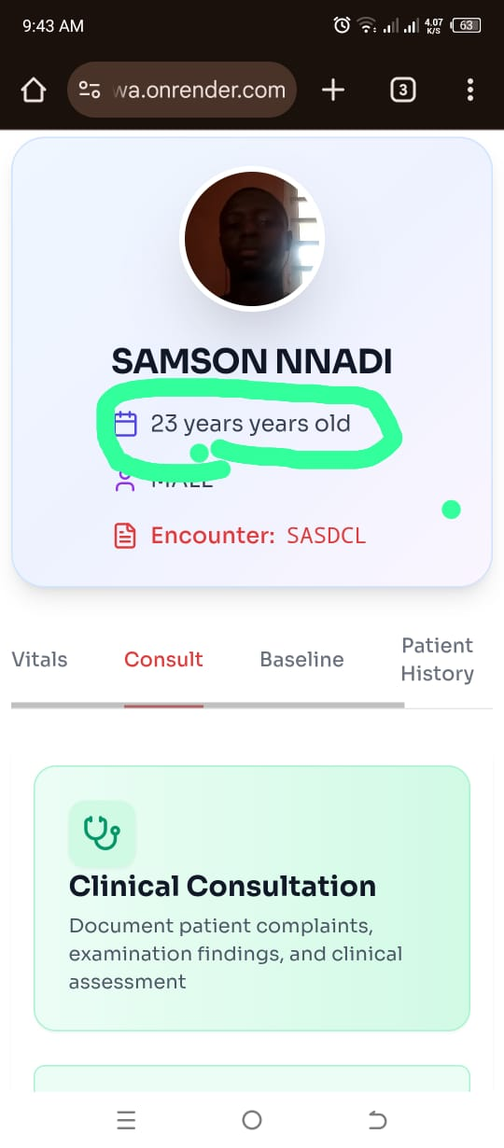 | The age of a beneficiary in the doctor’s follow-up view shows the word “years” twice. For example, it appears as “25 years years” instead of “25 years.”  NOT FIXED (25/1/2026)  FIXED (9/2/2026)
15 | Encounter(Follow-up visit (Create prescription)) | 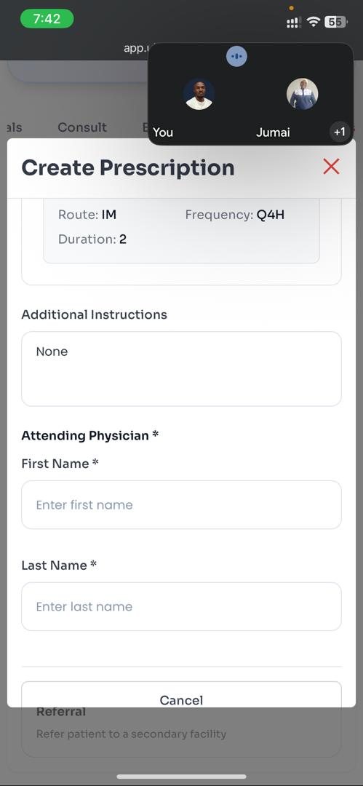 | During prescription creation, the doctor and pharmacist must enter their names manually instead of having them automatically filled from the login data.  NOT FIXED (25/1/2026)  NOT FIXED (9/2/2026)
16 | Encounter (Follow-up visit(Order laboratory investigation )) | 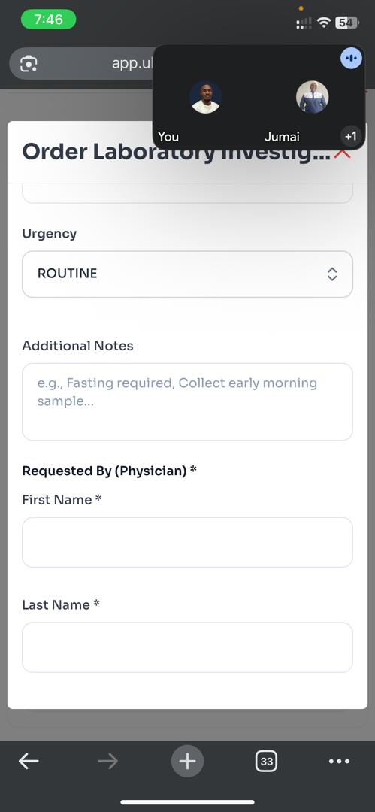 | When ordering a laboratory investigation under a follow-up visit encounter, the doctor still has to enter their name manually instead of it being automatically filled from the login data.  NOT FIXED (25/1/2026)  NOT FIXED (9/2/2026)
17 | Encounter | 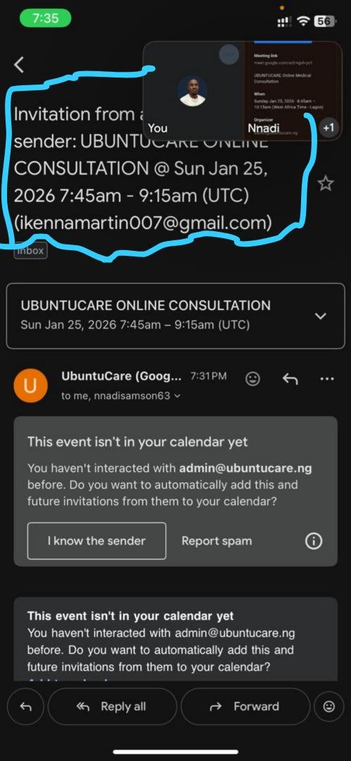 | After a chemist books an encounter for a beneficiary, the doctor receives an email with the wrong time. For example, when the chemist books 8:00, the email shows 7:45–9:15 instead.  NOT FIXED (25/1/2026)
18 | Assessment |  | Doctors can not see a nurse triage assessment history on a patient  NOT FIXED (27/01/2026)
19 | Order | 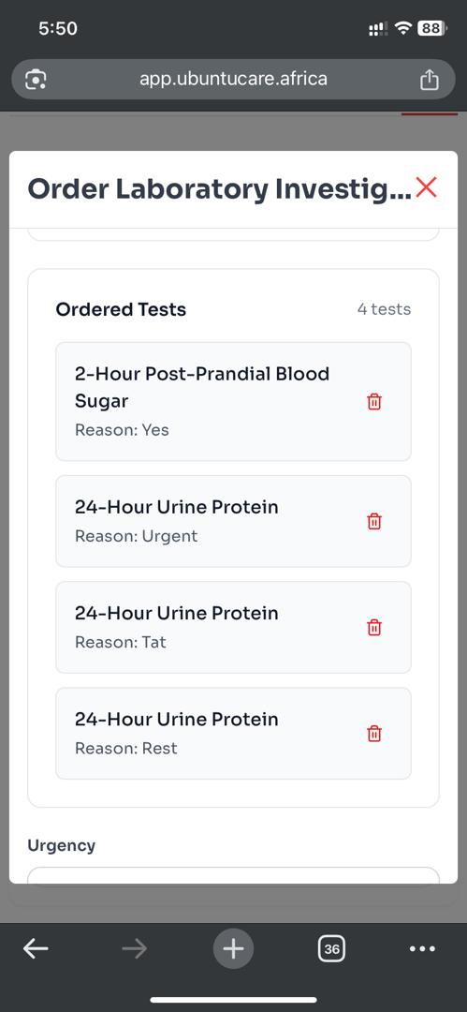 | Doctors can add same lab result multiple time  NOT FIXED (27/01/2026)
20 | Tagging |  | Doctors still add their name manually to all their actions; consultation, ordering, etc.  NOT FIXED (27/01/2026)
21 | Referral | 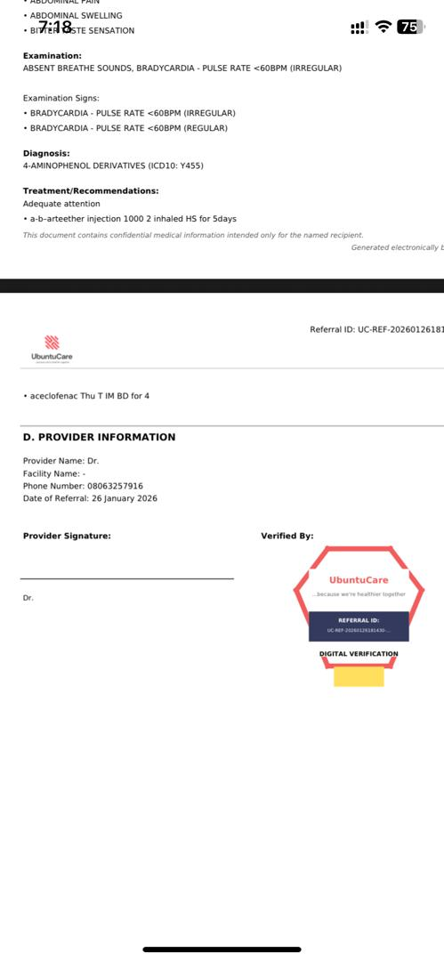 | - Referral notification email with pdf was only received by the doctor and none was sent to the beneficiary.  NOT FIXED (27/01/2026)  - There is no provider name on the referral pdf, only ‘Dr’ title was seen  NOT FIXED (27/01/2026)  - Stamp looks different from the original design  NOT FIXED (27/01/2026)  - If the service provider doesn’t have a registered facility, the field should carry “Ubuntucare” by default. If the facility name is present, it should read “Ubuntucare - {FACILITY NAME}”.  NOT FIXED (27/01/2026)
22 | Encounter(Patient Encounter) | 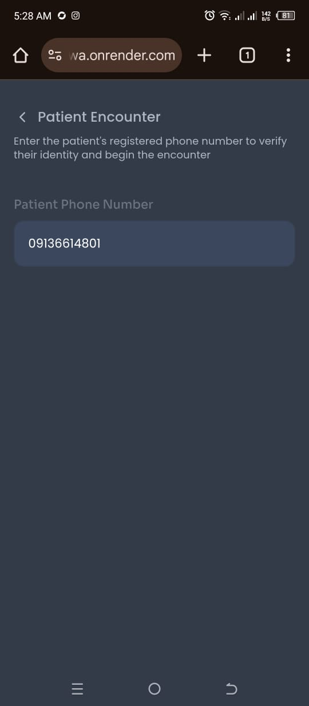 | During the patient encounter process, after entering the patient’s phone number, the service provider is required to scroll upward to access the “Verify Patient” button. This occurs despite there being sufficient available screen space to display the button without requiring any scrolling.  NOT FIXED (30/01/2026)
22 | Encounter (Appointment Request) | 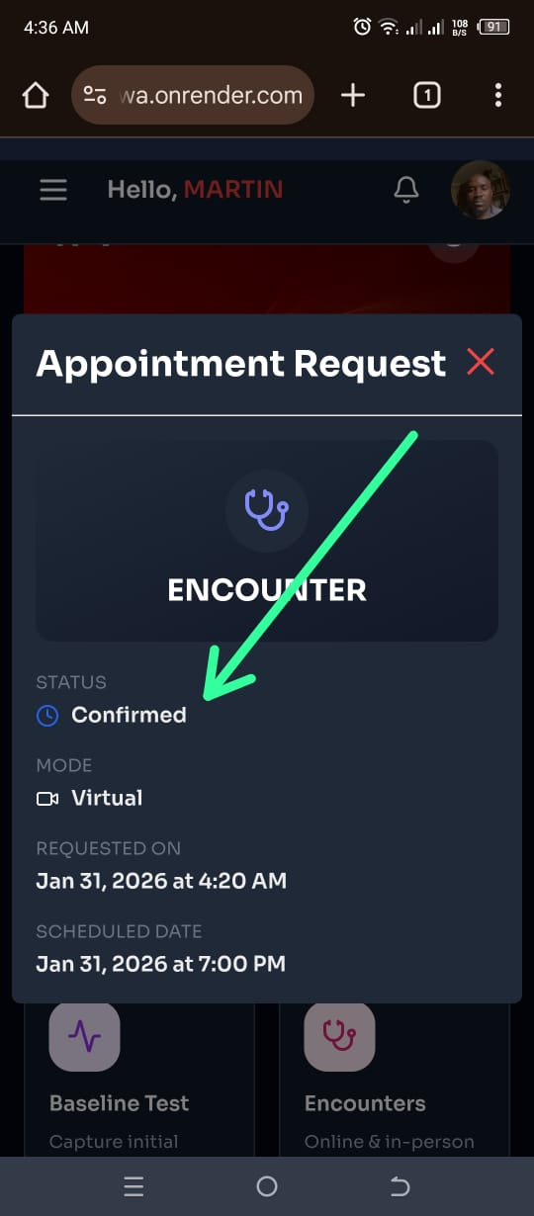 | Once an appointment is booked, the system immediately marks it as confirmed, even when the doctor has not yet confirmed availability. This behavior does not account for situations where the doctor may already be scheduled for the same time slot. As a result, the system may automatically accept and confirm multiple encounters for a single doctor at the same time, leading to scheduling conflicts.  NOT FIXED (30/01/2026)
23 | Prescription (Create prescripton) | 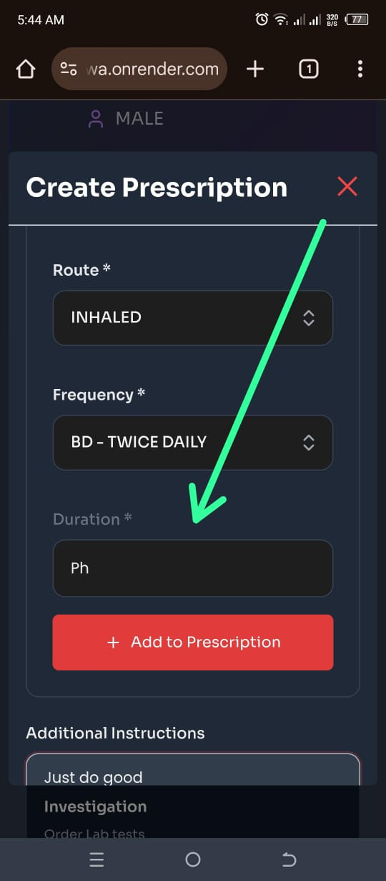 | The duration field currently accepts any type of input, including non-numeric characters. This allows users to enter invalid values. The field should be restricted to numeric digits only, or appropriate input validation should be implemented to prevent the entry of unsupported characters and ensure accurate data capture.  NOT FIXED (30/01/2026)
24 | Encounter | 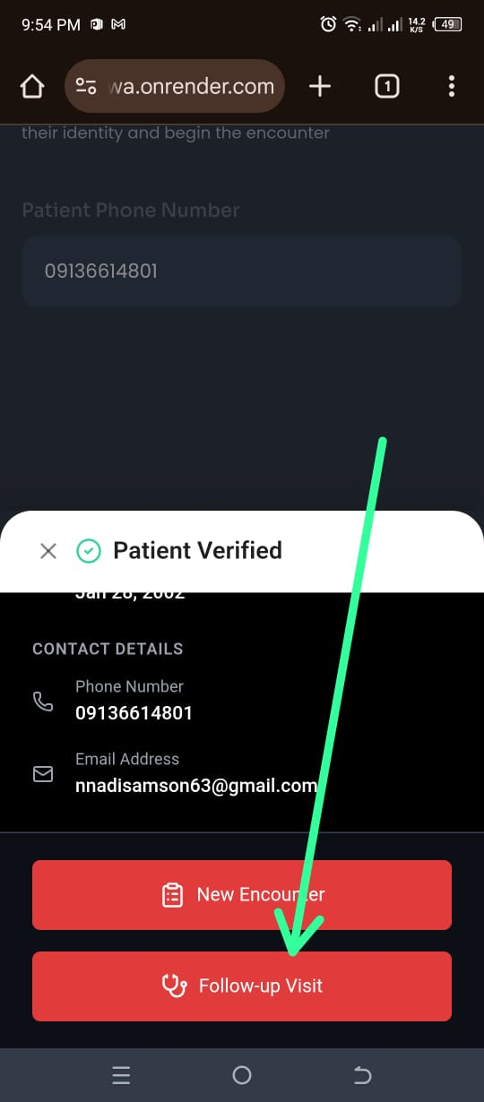 | When an encounter is initiated by a beneficiary and the doctor attempts to start the encounter for the first time with that beneficiary, selecting “Follow-Up Visit” instead of “New Encounter,” the system allows the process to proceed. The system does not flag that the doctor has not previously started an encounter with the beneficiary, even though this is the doctor’s first interaction with the patient.  NOT FIXED (31/01/2026)
25 | Encounter(Booking encounter for a beneficiary) | 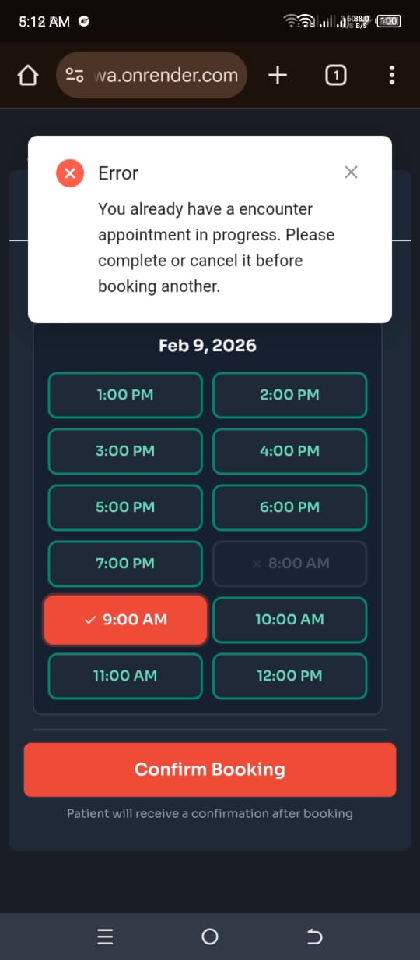 | When a chemist books an encounter for a beneficiary and then attempts to book another encounter for a different beneficiary, the system displays an error message indicating that an encounter has already been booked. This behavior suggests that the chemist is restricted to booking only one encounter at a time.  NOT FIXED (9/2/2026)
26 | Edit button |  | After a chemist completes the process of entering personal details, location, and other required information, the system does not provide an option to edit or correct the submitted details.  NOT FIXED (9/2/2026)
27 | Tabs |  | When a user opens the application in a new browser tab without closing the previously opened tab after entering their details, the new tab displays the account information from the old tab instead of loading a new or separate session.  NOT FIXED (9/2/2026)
28 | Encounter (Follow up) | 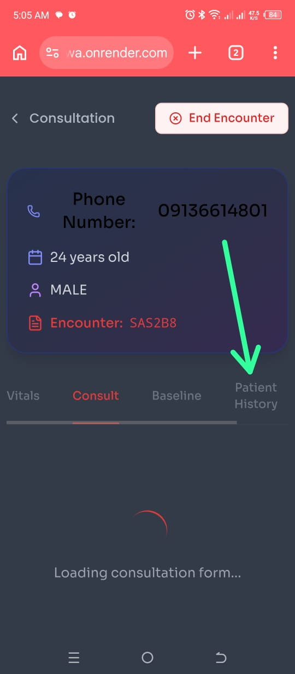  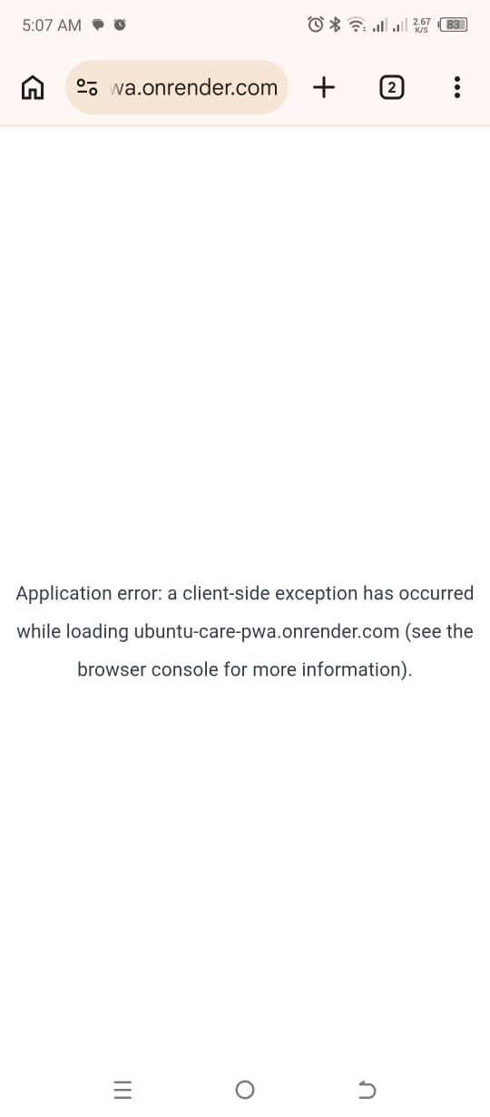 | When a user clicks on “Patient History” under the Encounters section, the system does not load the requested page. Instead, it displays the following error message:  “Application error: a client-side exception has occurred while loading ubuntu-care-pwa.onrender.com (see the browser console for more information).”  NOT FIXED (19/2/2026)
29 | Walkthrough video | 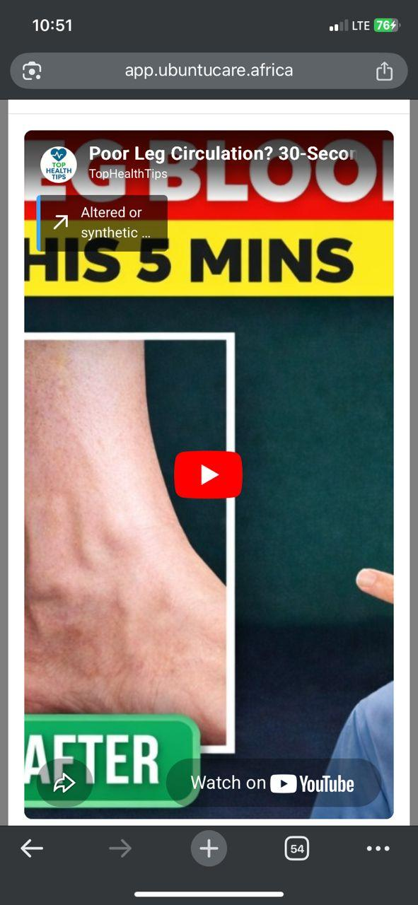 | There is no close(x) button on the iframe modal.
30 | Schedule availability | 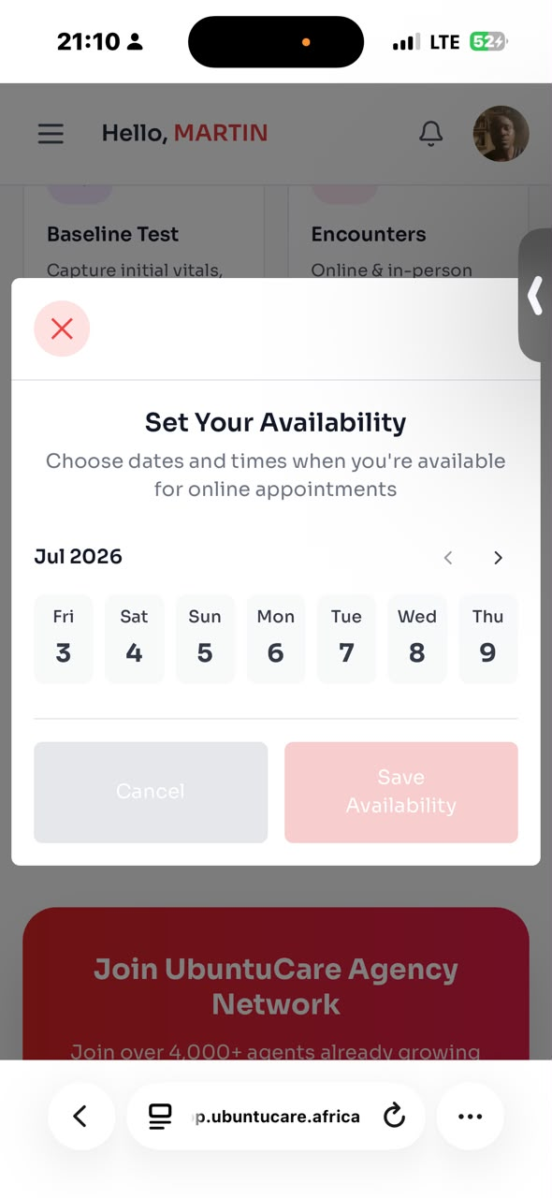  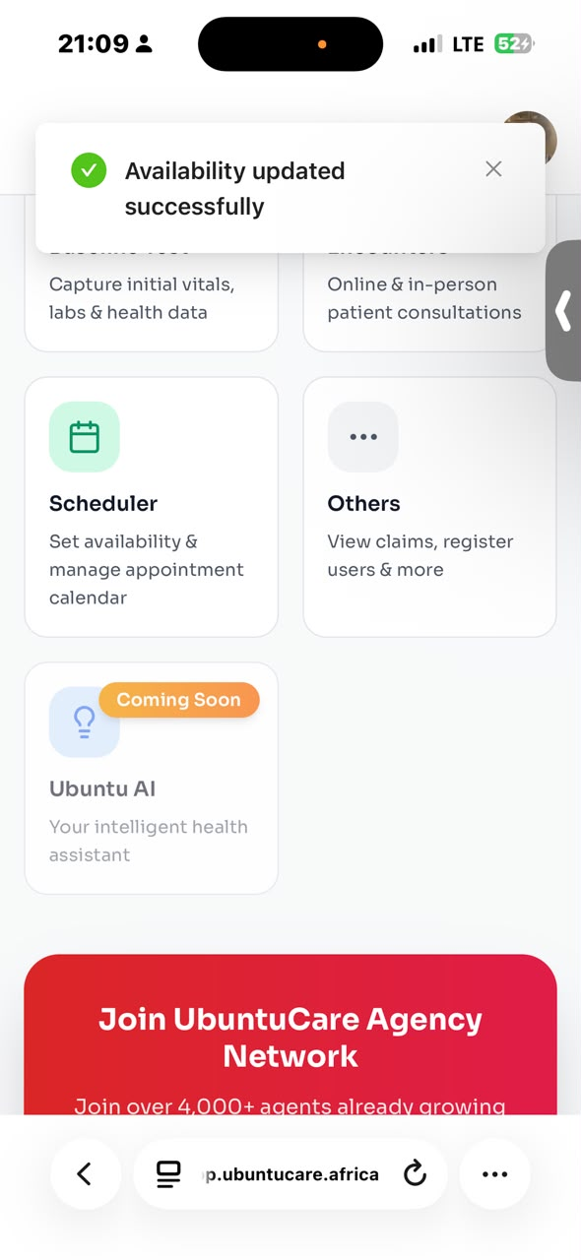 | While setting provider availability, the system does not retain or display the selected time slots after saving.  NOT FIXED (3/7/2026)
31 | Schedule availability | 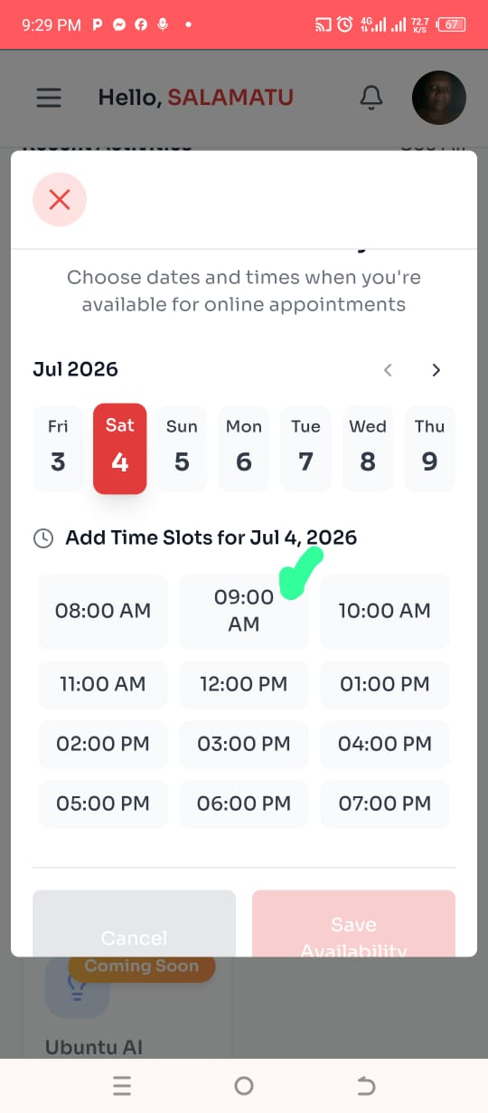 | 1. After adding time slots for July 4, 2026 and saved availability, it was updated successfully but when I came back, the time slots I added were not highlighted.  2. The UI for 09:00 AM is different from other time slots  NOT FIXED (3/7/2026)
32 | Set availability(Cancel button) | 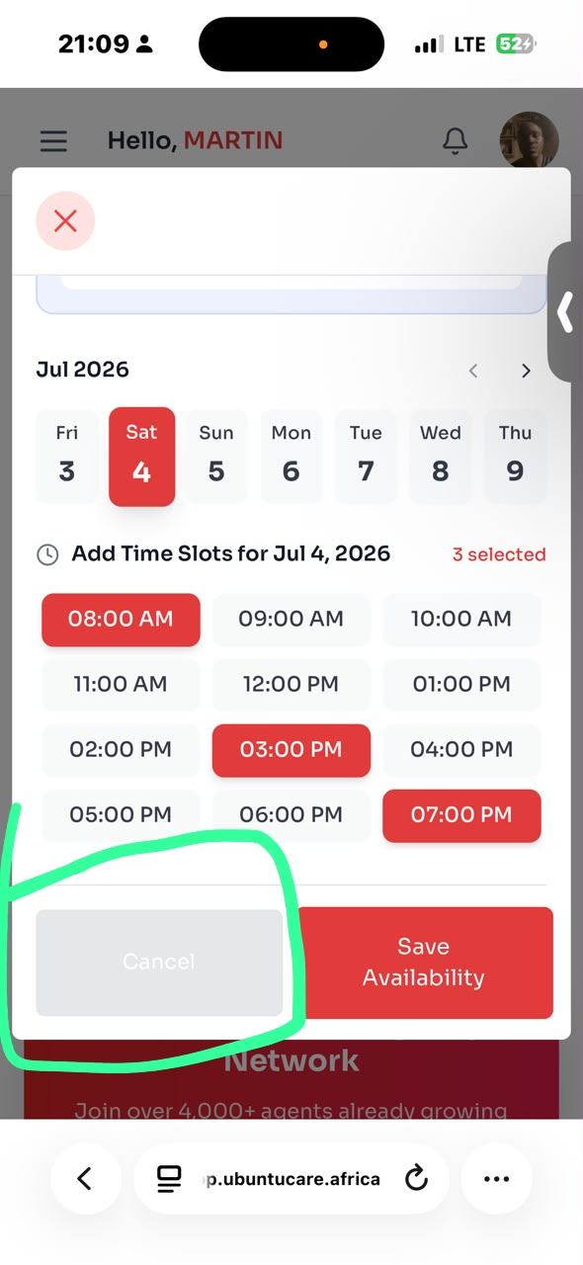 | The Cancel button in the Set Availability modal appears visually disabled (greyed out), making it seem non-clickable or inactive to users.  NOT FIXED (3/7/2026)
33 | Push notifications | 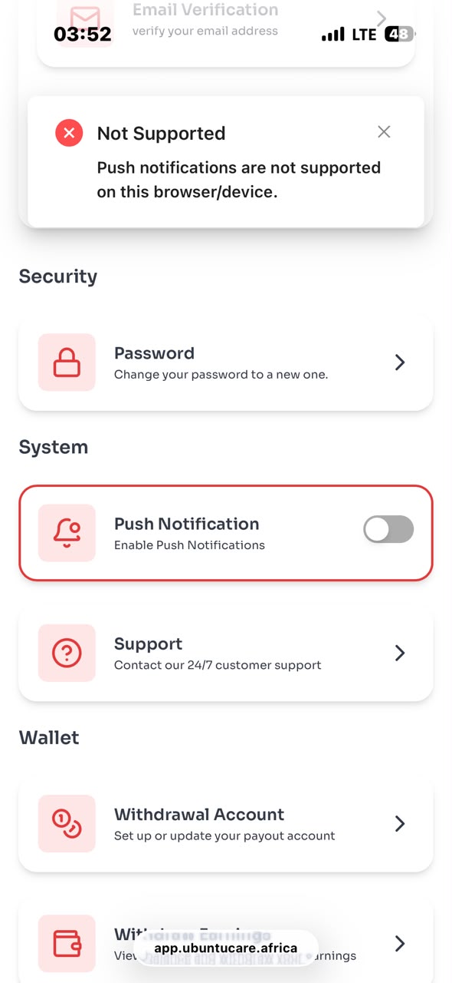 | The Push Notification toggle in the system settings is not functional on iOS devices. When attempting to enable it, the system displays an error message stating that push notifications are not supported on the current browser/device.  NOT FIXED (3/7/2026)

Chemist/pharmacy - Service provider
Nnadi onybuchi
5th January 2026

S/N | Feature | Screenshot | Remarks
1 | Onboarding |  | No email is sent to the user after onboarding is completed.  FIXED (25/1/2026)
2 | Encounter |  | There is no function to initiate an encounter on behalf of a beneficiary. The only available option is the Encounters function. When it is selected, the system requests the beneficiary’s phone number. After entering and verifying the phone number, the user is taken to the Follow-up Visit page. However, when the follow-up button is clicked, the system throws an error stating “No Prescription found for this encounter.” In addition, the doctor’s dashboard does not have a function to prescribe medication.  FIXED (25/1/2026)
3 | Medication dispension |  | There is no medication dispensing function available in the system.  FIXED (25/1/2026)
4 | Assist beneficiary on follow up encounter. | 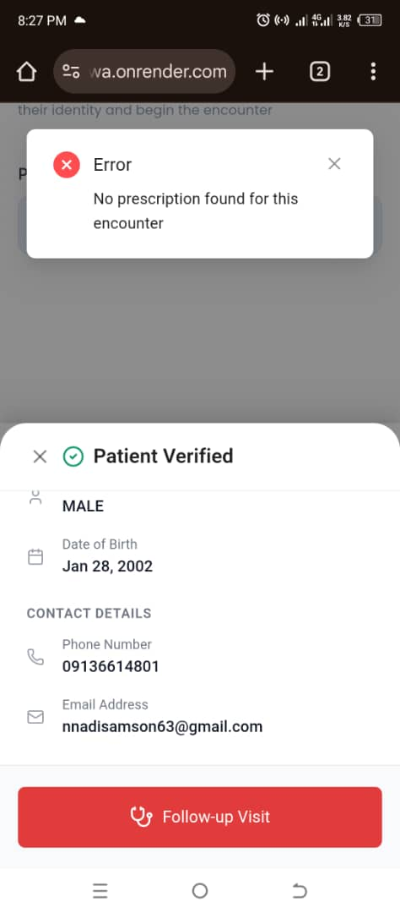 | When attempting to assist a beneficiary with a follow-up encounter, clicking the Follow-up Visit button causes the system to throw an error stating “No Prescription found for this encounter.  FIXED (25/1/2026)
5 | Dispensing drugs | 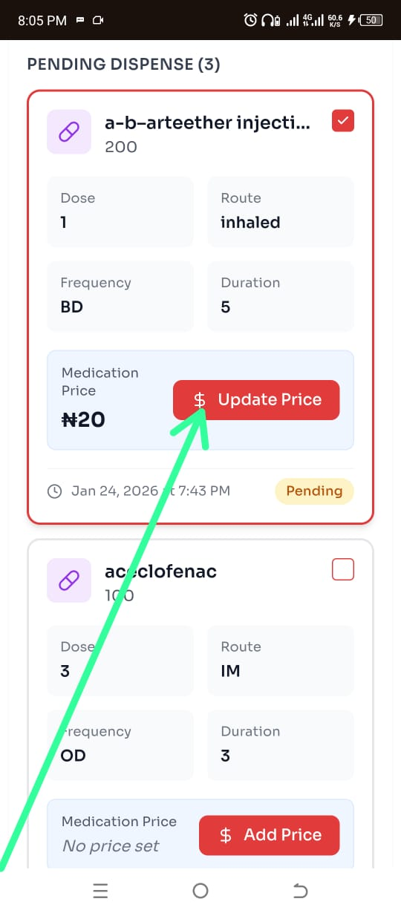 | During dispensing of prescribed drugs, the dollar sign ($) is displayed instead of the naira sign (₦).  NOT FIXED (25/1/2026)
6 | Lab Scientist Profile | 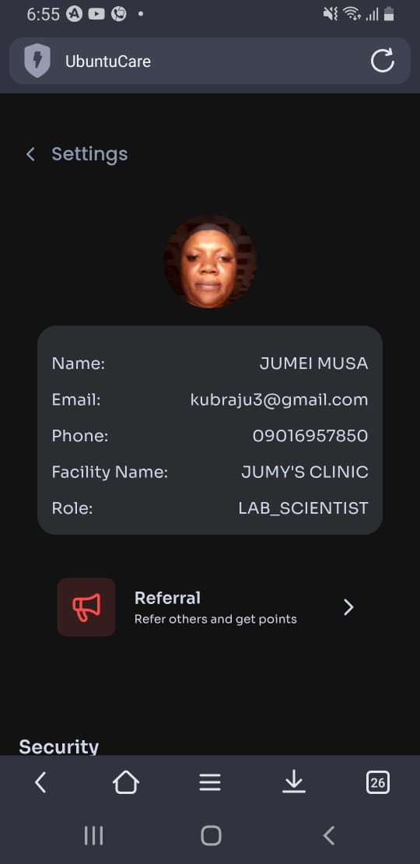 | Role still read as “LAB_SCIENTIST”  NOT FIXED (25/1/2026)
7 | Register user | 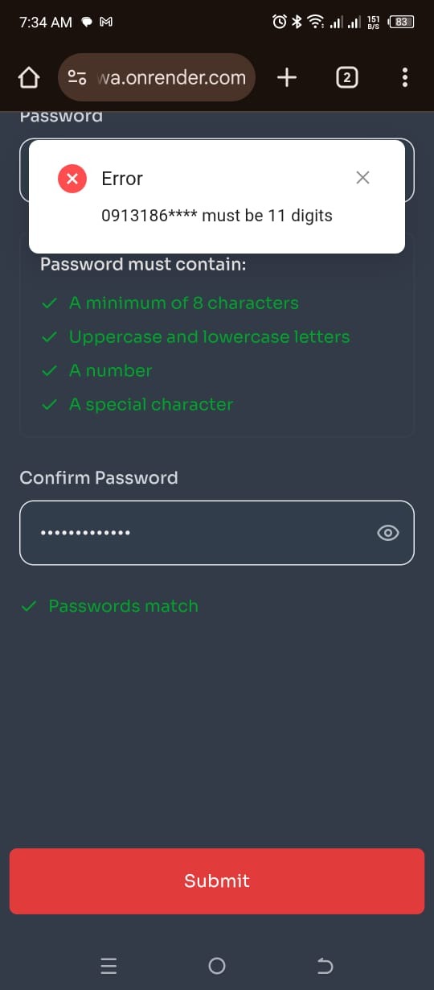 | When the chemist selects the option “Use the phone number linked to NIN”, the system returns an error message stating that the phone number must be an 11-digit number. Thereby preventing successful registration through this option.  On the other hand, when the chemist selects the second option, “Use another phone number”, and enters an 11-digit phone number manually, the registration process is completed successfully without any errors.  NOT FIXED (12/2/2026)
8 | Onboarding | 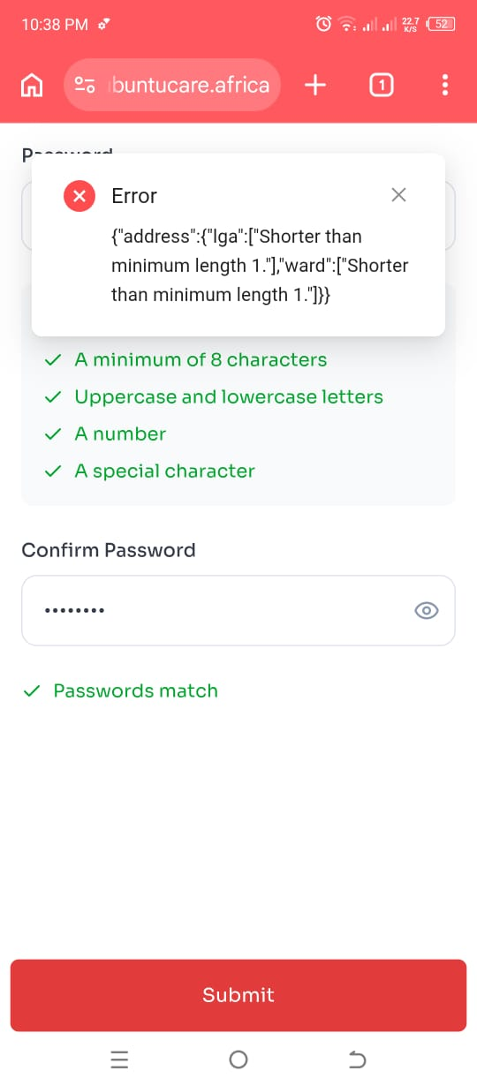 | During the chemist onboarding process, after entering the password and meeting all required conditions, clicking the submit button returns a validation error — {"address":{"Iga":["Shorter than minimum length 1."],"ward":["Shorter than minimum length 1."]}} — indicating that the address.Iga and address.ward fields are being validated as empty or below minimum length despite the form appearing to be properly completed  NOT FIXED (24/2/2026).
9 | Onboarding a beneficiary | 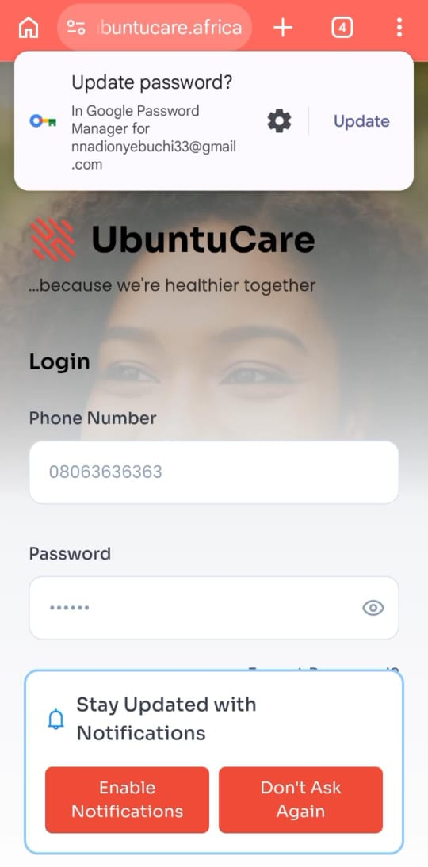 | When a chemist tries to onboard a beneficiary, there is no message to show whether the process was successful or not. After completing the process, the system simply takes the chemist back to the login page without explaining what happened. This makes it difficult for the chemist to know if the onboarding was successful or if there was an error.  Also, after creating the account, I tried to log in using the same details (phone number and password) for the newly onboarded beneficiary, but the system showed an error saying that the phone number does not exist. This suggests that the account may not have been created successfully.  NOT FIXED (18/3/2026).
10 | Login | 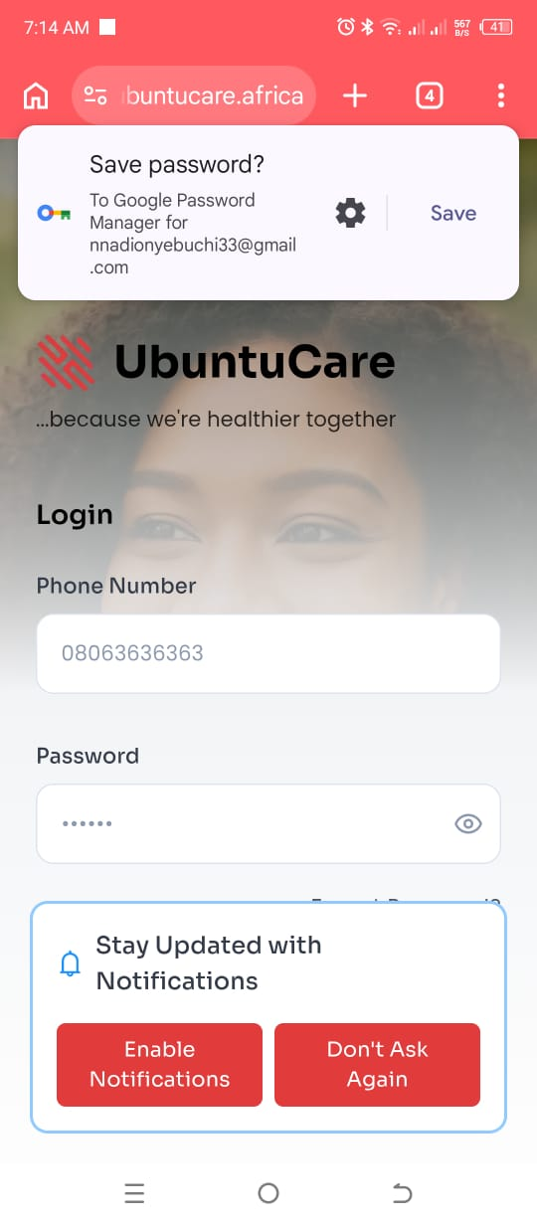 | When a user tries to log in with an incorrect password, no error message is displayed to inform them of the mistake. Instead, the user is shown a “Save Password” prompt from Google, along with another message asking them to stay updated with notifications, with options to “Enable Notifications” or “Don’t Ask Again.”  Even after selecting “Don’t Ask Again,” the notification message continues to appear again after another failed login attempt, which may cause confusion and a poor user experience.  NOT FIXED (18/3/2026).
11 | Add new beneficiary | 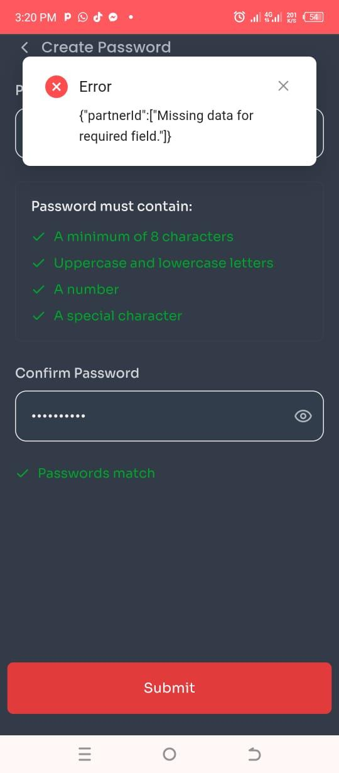 | I could not add new beneficiary from pharmacist account. After imputing password it shows error message "Missing data for required field". Even when no field was missed  NOT FIXED

Nurse - Service provider

S/N | Feature | Screenshot | Remarks
1 | Assessments | 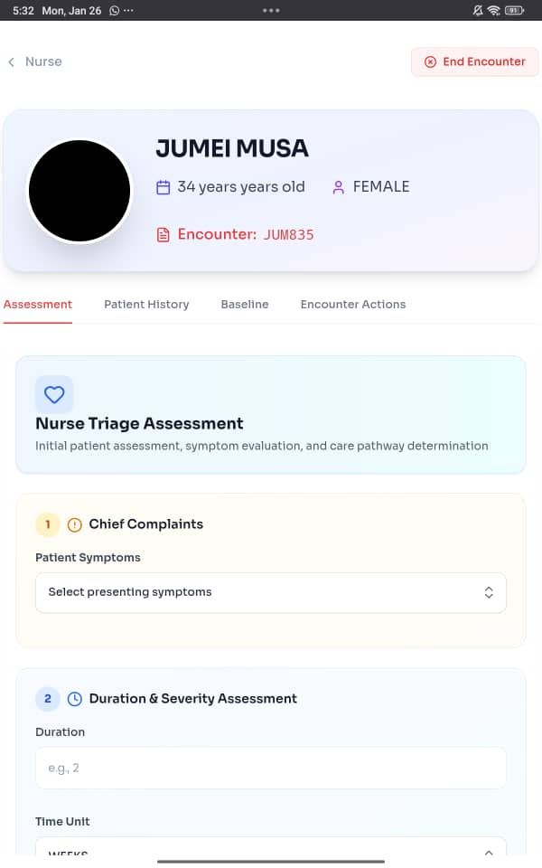 | No place to view previous assessments  NOT FIXED (27/01/2026)
 |  | 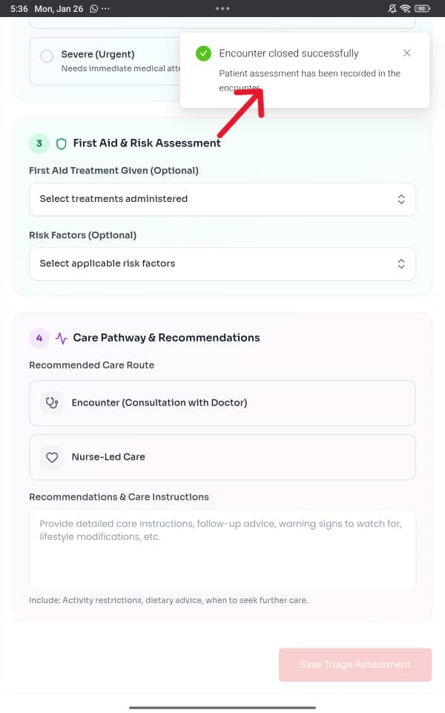 | Saving a tirage says “encounter closed”  NOT FIXED (27/01/2026)
 |  | 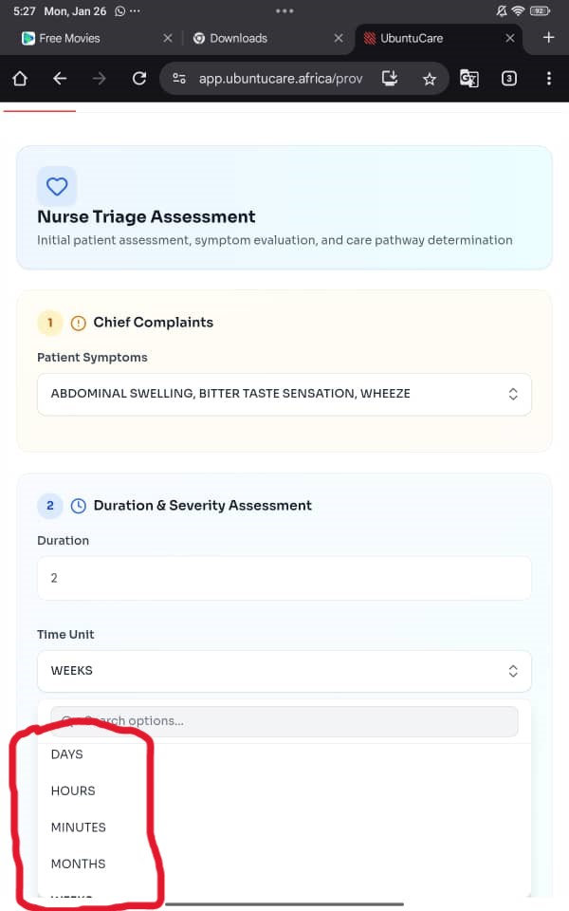 | Triage duration is not following a specific order of arrangement.  NOT FIXED (27/01/2026)

RETESTING

Pharmacist Account
Musa Jumai
24th June, 2026

S/N | Features | Screenshots | Remarks
1 | Onboarding (register a user) | 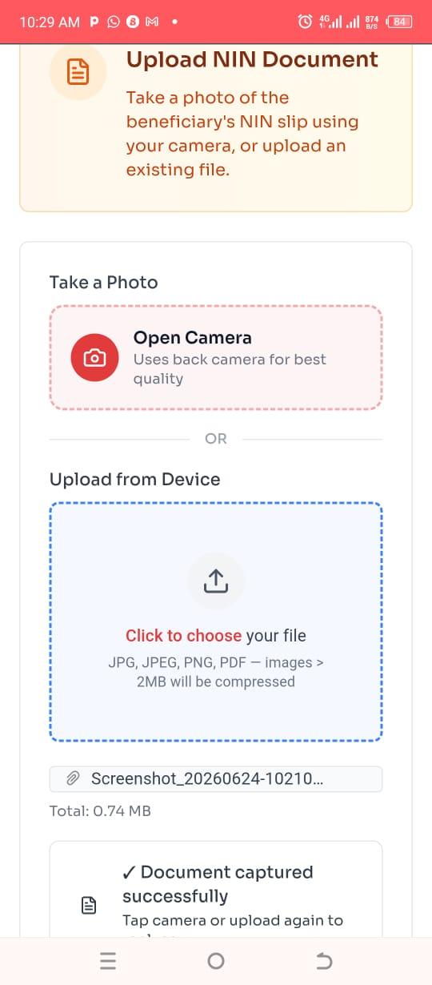 | After a service provider verifies the NIN, he/she can take a photo of the NIN document and can upload from device at the same time without seeing any message. Even when the service provider takes a photo of the original NIN document and uploads from device a different document, he can still continue to the next page
2 | Onboarding (register a user) | 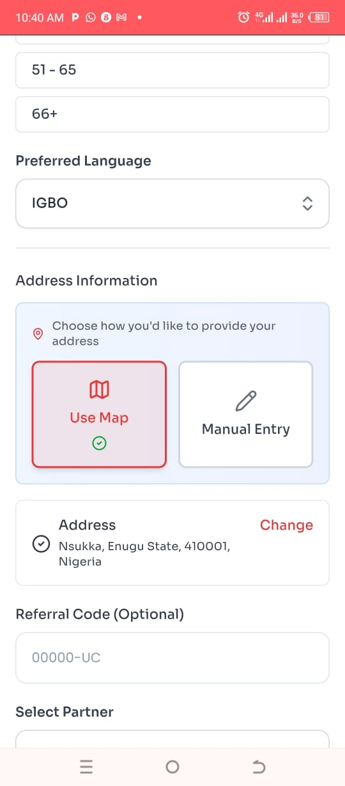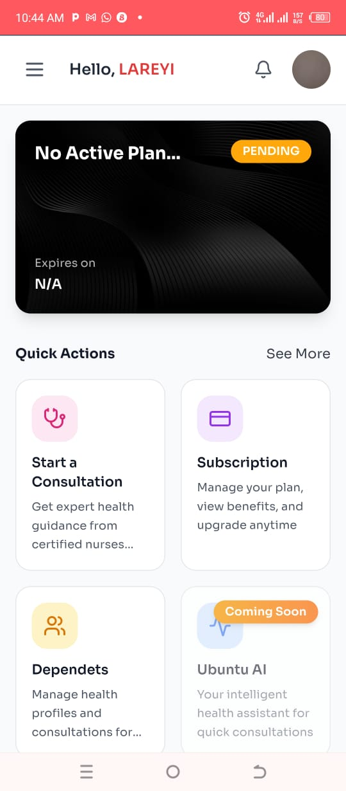 | I selected Igbo as preferred language while registering a beneficiary but after registration, I logged in to the beneficiary account and I didn't see anything written in Igbo
3 | Encounter | 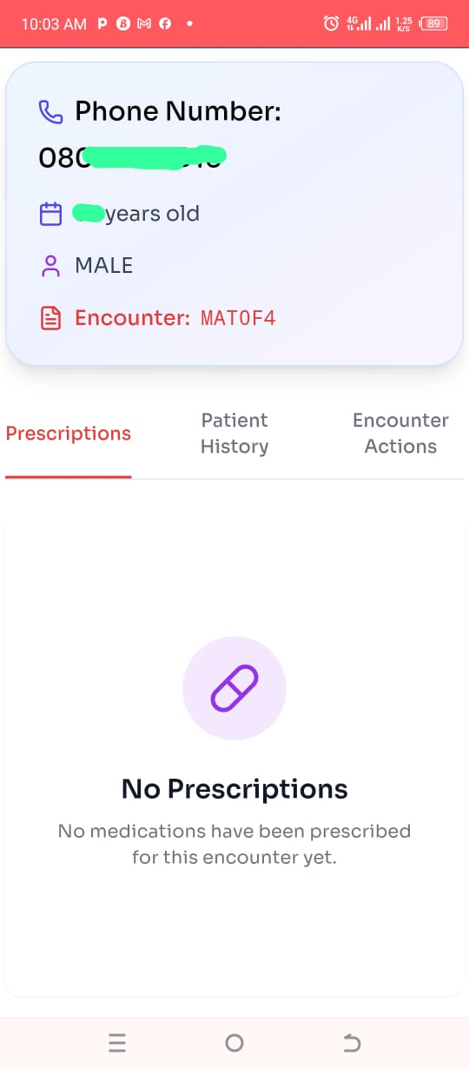 | It's showing "no prescription" for new encounter and follow-up visit. I think when a user taps on the "follow-up visit" button, there should be message telling the user to first start new encounter or that there is not previous encounter
4 | Encounter (dependent beneficiary) | 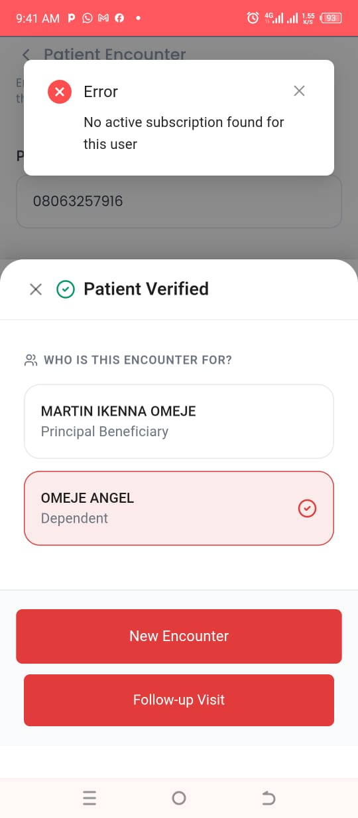 | Dependent beneficiary cannot start encounter if he has not subscribed even when the principal beneficiary has active subscription
5 | Patient Appointments | 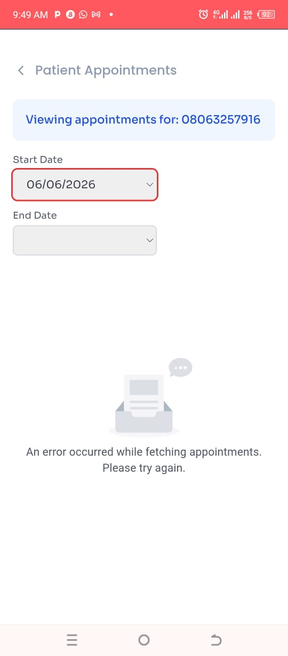 | When a patient searches previous appointment by entering the date the appointment started, it always shows error
6 | Scheduler | 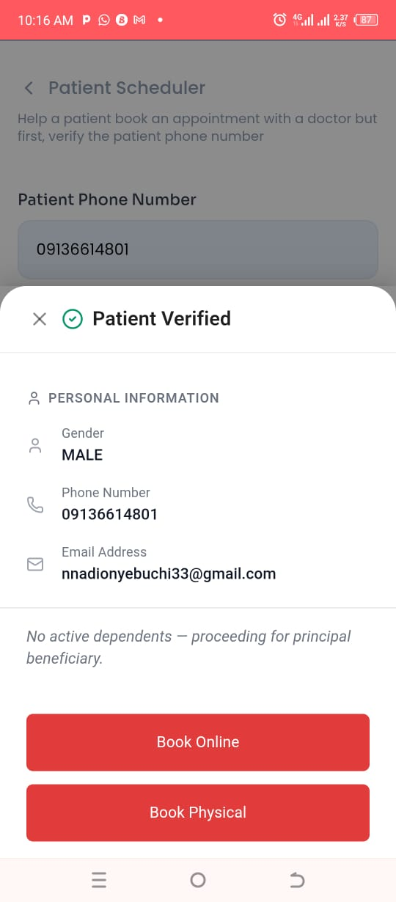 | A service provider can book appointment for a beneficiary that has no subscription but cannot start encounter with a patient phone number that has no active subscription
7 | Scheduler (book physical) | 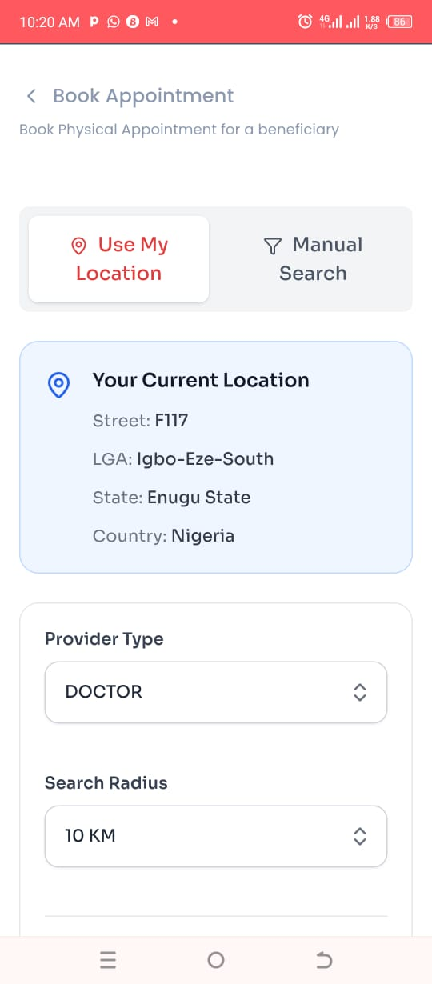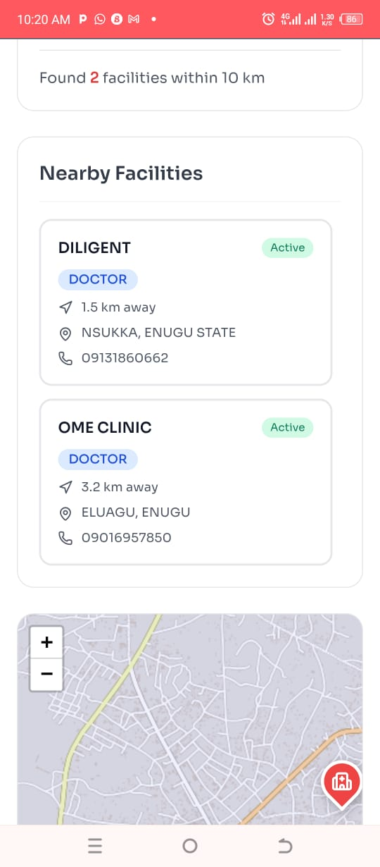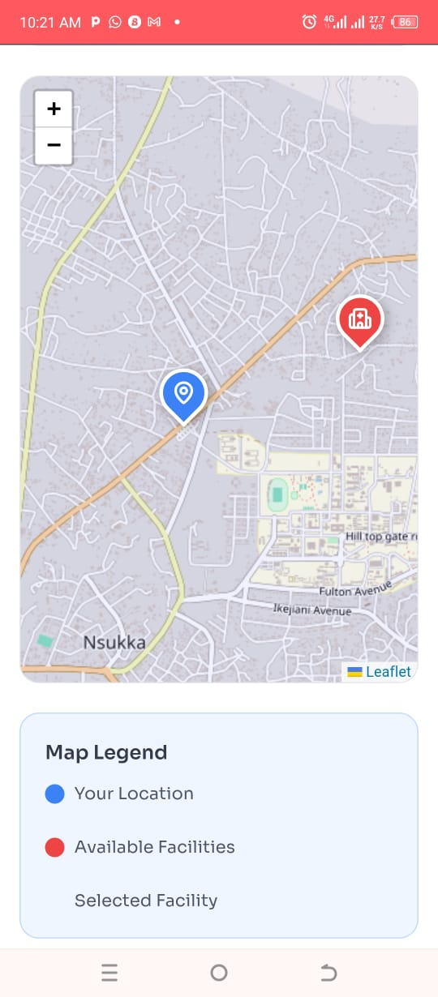 | When a user taps on book physical, it opens a page where there is no button to "continue" or "submit" at the bottom of the page to show successful booking

Lab Scientist Account
Musa Jumai
24th June, 2026

S/N | Features | Screenshots | Remarks
1 |  | 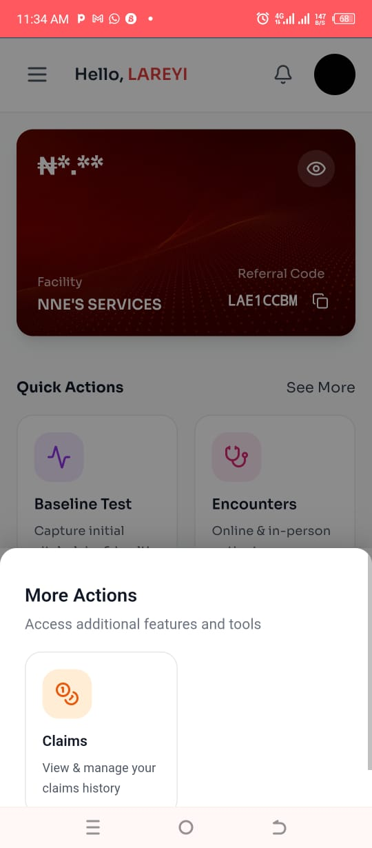 | Quick actions (Others)  "Others" show view claims, register users and more but when a users taps on it, it shows only claims

Beneficiary Account
Musa Jumai
24th June, 2026

S/N | Features | Screenshots | Remarks
1 | Spelling Error | 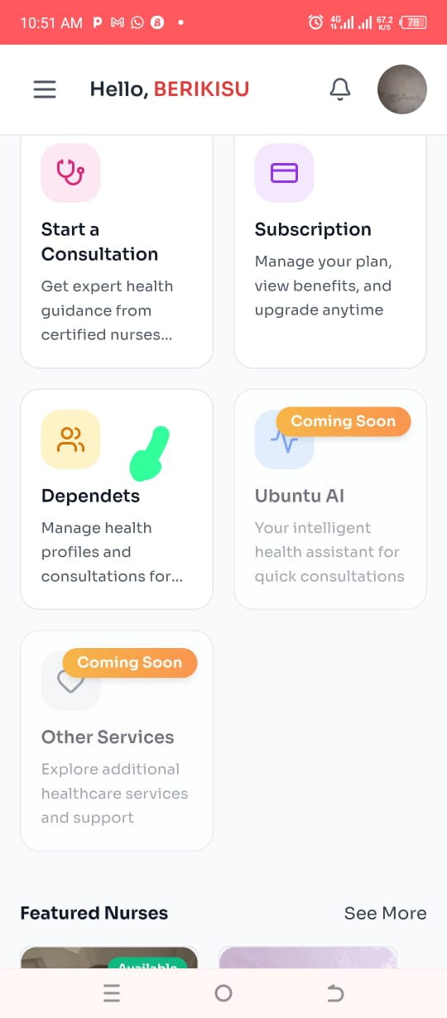 | It's dependents "N" was omitted before TS
2 | Wallet | 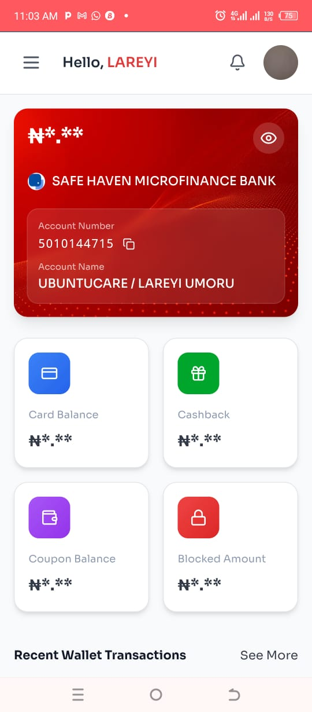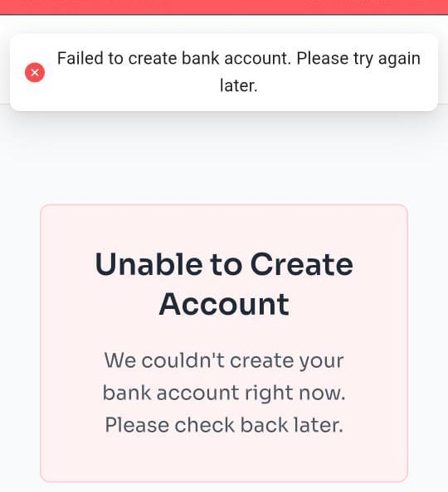 | I opened wallet from a beneficiary account registered by a service provider and it opened but I tried opening wallet from a beneficiary account that was registered independently and it showed error message

Admin Dashboard
Musa Jumai
24th June, 2026

S/N | Features | Screenshots | Remarks
1 | Wallet | 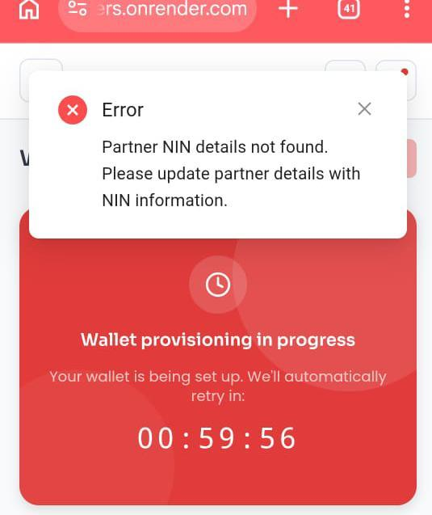 | After onboarding through admin I saw this while trying to find my account

General error to take note of :
- A reminder should be added after a doctor creates an account, prompting the doctor to set up their available time slots.
FIXED (25/1/2026)
- The doctor should be able to set weekly availability once, similar to WhatsApp Business. The selected days and times will remain active throughout the year, and the doctor can make changes only when they are unavailable or need to adjust their schedule.
- When a beneficiary attempts to book an appointment, the doctor’s availability is not displayed immediately after the doctor sets their time slots. The beneficiary must refresh the page before the doctor’s availability becomes visible.
- No email notification is sent after account creation, and no email notification is sent when an encounter is booked with a doctor.
- Push notifications are not working.
- After an encounter is booked with a doctor, refreshing the doctor’s page automatically displays the status as “Confirmed” rather than “Pending.”
OK FOR AN ONLINE ENCOUNTER (25/1/2026)
- When a doctor starts a scheduled encounter, Google Meet shows an error that the meeting does not exist, meaning the meeting was never link is not correct.
FIXED (25/1/2026)
- The system allows a beneficiary to book an appointment without first completing a baseline capture.
FIXED (25/1/2026)
- There should be a reconfirmation message when any actor (chemist, pharmacist, doctors, etc) clicks “New encounter” or “End encounter” just to make sure the actor doesn’t end an ongoing encounter abruptly.
NOT FIXED (27/01/2026)

