2.2

(eps = 0.12, MinPts = 3)

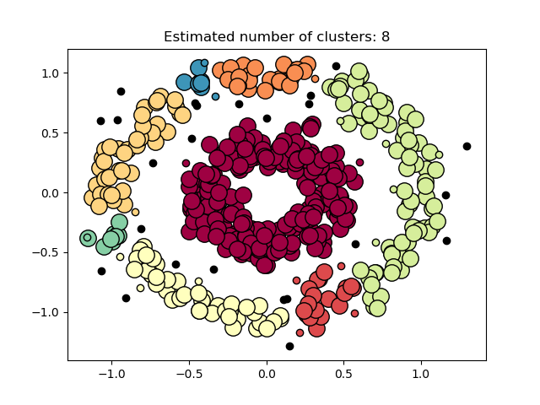

(eps = 0.15, MinPts = 3)

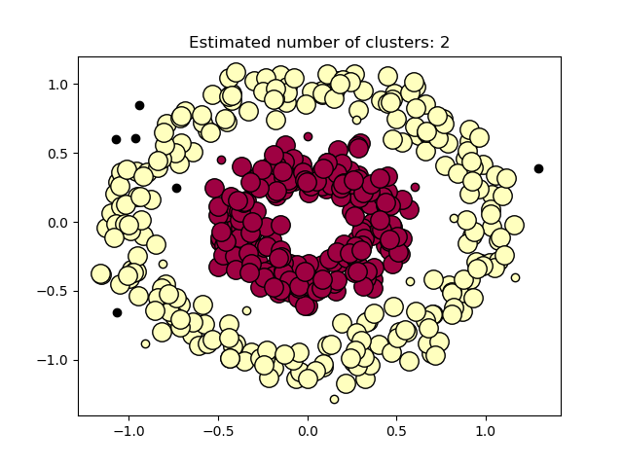

When epsilon increases, the number of cluster decreases. This is because there may be more density-reachable points from the selected point. These points joint together to form a large cluster.

(eps = 0.12, MinPts = 5)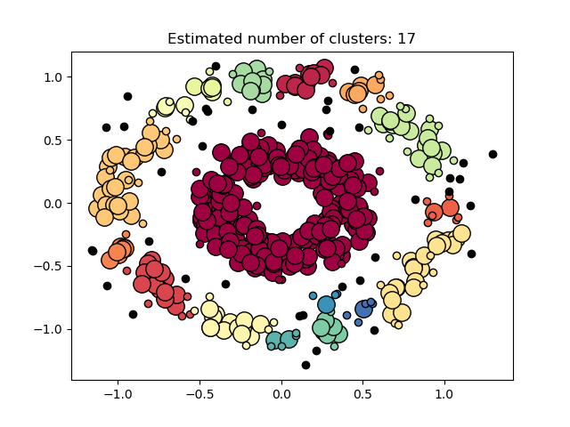

When the MinPts increases, the number of cluster and noise point increases. This is because some of the original cluster lose linkage. For example, as shown in the circle, they are originally a part of a large cluster. Yet, when the MinPts increases, some points in the middle of the circle do not contain enough neighbors to be a core, instead they become border (smaller circle represent border point) or noise. Therefore, the linkage is broken, and more clusters and noise points are present.

3.2

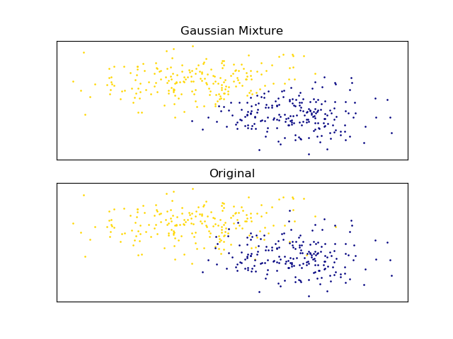

Accuracy = 0.935