COMP4421 (Fall 2018)

Assignment #1

**Name: Chan Nok Hin Student ID: 20349103 E-mail: nhchanaa@connect.ust.hk**

I. EXERCISES

1) **Solution**:

a) As figure c is padded with zeros, there is rapid change of the image in gray level, i.e. the edges between the black origin and original image. Therefore, in high-frequency region in figure d, the strength is greater and it is brighter vertically and horizontally.

b) As figure c is padded with zeros, there are more ‘smooth’ part of the image, which means more low-frequency signal. Therefore, the signal strength in low-frequency region will be higher.

II. PROGRAMMING TASKS

1) Task 1: Spatial Linear Filtering

a)

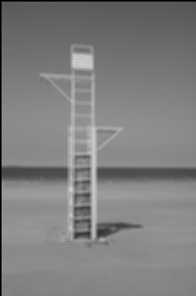

b)

dx:

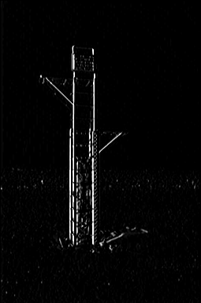

dy:

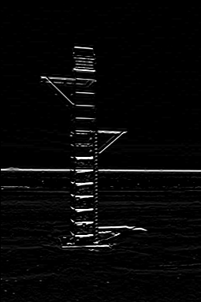

c)

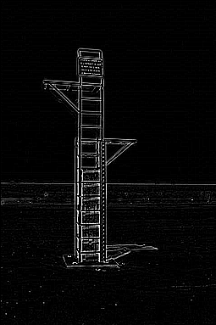

2) Task 2: Spatial Non-linear Filtering

a)

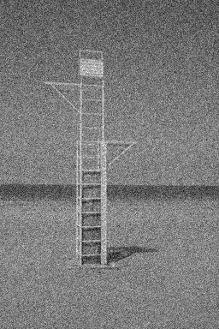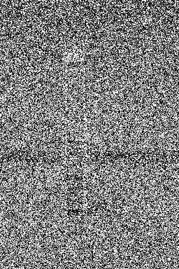

b)

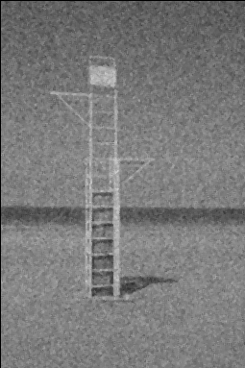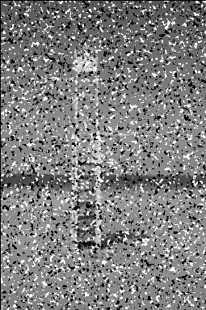

3) Task 3: Discrete Fourier Transform

a)

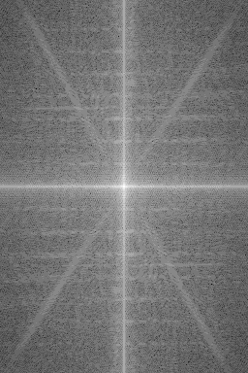

b)

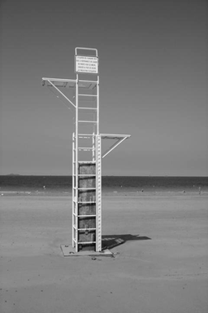

4) Task 4: Filtering in the Frequency Domain

a)

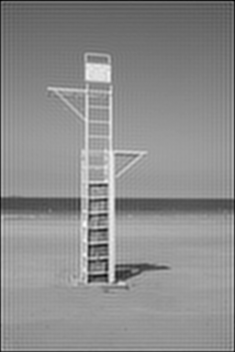

b)

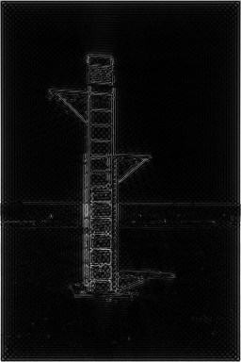

5) Task 5: High Frequency Emphasis

a) Butter

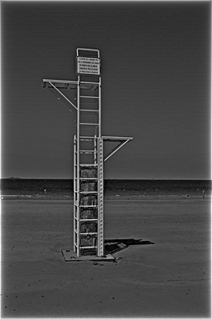

b) Gaussian

