COMP4421 (Fall 2018)

Assignment #2

**Name: Chan Nok Hin Student ID: 20349103 E-mail: nhchanaa@connect.ust.hk**

I. EXERCISES

1) **Solution**:

=

=

=

=

2) **Solution**:

<1> Dilation

|  |  |  |  |  |  |  |  |
| --- | --- | --- | --- | --- | --- | --- | --- |
| 0 | 0 | 0 | 0 | 1 | 1 | 1 | 1 |
| 0 | 0 | 0 | 1 | 1 | **1** | **1** | 1 |
| 0 | 0 | 0 | 1 | **1** | **1** | **1** | 1 |
| 0 | 1 | 1 | 1 | **1** | **1** | 1 | 1 |
| 1 | 1 | **1** | **1** | 1 | 1 | 1 | 0 |
| 1 | **1** | **1** | **1** | 1 | 0 | 0 | 0 |
| 1 | **1** | **1** | 1 | 1 | 0 | 0 | 0 |
| 1 | 1 | 1 | 1 | 0 | 0 | 0 | 0 |

<1> Erosion

|  |  |  |  |  |  |  |  |
| --- | --- | --- | --- | --- | --- | --- | --- |
| 0 | 0 | 0 | 0 | 0 | 0 | 0 | 0 |
| 0 | 0 | 0 | 0 | 0 | **0** | **0** | 0 |
| 0 | 0 | 0 | 0 | **0** | **0** | **0** | 0 |
| 0 | 0 | 0 | 0 | **0** | **0** | 0 | 0 |
| 0 | 0 | **0** | **0** | 0 | 0 | 0 | 0 |
| 0 | **0** | **0** | **0** | 0 | 0 | 0 | 0 |
| 0 | **0** | **0** | 0 | 0 | 0 | 0 | 0 |
| 0 | 0 | 0 | 0 | 0 | 0 | 0 | 0 |

<2> Dilation

|  |  |  |  |  |  |  |  |
| --- | --- | --- | --- | --- | --- | --- | --- |
| 0 | 0 | 0 | 0 | 0 | 1 | 1 | 0 |
| 0 | 0 | 0 | 0 | 1 | **1** | **1** | 1 |
| 0 | 0 | 0 | 1 | **1** | **1** | **1** | 1 |
| 0 | 0 | 1 | 1 | **1** | **1** | 1 | 0 |
| 0 | 1 | **1** | **1** | 1 | 1 | 0 | 0 |
| 1 | **1** | **1** | **1** | 1 | 0 | 0 | 0 |
| 1 | **1** | **1** | 1 | 0 | 0 | 0 | 0 |
| 0 | 1 | 1 | 0 | 0 | 0 | 0 | 0 |

<2> Erosion

|  |  |  |  |  |  |  |  |
| --- | --- | --- | --- | --- | --- | --- | --- |
| 0 | 0 | 0 | 0 | 0 | 0 | 0 | 0 |
| 0 | 0 | 0 | 0 | 0 | **0** | **0** | 0 |
| 0 | 0 | 0 | 0 | **0** | **1** | **0** | 0 |
| 0 | 0 | 0 | 0 | **0** | **0** | 0 | 0 |
| 0 | 0 | **0** | **0** | 0 | 0 | 0 | 0 |
| 0 | **0** | **1** | **0** | 0 | 0 | 0 | 0 |
| 0 | **0** | **0** | 0 | 0 | 0 | 0 | 0 |
| 0 | 0 | 0 | 0 | 0 | 0 | 0 | 0 |

II. PROGRAMMING TASKS

1) **Hough Transform**

a)

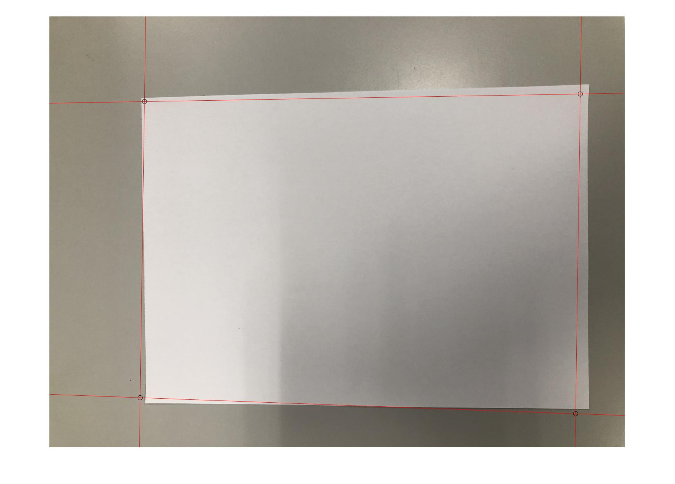

b)

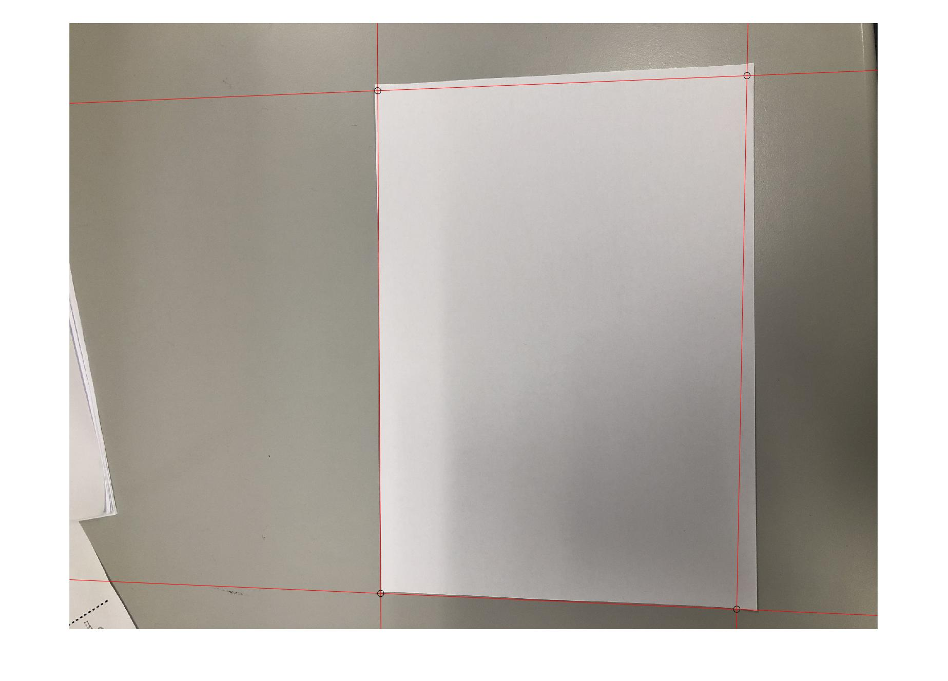

c)

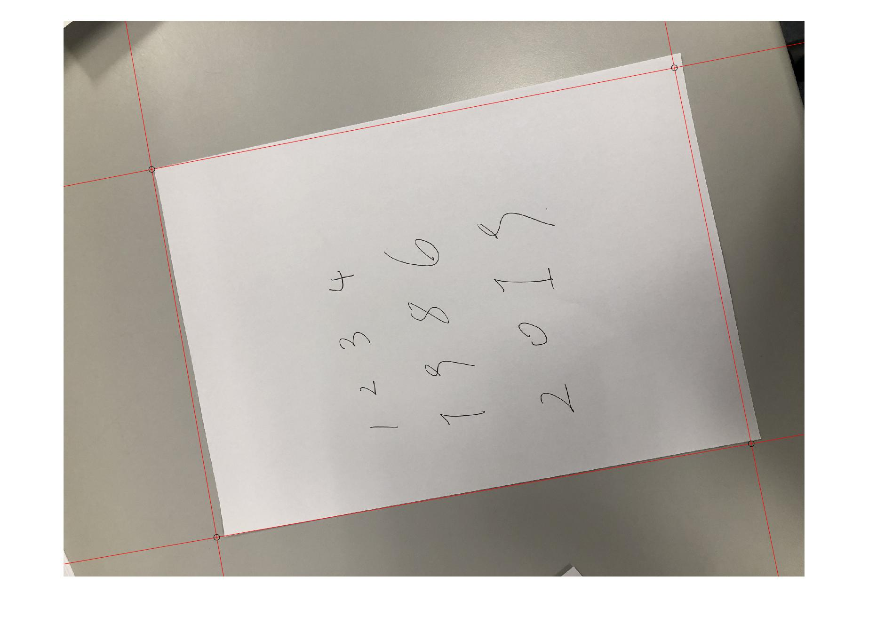

d)

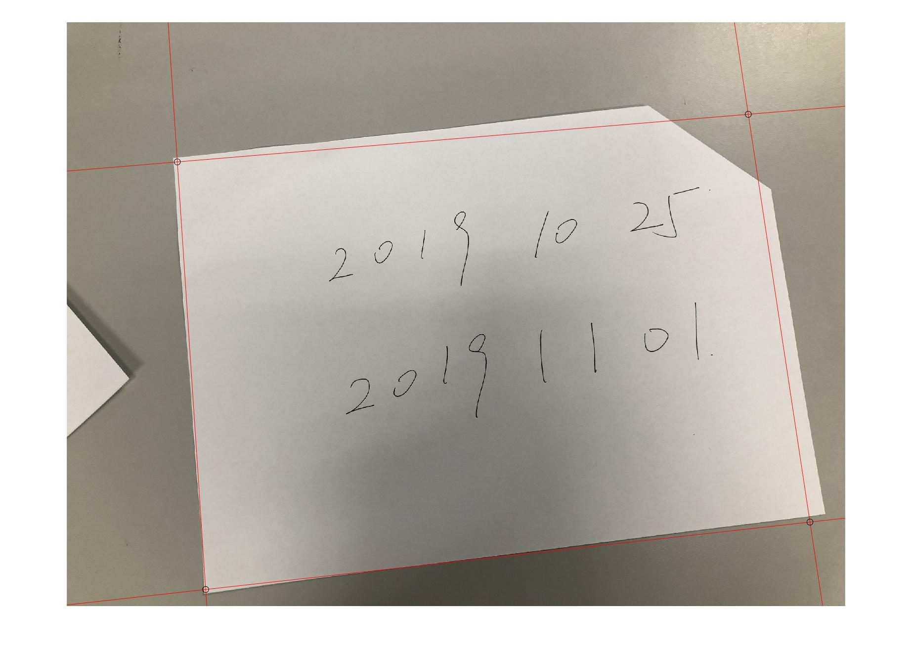

e)

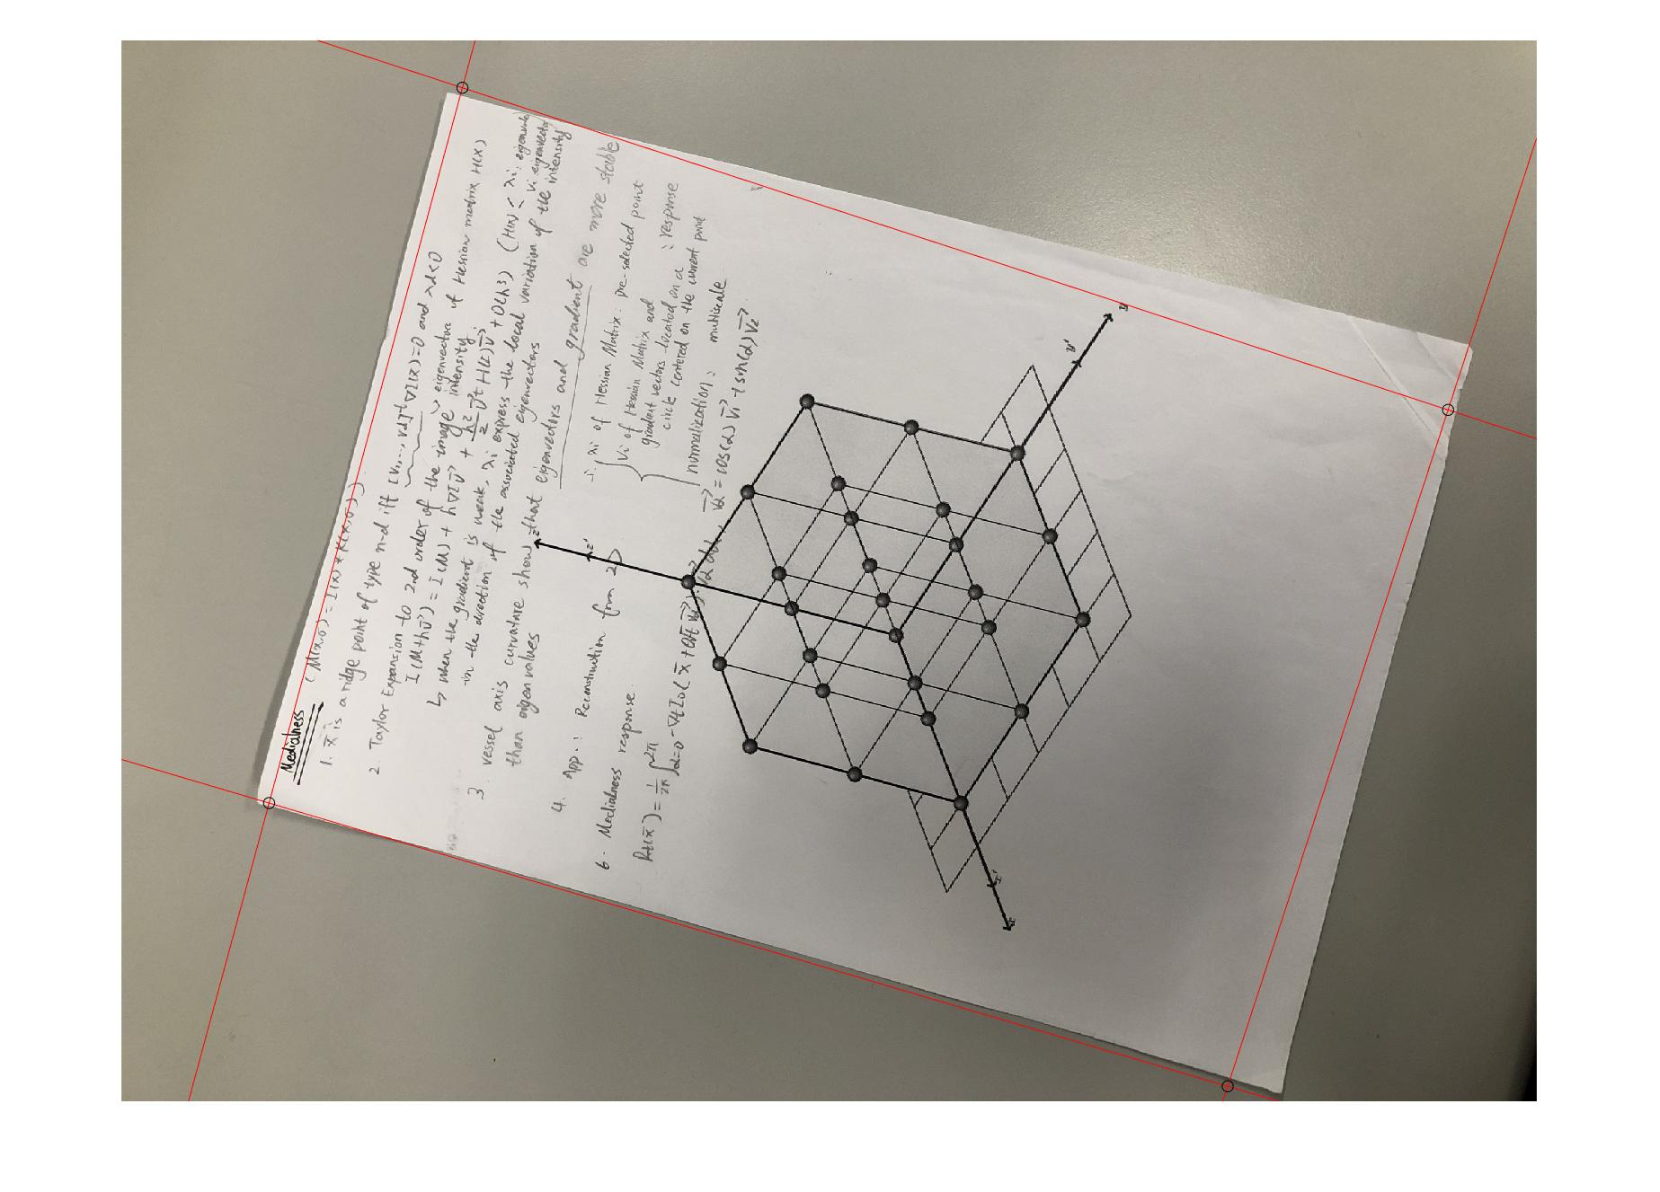

f)

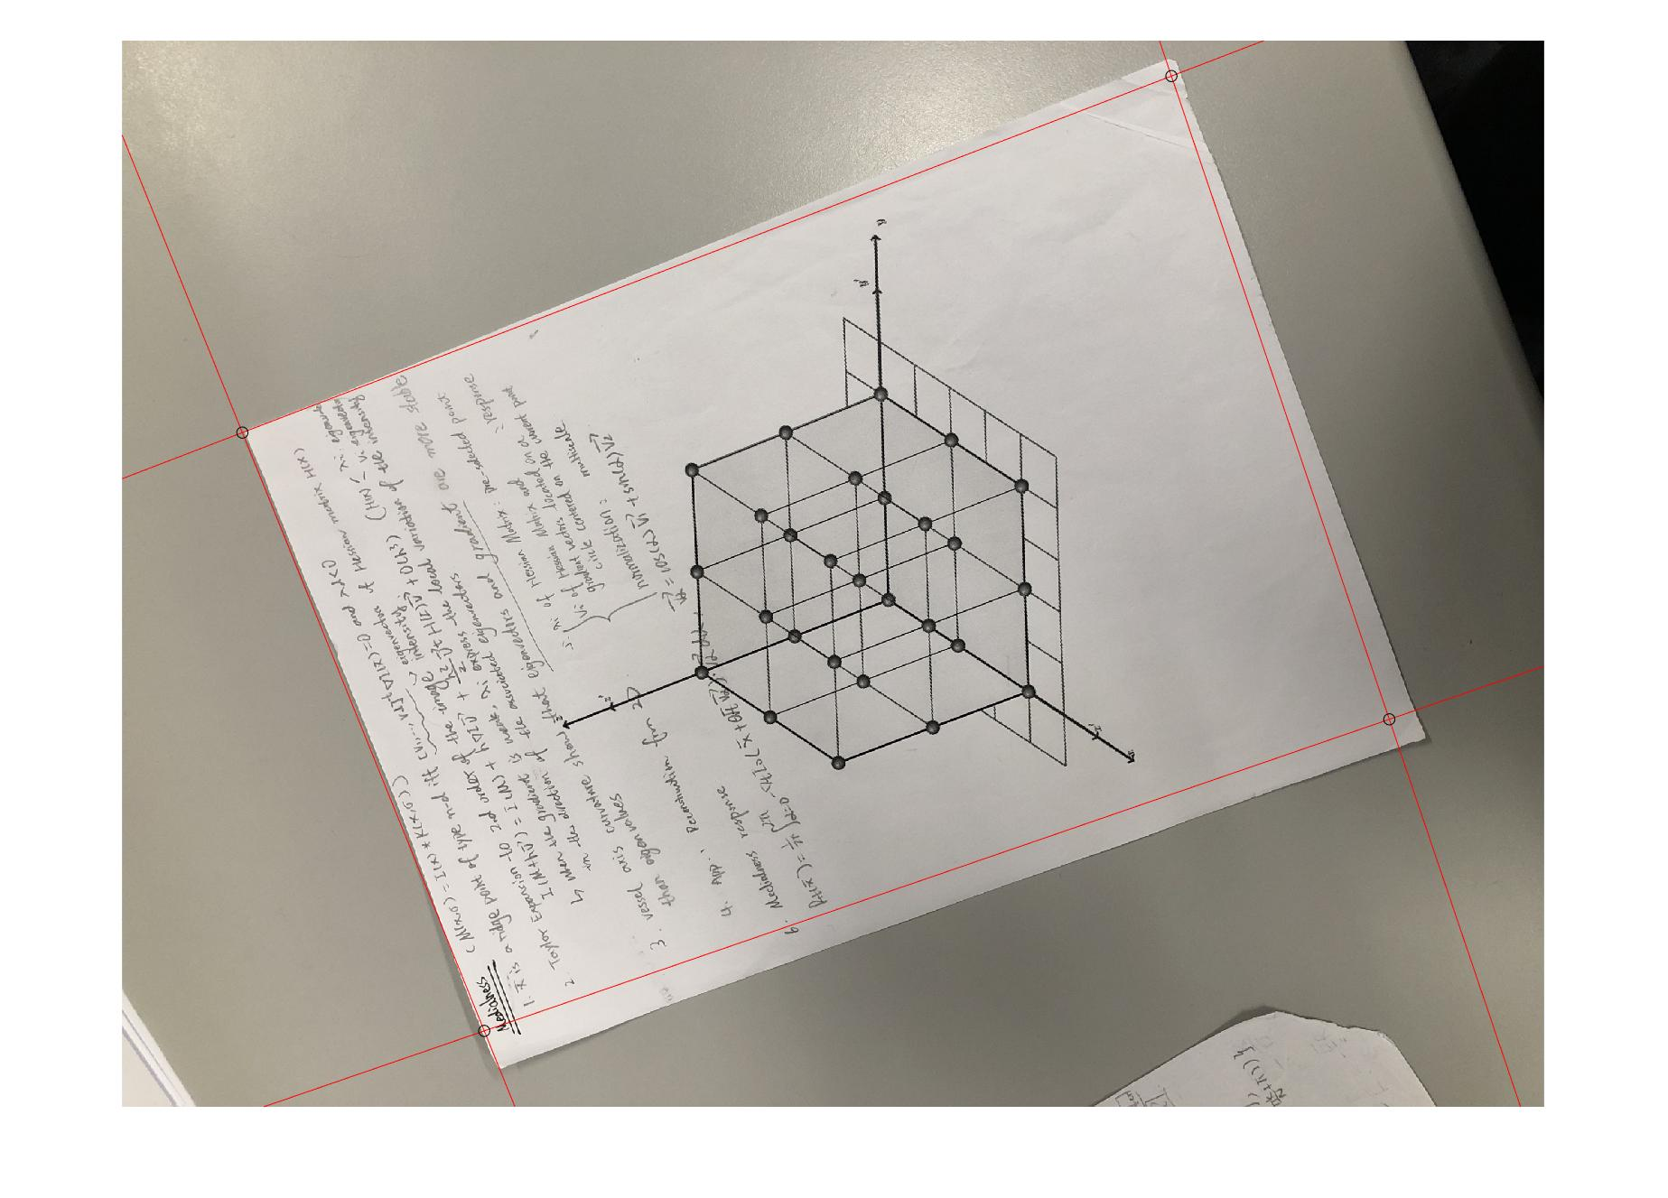

2) **Image Warping**

a)



b)



c)

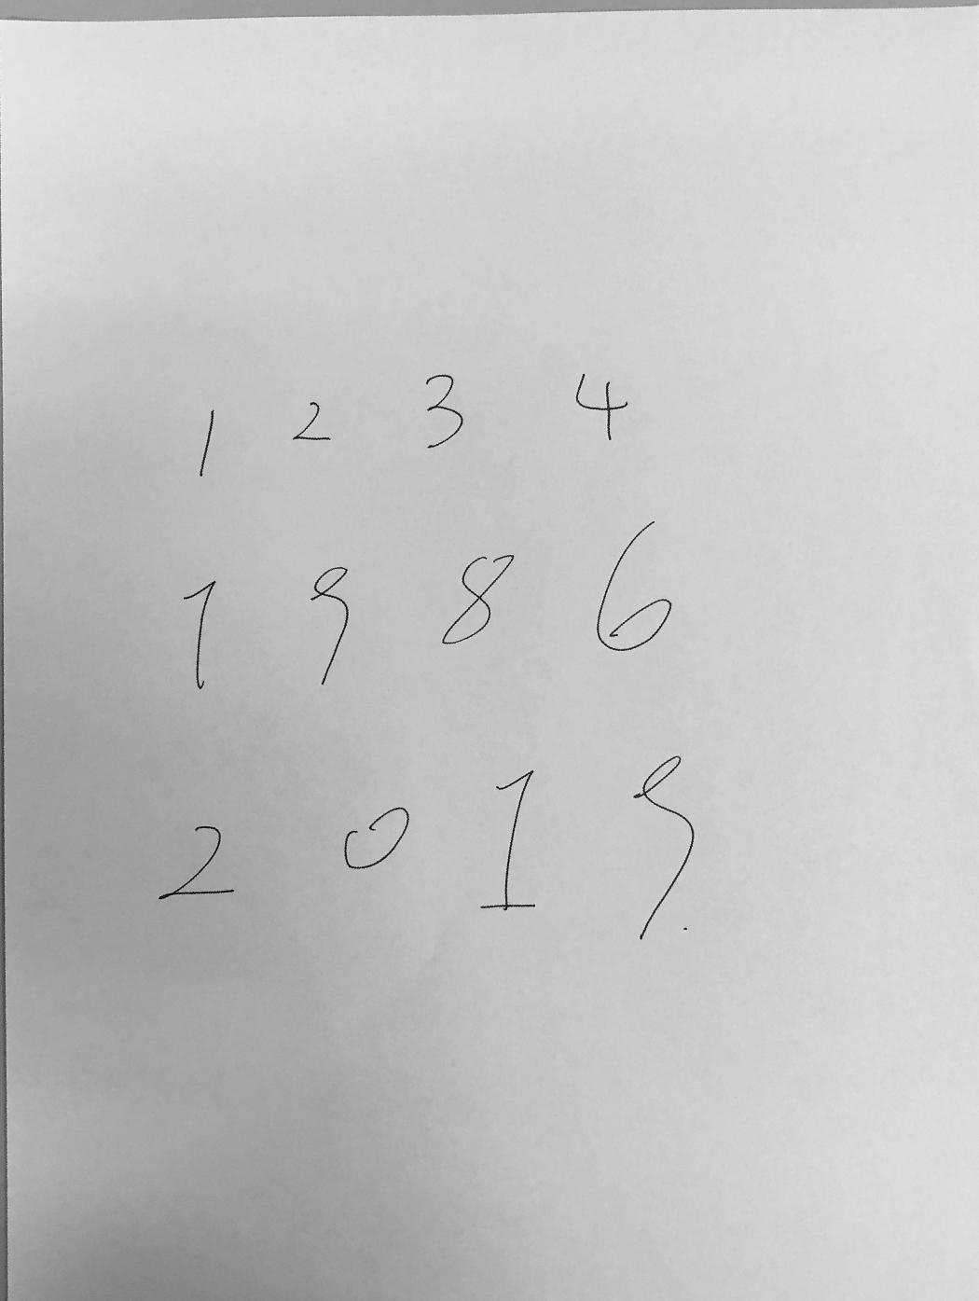

d)

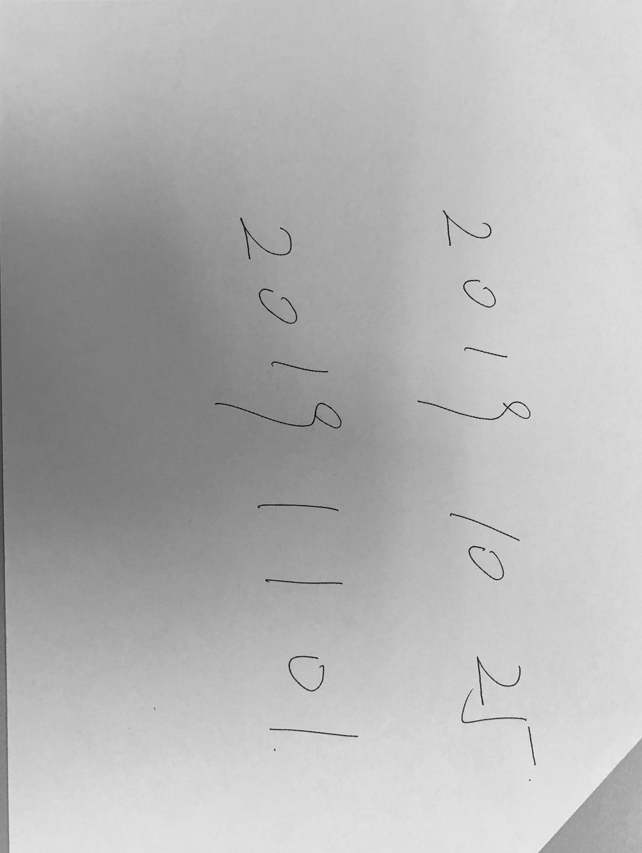

e)

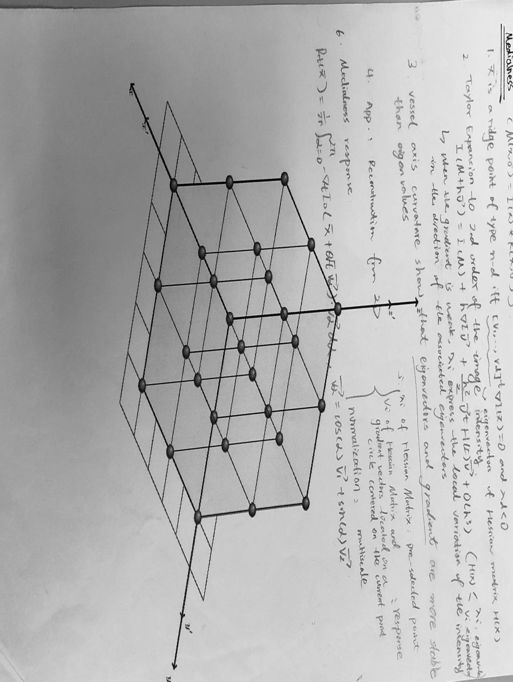

f)

