**Fundamental and Technical analysis report on**

**AMAZON INC.**

A Project Report submitted in partial fulfillment for the award of

MBA (Fintech)

Submitted by

SAMSON KURMANA

Regd No: 121823901004

Under the guidance of

Mr. Leben Johnson

Associate Professor



GITAM INSTITUTE OF MANAGEMENT

GITAM UNIVERSITY

(U/s 3 of UGC Act)

VISAKHAPATNAM

(2018-20)

**DECLARATION**

I, the undersigned, hereby declare that, the project titled “Fundamental and Technical analysis report of AMAZON INC, Visakhapatnam” submitted to GITAM Institute of Management, GITAM University for the award of the Masters of Business Administration (Fintech) is the original work done by me, under the guidance of Mr. Leben Johnson, Associate Professor, GITAM Institute of Management. The empirical findings in this report are based on the data collected by me. It was not copied from any other project. The project has not been submitted to any Substitute/University for the award of any Diploma/Degree.

Date: - Samson Kurmana Place: - Visakhapatnam RegdNo.121823901004

**CERTIFICATE**

This is to certify that the project entitled, “Fundamental and Technical analysis report of AMAZON INC, Visakhapatnam”, is a bonafide work done by Mr.Samson Kurmana, Regd No: 121823901004, and is submitted in partial fulfillment for the Masters of Business Administration (Fintech) of GITAM University. It has not been submitted for the award of any diploma/degree in any other Institution/University.

Date: Mr. Leben Johnson

Place: Visakhapatnam Associate Professor

**ACKNOWLEDGEMENT**

I am thankful to Prof. P.Sheela, Principal, GITAM Institute of Management, GITAM University, Vishakhapatnam, for giving me an opportunity to learn and have a study on very important topic of management. I am thankful to Mr. Leben Johnson, Program Coordinator and the project guide who helped me and guided me in completing this project. I am immensely thankful to friends and the respondents who have guided me at every stage in preparing and finishing this project with their valuable suggestions.

Samson Kurmana

Regd No. : 121823901004

**CONTENTS Pg. No’s**

About Amazon 6

Financial Analysis 7

**Fundamental Analysis of AMAZON 8**

Liquidity Ratio 10

Debt Management Ratio 12

Profitability 14

Asset Management 19

Market Value Ratios 22

**Technical Analysis 26**

Simple moving average 26

Exponential Moving average 27

Momentum 28

Bollinger bands 29

MACD 30

Relative strength indicator 32

Aroon indicator 33

Chaikin Money Flow 34

Heikin Ashi 35

Fibonacci Retracements 36

Competitors Analysis 37

**ABOUT AMAZON**

Amazon.com, Inc., incorporated on May 28, 1996, offers a range of products and services through its Websites. The Company operates through three segments: North America, International and Amazon Web Services (AWS). The Company's products include merchandise and content that it purchases for resale from vendors and those offered by third-party sellers. It also manufactures and sells electronic devices. The Company, through its subsidiary, Whole Foods Market, Inc., offers healthy and organic food and staples across its stores. The Company also offers a range of products like whole trade bananas, organic avocados, organic large brown eggs, organic responsibly-farmed salmon and tilapia, organic baby kale and baby lettuce, animal-welfare-rated 85% lean ground beef, creamy and crunchy almond butter, organic gala and fuji apples, organic rotisserie chicken.

The Company's Whole Foods Market healthy and private label products include 365 Everyday Value, Whole Foods Market, Whole Paws and Whole Catch available through Amazon.com, AmazonFresh, Prime Pantry and Prime Now. The Company also offers Amazon Lockers that is available in select Whole Foods Market stores. Customers can have products shipped from www.Amazon.com to their local Whole Foods Market store for pick up or send returns back to Amazon during a trip to the store.

, such as database offerings, fulfillment, publishing, certain digital content subscriptions, advertising and co-branded credit cards. The Company serves consumers through its retail Websites and focuses on selection, price and convenience. It designs its Websites to enable hundreds of millions of products to be sold by them and by third parties across dozens of product categories. The Company allows customers to access its Websites directly and through its mobile Websites and applications. It also manufactures and sells electronic devices, including Kindle e-readers, Fire tablets, Fire televisions and Echo. It develops and produces media content. In addition, the Company offers Amazon Prime, an annual membership program that includes access to unlimited instant streaming of thousands of movies and television episodes and other benefits. It offers programs that enable sellers to grow their businesses, sell their products on its Websites and their own branded Websites.

The Company serves authors and independent publishers with Kindle Direct Publishing, an online service that lets independent authors and publishers choose a royalty option and make their books available in the Kindle Store, along with its own publishing arm, Amazon Publishing. It also offers programs that allow authors, musicians, filmmakers, application developers and others to publish and sell content.

**FINANCIAL ANALYSIS**

Balance Sheet of AMAZON

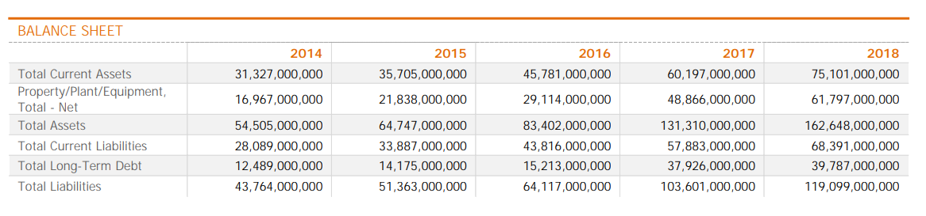

Fundamentals of AMAZON

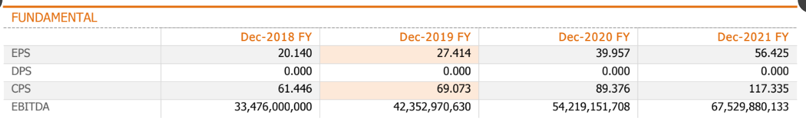

Income Statement of AMAZON

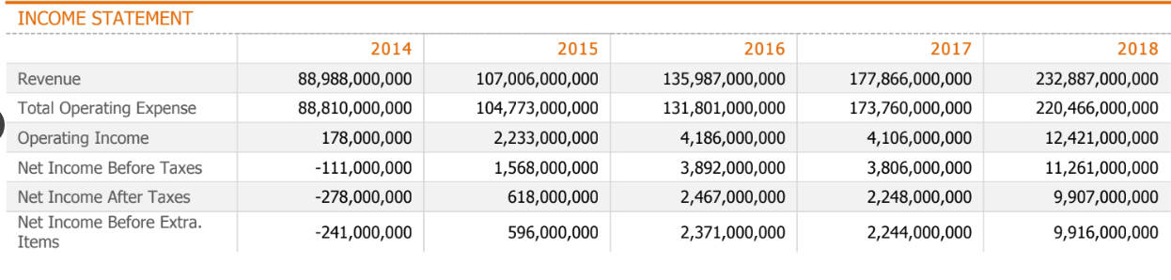

Profitability Analysis of AMAZON

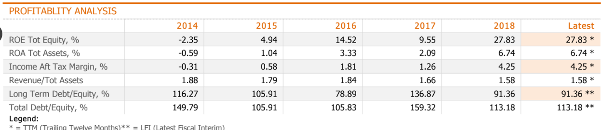

FUNDAMENTAL ANALYSIS

My Assessment on AMAZON :

TOTAL ASSETS

Total assets can be defined as the sum of all assets on a company's balance sheet.

* Amazon total assets for 2018 were **$162.648B**, a **23.87% increase** from 2017.
* Amazon total assets for 2017 were **$131.31B**, a **57.44% increase** from 2016.
* Amazon total assets for 2016 were **$83.402B**, a **28.81% increase** from 2015.

TOTAL LIABILITIES

Total liabilities can be defined as the total value of all possible claims against the corporation.

* Amazon total liabilities for 2018 were **$119.099B**, a **14.96% increase** from 2017.
* Amazon total liabilities for 2017 were **$103.601B**, a **61.58% increase** from 2016.
* Amazon total liabilities for 2016 were **$64.117B**, a **24.83% increase** from 2015.

SHAREHOLDER EQUITY

Share holder equity can be defined as the sum of preferred and common equity items

* Amazon share holder equity for 2018 was **$43.549B**, a **57.17% increase** from 2017.
* Amazon share holder equity for 2017 was **$27.709B**, a **43.68% increase** from 2016.
* Amazon share holder equity for 2016 was **$19.285B**, a **44.09% increase** from 2015.

REVENUE

Revenue can be defined as the amount of money a company receives from its customers in exchange for the sales of goods or services. Revenue is the top line item on an income statement from which all costs and expenses are subtracted to arrive at net income.

* Amazon annual revenue for 2018 was **$232.887B**, a **30.93% increase** from 2017.
* Amazon annual revenue for 2017 was **$177.866B**, a **30.8% increase** from 2016.
* Amazon annual revenue for 2016 was **$135.987B**, a **27.08% increase** from 2015.

Operating Income

Operating income can be defined as income after operating expenses have been deducted and before interest payments and taxes have been deducted.

* Amazon annual operating income for 2018 was **$12.421B**, a **202.51% increase** from 2017.
* Amazon annual operating income for 2017 was **$4.106B**, a **1.91% decline** from 2016.
* Amazon annual operating income for 2016 was **$4.186B**, a **87.46% increase** from 2015.

NET INCOME

Net income can be defined as company's net profit or loss after all revenues, income items, and expenses have been accounted for.

* Amazon annual net income for 2018 was **$10.073B**, a **232.11% increase** from 2017.
* Amazon annual net income for 2017 was **$3.033B**, a **27.92% increase** from 2016.
* Amazon annual net income for 2016 was **$2.371B**, a **297.82% increase** from 2015.

**LIQUIDITY RATIO**

CURRENT RATIO

Current ratio can be defined as a liquidity ratio that measures a company's ability to pay short-term obligations. Amazon current ratio by the end of December 31, 2018 was **1.10**.

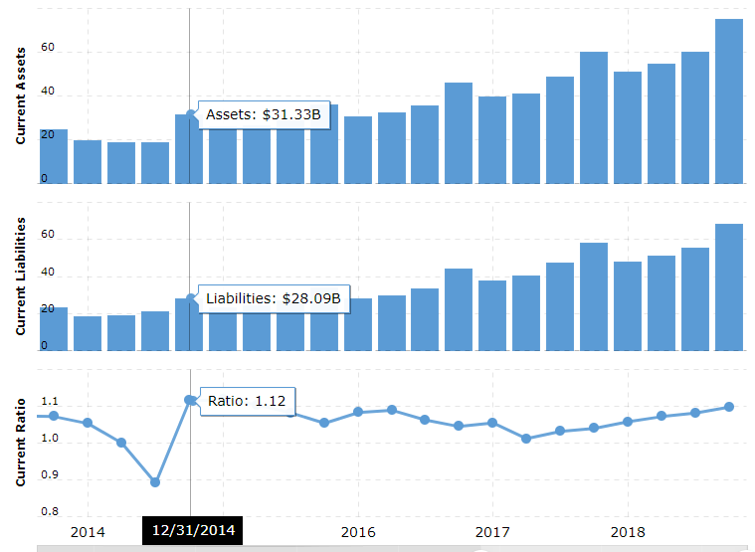



QUICK RATIO

The quick ratio measures the ability of a business to pay its short-term liabilities by having assets that are readily convertible into cash

**Quick Ratio = (Current Assets – Inventory) / Current Liabilities**

Amazon quick ratio by the end of December 31, 2018 was **0.85**.

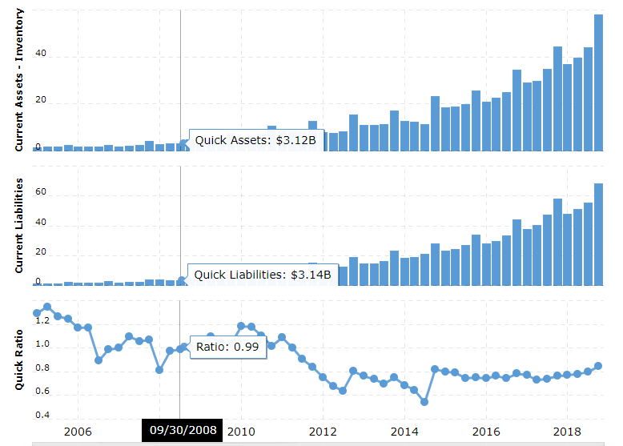



DEBT MANAGEMENT RATIO

*DEBT RATIO*

The debt ratio is defined as the ratio of total debt to total assets, expressed as a decimal or percentage. It can be interpreted as the proportion of a company’s assets that are financed by debt.

=Total Liabilities ÷ Total Assets

The debt ratio for ending December 31, 2018 was 0.732

|  |  |  |  |
| --- | --- | --- | --- |
| Debt- Ratio(in Millions) | | | |
| Year | Total Liabilities | Total Assets | Debt-Ratio |
| 2018 | 119,099 | 162648 | 0.732 |
| 2017 | 103,601 | 131310 | 0.789 |
| 2016 | 64,117 | 83402 | 0.769 |
| 2015 | 51,363 | 64747 | 0.793 |
| 2014 | 43,764 | 54505 | 0.803 |

TIMES INTEREST EARNED

It measures the proportionate amount of income that can be used to cover interest expenses in the future =Earnings before interest and taxes (EBIT)/Interest Charges

TIME INTEREST EARNED by the end of December was 8.765

|  |  |  |  |
| --- | --- | --- | --- |
| Times-Interest-Earned (TIE)(In Millions) | | | |
| Year | EBIT | Interest Expense | Times-Interest-Earned (TIE) |
| 2018 | 12,421 | 1,417 | 8.765702188 |
| 2017 | 4,106 | 848 | 4.841981132 |
| 2016 | 4,186 | 484 | 8.648760331 |
| 2015 | 2,233 | 459 | 4.864923747 |
| 2014 | 178 | 210 | 0.847619048 |

DEBT/EQUITY RATIO

The debt/equity ratio can be defined as a measure of a company's financial leverage calculated by dividing its long-term debt by stockholders' equity. Amazon debt/equity by the end of December 31, 2018 was **0.54**.



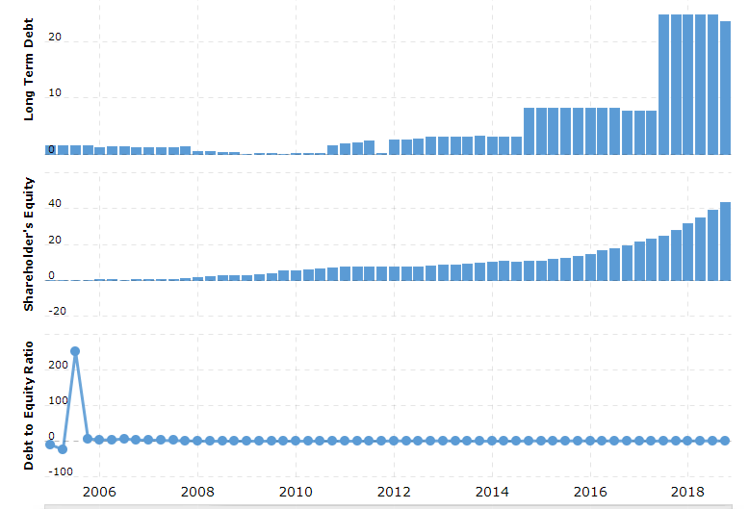

PROFITABILITY RATIOS

PROFITABILITY

To measure a firm’s overall performance, one must use a methodical analysis by starting with (ROE), return on equity. Profitability is broken into calculations which encompass various financial metrics. The most attractive profitability calculations used in a financial analysis include a profit margin, return on assets (ROA), and return on equity (ROE).  
However, all three profitability ratios can require disaggregation, depending on the analyst. For specific purposes, this section will include some disaggregation.

PROFIT MARGIN  
= Net Income ÷ Sales

Profit margin can be defined as the percentage of revenue that a company retains as income after the deduction of expenses. Amazon net profit margin as of December 31, 2018 is **4.33%**.

|  |  |  |  |
| --- | --- | --- | --- |
| PROFIT MARGIN(In Millions) | | | |
| Year | Net Sales | Net Income | Profit Margin |
| 2018 | 232,887 | 10,073 | 4.33% |
| 2017 | 177,866 | 3,033 | 1.71% |
| 2016 | 135,987 | 2,371 | 1.74% |
| 2015 | 107,006 | 596 | 0.56% |
| 2014 | 88,988 | (241) | -0.27% |

BASIC EARNING POWER

Basic earning power ratio is a measure that calculates the earning power of a business before the effect of the business' income taxes and its financial leverage. It is calculated by dividing earnings before interest and taxes (EBIT) by total assets.

The Basic Earning Power of Amazon by end of December 31st 2018 is 7.63%

|  |  |  |  |
| --- | --- | --- | --- |
| Basic Earning Power(in Millions) | | | |
| Date | EBIT | Total Assets | BEP |
| 2018 | 12,421 | 162648 | 7.64% |
| 2017 | 4,106 | 131310 | 3.13% |
| 2016 | 4,186 | 83402 | 5.02% |
| 2015 | 2,233 | 64747 | 3.45% |
| 2014 | 178 | 54505 | 0.33% |

ROE- RETURN ON EQUITYROE)  
ROE calculates the profit a company generates from shareholder’s invested funds. ROE is  
expressed as a percentage and beneficial to track year-over-year. A sound investor and analyst want to see a positive ROE. A ROE of 3% or less before disaggregating would indicate severe financial turmoil and a loss of investor confidence and stock valuation.  
ROE = Net Income ÷ Shareholders’ Equity

It measures a corporation's profitability by revealing how much profit a company generates with the money shareholders have invested. Amazon ROE for the three months ending December 31, 2018 was **27.02%**.

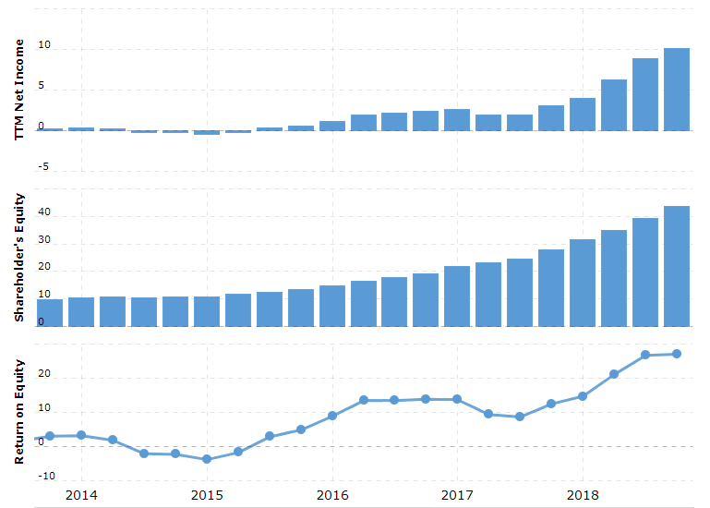



RETURN ON ASSETS (ROA)  
ROA often referred as ROI (return on investment), measures how efficient(profitable) a company’s management is at using their assets to produce earnings. In other words, are a company’s assets generating positive earnings, i.e. profit? ROA like ROE is expressed as a percentage and is highly suggested to disaggregate this calculation and monitor it year-over-year. Efficacious and yet few managers can deliver high ROAs or ROIs with little investment.

Calculated by dividing a company's operating earnings by its total assets

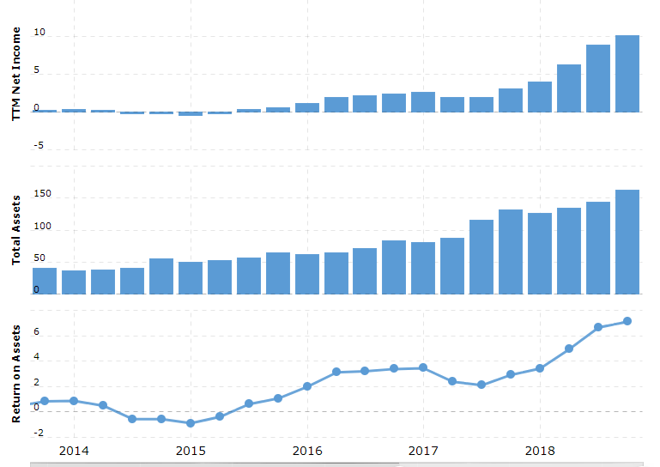



RETURN ON INVESTMENT(RONA)  
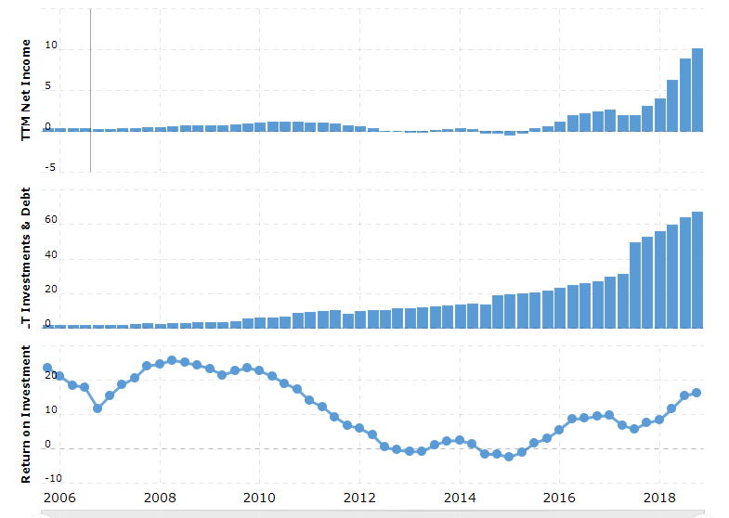



ASSET MANAGEMENT RATIOS

FIXED ASSET TURNOVER

This efficiency ratio compares net sales (income statement) to fixed assets (balance sheet) and measures a company's ability to generate net sales from its fixed-asset investments. The fixed asset balance is used as a net of accumulated depreciation. In general, a higher fixed asset turnover ratio indicates that a company has more effectively utilized investment in fixed assets to generate revenue.

Fixed Asset turnover

|  |  |  |  |  |  |
| --- | --- | --- | --- | --- | --- |
| Fixed Asset Turnover(In Millions) | | | | | |
| Date | Total Assets | Net Sales | Accumulated Depreciation, Total | Total Current Assets | Fixed Asset Turnover |
| 2018 | 162,648 | 232,887 | (33,973) | 75,101 | 1.916449967 |
| 2017 | 131,310 | 177,866 | (19,707) | 60,197 | 1.958445276 |
| 2016 | 83,402 | 135,987 | (13,327) | 45,781 | 2.669133234 |
| 2015 | 64,747 | 107,006 | (8,215) | 35,705 | 2.872104571 |
| 2014 | 54,505 | 88,988 | (5,763) | 31,327 | 3.074807367 |

TOTAL ASSET TURNOVER

The**Total Assets Turnover Ratio** shows how efficiently the total assets of the firm are employed to generate sales. This ratio gives an idea to the investor and the creditor about how the firm is managed, and the assets are utilized to generate revenues.

The Total Asset Turnover for Amazon by end of December, 2018 is 1.43%

= Sales ÷ Total Assets

|  |  |  |  |
| --- | --- | --- | --- |
| Total Asset Turnover | | | |
| Year | Total Assets | Net Sales | Total Asset Turnover |
| 2,018 | 162,648 | 232,887 | 143.18% |
| 2,017 | 131,310 | 177,866 | 135.46% |
| 2,016 | 83,402 | 135,987 | 163.05% |
| 2,015 | 64,747 | 107,006 | 165.27% |
| 2,014 | 54,505 | 88,988 | 163.27% |

*DAY SALES OUTSTANDING*

|  |  |  |  |
| --- | --- | --- | --- |
| *Day Sales Outstanding* | | | |
| *Date* | *Total Receivables* | *Net Sales* | *Days Sales Outstanding (DSO)* |
| *2018* | *16,677* | *232,887* | *26.13759033* |
| *2017* | *13,164* | *177,866* | *27.01393184* |
| *2016* | *8,339* | *135,987* | *22.38254392* |
| *2015* | *5,654* | *107,006* | *19.28592789* |
| *2014* | *5,612* | *88,988* | *23.01860925* |

*INVENTORY TURNOVER*

The inventory turnover ratio is an efficiency ratio that shows how effectively inventory is managed by comparing cost of goods sold with inventory for a period. This measures how many times the inventory is “turned” or sold during a period.

|  |  |  |  |
| --- | --- | --- | --- |
| *Inventory Turnover* | | | |
| *Date* | *Total Inventory* | *Net Sales* | *Total Inventory Turnover* |
| *2018* | *17,174* | *232,887* | *13.56* |
| *2017* | *16,047* | *177,866* | *11.08* |
| *2016* | *11,461* | *135,987* | *11.87* |
| *2015* | *10,243* | *107,006* | *10.45* |
| *2014* | *8,299* | *88,988* | *10.72* |

*MARKET VALUE RATIOS*

*EARNINGS PER SHARE*

Earnings per share can be defined as a company's net earnings or losses attributable to common shareholders per diluted share base, which includes all convertible securities and debt, options and warrants.

* Amazon 2018 annual EPS was **$20.14**, a **227.48% increase** from 2017.
* Amazon 2017 annual EPS was **$6.15**, a **25.51% increase** from 2016.
* Amazon 2016 annual EPS was **$4.9**, a **292% increase** from 2015.

|  |  |  |  |
| --- | --- | --- | --- |
| Earnings Per Share | | | |
| Date | Net Income | Total Common Shares Outstanding | Earnings Per Share |
| 2018 | 10,073 | 491 | 20.515 |
| 2017 | 3,033 | 484 | 6.267 |
| 2016 | 2,371 | 477 | 4.971 |
| 2015 | 596 | 471 | 1.265 |
| 2014 | (241) | 465 | (0.518) |

*CASH PER SHARE FLOW*

Cash Earnings Per Share (EPS) considers cash flow generated by a company on per share basis.  It is different from earnings per share, which looks at net income or profit of a company on per share basis. Cash EPS is calculated by adding all the non-cash transactions like depreciation, amortization, deferred tax and intangibles like royalty to net income of the company and then divide it by total number of shares.

|  |  |  |  |  |  |
| --- | --- | --- | --- | --- | --- |
| *Cash Flow Per Share* | | | | | |
| *Date* | *Amortization* | *Depreciation* | *Net Income* | *Total Common Shares Outstanding* | *Cash Flow Per Share* |
| *2018* | *475* | *15,341* | *10,073* | *491* | *52.73* |
| *2017* | *2,678* | *11,478* | *3,033* | *484* | *35.51* |
| *2016* | *1,716* | *8,116* | *2,371* | *477* | *25.58* |
| *2015* | *1,381* | *6,281* | *596* | *471* | *17.53* |
| *2014* | *1,146* | *4,746* | *(241)* | *465* | *12.15* |

**MARKET PRICE PER BOOK VALUE**

The price-to-book ratio (P/B Ratio) is a ratio used to compare a stock's market value to its book value.

|  |  |  |  |
| --- | --- | --- | --- |
| *Date* | *Market price per share* | *Book Value Per Share* | *Market Price Per Book Value* |
| *2018* | *1501.97* | *88.69450102* | *16.93419527* |
| *2017* | *1169.47* | *57.25* | *20.42742358* |
| *2016* | *765.15* | *40.42976939* | *18.92541094* |
| *2015* | *675.89* | *28.41613588* | *23.78542962* |
| *2014* | *310.35* | *23.09892473* | *13.43569035* |

*Price to Earnings Ratio*

The price to earnings ratio is calculated by taking the latest closing price and dividing it by the most recent earnings per share (EPS) number. The PE ratio is a simple way to assess whether a stock is over or under valued and is the most widely used valuation measure. Amazon PE ratio as of March 28, 2019 is **88.10**.

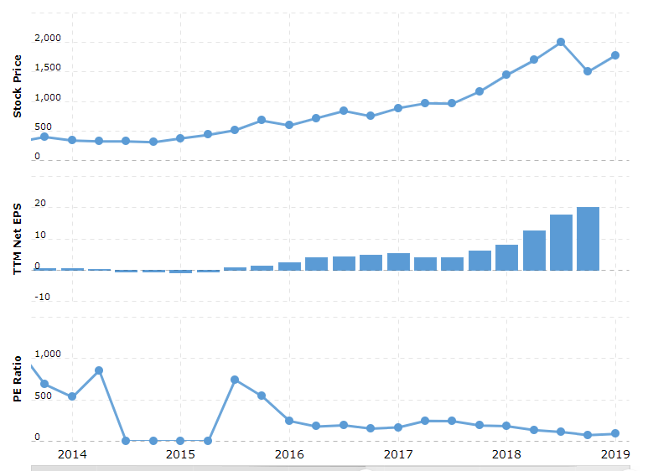



Dividend YIELD

The current TTM dividend payout for Amazon (AMZN) as of March 29, 2019 is **$0.00**

MARKET CAPITALIZATIONA  
Market Capitalization

* (Market capitalization) = (Cost per share) x (Number of shares)

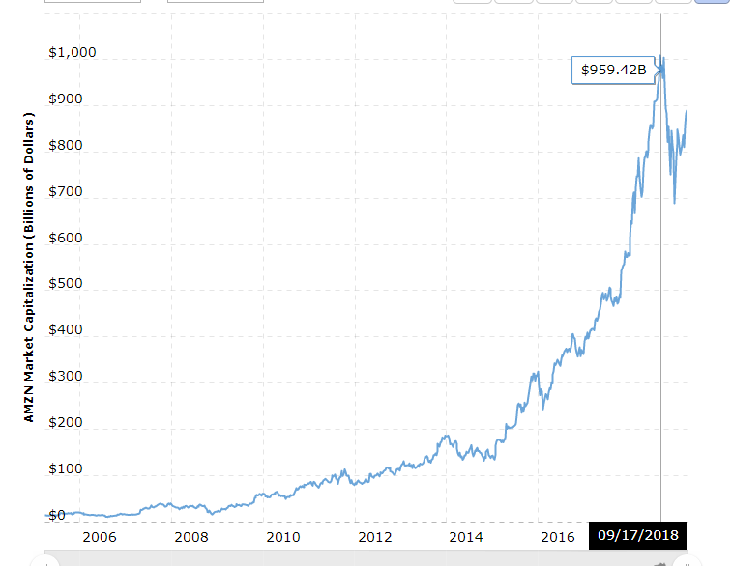

|  |  |  |  |
| --- | --- | --- | --- |
| Date | price per share | Total Common Shares Outstanding | Market Capitalization |
| 2018 | 1502.6454 | 491 | 737798.8914 |
| 2017 | 865.716 | 484 | 419006.544 |
| 2016 | 748.328 | 477 | 356952.456 |
| 2015 | 675.8875 | 471 | 318343.0125 |
| 2014 | 0.12 | 465 | 55.8 |
|  |  |  |  |

**TECHNICAL ANALYSIS**

## Simple Moving Average (SMA):

A simple moving average (SMA) is an arithmetic moving average calculated by adding the closing price of the security for a number of time periods and then dividing this total by the number of time periods.

It is used to identify trend direction, but can be used to generate potential buy and sell signals. The SMA is an average, or in statistical speak - the mean.

SMA for 20 50 144 days:

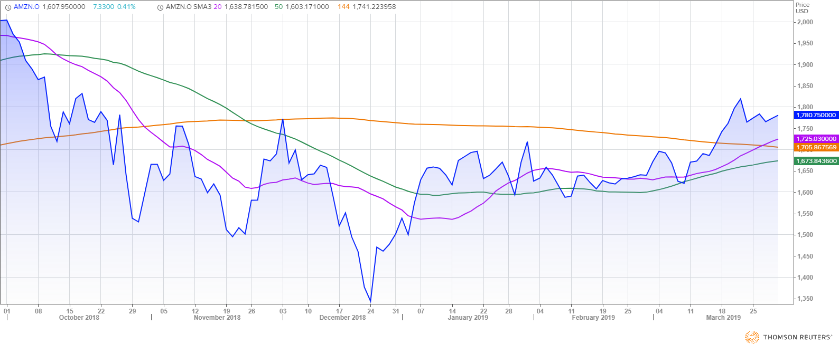

**EXPONENTIAL MOVING AVERAGES(EMA)**

The exponential moving average (EMA) is a weighted moving average (WMA) that gives more weighting, or importance, to recent price data than the simple moving average (SMA) does. The EMA responds more quickly to recent price changes than the SMA.

EMA for 20 50 150 days:

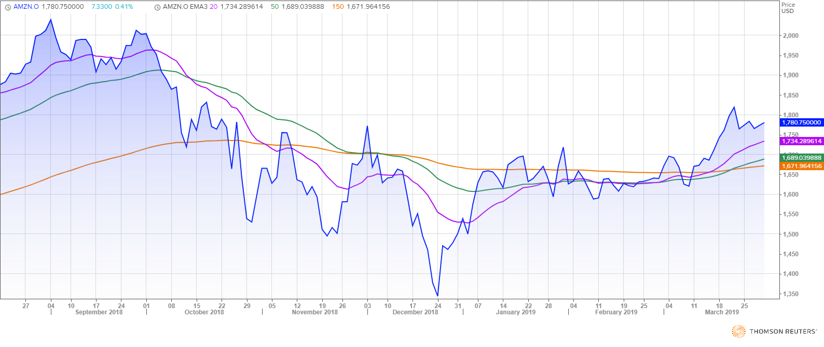

## MOMENTUM

Momentum in general refers to prices continuing to trend. Momentum is the rate of acceleration of a security's price or volume. In technical analysis, momentum is considered an oscillator and is used to help identify trend lines.

**Momentum = Todays close – Close N days ago.**

**Rate of change = Momentum / close N days ago.**

ROC- RATE OF CHANGE OF MOMENTUM

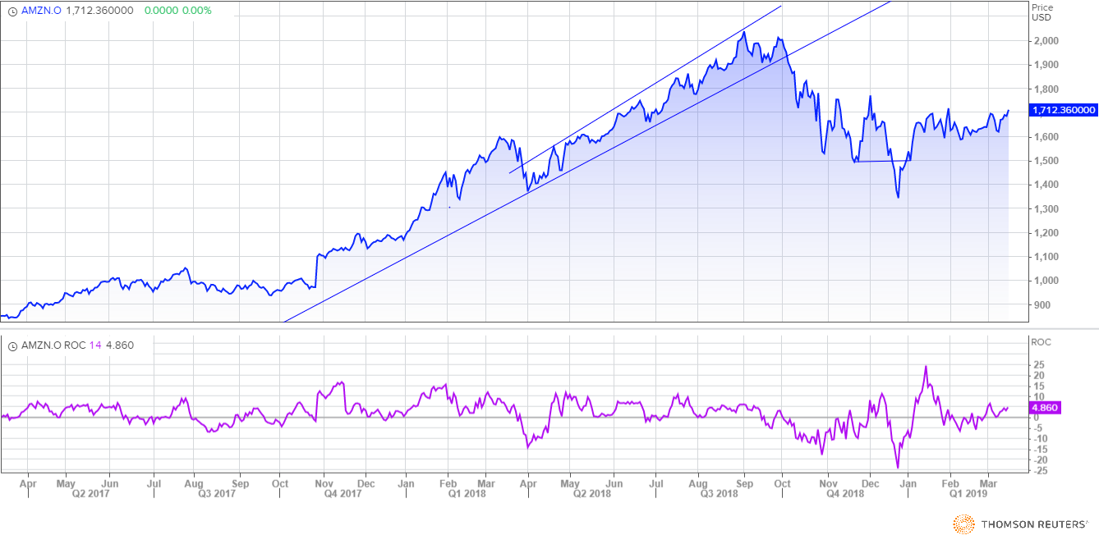

## BOLLINGER BANDS:

Bollinger Bands is a financial trading tool that is used to define the prevailing high and low prices in a market to characterize the trading band of a financial instrument or commodity.

Bollinger Bands with two sigma:

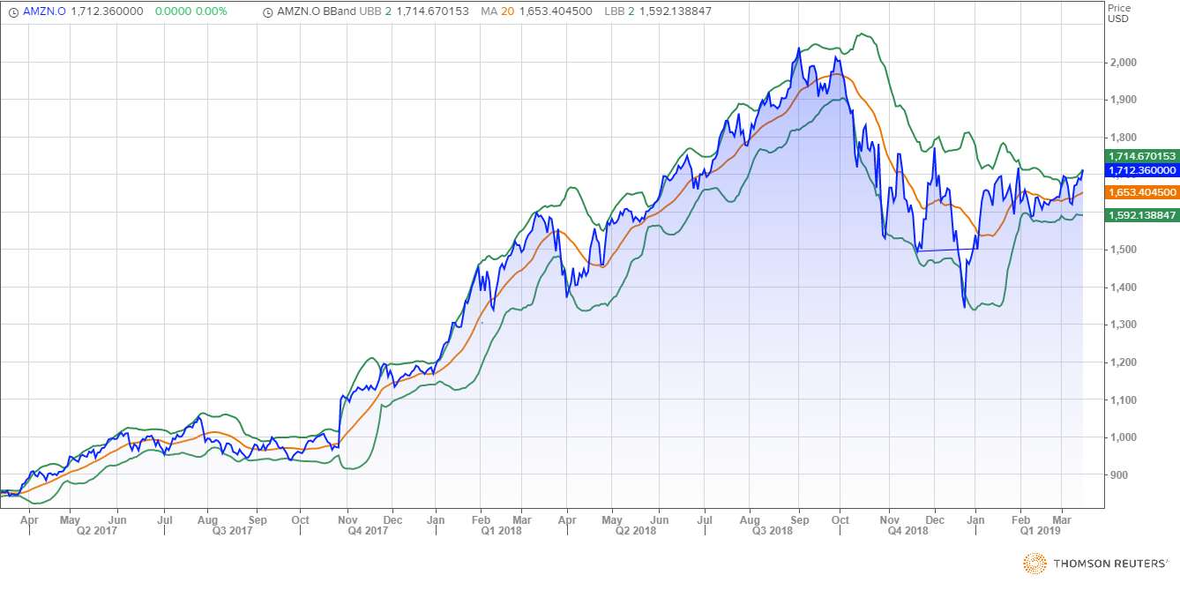

The closer the prices move to the upper band, the more overbought the market, and the closer the prices move to the lower band, the more oversold the market.

**Bollinger up = Simple moving average + (2*Standard deviation)**

**Bollinger down = Simple moving average - (2*Standard deviation)**

## MOVING AVERAGE CONVERGENCE DIVERGENCE (MACD):

## Moving average convergence divergence (MACD) is a trend-following momentum indicator that shows the relationship between two moving averages of prices. The MACD is calculated by subtracting the 26-day [exponential moving average](https://www.investopedia.com/terms/e/ema.asp) (EMA) from the 12-day EMA. A nine-day EMA of the MACD, called the "signal line", is then plotted on top of the MACD, functioning as a trigger for buy and sell signals. The MACD fluctuates above and below the zero line as the moving averages converge, cross and diverge. Traders can look for signal line crossovers, centerline crossovers and divergences to generate signals.

**Signal Line Cross Over**

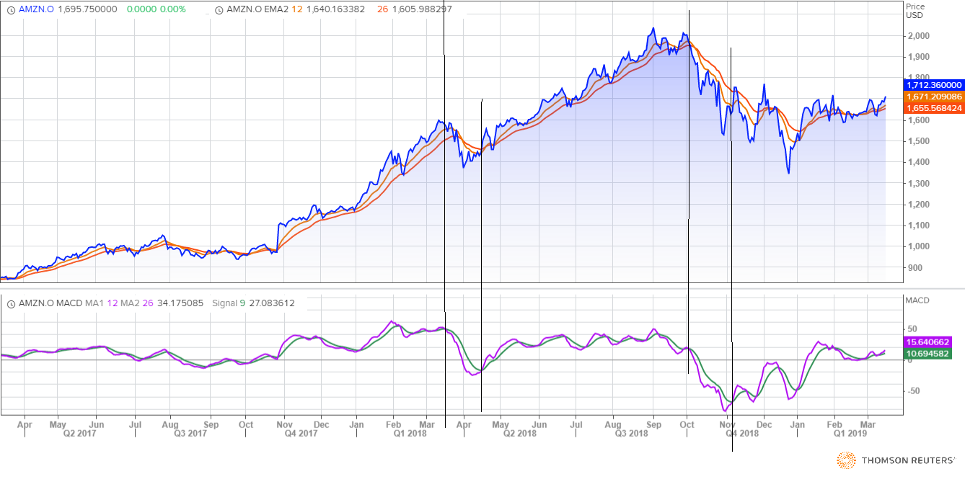

**Zero Line Cross Over**

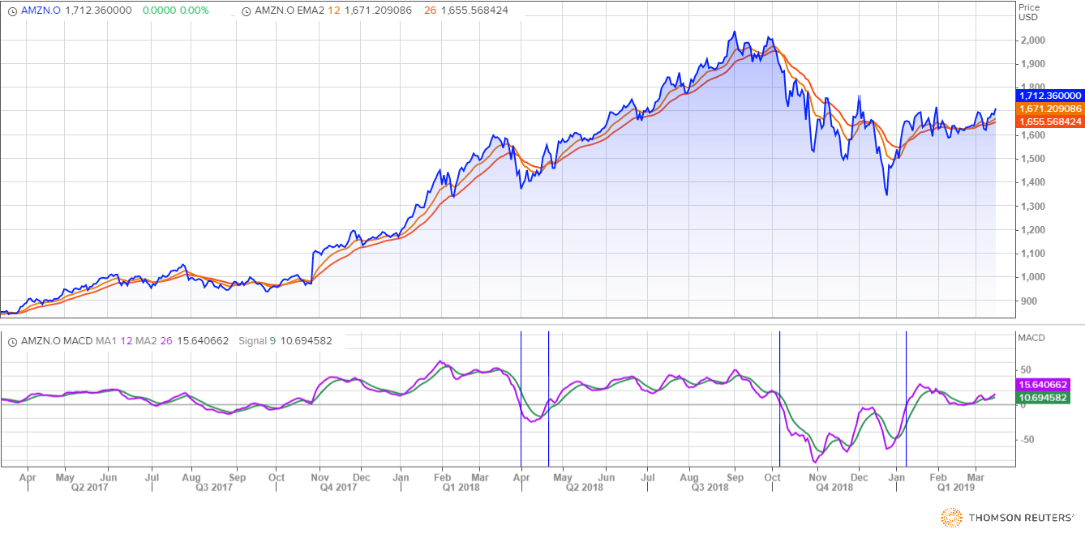

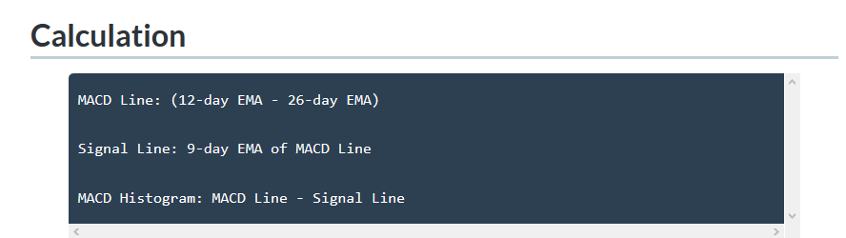

MACD offers the best of both worlds: **trend following and momentum.** The MACD fluctuates above and below the zero line as the moving averages converge, cross and diverge. Traders can look for signal line crossovers, centreline crossovers and divergences to generate signals.

The MACD is all about the convergence and divergence of the two moving averages. Convergence occurs when the moving averages move towards each other. Divergence occurs when the moving averages move away from each other. The shorter moving average (12-day) is faster and responsible for most MACD movements. The longer moving average (26-day) is slower and less reactive to price changes in the underlying security.

The MACD line oscillates above and below the zero line, which is also known as the centreline. These crossovers signal that the 12-day EMA has crossed the 26-day EMA. The direction, of course, depends on the direction of the moving average cross. Positive MACD indicates that the 12-day EMA is above the 26-day EMA. Positive values increase as the shorter EMA diverges further from the longer EMA. **This means upside momentum is increasing.** Negative MACD values indicate that the 12-day EMA is below the 26-day EMA. Negative values increase as the shorter EMA diverges further below the longer EMA. **This means downside momentum is increasing.**

RELATIVE STRENGTH INDEX (RSI)

The Relative Strength Index is a momentum oscillator that measures the speed and change of price movements. The RSI oscillates between zero and 100. Traditionally the RSI is considered overbought when above 70 and oversold when below 30.

Calculation:

Based on 14-periods

RSI = 100 - (100 /(1 + RS))

RS = Average Gain / Average Loss

First Average Gain = Sum of Gains over the past 14 periods / 14

First Average Loss = Sum of Losses over the past 14 periods / 14

Second and subsequent calculations:

Average Gain = [(previous Average Gain) x 13 + current Gain] / 14

Average Loss = [(previous Average Loss) x 13 + current Loss] / 14.

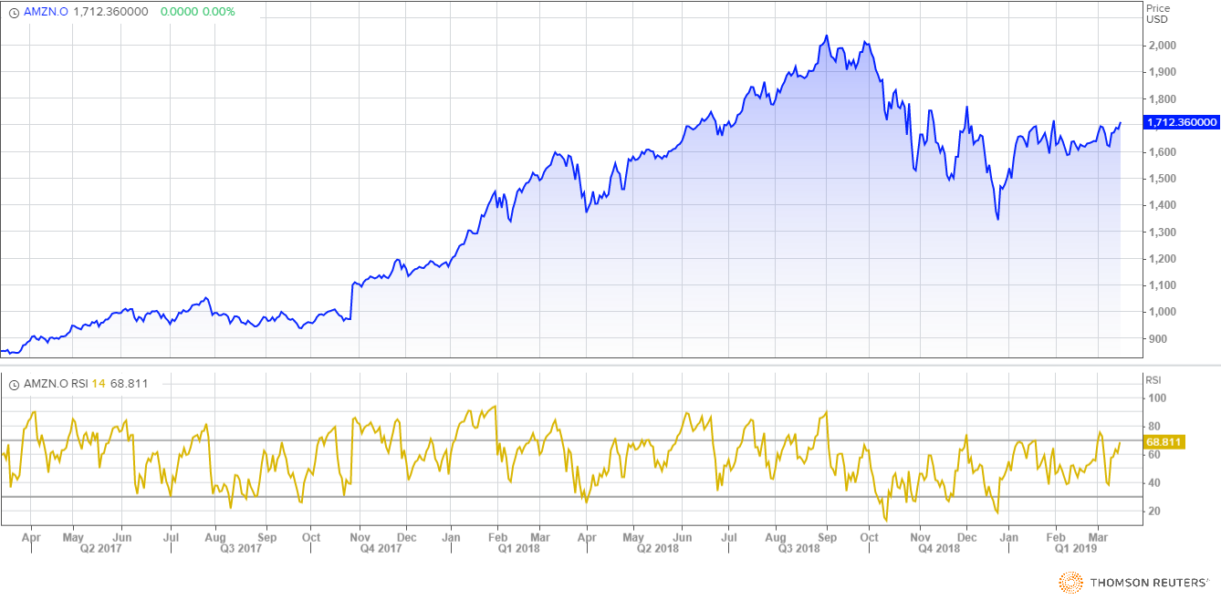

Consider the stock as overbought when RSI is above 70 and oversold when below 30

## AROON INDICATOR:

The Aroon indicator is a technical indicator that is used to identify when trends are likely to change direction. In essence, the indicator measures the time that it takes for the price to reach the highest and lowest points over a given timeframe as a percentage of total time. The indicator consists of the "Aroon up" line, which measures the strength of the uptrend, and the "Aroon down" line, which measures the strength of the downtrend.

Calculation:

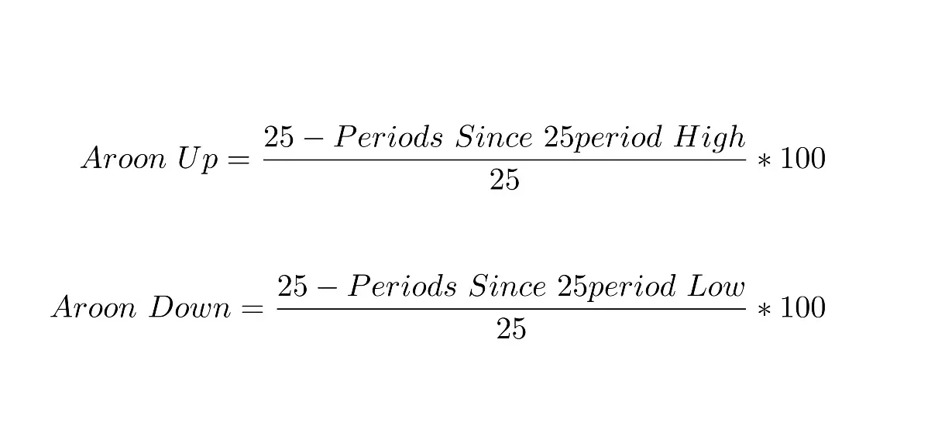

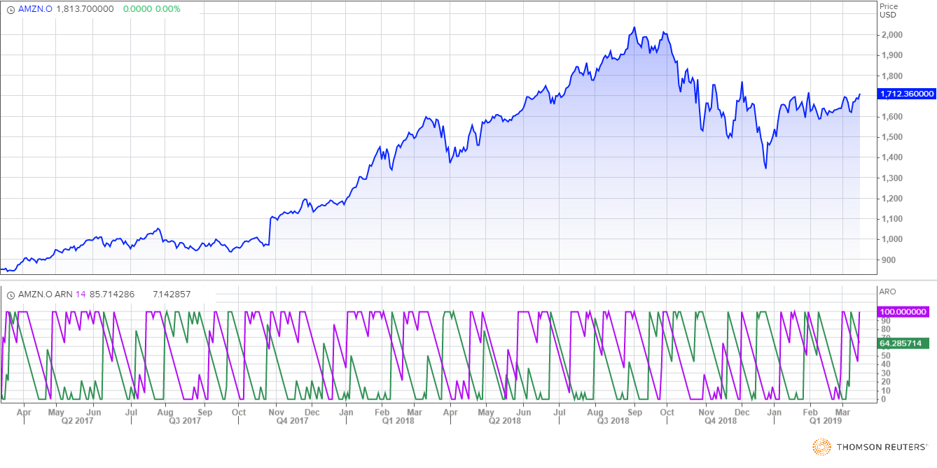

When Aroon up crosses Aroon down and goes up, its good time to buy, and Aroon indicator is related with money flow and not with the price action.

**CHAIKIN MONEY FLOW:**

[Chaikin Money Flow (CNF)](https://www.tradingview.com/chart/chaikinmoneyflow/) is a [technical analysis](https://www.tradingview.com/wiki/Technical_Analysis) indicator used to measure [Money Flow Volume](https://www.tradingview.com/wiki/Money_Flow_Volume) over a set [period](https://www.tradingview.com/wiki/Period) of time.

Calculation:

Money flow multiplier = [(close-low)-(high-close)]/(high-low)

Money flow volume = money flow multiplier / volume for the period

N days cmf = n period sum of money flow volume / n period sum of volume

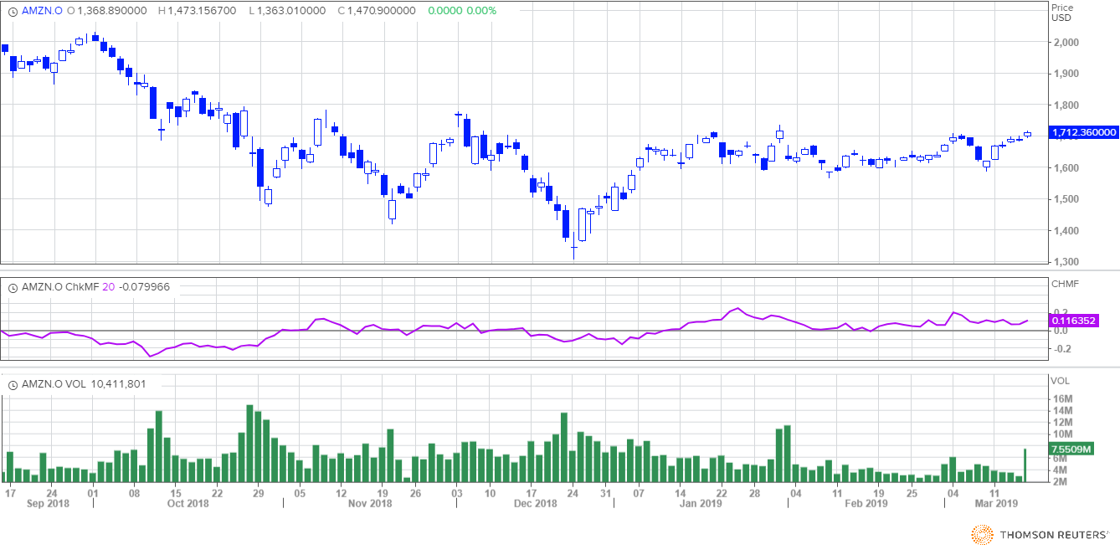

All about CMF

* A CMF value above the zero line is a sign of strength in the market, and a value below the zero line is a sign of weakness in the market.
* Wait for the CMF to confirm the breakout direction of price action through trend lines or through support and resistance lines. For example, if a price breaks upward through resistance, wait for the CMF to have a positive value to confirm the breakout direction.
* A CMF sell signal occurs when price action develops a higher high into overbought zones, with the CMF diverging with a lower high and beginning to fall.
* A CMF buy signal occurs when price action develops a lower low into oversold zones, with the CMF diverging with a higher low and beginning to rise.

**HEIKIN ASHI**

Calculation:

The Heikin-Ashi Close is simply an average of the open, high, low and close for the current period. **HA-Close = (Open(0) + High(0) + Low(0) + Close(0)) / 4**

The Heikin-Ashi Open is the average of the prior Heikin-Ashi candlestick open plus the close of the prior Heikin-Ashi candlestick. **HA-Open = (HA-Open(-1) + HA-Close(-1)) / 2**

The Heikin-Ashi High is the maximum of three data points: the current period's high, the current Heikin-Ashi candlestick open or the current Heikin-Ashi candlestick close. **HA-High = Maximum of the High(0), HA-Open(0) or HA-Close(0)**

The Heikin-Ashi low is the minimum of three data points: the current period's low, the current Heikin-Ashi candlestick open or the current Heikin-Ashi candlestick close. **HA-Low = Minimum of the Low(0), HA-Open(0) or HA-Close(0)**

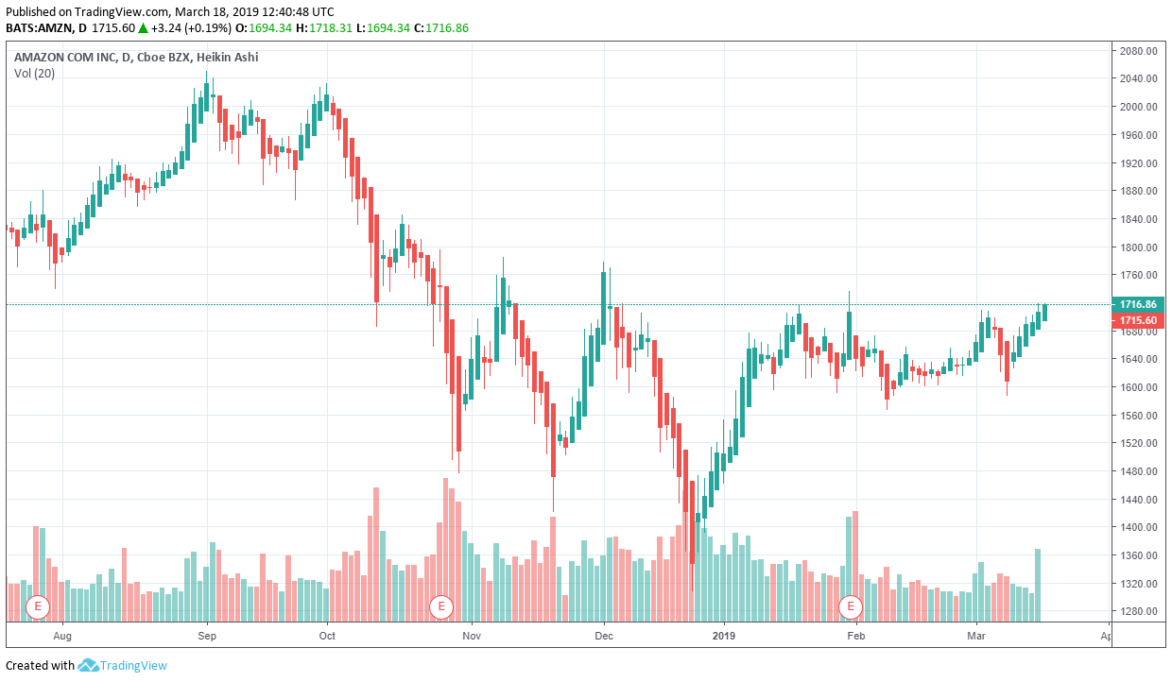

Fibonacci Retracements

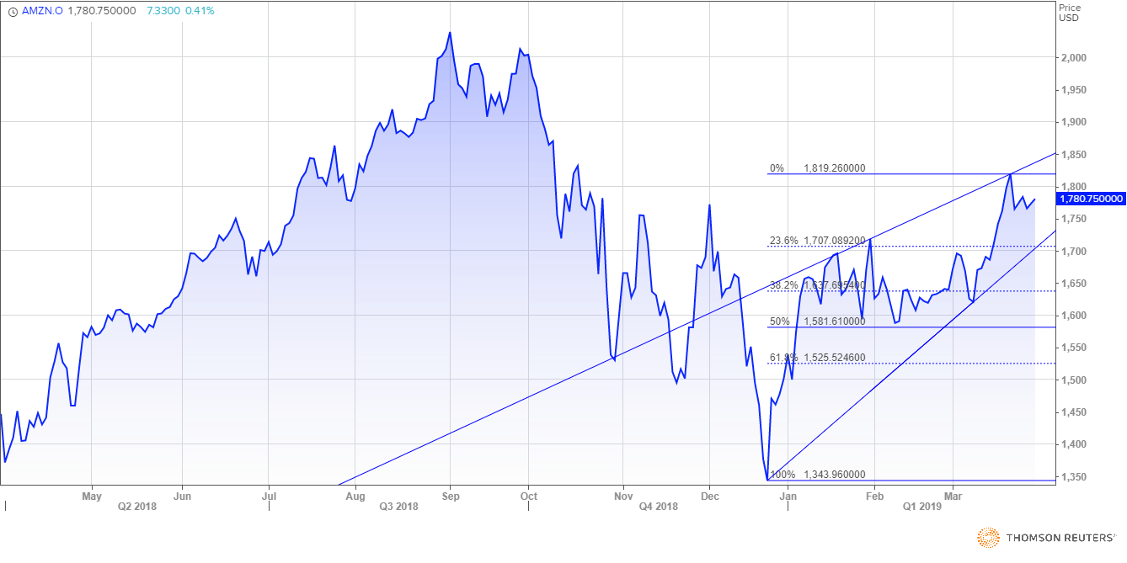

In technical analysis, a Fibonacci retracement is created by taking two extreme points (usually a major peak and trough) on a stock chart and dividing the vertical distance by the key Fibonacci ratios of 23.6%, 38.2%, 50%, 61.8% and 100%. Once these levels are identified, horizontal lines are drawn and used to identify possible support and resistance levels.

Fibonacci retracements are the most widely used of all the Fibonacci trading tools. This is partially due to their relative simplicity and partially due to their applicability to almost any trading instrument. They can be used to identify and confirm support and resistance levels, place stop-loss orders or target prices, and even act as a primary mechanism in a countertrend trading strategy.

COMPETITOR ANALYSIS:

Main Competitors and their stocks

Google

Apple

Alibaba

EBAY

Microsoft

The stock flow of Amazon with Google and Apple

Google, Apple, Amazon

The patterns of the downfall of the stock and sudden rise in the stock is all the same for the three companies. The major impact on the stocks where the downfall started as the US Fed has started pushing up the reference interest rates and with the recent increase on 26 September, the benchmark rates have crossed the 2% mark for the first time since 2008.

This monetary tightening by Fed is a key factor which is leading to a general fall in the tech company stocks.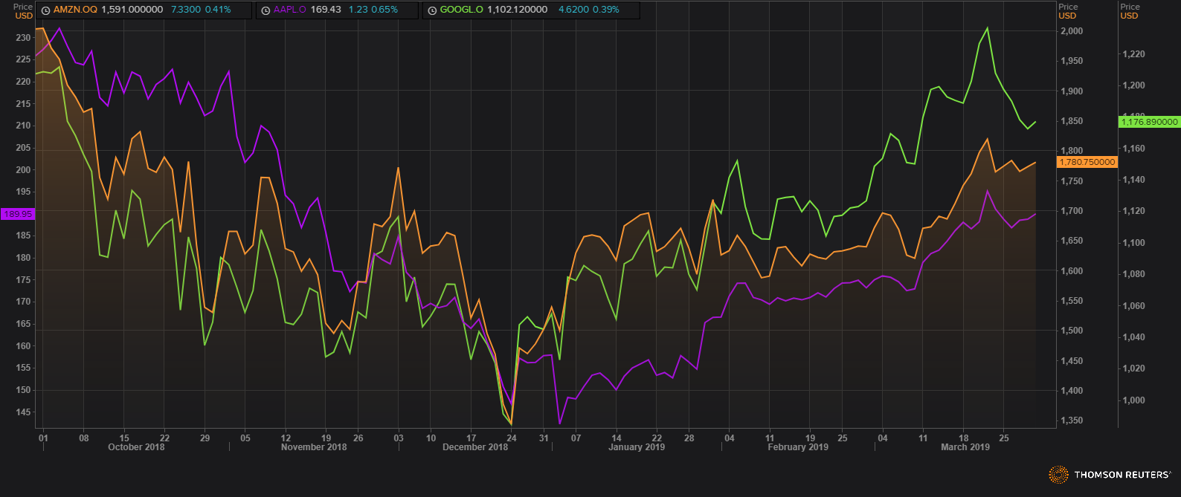

The rise in the stocks have started again after Christmas.

News:

Reasons for Downfall and increase in Amazon stocks is available

<https://www.thestreet.com/story/12627290/1/why-amazon-amzn-stock-is-down-today.html>

<https://money.usnews.com/investing/stock-market-news/articles/2018-03-28/amazon-com-inc-amzn-stock>

<https://www.zacks.com/stock/news/342854/buy-amazon-amzn-stock-on-the-dip-heading-into-2019>

<https://www.zacks.com/stock/news/344610/amazon-posts-recordbreaking-holiday-sales-time-to-buy-amzn-stock>

<http://fortune.com/2018/10/10/stock-market-news-today-apple-amazon-facebook-google/>

<https://www.fool.com/investing/2018/04/02/why-amazoncom-inc-stock-dropped-today.aspx>

<https://www.investors.com/news/technology/amazon-stock-dives-as-trump-targets-tax-treatment/>