**Boston Housing Prices Hike and Reasons**

A PROJECT REPORT

Submitted in partial fulfilment of the requirements for the award of degree of

**MASTERS OF BUSINESS ADMINISTRATION FINTECH**

Submitted by

**SAMSON KURMANA**

**Regd no.-121823901004**

Under the esteemed guidance of

**Mr.Leben Johnson Mannariat**

**Associate Professor**



**MBA**

**GITAM INSTITUTE OF MANAGEMENT**

**GITAM Deemed to be University**

**(Established U/S 3 of UGC Act, 1956)**

**VISAKHAPATNAM**

**DECLARATION**



I, **Kurmana Samson**, student of Integrated Masters of Business Administration(MBA), GITAM Institute of Management, GITAM University, hereby declare that the internship project work initiated on **“BOSTON PROJECT REPORT”** – is a genuine work done by me in partial fulfilment for the requirement of the degree of Masters of Business Administration.

**Place: Visakhapatnam**

**Date:**

**121823901004**

**CERTIFICATE**

This is to certify that the project report titled **“BOSTON PROJECT REPORT”**- is an original work carried out by **Kurmana Samson** (Regd.no: 121823901004), under my guidance and supervision, in partial fulfilment for the award of the degree of Integrated Master of Business Administration by **GITAM Institute of Management, GITAM (Deemed to be University), Visakhapatnam**, during academic year 2018-2019.

Project Guide

**ACKNOWLEDGEMENT**

It is my pleasure to acknowledge and express my gratitude to all those who helped me throughout in the successful completion of this project.

I wish to express my gratitude to **PROF. Y. GOUTHAMA RAO,** Director, **GITAM INSTITUTE OF MANAGEMENT, GITAM (Deemed to be University), VISAKHAPATNAM**, for giving this valuable opportunity to experience the work culture.

I am grateful to **Prof. Leben Johnson**, Associate professor, GITAM Institute of Management, GITAM (Deemed to be University), Visakhapatnam, for his continuous guidance to accomplish this project work successfully.

I am thankful to all who directly and indirectly helped me in successful completion this project.

**SAMSON KURMANA**

**121823901004**

Table of Contents

**INTRODUCTION** 6

**INTRODUCTION**

Boston (UK: /ˈbɒstən/, US: /ˈbɔːstən/)is the capital and most populous city of the commonwealth of Massachusetts in the United States, and the 21st most populous city in the United States. The city proper covers 48 square miles (124 km2) with an estimated population of 694,583 in 2018 making it also the most populous city in New England.

Latitude: 42.32 N, Longitude: 71.09 W  
  
Boston nicknames or aliases (official or unofficial): Athens of America, Beantown or Bean Town and variations 'The Bean', 'DA BEAN', Bean City, B-town, etc, The Hub , the Hub of the Universe, City of Notions, The Cradle of Liberty, Puritan City

Population in 2017: 685,094 (100% urban, 0% rural).

Population change since 2000: +16.3%

Boston is a very large coastal city (i.e. on the ocean, a bay, or inlet) located in the state of Massachusetts. With a population of 685,094 people and 179 constituent neighborhoods, Boston is the largest community in Massachusetts. Much of the housing stock in Boston was built prior to World War II, making it one of the older and more historic cities in the country.

Housing costs in Boston are among some of the highest in the nation, although real estate prices here don't compare to real estate prices in the most expensive communities in Massachusetts.

Boston is a decidedly white-collar city, with fully 89.70% of the workforce employed in white-collar jobs, well above the national average. Overall, Boston is a city of professionals, service providers, and sales and office workers. There are especially a lot of people living in Boston who work in office and administrative support (11.60%), management occupations (11.50%), and sales jobs (8.50%).

Also of interest is that Boston has more people living here who work in computers and math than 95% of the places in the US.

In addition, Boston also has a very large population of students, making it a major college town. As often the case, having so many students around has a strong influence on the local culture. In fact, Boston is one of only a few big cities that are also major college towns, making it one of the nation's prominent intellectual centers. In addition, the presence of thousands of college students gives Boston a sophisticated style, and provides lots of diversions and entertainment for students. Being a big "college town" not only means that Boston has a burgeoning arts, music, and nightclub scene, but the innovation sector of the local economy receives a great boost from both the intellectual output of the faculty and the thousands of enthusiastic students who graduate every spring.

This makes it a good place to live for young singles in their 20s and 30s and who have undergraduate or graduate degrees and are starting their professional careers. Although Boston is a large city, this demographic is significant enough that young professionals will find many others like themselves here, with really good opportunities for friendships, recreation, romance, and more.

Boston is also nautical, which means that parts of it are somewhat historic and touch the ocean or tidal bodies of water, such as inlets and bays. Such areas are often places that visitors and locals go for waterfront activities or taking in the scenery.

One downside of living in Boston is that it can take a long time to commute to work. In Boston, the average commute to work is 31.92 minutes, which is quite a bit higher than the national average. On the other hand, local public transit is widely used in the city, so leaving the car at home and taking transit is often a viable alternative. In addition, it is also a pedestrian-friendly city. Many of Boston’s neighborhoods are dense enough and have amenities close enough together that people find it feasible to get around on foot.

Boston is a big city, and with that comes lots of benefits. One benefit is that most big cities have public transit, but Boston really shines when it comes to the extensiveness and use of its public transit system. More than most large American cities, Boston citizens use public transit daily to get to and from work. And while there are transportation options, most people in Boston ride the subway. Whereas in some cities one is destined to sit in traffic every morning to get to work and every evening to get home, in Boston a lot leave their cars at home (if they even choose to own one), and hop a ride on the subway.

Boston is one of the most well-educated cities in the nation. 47.39% of adults in Boston have at least a bachelor's degree. Compare that to the average community in America, which has just 21.84% with a bachelor's degree or higher.

The per capita income in Boston in 2010 was $39,686, which is middle income relative to Massachusetts, and wealthy relative to the rest of the US. This equates to an annual income of $158,744 for a family of four. However, Boston contains both very wealthy and poor people as well.

Boston is an extremely ethnically-diverse city. The people who call Boston home describe themselves as belonging to a variety of racial and ethnic groups. The greatest number of Boston residents report their race to be White, followed by Black or African-American. Boston also has a sizeable Hispanic population (people of Hispanic origin can be of any race). People of Hispanic or Latino origin account for 19.36% of the city’s residents. Important ancestries of people in Boston include Irish, Italian, German, English, and Haitian.

In addition, Boston has a lot of people living here who were born outside of the US (28.35%).

The most common language spoken in Boston is English. Other important languages spoken here include Spanish and French.

**WAGES**

**2.1 Median Household Income**

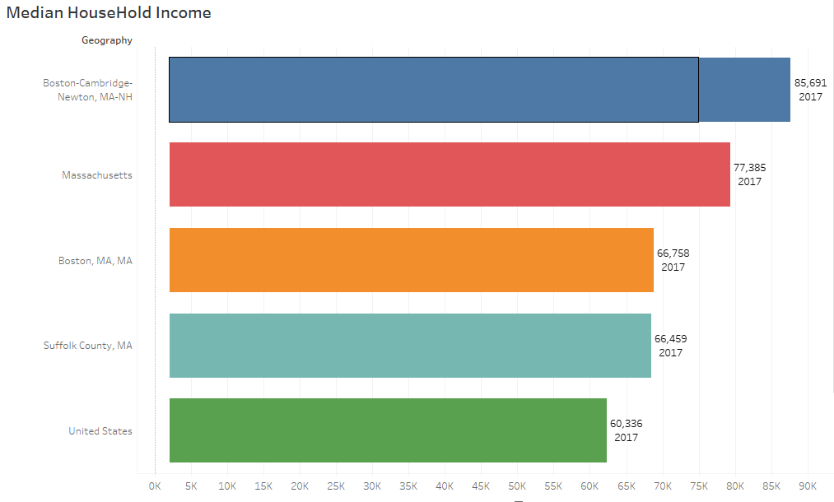

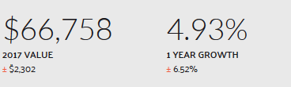



Households in Boston, MA have a median annual income of $66,758, in 2017, which is more than the median annual income of $60,336 across the entire United States. This is in comparison to a median income of $63,621 in 2016, which represents a 4.93% annual growth.

Estimated per capita income in 2017: $42,236 (it was $23,353 in 2000)

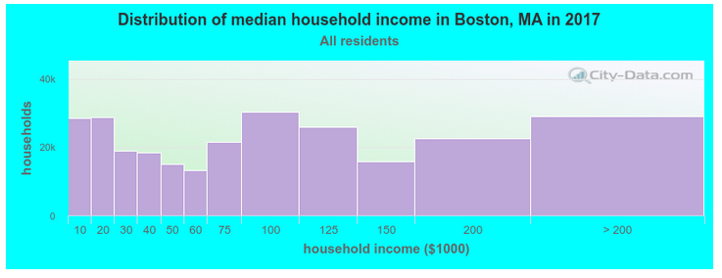

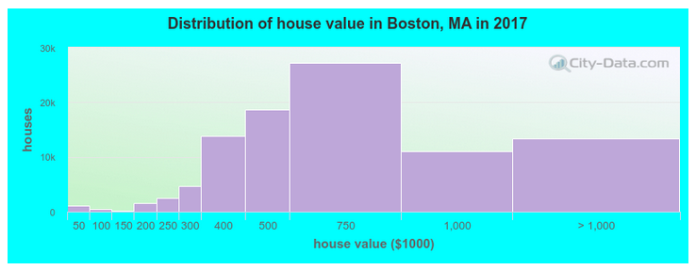

### 2.2 Wage by Race and Ethnicity in Common Jobs

### 

### 

### 

### In 2017 the highest paid race/ethnicity of Massachusetts workers was Asian. These workers were paid 1.1 times more than White workers, who made the second highest salary of any race/ethnicity.

### 2.3 [Poverty by Race and Ethnicity](https://datausa.io/profile/geo/boston-ma/#poverty_ethnicity)

### 

### 

### 

### The most common racial or ethnic group living below the poverty line in Boston, MA is White, followed by Black and Hispanic.

### OCCUPATION

### 3.1 [Employment By Occupations](https://datausa.io/profile/geo/boston-ma/#tmap_occ_num_emp)

### 

### 

### The most common job groups, by number of people living in Boston, MA, are Management Occupations (48,977 people), Office & Administrative Support Occupations (39,558 people), and Sales & Related Occupations (32,476 people). This chart illustrates the share breakdown of the primary jobs held by residents of Boston, MA.

### Compared to other places, Boston, MA has an unusually high number of residents working as Life, Physical, & Social Science Occupations (3.24 times higher than expected), Community & Social Service Occupations (1.58 times), and Business & Financial Operations Occupations (1.55 times)

### The highest paid jobs held by residents of Boston, MA, by median earnings, are Legal Occupations ($101,717), Management Occupations ($78,223), and Computer & Mathematical Occupations ($78,002).

### 3.2 [Employment By Industries](https://datausa.io/profile/geo/boston-ma/#tmap_ind_num_emp)

The most common employment sectors for those who live in Boston, MA, are Health Care & Social Assistance (70,056 people), Educational Services (49,769 people), and Professional, Scientific, & Technical Services (48,602 people). This chart shows the share breakdown of the primary industries for residents of Boston, MA, though some of these residents may live in Boston, MA and work somewhere else. Census data is tagged to a residential address, not a work address.

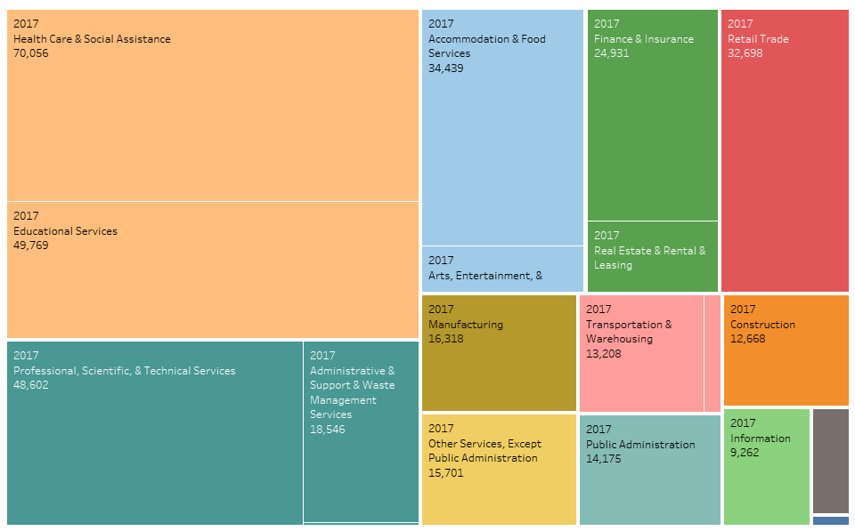



Employment in Boston,MA was 382k employees.

### 3.3 [Domestic Production & Consumption](https://datausa.io/profile/geo/boston-ma/#domestic_trade)

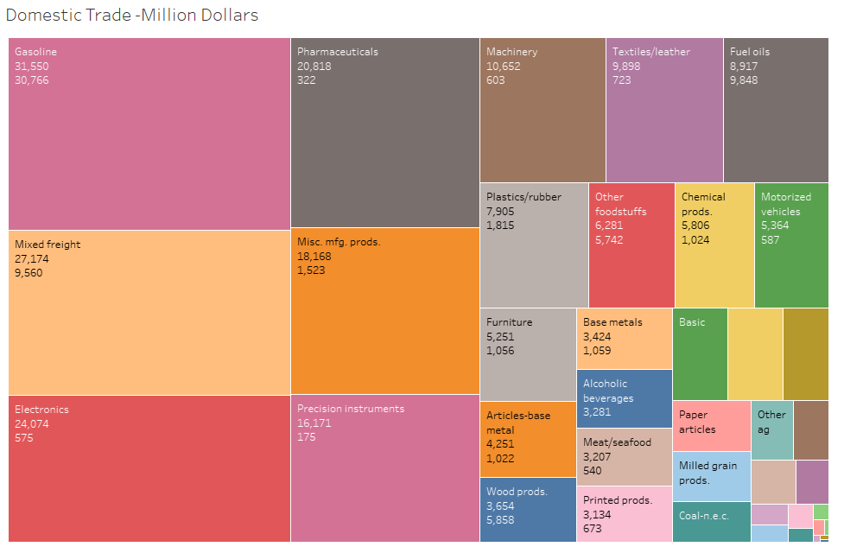

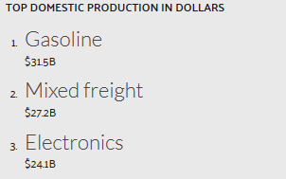

In 2015, the top outbound Massachusetts product (by dollars) was Gasoline with $31.5B, followed by Mixed freight ($27.2B) and Electronics ($24.1B).

**HEALTH**

### 4.1 [Health Care Spending](https://datausa.io/profile/geo/boston-ma/#health_spending)

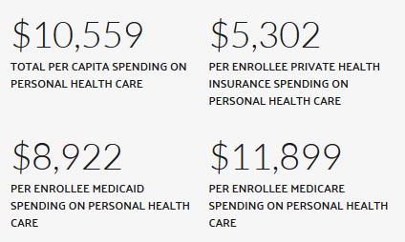

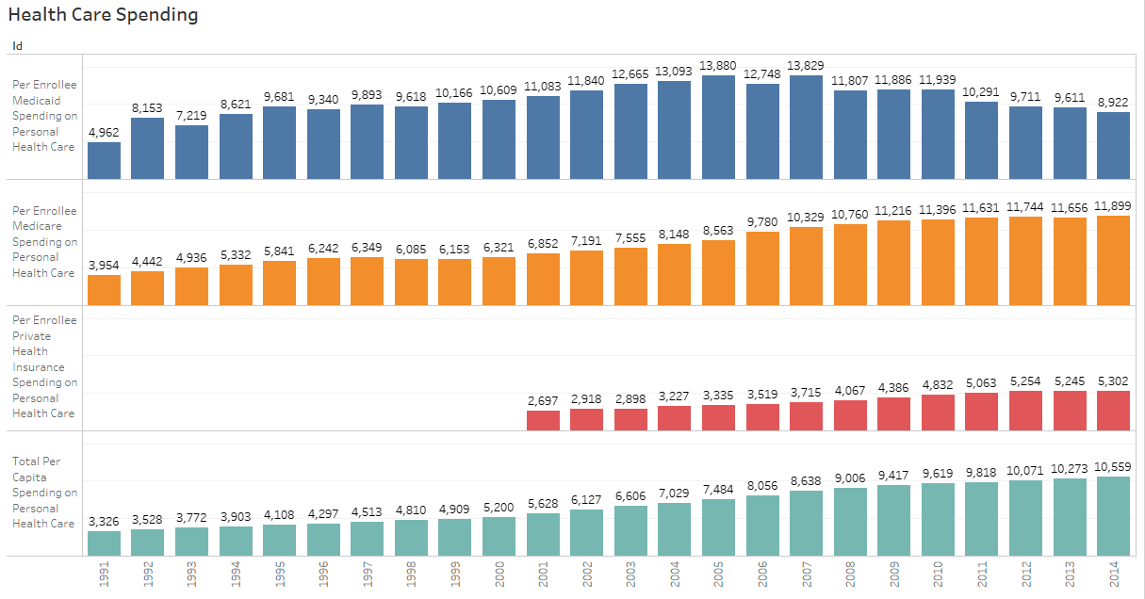

Between 2010 and 2014, all personal health care spending per capita in Massachusetts (including private, Medicare, and Medicaid) grew from $9,619 to $10,559.

### 

### EDUCATION

### 5.1 Concentration

### 

### 

### In 2015, the most common concentation for Bachelors Degree recipients in Boston, MA was [General Business Administration & Management](https://datausa.io/profile/cip/general-business-administration-management) with 1,719 degrees awarded.

### 5.2 [Universities](https://datausa.io/profile/geo/boston-ma/#universities)

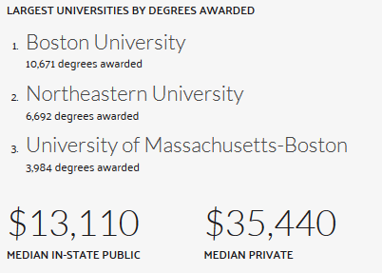

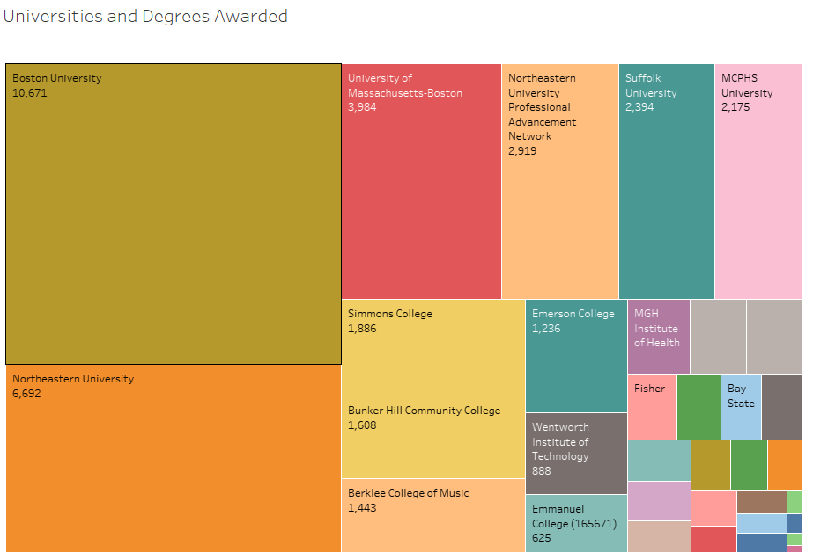

## [**DIVERSITY**](https://datausa.io/profile/geo/boston-ma/#demographics)

Boston, MA is home to a population of 685k people, from which 85.2% are citizens. As of 2017, 27.8% of Boston, MA residents were born outside of the country (190k people).

The ethnic composition of the population of Boston, MA is composed of 300k White Alone residents (43.9%), 158k Black or African American Alone residents (23.1%), 139k Hispanic or Latino residents (20.4%), 66.1k Asian Alone residents (9.67%), 12.9k Two or More Races residents (1.89%), 4.67k Some Other Race Alone residents (0.684%), 1.65k American Indian & Alaska Native Alone residents (0.241%), and 0 Native Hawaiian & Other Pacific Islander Alone residents (0%).

The most common foreign languages spoken in Boston, MA are Spanish (111,192 speakers), Chinese (Incl. Mandarin, Cantonese) (27,253 speakers), and Haitian (27,048 speakers).

### 6.1 [Global Diversity](https://datausa.io/profile/geo/boston-ma/#global_diversity)

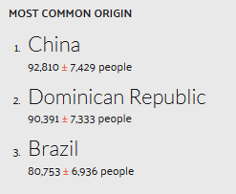

In 2017, the most common birthplace for the foreign-born residents of Massachusetts was China, the natal country of 92,810 Massachusetts residents, followed by Dominican Republic with 90,391 and Brazil with 80,753.

**6.2 CITIZENSHIP**

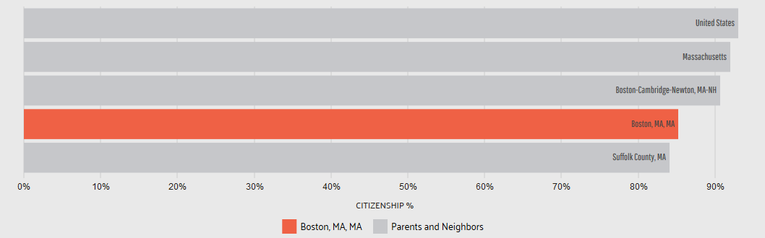

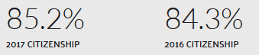

As of 2017, 85.2% of Boston, MA residents were US citizens, which is lower than the national average of 93.1%. In 2016, the percentage of US citizens in Boston, MA was 84.3%, meaning that the rate of citizenship has been increasing.

### 6.3 F[OREIGN-BORN POPULATION](https://datausa.io/profile/geo/boston-ma/#foreign_born)

### 

As of 2017, 27.8% of Boston, MA residents (190k people) were born outside of the United States, which is higher than the national average of 13.7%. In 2016, the percentage of foreign-born citizens in Boston, MA was 27%, meaning that the rate has been increasing.



### INCOME

### 7.1 [Household Income](https://datausa.io/profile/geo/boston-ma/#household_income)

In 2017, the median household income of the 268k households in Boston,MA grew to $66,758 .

The largest share of households have an income in the $75k - $100k range.

### 

### 7.2 Housing

### 7.2.1 [Property Value](https://datausa.io/profile/geo/boston-ma/#property_value)

### 

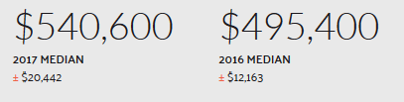

In 2017, the median property value in Boston, MA grew to to $540,600 from the previous year's value of $495,400. (it was $210,100 in 2000) –

Mean prices in 2017: all housing units: $700,914; detached houses: $524,281; townhouses or other attached units: over $1,000,000; in 2-unit structures: $577,010; in 3-to-4-unit structures: $643,310; in 5-or-more-unit structures: $912,177; mobile homes: $185,000

March 2019 cost of living index in Boston: 147.7 (very high, U.S. average is 100)

### 7.2.2 [Rent vs Own](https://datausa.io/profile/geo/boston-ma/#rent_own)

### Average Market Rent: $2,382 / per month

### 

In 2019, 32.8% of the housing units in Boston, MA were occupied by their owner.

67.2% by renters and 7.9% vacant

Median gross rent in 2017: $1,541- and in 2019:raised to 2,382 /month.

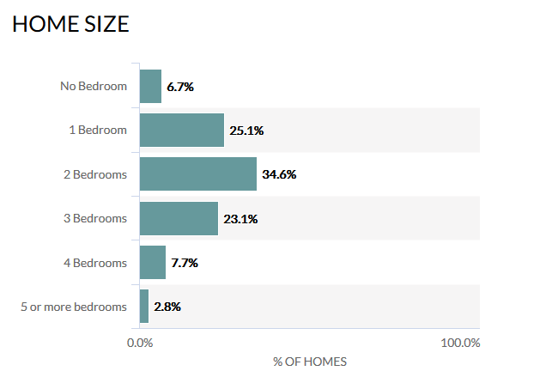

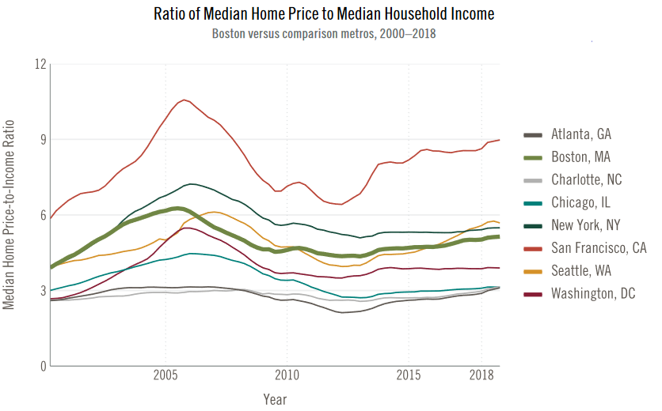

[**TRANSPORTATION**](https://datausa.io/profile/geo/boston-ma/#category_transportation)

### 8.1 [Car Ownership](https://datausa.io/profile/geo/boston-ma/#num_vehicles)

### 

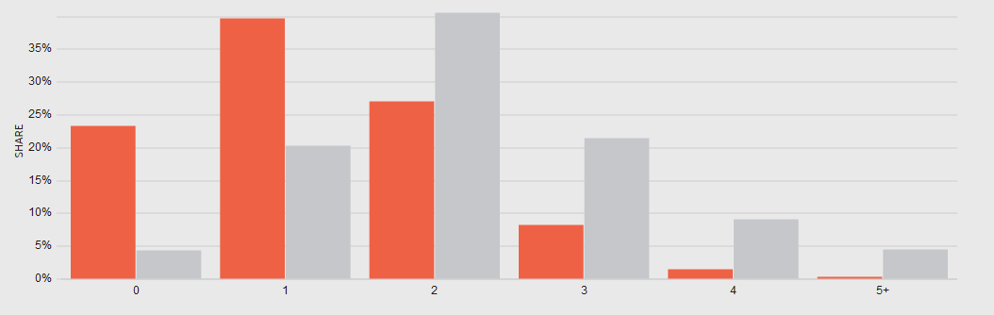

The households in Boston distributed between a series of car ownership buckets compared to the national averages for each bucket. The largest share of households in Boston, MA have 1 car, followed by 2 cars.

### 8.2 [Commute Time](https://datausa.io/profile/geo/boston-ma/#commute_time)

### 

### Using averages, employees in Boston, MA have a longer commute time (29.9 minutes) than the normal US worker (25.5 minutes). Additionally, 1.86% of the workforce in Boston, MA have "super commutes" in excess of 90 minutes.

### 

### 8.3 [Commuter Transportation](https://datausa.io/profile/geo/boston-ma/#mode_transport)

### 

### 

### In 2017, the most common method of travel for workers in Boston, MA was Drove Alone (37.6%), followed by those who Public Transit (35%) and those who Walked (14.3%).

### TOURISM

### Boston is easy to navigate on foot, as its major sights are relatively close, and America's first subway system, the T, connects its important neighborhoods. Over 19 million domestic and over 1.7 overseas visitors come to the city annually, making it a leading tourist destination

### Although a separate and independent city, for tourist purposes, Cambridge is part of Boston and connected by the same transit system. Here, you'll find two of America's most prestigious and important universities, Harvard and the Massachusetts Institute of Technology (MIT).

### These and the many other universities and colleges in the area help keep Boston a youthful and vibrant place to be, with a lively cultural scene. With all the music, theater, and entertainment options, plus its abundance of restaurants, you'll never be at a loss for things to do in Boston at night.

### 

### CRIME DATA

### 

### 

The crime rate in Boston is considerably higher than the national average across all communities in America from the largest to the smallest, although at 30 crimes per one thousand residents, it is not among the communities with the very highest crime rate. The chance of becoming a victim of either violent or property crime in Boston is 1 in 34. Based on FBI crime data, Boston is not one of the safest communities in America. Relative to Massachusetts, Boston has a crime rate that is higher than 97% of the state's cities and towns of all sizes.

However, compared to other communities of similar population size, Boston has a crime rate that is noticeably lower than the average. This means that for comparably sized cities all across America, Boston is actually safer than most other U.S. cities

### CORRELATION

### 

### 

### Why they’re so high?

Boston home prices have climbed in the first quarter of 2019, but not at the torrid pace of the last two years. And the number of condos listed for sale is rapidly growing.

In the last 10 years, Boston has experienced some of the highest home appreciation rates of any community in the nation. Boston real estate appreciated 69.51% over the last ten years, which is an average annual home appreciation rate of 5.42%, putting Boston in the top 10% nationally for real estate appreciation. If you are a home buyer or real estate investor, Boston definitely has a track record of being one of the best long term real estate investments in America through the last ten years.

In the last twelve months, short-term real estate investors have found good returns in Boston. Boston appreciation rates in the latest quarter were at 0.99%, which equates to an annual appreciation rate of 4.01%.

Currently the Boston housing market is relatively friendly to both buyers and sellers. The number of single family homes and condos sold in the Greater Boston region in March 2019 was essentially flat

Appreciation rates are so strong in Boston that despite a nationwide downturn in the housing market, Boston real estate has continued to appreciate in value faster than most communities. Looking at just the latest twelve months, Boston appreciation rates continue to be some of the highest in America, at 5.37%, which is higher than appreciation rates in 77.54% of the cities and towns in the nation. Based on the last twelve months, short-term real estate investors have found good fortune in Boston. Boston appreciation rates in the latest quarter were at 0.29%, which equates to an annual appreciation rate of 1.18%.

Relative to Massachusetts, Boston's latest annual appreciation rate is higher than 90% of the other cities and towns in Massachusetts.

One very important thing to keep in mind is that these are average appreciation rates for the city. Individual neighborhoods within Boston differ in their investment potential, sometimes by a great deal

2019 statistics

### Median Home Value: $569,298

### Number Of Homes And Apartments: 263,229

### Average Market Rent: $2,382 / per month

### Reasons for Rising House Prices:

* **Perennially high demand.** Boston proper’s population has been trending upward for nearly a decade. It’s still a ways from a peak of around 800,000 in the early 1950s, but it’s more than enough to fill the new condos and houses coming online. At the same time, the populations of surrounding municipalities such as Cambridge and Somerville have also bounced recently. A corollary to this is that, because demand is so strong and prices so high, generations tend to pass down housing in the Boston area more than in some other places. Hence houses spend several decades or more essentially off the market.
* **Too little supply.** Boston and the Boston area’s inventory of available homes has long failed to keep pace with this high demand. Despite a brisk pace of construction—particularly in Boston proper, where thousands of new condos have come online during the past decade—the need for housing continues to outstrip the supply.
* **Too little supply of the *right* kind of housing.** For decades, several towns and cities in the Boston area prioritized smaller multifamily for-sale housing or single-family houses, hoovering up available parcels with structures that in the end would not shelter that many people. Even in the City of Boston, larger-scale condo developments have historically been hard to come by. The very noteworthiness of the current building boom is proof of that.
* **Plenty of buyers who can afford the prices.** This goes back to the first point. It’s not just population growth in the Boston region. It’s that many of these new residents make the kind of coinage that allows them to afford $700,000 one-bedrooms and $2.5 million colonials. Sometimes being one of the world’s economic engines has its drawbacks.
* **Horrid commutes.** Commutes in and out of—and around—Boston have worsened in recent years. The share of Boston-area commuters who travel more than 90 minutes to and from work increased 50.1 percent from 2005 to 2016, for instance, according to a recent report. Living that much closer to the workplace to offset some of this time-sucking awfulness has helped drive the demand for housing near core commercial areas that much higher.
* **High barriers of entry to the rental market.** Hey, if the monthly costs of renting and owning are not all that different, why not take the plunge? That line of thinking has motivated more than a few buyers here.
* **History—a long, familiar history.** Like just about every other sizable housing market in the U.S., myriad meta-trends and milestones influenced the evolution of the Boston area’s market to this super-expensive point. These trends and events include the post-World War II suburban building boom; the so-called white flight of residents from urban areas to those fresher suburban digs; the real estate industry’s racist redlining approach (that government mandates often abetted); tax policy that favored (and favors) ownership over renting; and periods of cheap, cheap mortgage financing—such as the one we’re in now, where mortgage rates are in the low to middle single digits.

**Benefits from rising house prices**

1. Increased prices and housing transactions generates tax revenues e.g. from Stamp Duty. This helps to reduce the size of the government’s budget deficit.
2. Higher prices may lead to an expansion of new house-building as construction companies have the incentive of making more profit. This adds directly to GDP and may stimulate a multiplier effect in local areas / regions.
3. An increase in prices may lead to an improvement in the consumer confidence of home-owners which might then cause a rise in consumer spending
4. Householders can take equity withdrawal from the increased value of their house e.g. by re-mortgaging their property and releasing some of the housing equity

**Drawbacks from rising house prices**

1. Housing is becoming increasingly unaffordable especially for first-time buyers and families on median incomes. This leads to rising wealth inequality. Chances of owning home have more than halved in 20 years.
2. Expensive property leads to an increase in rents – because rented housing is a substitute for owner-occupation. This reduces geographical mobility.
3. Mortgages become harder to get and this encourages people to get into more debt – which has big risks if the economy suffers another recession.
4. Rapid house price inflation lead to unsustainable asset boom and busts which ultimately leads to macroeconomic instability.

Counter Measures for the Rising House Prices.

The persistent challenges that the region has faced over the past several decades: insufficient housing supply, lack of housing affordability, and inequity in access to housing

every city and town adopt viable multi-family zoning in areas most suitable for higher-density housing (e.g., in town/neighborhood centers or adja-cent to public transportation) as is now under serious consideration in California;

■allowing duplexes, townhouses and other multifamily housing types by right in all single-family zones, as recently adopted in Minneapolis;

Conclusion:

Massachusetts is one of few states where most land use decisions are made by municipal governments without regional, county, or state oversight. In this environment, it is no surprise that insufficient housing supply reflects how little land is zoned to allow for the development of new housing—particularly multifamily housing.

LEGISLATION A logical first step to address this supply crisis would be enactment of Governor Baker’s Housing Choices legislation, which enjoys broad support from planners, local officials, business leaders, and the development community.

There are four additional steps the legislature should consider that are also being pursued in other parts of the country:

* requiring that every city and town adopt viable multifamily zoning in areas most suitable for higher-density housing
* allowing duplexes, townhouses and other multifamily housing types by right in all single-family zones, as recently adopted in Minneapolis;
* penalizing frivolous appeals of local approvals to build new housing where the appeals are simply a delay tactic that raise no significant issues of law or fact.

without the need for legislation. New or expanded initiatives might include:

* increased technical support for cities and towns seeking to identify land appropriate for housing development;
* promotion of design and development models for multifamily developments of less than 50 units;
* guidance and support for civic leaders interested in learning about housing needs in their city or town and becoming advocates for new housing;
* public education about the economic benefits of new housing and data showing the minimal, if any, net fiscal impact on local school budgets;

find ways to make more effective use of existing resources. That may include ensuring a more efficient match between the type of housing that is built and what is in demand, adopting new construction techniques, increasing use of low-cost or no-cost public land for new housing development, and leveraging the existing subsidized housing stock by enabling tenants to purchase homes or otherwise secure housing in the unsubsidized market.

Strong markets provide unique opportunities to create new affordable housing units without public subsidies through inclusionary zoning

Two public policy interventions have potential to break patterns of segregation. First is the development and expansion of state housing finance programs that promote upward mobility, such as mortgage products that target historically underserved borrowers and construction of affordable housing in all types of communities. The second is strong enforcement of state and federal fair housing and antidiscrimination laws that go beyond the letter of the law to capture its broader social goals