🗹 Preliminary Examination | □ Midterm Examination | □ Final Examination

ITP105- NETWORKING AND COMMUNICATION 2

MIdyear | Semester, AY | 2025-2026

Student Name  (LN, FN MI.): | Magbayao, Jonathan D.  Melu, John Lloyd E.  Palentinos, Althea Kaye T.  Reves, Mark Jerome G.  Samson, Marco C. |  |  | Date: | 5/21/2026
Section: | 3IT-C | Instructor: | Sairine Pregonero | Sem./ A.Y. | Mid/ 25-26
Video Presentation Link: | (Make sure it is accessible)
PRELIM LABORATORY EXAMINATION
VLAN and Switch Security Configuration
Overview
Objective: Configure VLANs, trunking, and basic switch security to establish a functional switched network.
Scenario: A company wants to organize its departments using VLANs and secure the switch ports from unauthorized access. Configure the network according to the given requirements.
Devices Required: 2 Switches, 4 PCs

Devices
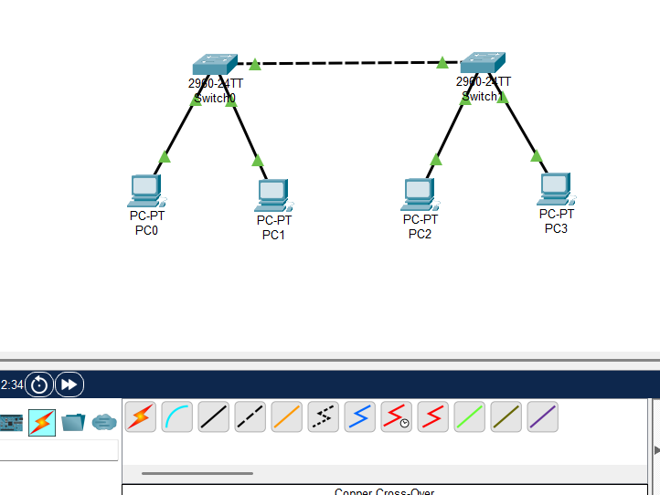

PART 1: BASIC SWITCH CONFIGURATION
Configure the following on BOTH switches:
- Hostname
- Console Password
- Enable Secret Password
- MOTD Banner
- Password Encryption
- Disable DNS Lookup
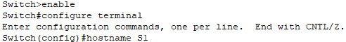
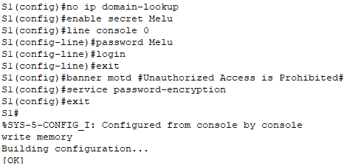

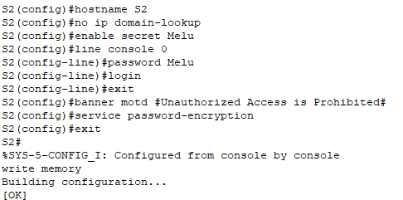
NOTE: Use the SURNAME OF THE LEADER as all passwords.

Switch 1 Hostname: S1
Switch 2 Hostname: S2
Leader’s Surname (Password): Melu

PART 2: VLAN CONFIGURATION
Create the following VLANs on both switches:
VLAN ID | VLAN Name
10 | HR
20 | SALES
30 | IT
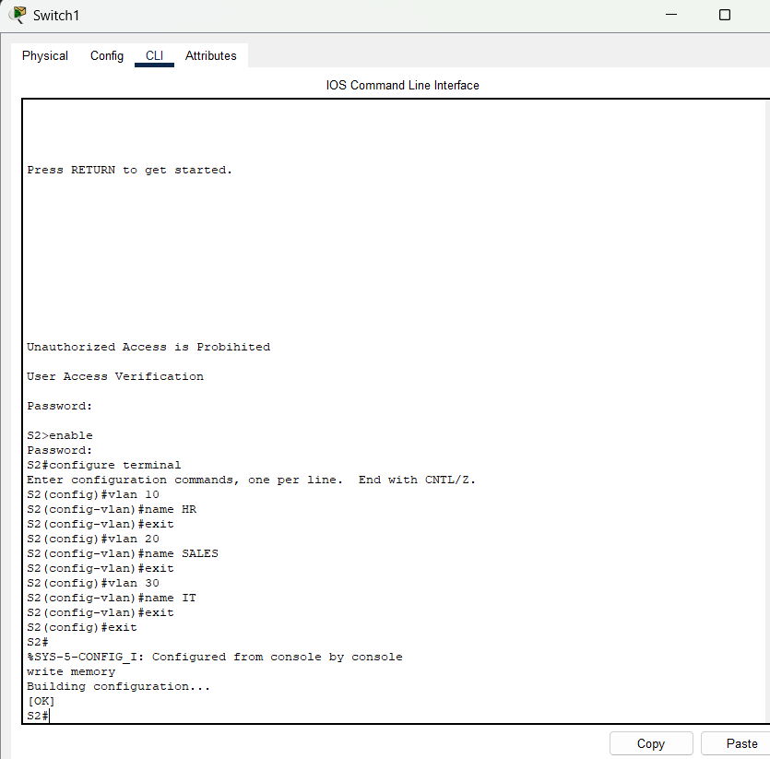
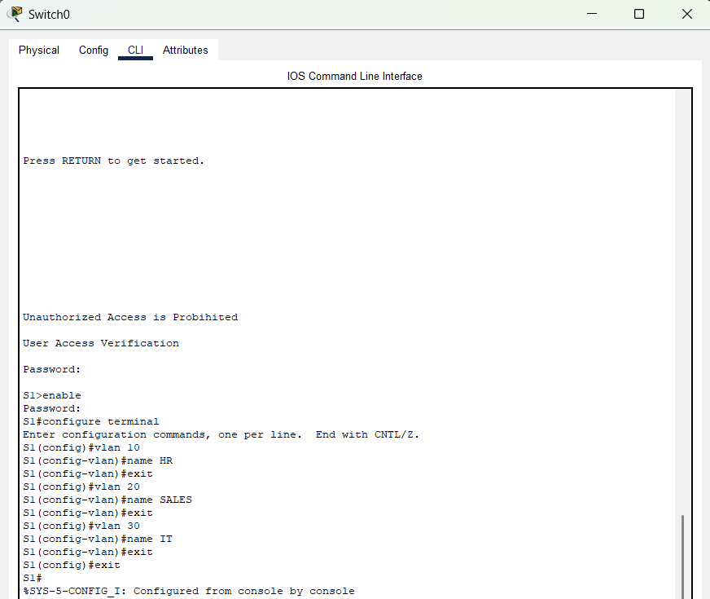
PART 3 : SWITCH PORT ASSIGNMENT
SWITCH 1:
Port | Device | VLAN
Fa0/1 | PC1 | VLAN 10 (HR)
Fa0/2 | PC2 | VLAN 20 (SALES)

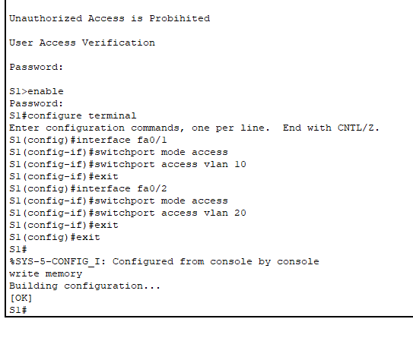
SWITCH 2:
Port | Device | VLAN
Fa0/1 | PC3 | VLAN 30 (IT)
Fa0/2 | PC4 | VLAN 30 (IT)

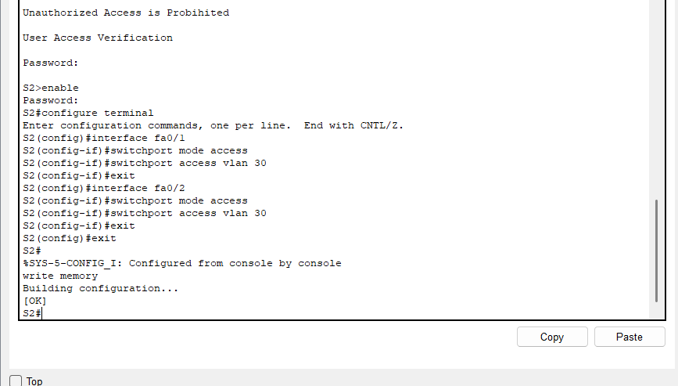

PART 4 — TRUNK CONFIGURATION
Configure the connection between Switch 1 and Switch 2 as a TRUNK link.
Trunk Port on S1: _____________
Trunk Port on S2: _____________
Mode: TRUNK

PART 5 : IP ADDRESSING
Each group must create and assign their own valid IP Addressing Scheme.
IP Addressing Table:
Device | Interface | IP Address | Subnet Mask | Default Gateway
PC1 | NIC | ______________ | ______________ | ______________
PC2 | NIC | ______________ | ______________ | ______________
PC3 | NIC | ______________ | ______________ | ______________
PC4 | NIC | ______________ | ______________ | ______________
S1 | VLAN 1 | ______________ | ______________ | ______________
S2 | VLAN 1 | ______________ | ______________ | ______________

PART 6: PORT SECURITY
Configure Port Security on Fa0/1 of both switches with the following settings:
Interface | Maximum MAC Address | Violation Mode
S1 Fa0/1 | 1 | shutdown
S2 Fa0/1 | 1 | shutdown

PART 7: VERIFICATION COMMANDS
Execute the following verification commands and record the results:
Command | Purpose | Done?
show vlan brief | Verify VLAN creation and port assignments | ☐ Yes ☐ No
show interfaces trunk | Verify trunk link between switches | ☐ Yes ☐ No
show running-config | Review all switch configurations | ☐ Yes ☐ No
show port-security | Verify port security settings | ☐ Yes ☐ No
show ip interface brief | Check IP addressing on switch interfaces | ☐ Yes ☐ No

PART 8 : CONNECTIVITY TESTING
Perform the following connectivity and verification tests:
Test | Expected Result | Status
PC1 pings PC2 (same VLAN 10 — HR) | Both in same subnet, 4 replies expected | ☐ Pass ☐ Fail
PC3 pings PC4 (same VLAN 30 — IT) | Both in same subnet, 4 replies expected | ☐ Pass ☐ Fail
PC1 pings PC3 (cross-VLAN test) | Should FAIL (different VLANs, no routing) | ☐ Pass ☐ Fail
Verify VLAN database on S1 | VLANs 10, 20, 30 visible in show vlan brief | ☐ Pass ☐ Fail
Verify trunk link between S1 and S2 | show interfaces trunk shows active trunk | ☐ Pass ☐ Fail
Observation / Notes:

Performance Rubric:
Criteria | Excellent (5) | Very Good (4) | Good (3) | Fair (2) | Poor (1) | Score
Basic Switch Configuration | Hostname, passwords, MOTD, encryption, no DNS — all correct. | Mostly correct, minor errors. | Some configs missing. | Multiple errors. | Failed to configure.
VLAN Configuration | All VLANs created, named, and functioning correctly. | Minor VLAN errors. | Some VLANs incomplete. | Multiple VLAN errors. | Not configured.
Port Assignment & Trunk | All ports correctly assigned; trunk functioning. | Minor port/trunk errors. | Some ports incorrect. | Multiple errors. | Failed to configure.
IP Addressing | All devices have valid IPs, masks, gateways. | Minor IP errors, minimal impact. | Some devices incorrect. | Multiple IP conflicts. | Not configured.
Port Security | Port security fully and correctly configured. | Minor port security issues. | Partially configured. | Incorrect implementation. | Not configured.
Verification & Connectivity | All commands executed; all tests successful. | Minor issues in testing. | Some commands incomplete. | Multiple failures. | Not performed.
Troubleshooting Skills | All problems resolved independently. | Most issues solved, minimal help. | Some issues solved with assistance. | Limited ability shown. | Unable to identify or solve.
Documentation (PDF) | Complete, organized, all screenshots included. | Mostly complete, minor gaps. | Adequate but lacks organization. | Incomplete and unclear. | Not submitted.
Video Presentation | Clear, organized, professional; all configs shown. | Understandable, minor issues. | Most tasks covered; lacks clarity. | Unclear or incomplete. | Not submitted or failed.
TOTAL |  |  |  |  |  | / 45
DELIVERABLES
Submit the following:
1. PDF Documentation containing:
• Complete configurations
• Screenshot of VLAN configuration
• Screenshot of trunk configuration
• Screenshot of port security configuration
• Screenshot of verification commands
• Screenshot of successful/failed ping tests
• Network topology
2. Packet Tracer File (.pkt)
3. Video Presentation (5–10 minutes) explaining:
• VLAN creation
• Port assignments
• Trunk configuration
• Port security configuration
• Verification and connectivity testing

