TITLE | CASH ADVANCE FOR LIQUIDATION (CAFL)
OBJECTIVE | To be able to request funds for specific purposes and be able to properly liquidate the expenses within the set deadline.
SCOPE | This procedure includes all activities in requesting cash funds and how it should be liquidated to justify expenditures.

Responsibility | Activities |  | Interfaces
Employee | Request for CAFL approval | Note 1 | Email, Telegram, SMS  CAFL Request Form  Printed CEO/VP’s approval
CEO & President  VP for Admin & Finance  Finance Manager | Approve?  No  END  Yes | Note 1
Employee | Submit CAFL Request Form | Note 1
Finance Assistant | Encode in QnE and Print RF Voucher and Debit Note | Note 2 | QnE Debit Note/ RF Voucher
Finance Officer | Check RF Voucher and Debit Note | Note 2 | CAFL Request Form  QnE Debit Note/RF Voucher
Corporate Finance Manager | Approve the Cash Advance Liquidation Report | Note 2 | CAFL Request Form  QnE Debit Note/RF Voucher
Head Cashier | Release Funds | Note 3 | QnE Debit Note/RF Voucher, Telegram
Employee | Submit Liquidation of Expenses | Note 3 | Cash Advance Liquidation Report  Official Receipts
Finance Assistant | Prepare Payment Voucher (PV) |  | Payment Voucher  CAFL Report
Head Cashier | Match the Payment Voucher (PV) to CAFL |  | QnE
Head Cashier | Return the Payment Vouchers (PV) to Finance |  | Payment Vouchers  Invoice Listing
Finance Assistant | Process Check for Reimbursement to Revolving Funds (RF) |  | Payment Vouchers  Liquidation Summary  Check

NOTE 1:

- The employee must first secure approval from the following.
AMOUNT | APPROVING AUTHORITY
5,000 and Below | Department Heads
Above 5,000 | CEO/President or VP for Admin & Finance

- All CAFL requests must be noted by the requesting employee’s Department Head in order to be processed or attach the proof of approval from the approving authority.

- Accomplished CAFL Request Form shall then be forwarded to the Finance Assistant.

NOTE 2:

- The Finance Assistant will then encode the details in QnE then print the Revolving Fund Voucher and Debit Note. Forward these to the Finance Officer.

- The Finance Assistant will then forward the Revolving Fund Voucher and Debit Note to the Finance Officer for checking then forward it to the Corporate Finance Manager for approval.

NOTE 3:
- The Corporate Finance Officer shall inform the Head Cashier through Telegram in order to release the amount to the requesting employee.

- The employee will be informed by the Finance Assistant when they can receive their CAFL.

- CAFLs must be liquidated within 7 working days from the date of disbursement.

- The employee shall fill out the Cash Advance Liquidation Report and attach corresponding receipts to support the liquidation.

- Receipts must be glued neatly in a bond paper for proper documentation of liquidation.

- Any excess cash must be returned to the Finance Assistant as part of the liquidation report.

- All thermal receipts must be photocopied to ensure the amount and items on the receipts are readable.

ADDITIONAL NOTES:

- If the purpose of CAFL is for travelling outside Bacolod for more than 1 day, liquidation of expenses must be submitted within 7 working days from the date of return.

- If the employee needs to travel before the 1st Cash Advance was liquidated, the Liquidation Report shall be submitted within 7 working days after completion of the next travel.

- All unsupported/unofficial and unliquidated CAFL shall be charged to the account of the requesting employee and shall be outright deducted from the salary.

- If prompt charging is not done, unliquidated CAFL shall be charged to the account of Finance Officer concerned.

- In case of charging the unliquidated amount, the employee shall sign the CAFL Liquidation Report and shall serve as acknowledgement of the amount to be outright deducted.

- The Quality Management Head/Associate will send soft copy of the following forms to every Immediate Heads:

- Cash Advance Request Form
- Cash Advance Liquidation Report

- The Immediate Supervisors will then print copies and the employee may get a copy to fill out before they go to the Finance Department for processing.

RECORDS GENERATED:

- QnE Records
- Cash Advance Request Form HW-FM-FIN-009
- Revolving Funds (RF) Voucher
- QnE Debit Note
- Cash Advance Liquidation Report HW-FM-FIN-004
- Official Receipt/s
- Supporting Documents
- Reimbursement Form HW-FM-FIN-010

REFERENCES:

- QMS Memorandum No. 2022-005

Prepared by:  Joymie R. Reyes  QMS Assistant | Reviewed by:  Karen S. Ramirez  Finance Manager | Approved by:  Suzette B. Baguitan  Corporate QMS Head
Date: April 4, 2022 | Date: April 4, 2022 | Date: April 4, 2022

Cash Advance Request Form HW-FM-FIN-009
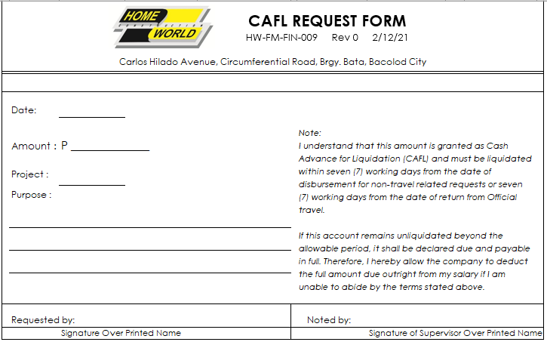

Reimbursement Form HW-FM-FIN-010

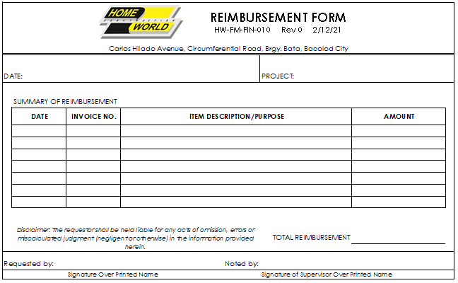

Cash Advance Liquidation Report HW-FM-FIN-004
